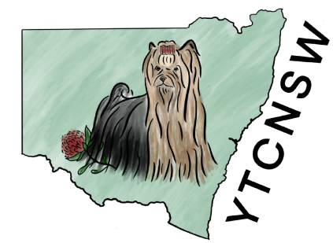

(Affiliated with DOGS NSW)
MEMBERSHIP APPLICATION / RENEWAL 2026-2027

I/We ______________________________________________________wish to make Application
to The Yorkshire Terrier Club of NSW Inc. for Single Dual/Family Membership for the Year 1st
July 2026 to 30Th June 2027, and agree to abide by The Rules and Regulations of The
Club.
I/We will also deposit directly into the club bank account the appropriate fees of:
(Single $15.00) (Dual $20.00) (Family $20.00) $____________________________________________________
I/We
................................................................................................................................
Address
................................................................................................................................
Phone Number___________________Email__________________________________________________________
Kennel Prefix ____________________DOGSNSW Membership Number _________________________________
I/We hereby apply for Membership/Renewal (strike out words that do not apply)
SIGNATURE NEW MEMBERS: ........................................................................................
(In Dual Membership both must sign)
Nominator ...................................................
Seconder ..................................................... Date ............................................................
Committee Decision ....................................
President .................................................... Date ............................................................
Note: Nominations are only required for New Members, not for Renewals. Additionally, Nominators must be Financial Members.
This Application form and appropriate Fees to be returned to:
The Secretary: Miss Julie-Anne Morris Club Email: Ytcnsw1@outlook.com
Account Details
Bank: CBA
BSB: 062-805 Account No.1023 2222

