RESUME  Felicity Thompson (Barnesmore)  Judging Championship Conformation Classes and General Specials  I am fully qualified to judge both FCI Group 10 Breeds & Group & FCI Group 6 Breeds & Group. I am currently progressing in FCI Group 5.  I have been involved with whippets and greyhounds since early childhood. I have been judging since 2000, and am FCI qualified to judge all Group 10 Breeds & Group and Group 6 breeds and Group, as well as Siberian Huskies (my progression into Group 5 breeds). I have judged extensively throughout Ireland and the UK, as well as across Europe including Finland, Germany, Sweden, Switzerland and Belgium. | 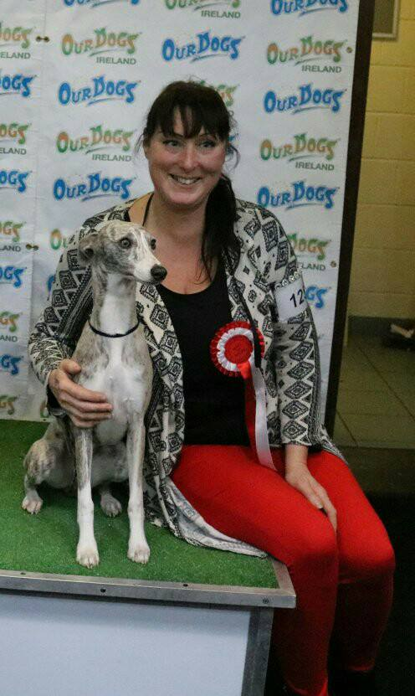
I am lucky to be born into a family of animal lovers. Over 90 champions have now been bred or owned in various breeds worldwide since the Barnesmore affix was originally registered in the late sixties. We have now produced over 60 whippet champions including champions in 10 different countries worldwide. I have bred and owned many multi champion whippets, Greyhounds & Ibizan Hounds, as well as campaigning my Borzois to their Irish/International & UK titles. I was honoured to have won the CC & Best of Breed at Crufts with my whippet bitch some years ago and then watch with delight to see her homebred son take the CC at Crufts handled by my mother a few years later.

I am a member of the Whippet Club (N.I), Greyhound Club (UK) and the Ibizan Club (UK), and was previously a Committee Member of the English Ibizan Hound Club, as well as having been Chairperson of the N.I Whippet Club. I have stewarded from the age of twelve and been involved in exhibiting since the age of four. I thoroughly enjoy judging and showing, especially the delight and joy my dogs give me, in and out of the show ring.

Felicity Thompson

