STENNAROO BULLMASTIFFS
Welcome to my world – Maria Stennings
Stennaroo Bullmastiffs came about in 2011 when we acquired our 1st Australian girl Gemma.
She is the Matriarch of our Family. She is our very special girl and she was born to be a mum.
In her first litter she gave us 7 puppies and her second she gave us 8 puppies. She has always been attentive to any of our Mums litters and she has taught all of our babies how to be calm and obedient.
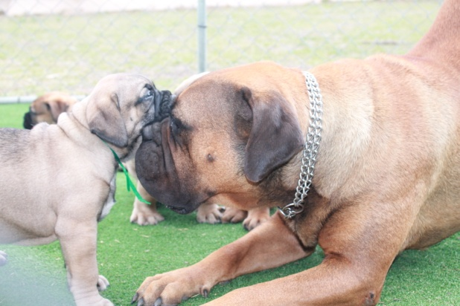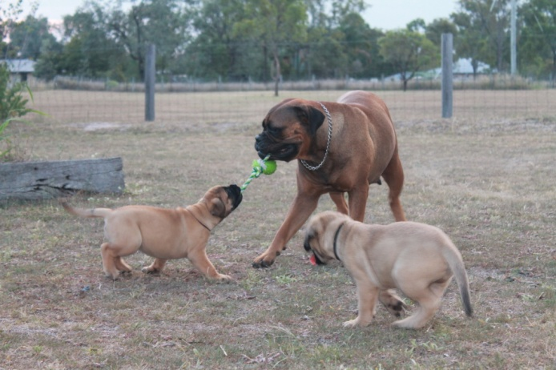
Gemma and her babies.
We acquired Angie next. Another gorgeous red girl and we mated her to a Supreme Champion named Bravo. Bravo was a Fawn boy so we got half Fawn and half Red babies.
We kept one girl for the Show ring and her name was Sassy. She was able to gain her Championship before her 1st Birthday. During her Show career, she also gained PUPPY IN SHOW on one occasion.
We were planning to breed with Sassy – but that didn’t happen because we found she had a Heart murmur. We desexed her and found a lovely family who had just lost their Bullmastiff to Cancer. She is now living the life of Luxury up on the Sunshine coast of QLD.
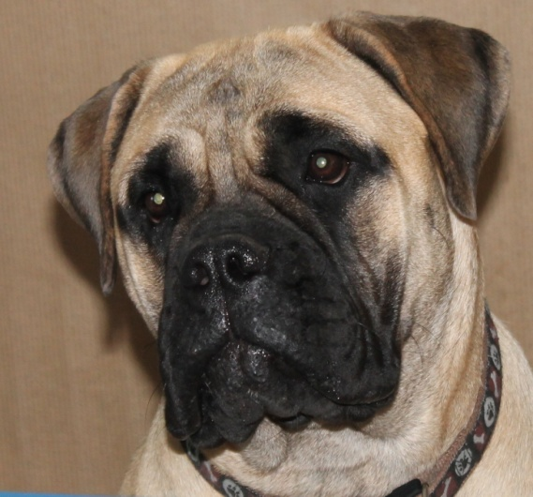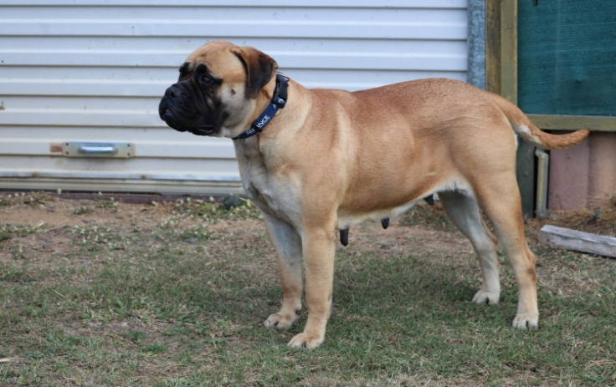
Sassy and Mum – Angie
Angie was mated with a very Handsome Brindle boy named Spartan, for her second mating. His Hereditary came from Denmark with renowned Champions.
We had a mixture of Brindle, Red and Fawn babies in the litter.
Angie and Spartan gave us another 11 puppies. We knew this was a special litter and so we kept 5 for the Show ring. Gryphon, our handsome Red boy. Junior, our Gorgeous Brindle Boy. Babe, our clear Fawn girl. Violet, our Red Brindle girl and Brin our Fawn Brindle girl.
Junior is Co Owned and lives in ACT. He was awarded 2 x BABY PUPPY IN SHOW on his second time out in the Show ring. He is still doing very well when shown.
Gryphon was awarded his Championship on his 11th month Birthday. He also gained a PUPPY IN GROUP on the same Weekend. Our plan is to hopefully get to his Grand Champion Status before his 3rd Birthday. He needs 1000 points for that award.
Babe has also gained her Championship at 13 months old and a PUPPY IN GROUP on the same day.
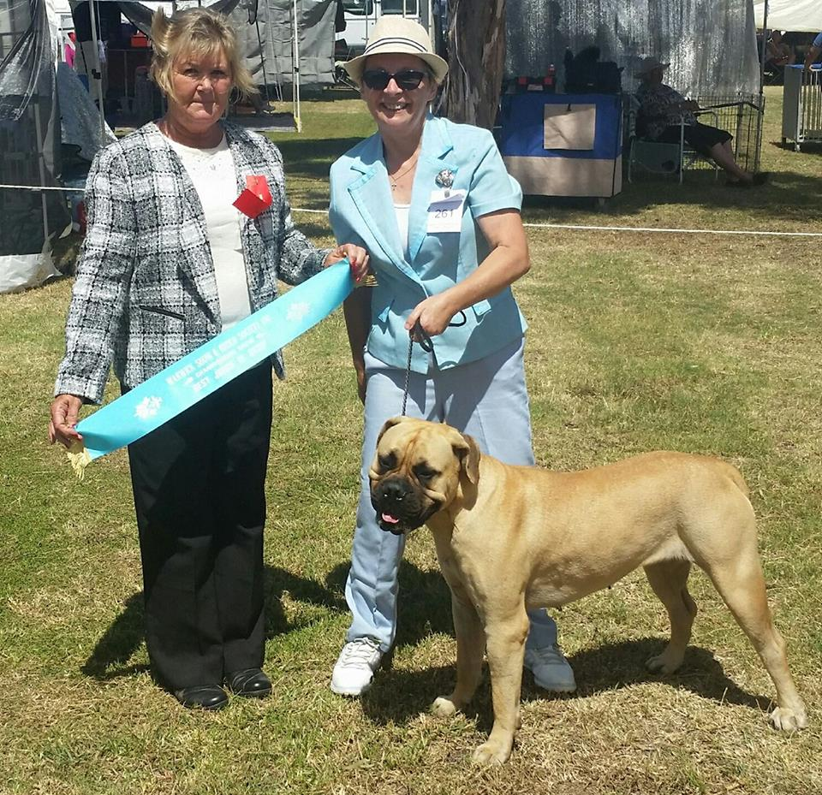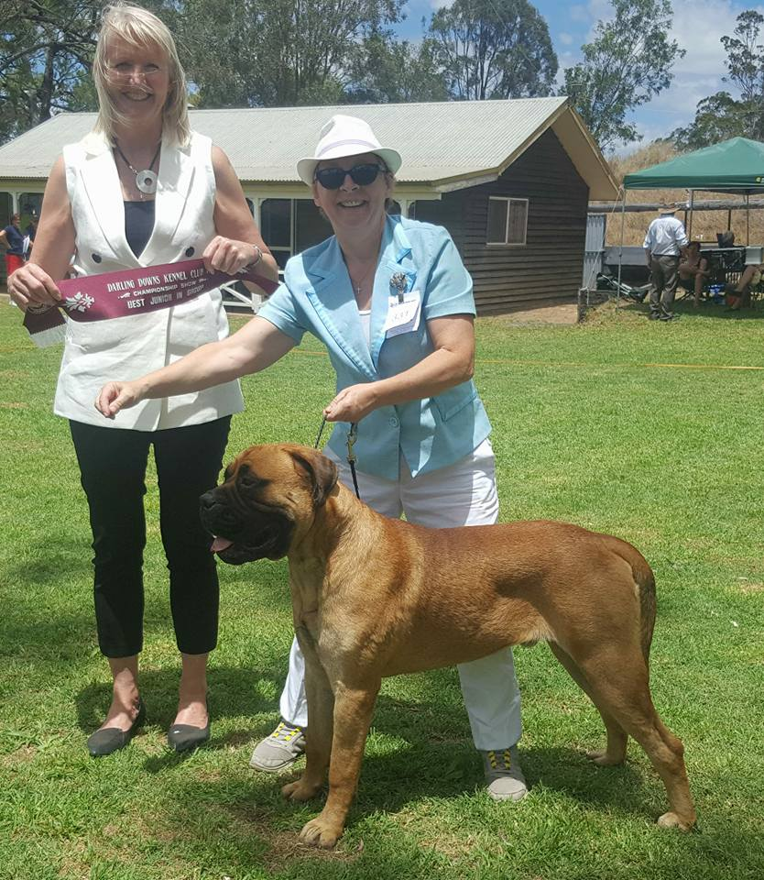
Babe Gryphon
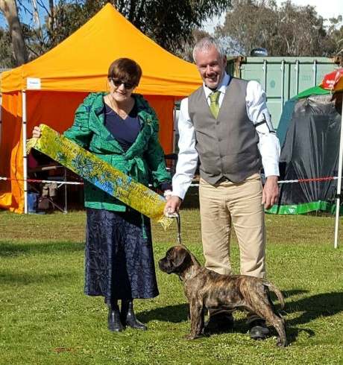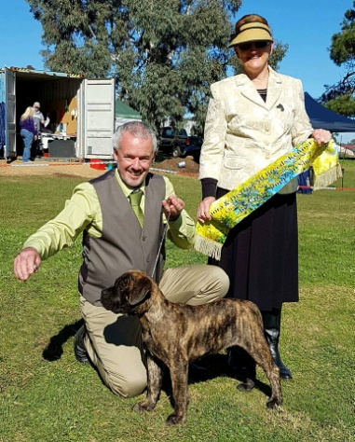
Junior - Awarded BEST BABY IN SHOW X 2
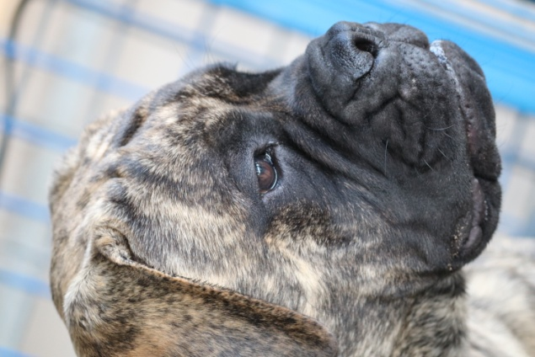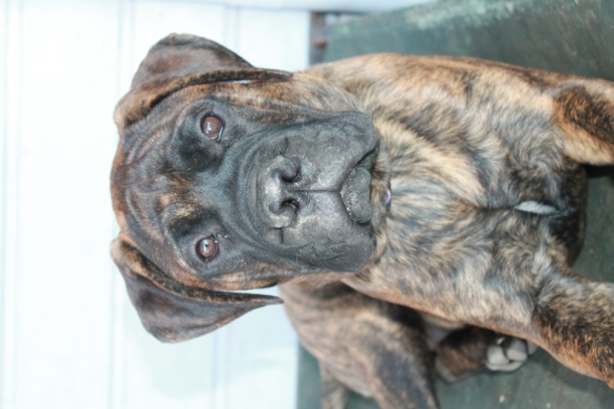
Brin Violet
Being a Breeder of Bullmastiffs is very enjoyable. However we have had some heartache on our journey. It is a very expensive hobby and is definitely not for the faint hearted.
You need at least $10.000 in the bank before you start – if you are going to do things right.
Fees include – Cost of Frozen Semen – Australia $2500.00 Rest of the world - $5000.00 $8000.00.
Female Progesterone testing $60.00 every test. Five to six needed.
Surgical Insemination of Frozen Semen $650.00
Pregnancy medication $100.00
USS at five weeks gestation $200.00
C-Section plus all necessary medications $2000.00
Sutures out at ten days $80.00
Vet Checks, Microchiping, Registration with Kennel Council and DNA testing of every puppy $400.00 each. This happens at six weeks old.
Newborns require 2 hourly feeds until around 8 days old. Then 3 hourly, until around 14 days old. Then 4 hourly until properly weaned off mum. Puppies are weaned from 3 weeks old. If there are more than six puppies, they need to be topped up using Goats milk after suckling from mum.
Mum needs a high protein and calcium diet to provide for herself and her puppies.
At ten weeks old, we have a Vasectomy performed on the boys and a Tubal Ligation on the girls. This is for puppies that are going to Pet homes. This procedure ensures that the growth hormones are not interfered with and puppies will grow correctly. Puppies that are good enough for a Show career do not need this procedure performed.
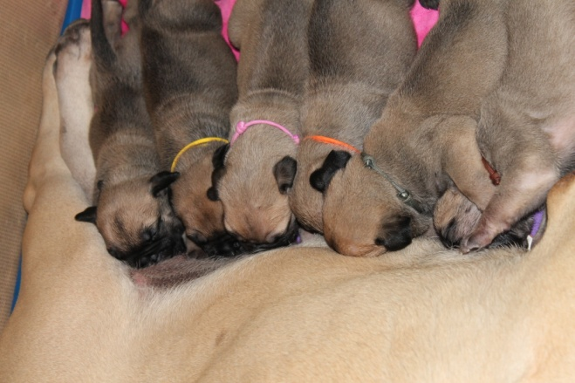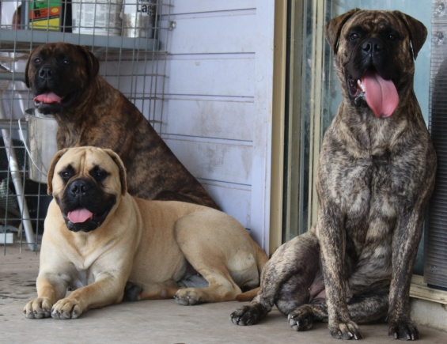
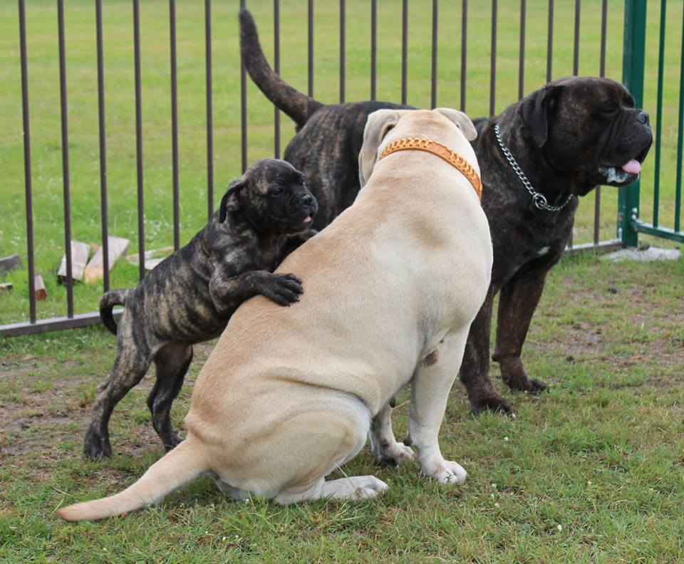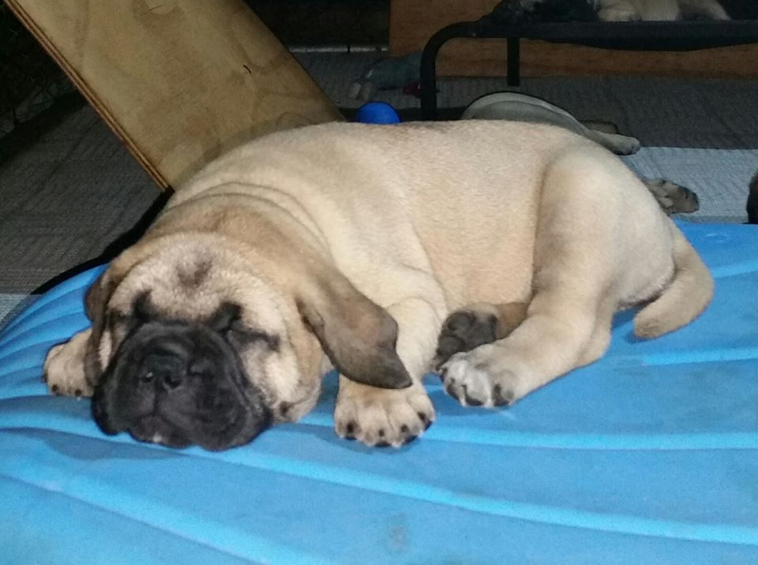
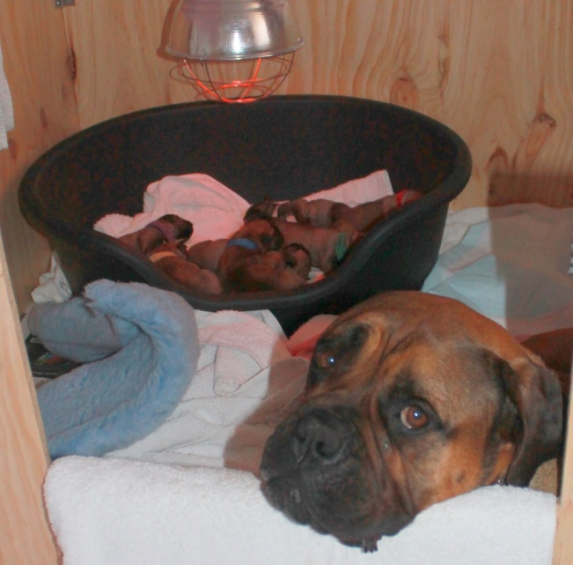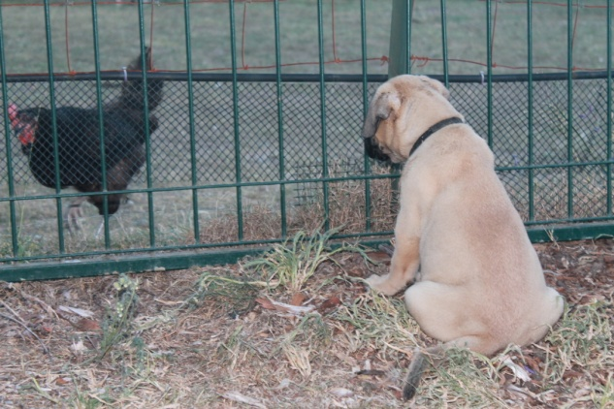
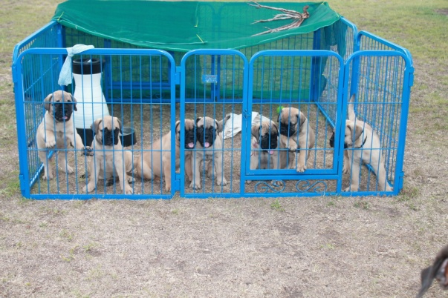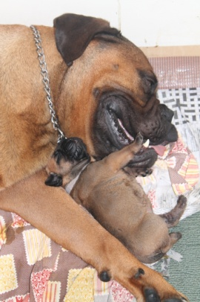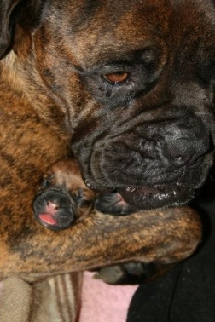
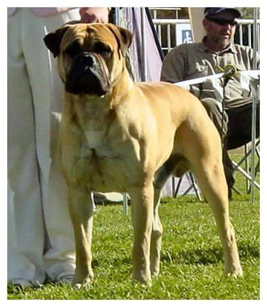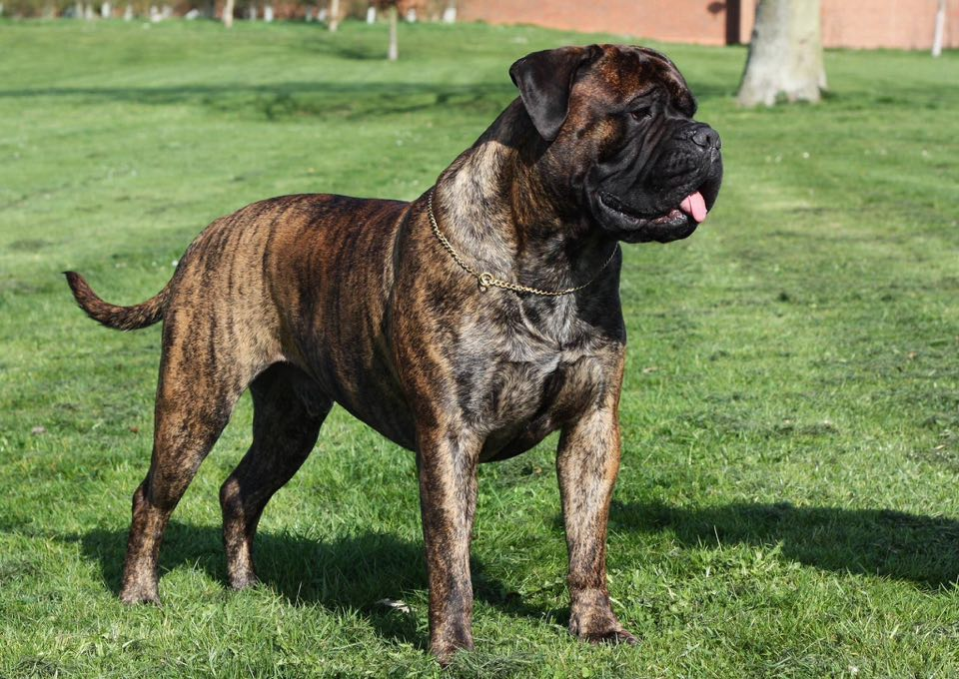
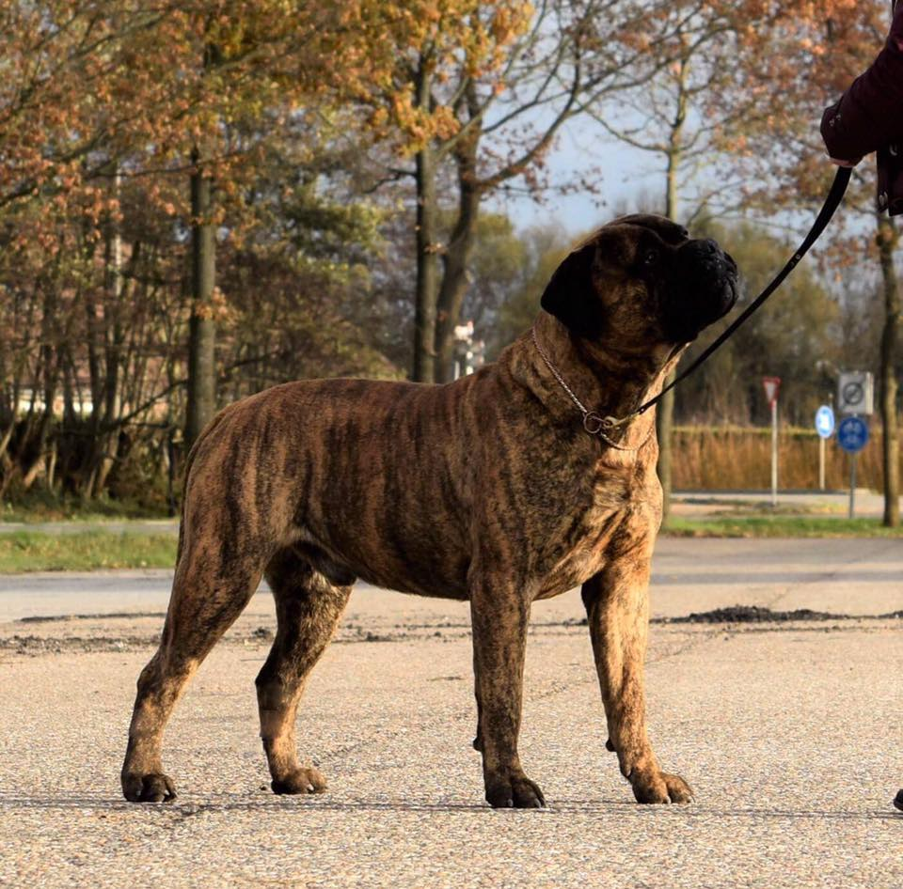
These are the Sires of the future for our Stennaroo Kennel
Top left – Alex NZ and AUS Champion – Semen cost - $1,000.00
Top right – Sirious Russian Bred Multi European Champions in his line Semen cost $6500.00
Bottom left – Baine Bred in the Netherlands with Multi European Champions Semen cost $6800.00

