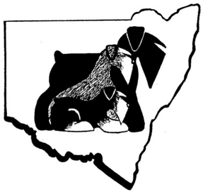
The Schnauzer Club of NSW Incorporated
Affiliated with DOGS NSW
Breeders’ Listing Application
(Breeder’s listing fee is additional to membership subscription)
Please Print Clearly
Date:……………………..….
Name: Ms/Mr/Mrs………………………………….……., …………………………………………………..
(First Name) (Surname)
Breeder Prefix: ………………………………………………………
DOGS NSW Number *(1).……………..…..….
Breeder Identification Number (BIN)*(2)………..………………..(Starts with B followed by 9 numbers)
Address: …………………………………………………………………………………….…………..
(Number/Street)
……………………………………………………………………………………….…….…..
(Town/Suburb) (Postcode/State)
Contact Number/s: ……………………………………………………………………….…………….

Email: ……………………………………………………………………………………………………..……
Breed/s; Please mark relevant breed/s
 Giant Schnauzers Schnauzers Miniature Schnauzers

Which Activities Do You Participate In With Your Dogs?
Mark Applicable box/es
Conformation/Showing

Obedience

Agility

Rally

Tricks

Dances with Dogs

Scent Work

Other (Please indicate): ……………………………………………………………………………………………………………………………………………………………..
*(1) Details should match DOGS NSW registration records
*(2) Number is for Club records only, not for publication.

