THE SCHNAUZER CLUB of NSW Inc.
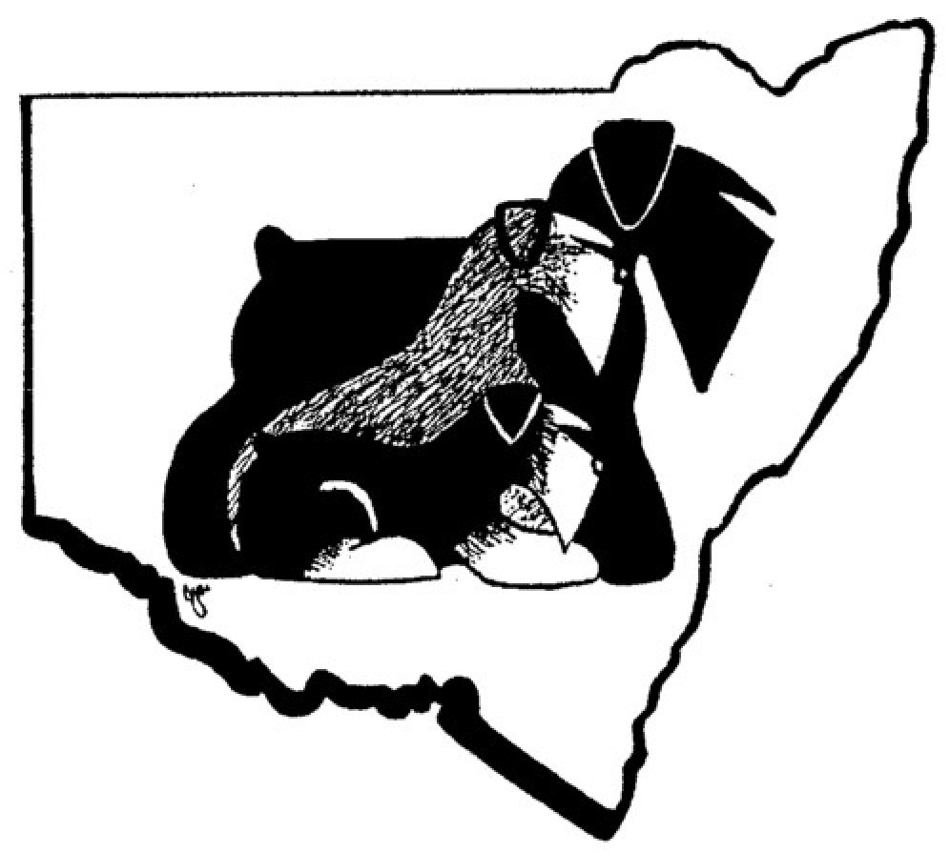
Obedience , Rally & Tricks Trial
Saturday 21st June 2025

Judges:
Mr C. Giles (ACT) Obedience – All Classes

Ms M. Fazekas (NSW) Rally – All Classes

Ms C Jensen (NSW) Tricks – All Classes

Dogs NSW Representative: Linda Dibbin

Judging Commences: 10am with Obedience Classes and Rally Classes
Tricks not before 1pm

ClubOfficials:
President – Jane Jackson, Secretary – Julie-Ann Morris Treasurer – Rob Laughton, Show/Trials Secretary – Mrs Veeni Craig

TRIAL WILL BE CONDUCTED UNDER THE RULES & REGULATIONS OF DOGS NSW.

TROPHIES & PRIZES

ALL CLASSES 1ST 2ND 3RD SASH & CASH
QUALIFIERS – SASH
TITLES GAINED - SASH

**********************************************************************

Presidents Message

The Schnauzer Club of NSWInc warmly welcomes everyone today to its annual Obedience trial for 2025 – 21 June

We hope you all enjoy the day and wish all competitors great success
Special Thanks and appreciation to our Judges who accepted our invitation,
Mr Charles Giles – (ACT) Obedience
Ms Maryanne Fazekas – (NSW) Rally
Mrs Carolyn Jensen – (NSW) Trick Dog
To all our officials who have supported and helped today to make this trial possible, our sincere thanks -
Stewards – Sandra Gluck, Patricia Ohm, Carol Domsalla, Heidi Fluder ,
and DOGS NSW Representative, Linda Dibbin

Also to our dedicated Trial Secretary Mrs Veeni Craig who has put in place all necessary arrangements and preparation for the trial, to ensure the trial runs smoothly and successfully, an enormous, thank you
Safe travel to all following the trial
Jane Jackson

OBEDIENCE – Judge Mr Charlie Giles (ACT)

CCD Community Companion Dog

1 Mr G & Mrs S Langley
BOXAMORE SPECIAL ENDEAVOUR (AI) 2100580141 29/12/2021 M
Sire: Uk. Ch. Norwilbeck Special Blend Dam: Sup.ch. Boxamore Leading Lady
Bred By: Mr G & Mrs S Langley Breed: Boxer

2 Miss J Leckie
CH BRANBERN GRAND DESIGN RN 2100612901 08/02/2024 M
Sire: Bih. Ch. Blr. Ch. Blr. Jch. Me. Ch. Mk. Ch. Ru. Jr Ch. Rus. Ch. Rus. Gr. Ch. Sr. Bu. Ch. Srb. Ch. Bern Haus On Oka GrandWinner (Imp Srb) Dam: Branbern Waltz On Ice
Bred By: Mrs L D Brand Breed: Bernese Mountain Dog

3 Mr G Sparham & Miss B Turner
CH. GAMEGUARD BLACK SAMBUCA (AI) 2100482106 23/08/2017 M
Sire: Hanbar Matcho Dam: Ch. Skymist Abracadabra
Bred By: Mr G Sparham & Miss B Turner Breed: Rottweiler

4 Ms R Israel
CH. KOOBALIES DOMINO EFFECT TK.N. RA. SWA ADX. JDM 3. JDO. GDX. SDX. SPD. FS.N. HTM.S. 2100521620 05/06/2019 M
Sire: Ch. Myltans Play Off (Imp Swe) Dam: Ch. Schonhardt Tango Lovesto Tango (Iid)
Bred By: Mr A Mcilrath Breed: Schnauzer (Miniature)

5 Mrs R Rothwell
KEFTIU JUST THE WAY UR 􀔻AI􀔼 RE SWA 2100581625 23/02/2022 M
Sire: Sup.ch. Kchise Quest Of Love Dam: Keftiu Bella Rosa(Ai) Tk.s. Sd. Ra.
Bred By: Mrs R Rothwell Breed: Samoyed

6 Ms S Womersley
BONSUE WORTH A KINGS RANSOM RN (AI) 6100132464 19/10/2021 F
Sire: Ch. Ronin Digital Lock(Ai) (mp Nzl) Dam: Bonsue Because Youre Worth It
Bred By: Miss L Herd Breed: Boxer

1st _____ 2nd _______ 3rd _________

CD Novice

7 Ms D Hunter Ward
CH. OVASHUN SHAKEN NOT STIRRED CCD. RN. 2100518503 25/04/2019 M
Sire: Ch. Morgan Saltus Ze Zahrabske (Imp Hrv) Dam: Ch. Montkhan Waltzing With
Destiny Ccd.
Bred By: Mrs J Jackson & Mrs M Outten Breed: Schnauzer

8 Mrs J Jackson & Mrs M Outten
CH. MONTKHAN WALTZING WITH DESTINY 2100372817 28/10/2012 F
Sire: Grand. Ch. Neut. Grand Ch. Treuliebe Takit T Thlmit Dam: Ch. Treuliebe Dancing
With Destiny Ccd. Rn.
Bred By: Mr F B & Ms A D Anderson Breed: Schnauzer

9 Ms S M Turner & Mrs V A Craig
EBSHINE MR MUTIG RA CCD TD TSD SWA 2100522992 30/06/2019 M
Sire: Ch. Ebshine Perfect Match Cd. Dwdf.s. Re. Dam: Ch. Ebshine Country Songstress Re.
Bred By: Mrs V A Craig Breed: Schnauzer (Miniature)

1st _________ 2nd ______ 3rd ______

CDX Open

10 Mrs N Badger F
CH. OVASHUN LADY SORELLA CCD. CD. RE. FS.S. HTM.S. FS.N. 2100498647 16/04/2018
Sire: Grand. Ch. Treuliebe Takit T Thlmit Dam: Ch. Treuliebe Dancing With Destiny Ccd. Rn.
Bred By: Mrs J Jackson & Mrs M Outten Breed: Schnauzer

11 Mrs L Horton
KARLEKEN MYSTIC ANGEL CCD CD RA 4100285912LR 06/01/2017 F
Sire: Ch Alpenhund Prayers Are Answered Dam: Zeigen Pride And Prejudice
Bred By: Ms A Harder Breed: Bernese Mountain Dog

1st ______________ 2nd _______________

RALLY - Judge Ms Maryanne Fazekas (NSW)

Rally Novice RN

12 Miss J Barnard
ARYDAN BLAK MOLLY TK.S. 2100507856 07/10/2018 F
Sire: Grand. Ch. Ebshine Daringly Debonair(Ai) Dam: Arydan New Moon On The Horizon
Bred By: Ms A Earley Breed: Schnauzer (Miniature)

13 Mrs J Jackson & Mrs M Outten
CH. MONTKHAN WALTZING WITH DESTINY 2100372817 28/10/2012 F
Sire: Grand. Ch. Neut. Grand Ch. Treuliebe Takit T Thlmit Dam: Ch. Treuliebe Dancing With
Destiny Ccd. Rn.
Bred By: Mr F B & Ms A D Anderson Breed: Schnauzer

14 Ms R Israel
CH. KOOBALIES CODEBREAKER TK.S. SWN JD. 2100602568 22/04/2023 M
Sire: Arg. Jr Ch. Brz. Jr Ch. Ch. Dog-Otho's My One And Only (Imp Arg) Dam: Koobalies
St Patricks Day
Bred By: Mr A Mcilrath Breed: Schnauzer (Miniature)

15 Mr N Breen
VERADIS GHOST PEPPER 2100618921 12/07/2024 M
Sire: Ch. Schonhardt Hot Chilli Pepper (Iid) Je. Tk.s. Dam: Ch. Neut. Ch. Heisspur Choo
Give Me Fever N.SPRD TK.S
Bred By: Mrs L & Miss B Kolodziej Breed: Schnauzer (Miniature)

16 Miss J Barnard
ARYDAN SUNRISE OVER BRONTE TK.S. 2100565074 04/06/2021 F
d
Bred By: Ms A Earley Breed: Schnauzer(􀔻Miniature)

1st ____________ 2nd _____________ 3rd ____________

Rally Advanced RA

17 Mr G & Mrs S Langley
BOXAMORE SPECIAL ENDEAVOUR (AI) 2100580141 29/12/2021 M
Sire: Uk. Ch. Norwilbeck Special Blend Dam: Sup.ch. Boxamore Leading Lady
Bred By: Mr G & Mrs S Langley Breed: Boxer

18 Mr G Sparham & Miss B Turner
CH. GAMEGUARD BLACK SAMBUCA (AI) 2100482106 23/08/2017 M
Sire: Hanbar Matcho Dam: Ch. Skymist Abracadabra
Bred By: Mr G Sparham & Miss B Turner Breed: Rottweiler

19 Ms S Womersley
BONSUE WORTH A KINGS RANSOM RN (AI) 6100132464 19/10/2021 F
Sire: Ch. Ronin Digital Lock(Ai) (Imp Nzl) Dam: Bonsue Because Youre Worth It
Bred By: Miss L Herd Breed: Boxer

20 Ms D Hunter Ward
CH. OVASHUN SHAKEN NOT STIRRED CCD. RN. 2100518503 25/04/2019 M
Sire: Ch. Morgan Saltus Ze Zahrabske (ImpHrv) Dam:Ch. Montkhan Waltzing With
Destiny Ccd.
Bred By: Mrs J Jackson & Mrs M Outten Breed: Schnauzer

21 Mrs M Harrison
CH. AHZU THE MAHARAJAHS DAUGHTER N.SPRD TK.S. RN. ET. WPD. 2100564326 F 25/04/2021 Sire: Ch. Sup.ch. Samspring Phantom Of Opera 􀔻Imp Prt)
Dam: Grand. Ch. Ahzu You Better Watch Out Wpd.
Bred By: Mrs M Harrison Breed: Samoyed

22 Mrs L & Miss B Kolodziej
CH. VERADIS OFF WITH A BANG ET. JC. N.SPRD RN. TK.S. WPD. 2100591080 21/08/2022 F
Sire: Sup.ch. Engelhuette Kissin Dynamite (Imp Nzl) Dam: Ch. Fireax Wild About The Chacha
N.sprda.Tk.s. Wpd.
Bred By: Mrs L & Miss B Kolodziej Breed: Dobermann

23 Ms R Israel
CH. MONTKHAN DREAM CATCHER RN. JDX. GD. TK.N. ADX. SDX. SWN 2100445550 M
25/01/2016 Sire: Ch. Treuliebe Talk The Talk Dam: Ch. Montkhan Close Encounters
Bred By: Mr F B & Ms A D Anderson Breed: Schnauzer(Miniature)

24 Miss J Barnard
ARYDAN HARLEY DAVIDSON CCD, TK.N, RE, JD 2100470699LR 28/01/2017 F
Sire: Evadouc Master Rebel Heart Dam: Arydan Wind In The Willows
Bred By: A J A Earley Breed: Schnauzer(Miniature)

1st ____________ 2nd _____________ 3rd ____________
Rally Excellent RE

25 Mrs L Horton
KARLEKEN MYSTIC ANGEL CCD CD RA 4100285912LR 06/01/2017 F
Sire: Ch Alpenhund Prayers Are Answered Dam: Zeigen Pride And Prejudice
Bred By: Ms A Harder Breed: Bernese Mountain Dog

26 Ms R Israel
CH. KOOBALIES DOMINO EFFECT TK.N. RA. SWA ADX. JDM 3. JDO. GDX. SDX. SPD. FS.N. HTM.S. 2100521620 05/06/2019 M
Sire: Ch. Myltans Play Off (Imp Swe) Dam: Ch. Schonhardt Tango Lovesto Tango (Iid)
Bred By: Mr A Mcilrath Breed: Schnauzer(Miniature)

27 Miss J Barnard
ARYDAN HARLEY DAVIDSON CCD, TK.N, RE, JD 2100470699LR 28/01/2017 F
Sire: Evadouc Master Rebel Heart Dam: Arydan Wind In The Willows
Bred By: A J A Earley Breed: Schnauzer (Miniature)

28 Ms S M Turner & Mrs V A Craig
EBSHINE MR MUTIG RA CCD TD TSD SWA 2100522992 30/06/2019 M
Sire: Ch. Ebshine Perfect Match Cd. Dwdf.s. Re. Dam: Ch. Ebshine Country Songstress Re.
Bred By: Mrs V A Craig Breed: Schnauzer(􀔻Miniature)

1st ____________ 2nd ______________ 3rd _____________

Rally Master RM

29 Mr J Leung & Mrs M Harrison
AHZU A WALK IN THE PARK RE. TK.N. 2100581808 19/02/2022 M
Sire: Sup.ch. Aldonza Cash Made Easy Dam: Ch. Ahzu Dancing With Fire Tk.n. Re. Jc. Wpd.
Bred By: Mrs M Harrison Breed: Samoyed

30 Miss J Barnard
ARYDAN HARLEY DAVIDSON CCD, TK.N, RE, JD 2100470699LR 28/01/2017 F
Sire: Evadouc Master Rebel Heart Dam: Arydan Wind In The Willows
Bred By: A J A Earley Breed: Schnauzer (Miniature)

31 Mrs R Rothwell
KEFTIU PERFECT REFLECTION CCD. TK.N. RE. RAE. SW.N 2100476192 09/05/2017 F
Sire: Ch. Keftiu Mccoys Bayuani Ht Pt. Dam: Keftiu Destind To Enchant(Ai)
Bred By: Mrs R Rothwell Breed: Samoyed

32 Mrs N Badger
CH. OVASHUN LADY SORELLA CCD. CD. RE. FS.S. HTM.S. FS.N. 2100498647 16/04/2018 F
Sire: Grand. Ch. Treuliebe Takit T Thlmit Dam: Ch. Treuliebe Dancing With Destiny Ccd. Rn.
Bred By: Mrs J Jackson & Mrs M Outten Breed: Schnauzer
RM cont’

33 Mr J Leung
CH. AHZU DANCING WITH FIRE TK.N. RE. JC. WPD. 2100530766 18/11/2019 F
Sire: Mezen A Song Of Fire And Ice Dam: Ch. Ahzu Breakfast At Tiffanys
Bred By: Mr J & Mrs M Harrison Breed: Samoyed

1st __________ 2nd __________ 3rd ___________

TRICKS – Judge Ms Carolyn Jensen (NSW)

Tricks Starter

34 Mr G & Mrs S Langley
BOXAMORE SPECIAL ENDEAVOUR (AI) 2100580141 29/12/2021 M
Sire: Uk. Ch. Norwilbeck Special Blend Dam: Sup.ch. Boxamore Leading Lady
Bred By: Mr G & Mrs S Langley Breed: Boxer

35 Miss J Leckie
CH BRANBERN GRAND DESIGN RN 2100612901 08/02/2024 M
Sire: Bih. Ch. Blr. Ch. Blr. Jch. Me. Ch. Mk. Ch. Ru. Jr Ch. Rus. Ch. Rus. Gr. Ch. Sr. Bu. Ch. Srb. Ch. Bern Haus On Oka Grand Winner (Imp Srb) Dam: Branbern Waltz On Ice
Bred By: Mrs L D Brand Breed: Bernese Mountain Dog

36 Mrs R Rothwell
KEFTIU JUST THE WAY UR (AI) RE SWA 2100581625 23/02/2022 M
Sire: Sup.ch. Kchise Quest Of Love Dam: Keftiu Bella Rosa(Ai) Tk.s. Sd. Ra.
Bred By: Mrs R Rothwell Breed: Samoyed

37 Ms S Womersley
BONSUE WORTH A KINGS RANSOM RN (AI) 6100132464 19/10/2021 F
Sire: Ch. Ronin Digital Lock(Ai) (Imp Nzl) Dam: Bonsue Because Youre Worth It
Bred By: Miss L Herd Breed: Boxer

38 Ms D Hunter Ward
CH. OVASHUN SHAKEN NOT STIRRED CCD. RN. 2100518503 25/04/2019 M
Sire: Ch. Morgan Saltus Ze Zahrabske (Imp Hrv) Dam: Ch. Montkhan Waltzing With
Destiny Ccd.
Bred By: Mrs J Jackson & Mrs M Outten Breed: Schnauzer

39 Ms S M Turner & Mrs V A Craig
EBSHINE MR MUTIG RA CCD TD TSD SWA 2 100522992 30/06/2019 M
Sire: Ch. Ebshine Perfect Match Cd. Dwdf.s. Re. Dam: Ch. Ebshine Country Songstress Re.
Bred By: Mrs V A Craig Breed: Schnauzer (Miniature)
Tricks Starter – cont’

40 Miss M Lalor
CH. MUNCHENER ZENIA VON ULIX 4100396423 31/01/2024 F
Sire: Munchener Undercover Ulix(Ai) Dam: Ch. Jenga Vom Moisburger Berg (Imp Deu)
Bred By: Mrs Y & Miss F Hopf Breed: Schnauzer (Giant)

41 Miss R Mills & Mr J & Mrs M Harrison
SUP.CH. AHZU NIGHTMARE BEFOR CHRISTMAS RN. WPD. 2100444595 24/12/2015 M
Sire: Ch. Anaky Im An Idol Dam: Ch. Anaky Were All Mad Here
Bred By: Mr J & Mrs M Harrison Breed: Samoyed

42 Mrs M Harrison
CH. AHZU A STAR IS BORN (AI) RN. SWN. JC. 2100577334 27/11/2021 F
Sire: Ltu. Jr Ch. Pol. Ch. Pol. Jr Ch. Winnie The Pooh Of Yarak The Glow Of The Snowy Star
Dam: Ch. Ahzu Breakfast At Tiffanys
Bred By: Mrs M Harrison Breed: Samoyed

1st ___________ 2nd ____________ 3rd _____________

Tricks Novice

43 Ms R Israel
CH. KOOBALIES CODEBREAKER TK.S. SWN JD. 2100602568 22/04/2023 M
Sire: Arg. Jr Ch. Brz. Jr Ch. Ch. Dog-Otho's My One And Only (Imp Arg)
Dam: Koobalies St Patricks Day
Bred By: Mr A Mcilrath Breed: Schnauzer (Miniature)

44 Mrs L & Miss B Kolodziej
CH. NEUT. CH. HEISSPUR CHOO GIVE ME FEVER N.SPRD TK.S. 2100571401 20/08/2021 F
Sire: Loughrobn Sliding Doors Dam: Heisspur Evita
Bred By: Ms K Burey Breed: Schnauzer (Miniature)

45 Ms M Langford
NEUT. CH. AHZU PRINCE OF FIRE RN. TK.S. WNPD. 2100530764 18/11/2019 M
Sire: Mezen A Song Of Fire And Ice Dam: Ch. Ahzu Breakfast At Tiffanys
Bred By: Mr J & Mrs M Harrison Breed: Samoyed

46 Mrs M Harrison
CH. AHZU THE MAHARAJAHS DAUGHTER N.SPRD TK.S. RN. ET. WPD. 2100564326 F 25/04/2021 Sire: Ch. Sup.ch. Samspring Phantom Of Opera (Imp Prt)
Dam: Grand. Ch. Ahzu You Better Watch Out Wpd.
Bred By: Mrs M Harrison Breed: Samoyed

Tricks Novice – cont’

47 Mrs N Badger CH. OVASHUN LADY SORELLA CCD. CD. RE. FS.S. HTM.S. FS.N. 2100498647 F 16/04/2018 Sire: Grand. Ch. Treuliebe Takit T Thlmit Dam: Ch. Treuliebe Dancing
With Destiny Ccd. Rn.
Bred By: Mrs J Jackson & Mrs M Outten Breed: Schnauzer

48 Mrs L & Miss B Kolodziej
CH. VERADIS OFF WITH A BANG ET. JC. N.SPRD RN. TK.S. WPD. 2100591080 21/08/2022 F
Sire: Sup.ch. Engelhuette Kissin Dynamite (Imp Nzl) Dam: Ch. Fireax Wild About The
Chacha N.sprd Ra. Tk.s. Wpd.
Bred By: Mrs L & Miss B Kolodziej Breed: Dobermann

Tricks Intermediate

49 Mr J Leung & Mrs M Harrison
AHZU A WALK IN THE PARK RE. TK.N. 2100581808 19/02/2022 M
Sire: Sup.ch. Aldonza Cash Made Easy Dam: Ch. Ahzu Dancing With Fire Tk.n. Re. Jc. Wpd.
Bred By: Mrs M Harrison Breed: Samoyed

50 Ms R Israel
CH. KOOBALIES DOMINO EFFECT TK.N. RA. SWA ADX. JDM 3. JDO. GDX. SDX. SPD. FS.N. HTM.S. 2100521620 05/06/2019 M
Sire: Ch. Myltans Play Off (Imp Swe) Dam: Ch. Schonhardt Tango Lovesto Tango (Iid)
Bred By: Mr A Mcilrath Breed: Schnauzer (Miniature)

51 Mr J Leung
CH. AHZU DANCING WITH FIRE TK.N. RE. JC. WPD. 2100530766 18/11/2019 F
Sire: Mezen A Song Of Fire And Ice Dam: Ch. Ahzu Breakfast At Tiffanys
Bred By: Mr J & Mrs M Harrison Breed: Samoyed

1st _____________ 2nd _____________ 3rd ___________m

*******************************************************

THANK YOU TO ALL JUDGES, STEWARDS, HELPERS AND TRIALERS.

THE SCHNAUZER CLUB HOPE YOU HAVE ENJOYED YOUR DAY AND SAFE TRAVELS HOME.

*****************************************************************

