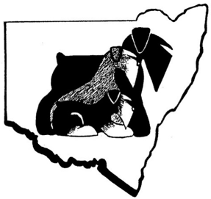
The Schnauzer Club of NSW Incorporated
Affiliated with Dogs NSW

Breeders Listing Application
Please Print Clearly
Name: Ms/Mr/Mrs……………………………………., …………………………………………………..
(First Name) (Surname)

Breeder Prefix: ……………………………………………………………………………

Address: ……………………………………………………………………………………..
(Number/Street)
……………………………………………………………………………………..
(Town/Suburb) (State/Postcode)
Contact Number/s: …………………………………………………….

Email: ………………………………………………………………….……..

Breed/s; (Please circle relevant breed/s)
Giant Schnauzers Schnauzers Miniature Schnauzers

In Which Activities Do You Participate With Your Dogs?
Tick Applicable box/es
Conformation/Showing

Obedience

Agility

Rally

Tricks

Dances with Dogs

Other (Please indicate): ……………………………………………………………………………………………………………………………………………………………..

