The Schnauzer Club of NSW Inc
122nd CHAMPIONSHIP SHOW
Sunday 13th April 2025

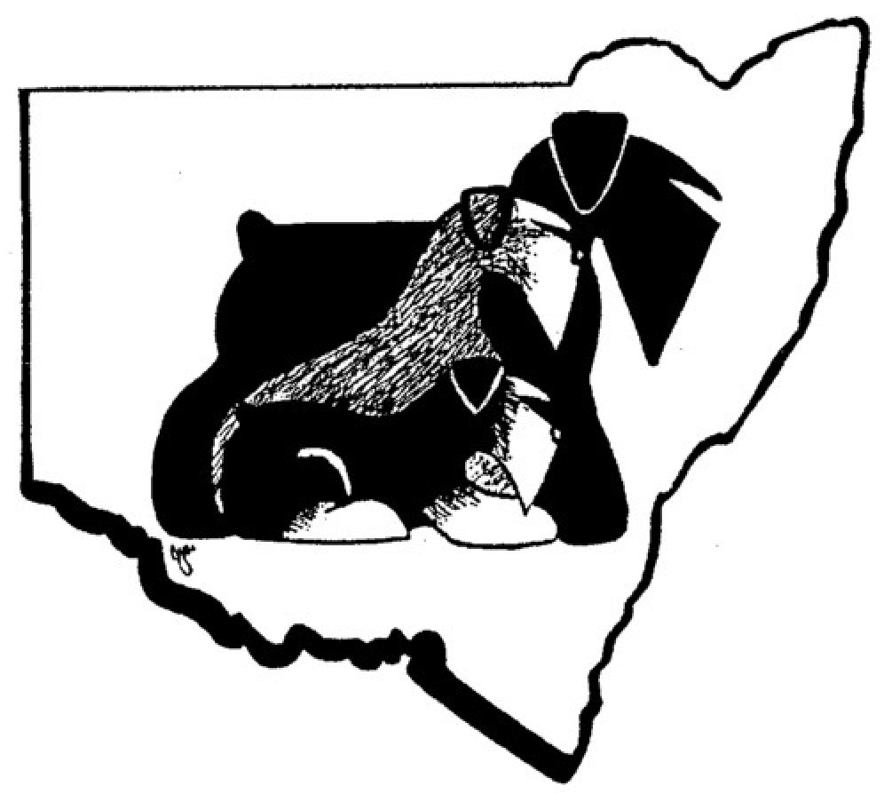

Judge: Mr Johnny Lee (China)

Venue: Bill Spilstead Complex Luddenham Rd, Orchard Hills.
Classes to be Judged: 1, 2, 3, 4, 5, 10, 11, 18 (dogs & bitches)
Judging commences 10am with SCHNAUZERS (Giant) followed by SCHNAUZERS then SCHNAUZERS (Miniature) and General Specials.

Dogs NSW Rep: Mrs Julie O’Flynn Ring Steward: Ms Pat Ohm

This show is conducted under the rules & regulations of Dogs NSW

SPONSORED BY:


President: Jane Jackson Secretary: Julie-Anne Morris Treasurer: Rob Laughton
Vice Presidents: Marelynne McLeod-Woodhouse & Melissa Outten
Show Secretary: Veeni Craig Committee Members: Robyn Israel, Kim Martin, Angus McIlrath, Sue Turner, Veeni Craig, Gail Boyd
Editor & Public Officer: Deidre Hunter Ward
******************************************************
PRESIDENT’S MESSAGE
As President of The Schnauzer Club of NSW Inc, I would like to extend a very warm welcome to our international Judge Mr Johnny Lee from China, our Steward, Ms Pat Ohm, our DOGS NSW Canine Representative Mrs Julie O’Flynn and all our exhibitors who have come from near and far today.
The Club greatly appreciates your entries and your support for the show and wishes everyone a most successful and enjoyable day.
On behalf of the Club, I especially wish to thank our very capable and well organised Show Secretary, Mrs Veeni Craig for all her diligent preparation and hard work towards making this Show a success. I would also like to thank members of the Committee who have contributed to the Show’s organisation and arrangements.
To our most generous Sponsors, Black Hawk, Plush Puppy and to our Donors for the ‘in-show’ rosettes & prizes, to our Patron and our members. You are all outstanding. The Club recognises and very much appreciates your contributions.
If you are showing tomorrow at the Sydney Royal, I also wish you every success.
A safe and Happy Easter to all,
Jane
*********************************************************************
WELCOME TO OUR JUDGE - Mr JOHNNY LEE (CHINA)
Mr Johnny Lee dedicated himself to breeding Miniature Schnauzers, the miniature schnauzers he breed have brought back to the kennel hundreds BIS awards and China Championship, Silver Championship, Gold Championship, World Championship and Grand Championship. In 2016，CKU assessed Eternal China kennel , which founded by Mr. Johnny Lee, the highest level honor-ship as “ Five star Michelin Kennel ”, ranking first in Chinese Miniature Schnauzer kennel.
Eternal China kennel also breeds poodles, Bichon Frise, Fox Terriers, Welsh Terriers, Bedlington Terriers and American Cocker Spaniels, and the poodles he bred achieved lots of BIS level awards. Mr. Johnny Lee is one of China’s first batch of judges, and he was already certified BIS judge.
Mr. Johnny Lee is one of China’s first batch of Grooming Judges. He judged at CKU Grooming Competitions and Activities all over China. Mr. Johnny Lee is the first Chinese judge ever being invited as a grooming judge to Malaysia Asia Cup in 2018.
Mr. Johnny Lee has great passion for dog show and teaching pet grooming. He founded Eternal pet grooming training school and is often being invited to variety grooming lectures as lecturer and specializing in grooming for Schnauzer, poodles, Bichon Fries, Fox Terriers, Welsh Terriers, Bedlington Terriers, etc.. He had received the first and second prizes in groomer contest in and out of China for many times.
The Club would very much like to thank and acknowledge the following people for their kind and generous donations.
All Rosettes & Prizes for in Show
The biggest Thank You is to go to Angus & Gail McIlrath of Koobalies Miniature Schnauzers and Deborah Lawson of Redorah Miniature Schnauzers for their massive contribution and donation of all the sensational Rosettes and Prizes for General Specials at this very special show.
They have donated continually for many years with BIS & RUBIS massive Rosettes and we would like to officially Thank them for their continued support
Cash Donation
Thank you to the following people for their Cash donations toward the Prizes
Luci Ellem – Club Patron
Robyn Kerr
Denise Young
Breckingrove Miniature Schnauzers
Ralph Richardson
Bob & Norrie Inglis
Teresa Staffin
Jason Bridge
Andrew Baker

All Class Placing Gift Bags
In lieu of small ribbons for class placings, small gift bags donated by Veeni Craig

We also Thank our Sponsors BLACKHAWK & PLUSH PUPPY
GENERAL SPECIALS PRIZES - All Kindly Donated
BEST IN SHOW
**Giant Rosette & Gift Trophy
- donated by Koobalies & Redorah Miniature Schnauzers
- $200 Cash – donated by Luci Ellem (Club Patron)
-20kg BlackHawk Food donated by Sponsor
RUNNER-UP BEST IN SHOW
**Giant Rosette & Gift Trophy
– donated by Koobalies & Redorah Miniature Schnauzers
- $100 Cash by donation allocation
-10kg BlackHawk Food donated by Sponsor
ALL CLASSES IN SHOW
**All Rosettes & Gift Trophies
-donated by Koobalies & Redorah Miniature Schnauzers
- $50 Cash by donation allocation -3kg BlackHawk Food donated by Sponsor
BEST NEUTER IN SHOW
**Rosette & Prize - donated by Koobalies & Redorah Miniature Schnauzers
$55 Cash by donation allocation 3kg BlackHawk Food
RUNNER-UP NEUTER IN SHOW
***Rosette & Prize - donated by Koobalies & Redorah Miniature Schnauzers
$30 Cash by donation allocation 3kg BlackHawk Food
BREEDER of BEST in SHOW SASH - donated by Marellan Show Ribbons
BEST OF BREEDS SASH & $35 Voucher - donated by Sponsor Plush Puppy
RUNNER-UP BEST OF BREEDS SASH & $25 Voucher donated by Plush Puppy
CHALLENGES SASH & $15 by donation allocation
RESERVE CHALLENGES SASH & $10 by donation allocation
GIANT SCHNAUZER
11 Open Dog
1 Miss L Sorensen Best Open in Breed
CH.MUNCHENER SIR CHARLIE CHAPWIN (ai) 4100373143 21/05/2022
1st S Greif Hakon Vom Schenkenwald (ImpDeu)
D Aust Ch. Jenga Vom Moisburger Berg (Imp Deu) Bred By Mrs Y & Miss F Hopf
Ch ___1_____Pts____6____
3A Puppy Bitch
2 Mrs S Jamieson Best Puppy in Show
TREULIEBE FOR THE GOOD TIMES (AI) 2100619211 13/06/2024
1st S Am. Ch. Kirsch De Che Chin Gos
D Ch. Cassandra I De Cethuz (Imp Arg) Bred By Mrs S Jamieson
4A Junior Bitch
3 Miss M Lalor Best Junior in Breed
MUNCHENER ZENIA VON ULIX 4100396423 31/01/2024
1st S Munchener Undercover Ulix (Ai)
D Ch. Jenga Vom Moisburger Berg (Imp Deu) Bred By Mrs Y & Miss F Hopf

5A Intermediate Bitch
4 Miss K Grigg & Mrs S Gendle Best Intermediate in Breed
CH WULFGAR LUNA (AI) 2100595880 06/11/2022
1st S Sup.ch. Wulfgar Royal Finn
D Ch. Wulfgar Moff Delian Mors Bred By Mrs S Gendle
Ch___2_____ Pts___8_____ Res___4_____
BOB___2_____ Pts___9_____ R/Up____4____
SCHNAUZER
10 Australian Bred Dog
5 Mrs S Ansell Best Aus-Bred in Show
GRAND. CH.C.I.B. REGENSTAUF MASTER OF MAYHEM 4100323950 23/06/2019
1st S Regenstauf Magic And Mayhem
D Regenstauf Masters Mistress Bred By Mrs K & Miss T Ninnes
11 Open Dog
6 Mrs M Outten
CH. MORGAN SALTUS ZE ZAHRABSKE (IMP HRV) HR10791 23/12/2017
1st S Fin.ch. Hrv.ch. Hun.ch. Int.ch. Svk.ch. Skippy Saltus Ze Zahrabske
D Hrv.ch. Hakuna Matata Saltus Ze Zahrabske Bred By Damir & Monika Skok
Ch___5_____ Pts___7_____ Res____6____
10A Australian Bred Bitch
7 Mrs J Jackson & Mrs M Outten
CH. OVASHUN DESTINYS CHILD 2100518504 25/04/2019
1st S Ch. Morgan Saltus Ze Zahrabske (Imp Hrv)
D Ch. Montkhan Waltzing With Destiny Bred By Mrs J Jackson & Mrs M Outten
11A Open Bitch
8 Ms K Martin Best Open in Breed
SUP.CH. OVASHUN TEQUILA SUNRISE 2100518507 25/04/2019
1st S Ch. Morgan Saltus Ze Zahrabske (Imp Hrv)
D Ch. Montkhan Waltzing With Destiny Ccd. Bred By Mrs J Jackson & Mrs M Outten

Ch___8____ Pts____7____ Res___7_____ BOB___5_____ Pts___9_____ R/Up___8____

18A Open Neuter Bitch
9 Mrs N Badger Best Neuter in Show
CH. OVASHUN LADY SORELLA CCD. CD. RE. FS.S. HTM.S. FS.N. 2100498647 16/04/2018
1st S Grand. Ch. Treuliebe Takit T Thlmit
D Ch. Treuliebe Dancing With Destiny Ccd. Rn. Bred By Mrs J Jackson & Mrs M Outten
Ch ____9______ NBOB ___9_____ Pts ___6______
MINIATURE SCHNAUZER
3 Puppy Dog
10 Mrs B Andersen
MANAUZER TA KAS HI 2100619048 05/08/2024
3rd S Ch. Ebshine Kiss Me Karlo
D Ch. Ebshine Talk The Talk Bred By Mrs B Andersen
11 Mrs L & Miss B Kolodziej
VERADIS JALAPENO BUSINESS 2100618919 12/07/2024
1st S Ch. Schonhardt Hot Chilli Pepper (Iid) Je. Tk.s.
D Ch. Heisspur Choo Give Me Fever Tk.s. Bred By Mrs L & Miss B Kolodziej
12 Ms R Mahoney
SCHONHARDT THE CATS BUTLER ALFRED 2100619073 09/06/2024
2nd S Schonhardt Kaos In The Kathaus(Ai)
D Ch. Schonhardt Watchout Cats About Bred By Miss M Macleod-Woodhouse
4 Junior Dog
13 Mrs D E Cooper
REDORAH THE HIGHWAYMAN 2100612876 17/01/2024
3rd S Ch. Manit's Code Talker (Imp Usa)
D Redorah Setz The Style Bred By D Lawson
14 Mrs T & Mr P Griffin
AUST CHAMP AMBALEE ROCK ME AMADEUS 3100479501 28/03/2024
4th S Mex. Ch. The Gladiator (Rojas) (Imp Mex)
D Ambalee Tiger Lily Bred By Mrs T & Mr P Griffin
15 Mrs Ziyi Wang
APEXW A MAGIC DREAM 2100614423 25/11/2023
2nd S Ch. Apexw Dream Time
D Balekabay Blue Moon Rose Bred By Mrs Ziyi Wang
16 Mr M Williams & Mr F Lay
AUST.CH RUSHMERE SENSEI 3100477541 30/01/2024
1st S Grand. Ch. Joker Land's Top Seaclet Fci (Imp Jpn)
D Ch. Rushmere Its All About Me Bred By Mr F J Lay & Mr M J Williams
5 Intermediate Dog
17 Ms B A Tan
SING. CH. CH. SUP.CH. ACESTAR HIGH HOPES FOR VALEHAVEN (IMP SGP) 86664/22 18/08/2022
1st S Sing. Ch. Jokerland's Bright Future
D Sing. Ch. Diego China Narcis Of Elites Bred By K Tan
10 Australian Bred Dog
18 Ms S Chen RUNQUE DRAMA JOKER 2100598670 05/01/2023
2nd S Arg. Jr Ch. Brz. Jr Ch. Ch. Dog-Otho's My One And Only (Imp Arg)
D Schonhardt Rain Falls Pearl Bred By Ms S Chen
19 Miss M Macleod-Woodhouse Best Aus-Bred in Breed
SUP.CH. SCHONHARDT CAT GOES LINEDANCIN 2100483520 04/09/2017
1st S Sup.ch. Schonhardt Cats Out Of The Bag(Ai)
D Dog-Otho's Last Ride Of The Day (Imp Arg) Bred By Miss M Macleod-Woodhouse
20 Mr D Ritzau
CH EBSHINE XPIALIDOCIOUS 2100610988 16/12/2023
3rd S Ebshine Ra Ra Rasputin
D Ch. Ebshine Quality Street Bred By Mrs V A Craig
11 Open Dog
21 Mr A & Ms H Baker
CH. NIEDLEICH WINNER TAKES IT ALL 3100418909 08/11/2020
3rd S Ch. Niedleich Romeo Of Verona
D Ch. Niedleich Queen Of The Dance Bred By Mrs M A Edwards
22 Miss M MacLeod-Woodhouse & Miss J Morris
AM & AUST CH CARMEL SKY HIGH IN THE SOUTHERN CROSS (IMP USA) RN39809102 10/06/2023
2nd S Am. Ch.Am.Gr.ch. Pl. Carmel Sky High Stargazer
D Am. Ch. Carmel Summer's Show Case Bred By Dr J Hunt
23 Mrs I Mundy & Mrs C Ellis
CH. STEADLYN INCANDESCENTE (IMP ITA) ROI18/76218 30/03/2018
4th S Steadwyn Real Deal
D Steadlyn Affirmation Bred By M Ejerstad
24 Mrs A Neyle & Mrs V Craig
CH. ALCLAY MEETS EBSHYNE 2100565662 18/05/2021
Absent S Grand. Ch. Ebshine Daringly Debonair(Ai)
D Ch. Ebshine Google Me Bred By Mrs A Neyle
25 Mrs Ziyi Wang BIS & Best Open in Show
CH APEXW DREAM TIME 2100587069 03/05/2022
1st S Sup.ch. Schonhardt Cat Goes Linedancin
D Ch. Pin Shang China Daisie (Imp Chn) Bred By MrsZiyi Wang
Ch___25_____ Pts ___20____ Res ____17_____
2A Minor Puppy Bitch
26 Mrs B Andersen Best Minor in Show
MANAUZER THE DEVIL WEARS PRADA 2100619049 05/08/2024
1st S Ch. Ebshine Kiss Me Karlo
D Ch. Ebshine Talk The Talk Bred By Mrs B Andersen
3A Puppy Bitch
27 Mrs D Lawson Best Puppy in Breed
REDORAH TANGO IN THE DARK 2100617114 07/05/2024
1st S Arg. Ch. Dog-Otho's Monteverdi (Imp Arg)
D Dog-Otho's Shae (Imp Arg) Bred By Mrs D Lawson
4A Junior Bitch
28 Ms S Chen
RUNQUE CRAFTED PANTHER 2100614042 26/01/2024
6th S Schonhardt Panther In The Cold
D Schonhardt Cat In Kinky Boots Bred By Ms S Chen
29 Mr R & Mrs N Inglis
APEXW MY CHINA DOLL 2100609476 19/10/2023
5th S Xing Yue Aicha (Imp Chn)
D Durrant Aussie Rose Bred By Mrs Ziyi Wang
30 Mrs D Lawson RUBIS & Best Junior in Show
REDORAH PITCH PERFECT 2100612875 17/01/2024
1st S Ch. Manit's Code Talker (Imp Usa)
D Redorah Setz The Style Bred By Mrs D Lawson
31 Miss M MacLeod-Woodhouse & Miss J Morris
SCHONHARDT KAT STARTS A RIOT 2100616387 16/03/2024
2nd S Schonhardt Kaos In The Kathaus(Ai)
D Ch. Kalamino Kaos In The Kathouse Bred By Miss M Macleod-Woodhouse
32 Ms K R March
THYLIEBE FIRST LADY EVA PERON 2100609007 21/11/2023
Absent S Brz. Jr Ch. Dog-Otho's Anything's Possible (Imp Nzl)
D Ch. Ebshine Rainbow Connection Bred By Ms K R March
33 Miss K Strahan
KIEREE LOVE S A BATTLE FIELD 3100477166 16/01/2024
3rd S Mex. Ch. The Gladiator (Rojas) (Imp Mex)
D Kieree Way Back Into Love Bred ByMiss K Strahan
34 Ms B A Tan
MEGAZTAR MYSTICALPHOENIX 3100478858 11/02/2024
4th S Sing. Ch. Ch. Sup.ch.Acestar High Hopes For Valehaven (Imp Sgp)
D Ch.Megaztar Gin N Tonic Bred By Ms B A Tan
5A Intermediate Bitch
35 Ms G Boyd
CH. EBSHINE WAKE UP LITTLE SUSIE 2100599168 29/01/2023
3rd S Ch. Alclay Meets Ebshyne
D Ebshine Miss Congeniality (Ai) Bred By Mrs V A Craig
36 Mrs D Lawson
CH REDORAH TUCKERS DAUGHTER 2100589770 25/06/2022
2nd S Ch. Redorah Kool Katz
D Ch.Schonhardt Time For A Kit Kat Bred By Mrs D Lawson
37 Ms D Strahan Best Intermediate in Show
CH. MIAVISTA SERENADE OF SHADOWS 3100451177 01/06/2022
1st S Manits Fawlty Towers (Imp Usa)
D Ch. Miavista Brandy And Ice Bred By Ms D Strahan
38 Mrs C Young
KOOBALIES SWEET MELODY 2100588847 08/06/2022
4th S Koobalies Royal Rock
D Koobalies Iguazu Bred By Mr A Mcilrath
10A Australian Bred Bitch
39 Mrs V A Craig
THYLIEBE READY FOR BATTLE AT EBSHINE 2100609008 21/11/2023
1st S Brz. Jr Ch. Dog-Otho's Anything's Possible (Arg) (Imp Nzl)
D Ch. Ebshine Rainbow Connection Bred By Ms K R March
40 Mrs S Jamieson
BABETAL WILLOW WAND AT TREULIEBE 4100374734 21/06/2022
3rd S Babetal Black Griffindorf
D Babetal Silver On The Bridge Bred By Mr T& Mrs C Lindenberg
41 Mr R Richardson
CH SCHONHARDT KAT LOVESKAOS 2100616388 1 6/03/2024
2nd S Schonhardt Kaos In The Kathaus (Ai)
D Ch. Kalamino Kaos In The Kathouse BredBy Miss M Macleod-Woodhouse
11A Open Bitch
42 Miss M Macleod-Woodhouse
CH SCHONHARDT CAT STEALS THE SHOW 2100601860 19/02/2023
2nd S Xing Yue Aicha (Imp Chn)
D Ch. Schonhardt Watchout Cats About Bred By Miss M Macleod-Woodhouse
43 Mrs I Mundy & Mrs C Ellis
RECOGNITION'S FAVOLOSA_PS (IMP ITA) ROI20/135038 13/07/2020
3rd S Steadlyn Look Twice-Pc
D Steadlyn Bella Come Sei-Ps Bred By F Bocchino
44 Ms B A Tan
MEGAZTAR PICTURE PERFECT 3100480607 17/02/2024
1st S Sing. Ch. Ch. Sup.ch. Acestar High Hopes For Valehaven (Imp Sgp)
D Ch. Megaztar Lucky Clover Bred By Ms B A Tan

Ch__30___ Pts__23___ Res___37___ BOB___25___ Pts____25____ R/Up__30____

18 Open Neuter Dog
45 Mrs B Andersen R/U Neuter in Show
CH. EBSHINE KISS ME KARLO 2100511548 26/12/2018
1st S Grand. Ch. Ebshine Daringly Debonair(Ai)
D Ch. Cersei Dexters Daughter(Ai) RA. Bred By Mrs V A Craig

Ch__45____ Pts___6_____

18A Open Neuter Bitch
46 Mrs L & Miss B Kolodziej
CH. NEUT. CH. HEISSPUR CHOO GIVE ME FEVER TK.S. 2100571401 20/08/2021
1st S Loughrobn Sliding Doors
D Heisspur Evita Bred By Ms KBurey

Ch____46_____ Pts___6_____ NBOB__45_____ Pts___7___ R/Up____46____

*****************************************************************
GENERAL SPECIALS
BEST EXHIBIT IN SHOW ____25______
RUNNER-UP BEST IN SHOW ____30______
BEST BABY PUPPY IN SHOW ____--_____
BEST MINOR PUPPY IN SHOW ____26_____
BEST PUPPY IN SHOW _____2_____
BEST JUNIOR IN SHOW ____30_____
BEST INTERMEDIATE IN SHOW _____37____
BEST AUST. BRED IN SHOW _____5_____
BEST OPEN IN SHOW _____25_____
BEST NEUTER IN SHOW _____9_____
RUNNER-UP BEST NEUTER IN SHOW _____46_____
***********************************************************
THANK YOU TO OUR SPONSORS:
For their continued support For their kind donations and
and donations of their support of our 3 breeds
wonderful food products.

