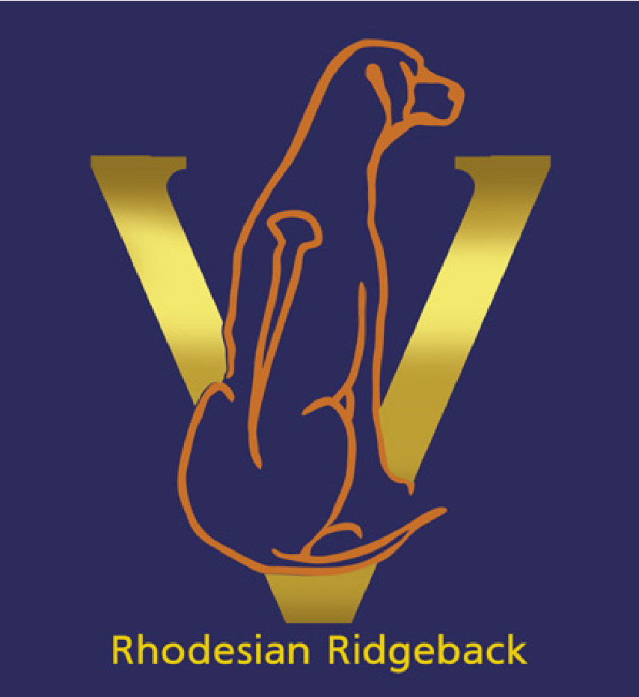
Rhodesian Ridgeback Club of Victoria
A0010860A
Annual General Meeting Agenda

Location: KCC Park, 655 Westernport HWY, SKYE Vic, Room to be confirmed.
Date: 27th January 2021 Time: 7.00pm

1. Opening
In attendance: John Cassar, Graham, Barb McVilly, Lisa Barringer, Michelle Howell, Sheena Draai, Anastasia Courtney, Sharyn Courtney, Christa Kramptiz
2.i) Apologies Alan McVilly, Leanne Cassar, Gerry Jane, Cat Glenn
2.ii) Apologies Be Accepted
Moved: Michelle Howell Seconded: Anastasia Courtney Carried
3.) Minutes from Previous AGM be accepted.
Moved: Sharyn Courtney Seconded: Sheena Draai Carried
4.i) President’s Report
See appendix 1
Moved: Lisa Barringer Seconded: Michelle Howell Carried
4.ii) Treasurer’s/Financial Report
See appendix 2
Moved: Michelle Howell Seconded: John Cassar Carried
4.iii) Secretary’s Report
See appendix 3
Moved: Anastasia Courtney Seconded: Barb McVilly Carried
5.) Election of Office Bearers
President: John Cassar
Vice. President: Alan McVilly
Secretary: Barb McVilly
Treasurer: Michelle Howell
Committee: Anastasia Courtney, Sharyn Courtney, Graham, Christa, Leanne Cassa
Nominations from the floor:
Moved: John Cassar Seconded: Sharyn Courtney Carried

6.) Motions on Notice:
(6.1) Reduced price 1st year membership fee of $10 for puppy buyers signed up by the breeder as well as any rescues facilitated by the club or Ridgeback Rescue Victoria.
As a way to increase membership and to expand the reach of the club to the general public a reduced fee of $10 will be offered to breeder members puppy buyers as well as anyone that rescues a Rhodesian Ridgeback. The reduced fee is set at $10 to cover any non-affiliate fees that will be paid to Dogs Victoria.
Carried
(6.2) Reduced Show/Trial entry fees for members
Proposed as a way to encourage more people to join the club and provide members a ‘perk’ for being a member. It was raised that this is unlikely to increase memberships as had been shown in the past. The club has ongoing expenses that must be paid in order to stay an affiliate of Dogs Victoria.
Not Carried
(6.3) Change to Code of Ethics Rule #4
The rule currently states:
4. I will cull (humane euthanasia):
(i) Puppies with Dermoid Sinus. I will inform buyers of the Dermoid Sinus and how to detect it. Should a Dermoid Sinus be detected following sale of the puppy I will recommend euthanasia or Neutering and take financial responsibility for surgical removal of the Dermoid Sinus(s).
(ii) I recognise ridgeless pups, blue/grey or any unusual colours are not in the standard, and I under take to desex them prior to leaving my care.

Proposed change:
4. I will cull from my Breeding Program:
(i) Puppies with Dermoid Sinus. If Dermoid Sinus detected at birth or while in my care, I will either euthanise the pup or have the Dermoid Sinus surgically removed. I will inform buyers about Dermoid Sinus and how to detect it.
Should a Dermoid Sinus be detected following sale of the puppy, I will recommend euthanasia or neutering and surgical removal. In line with Dogs Victoria Rule 20.1.25.3, I will refund 100% of the purchase price of the puppy or take financial responsibility for surgical removal of the Dermoid Sinus(s), whichever is the lesser.

(ii) I recognise ridgeless pups, and pups that are blue/grey or any unusual colours are not in the standard. I undertake to desex them prior to leaving my care OR to sell the pup with a contract that stipulates that the purchaser will not breed, and will neuter the pup.

Carried

7.) Other Business:
8.) Meeting Closed:
9.) Appendices:
1. Presidents Report
2. Treasurers Report

