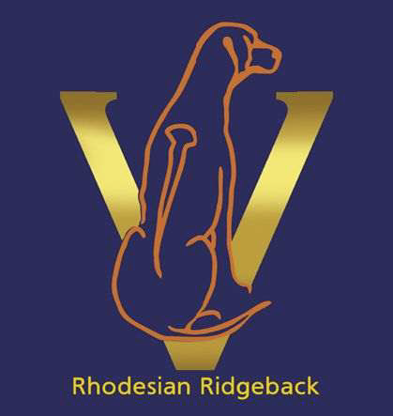

RHODESIAN RIDGEBACK CLUB OF
VICTORIA INC.
(Affiliated with the Victorian Canine Association)
Reg No. A0010860A

ANNUAL GENERAL MEETING OF THE RHODESIAN RIDGEBACK CLUB OF VICTORIA INC
HELD VIA Microsoft TEAMS
THURSDAY NOVEMBER 20TH 2025 AT 7.30PM

- Meeting Opened: 7.35pm
- Apologies: V Moritz, M Gardner, C Krampitz, B & G Stanyon, M Davis, J Lowe, M Sung
- Attendees: C Smart, L Barrenger, D Perkins, L King, L Fairhall, F Parsons, B McVilly
- Minutes of AGM held November 14th, 2024
Motion: That the minutes of the AGM, held on November 14th, 2024, be endorsed
as a true and correct record. Moved L King, Seconded B McVilly
- Minutes of Special General Meeting held June 19th, 2025
Motion: That the minutes of the Special General Meeting, held on June 19th, 2025, be endorsed as a true and correct record. Moved D Perkins, Seconded L Fairhall
- President’s Report: Moved L Barrenger, Seconded D Perkins
- Treasurer’s Report:
The financial year opened at 1st October 2024. Future financial years will end 31st August each year

Motion: That the Statement of Expenditure and Income for the year ending 31 August 2025 be adopted. Moved L Fairhall, Seconded C Smart
  - Auditors Report:
Motion: That an Independent auditor be appointed. Moved L Fairhall, Seconded F Parsons
- Secretaries Report:
- Election of Office Bearers and Nomination of Committee:
President: L Barrenger. Nominated L King, Seconded L Fairhall
Vice President: Vacant
Secretary: D Perkins. Nominated L Barrenger, Seconded L King
Show Secretary: L King. Nominated L Fairhall, Seconded L Barrenger
Treasurer: L Fairhall. Nominated L King, Seconded D Perkins
Committee: C Krampitz (Rescue), C Smart, F Parsons.
V Moritz will continue as webmaster.
L Barrenger thanked the outgoing Committee members for their involvement and support

- Special Resolution:
Motion: Setting of Membership Fees per By-Law Number 1. L King proposed that Membership fees remain the same, Seconded D Perkins
- Next AGM: November 2026, date to be advised

Close of AGM: 8.02pm

