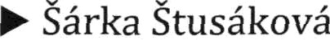

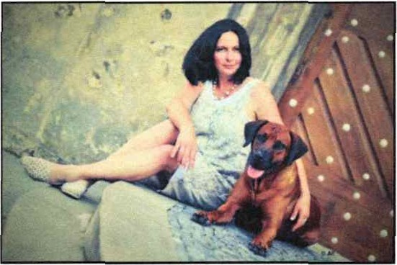
Web www.anunnaki.cz

FC1 International Judge specialist for Rhodesian Ridgeback,

With possibility to C./LC.I.B. Appreciate

I have loved all living creatures all my life. Since the early childhood I have been interested in dogs’ ethology, their naming and breeding. I grew up with a Dalmatian, a Belgian Shepherd crossbreed, Slovakian Chuvach and German Shepherd. They formed my thinking and taught me to love all beings, the art of co-operation and love for Nature. Being influenced by all that, it was logical that I have established a kennel in 1998.” ANUNNAKI” (a Sumerian word meaning” those coming from the sky"). Since that I have bred 8 litters of Rhodesian Ridgebacks. Although 1 didn’t have many dogs coming from my own breeding they (besides other things) won 6 Inter champion titles, 27 Champion titles from different counties, the title of European Junior Winner...
I am really interested in health problems of our RRs. 1 have been making a database of them, trying to put people with same problems together, thinking about the sense and the way we are going through with our breeding. I also attend to work in the Czech Rhodesian Ridgebacks Breeding Club (KCHRR) as a main breeding adviser. You can find more information about our club on www.kchrr.cz

I became a national judge (breed specialist) after successfully passing the exams in 2012. In 2016 I was recognized by the International Judge F.C.I.
I have been judging those shows:

09-21-2013 KCHRR Club Show - Lukova (Czech Republic]
01-04-20 14 Hanacl‹a National Show - Brno (Czech Republic)
08-30-2014 International Dog Show/ Mlada 8oIes1av (Czerh Republic)

06-21-2015 BRCC Club Show / (Belgium)
09-13-20 IS SKCHR Special RR Show-(Slovakia)

09-20-2015 RRKZ Club Show - (Croatia)
02-06-20 16 International Dog Show- Brno (Czech Republic)

08-13-2016 International Dog Show/ Mlada Boleslav (Czech Republic)
08-05-2017 ELSA Club Show - Bernhard (Germany)
08-06-2017 ELSA Special Show - Meinhard (Germany)
09-02 -2017 RR Special Show - Billund (Denmark)
09-06-20 17 Moravskoslezska National Show - Brno (Czech Republic)
02-03-2018 International Dog Show- Brno (Czech Republic)
06-09-2018 KCH RR Club Show - Jangelec (Czech Republic)

06-10-2018 RR Special Show - [Angelec [Czech Republic]

