MINUTES OF GENERAL MEETING
The Poodle Club of NSW Inc

Date: 09/04/18 Venue: George Bell Building Castle Hill Showgrounds
Those Present: K.Wright; G. Stynes McIlrath; A McIlrath: B. Wright, Karen Wyers, Brad Wenzel S. Kearnes, Neil & Bernie Monteith
Apologies: T. Mangan, Jenny Kent, M O’Donnell
Meeting Opened By Chairperson At: 7 -50pm.
Minutes From Previous Meeting:
Correction Brad’s name – Should read Brad Wenzel, not Brian Wenzel
Accepted as Read
Moved A. McIlrath Sec K.Wright CARRIED
Business Arising From Previous Minutes:
- MC for National – Invite Rob Zammit were suggested. Secretary to send EOI’s.
- Brian York still to be asked re Photography for National Angus to Follow up
- Internet Banking to be set up by Treasurer
- Secretary to send letter to Dogs NSW requesting progress on applications for 2018 Oct Trial, 2019 National Conformation and Trials
Correspondence Out: to 9th April 2018
Date | Addressee | Subject | Action
21/3/18 | Dogs NSW | Update Club Details
22/3 | Committee | Update on show entries
22/3 | R Cavallo RAS | Various queries and replies re 2018 Easter show and EOI for 2019 Easter
25/3 | T Mangan | Re Geraldine Myers fb posts | Replied
25/3 | Bridgett Collis | Enquiry re fun days | Replied
22/3/18 | Marnie | Dog Lovers Application Receipt
22/3 | Stephanie Lynch Dogs NSW | Draft Schedule Approved asking for ammendments | Ammendments to Start time and Rep advised
5/4/18 | All Members | Notice Of Meeting
5/4/18 | All Members | Show Results

Correspondence In: T0 9th April 2018
Date | From | Subject
19/3 | Tom Mangan | Written submission for NPC | Forwarded to NPC
21/3 | Committee | Re Fun Day
21/3 | Committee | Re permission to use photo
22/3 | Stephanie Lynch Dogs NSW | Draft Schedule Approved asking for ammendments | Ammendments to Start time and Rep advised
22/3 | R Cavallo RAS | Various queries and replies re 2018 Easter show and EOI for 2019 Easter
22/3 | Committee | Update on show entries
25/3 | Bridgett Collis | Enquiry re fun days | Replied
25/3 | T Mangan | Re Geraldine Myers fb posts | Replied
25/3 | Ozentries | Copy of Settlement for entries $1100 | Forwrded to Treasurer
26/3 | Qld PC | 50yr Anniversary Invite
28/3 | Dogs NSW | Approval for July 2018 Show Date
28/3 | Caitlin Potter RAS | Maps for Parking
28/3 | President | President’s Welcome for Catalogue
28/3 | Danielle & Various | Arrangements for passes & tickets to RAS | Replied
29/3 | Kazoo | Re Resignation | Awaiting further advice
¾ | The Hills | Booking Notification for 20/5/18 Invoice | Forwarded to Treasurer
5/4/18 | Marnie | Dog Lovers Application Receipt
5/4/18 | Members | Responses to Notice of Meeting
6/4/18 | Lorraine Boyd | Re Framed Rosettes
8/4/18 | B Monteith | Re Newsletter
9/4/18 | Michael Chin | Female Factory Venue

REPORTS
Presidents Report:
Good evening and thank you for your attendance. As you know the meeting date was
changed due to a few of the executive being unavailable for the next Monday. Well
the Sydney royal is done and dusted for another year. Congratulations to all of you
who exhibited at both the royal and our show.
I would like to take this opportunity of thanking the committee members who made
this show the success I believe it was. We still have a busy year ahead of us with the
fun day, the show and of course the national. Many hands make light work and it
would be appreciated if we can all work together to make them successful. Travel
home safely
Gail McIlrath

Secretary Report
March show was well attended and ran smoothly. 60 entries across the 3 varieties and the judge Mark Cocozza (UK) was well received. Special Thanks to Pauline Griffiths, Kathy Collier, Angus McIlrath and Bernie and Neil Monteith for their assistance on the day.

Membership Renewals are due in June and I would like authority to upgrade the membership form.

MOTION: Secretary authorised to update Membership Renewal Form.
Moved: K. Wright Sec A McIrath CARRIED
Susie Kearnes

Treasurer’s Report:
Kay will start calling for donations for the National.
Approval sought to Pay S. Kearnes $124.33 for show costs, The Hills Council Account and NPC Affiliation Fees.
MOTION: Expenditure Approved. Moved B. Wright Sec A. McIlrath. CARRIED

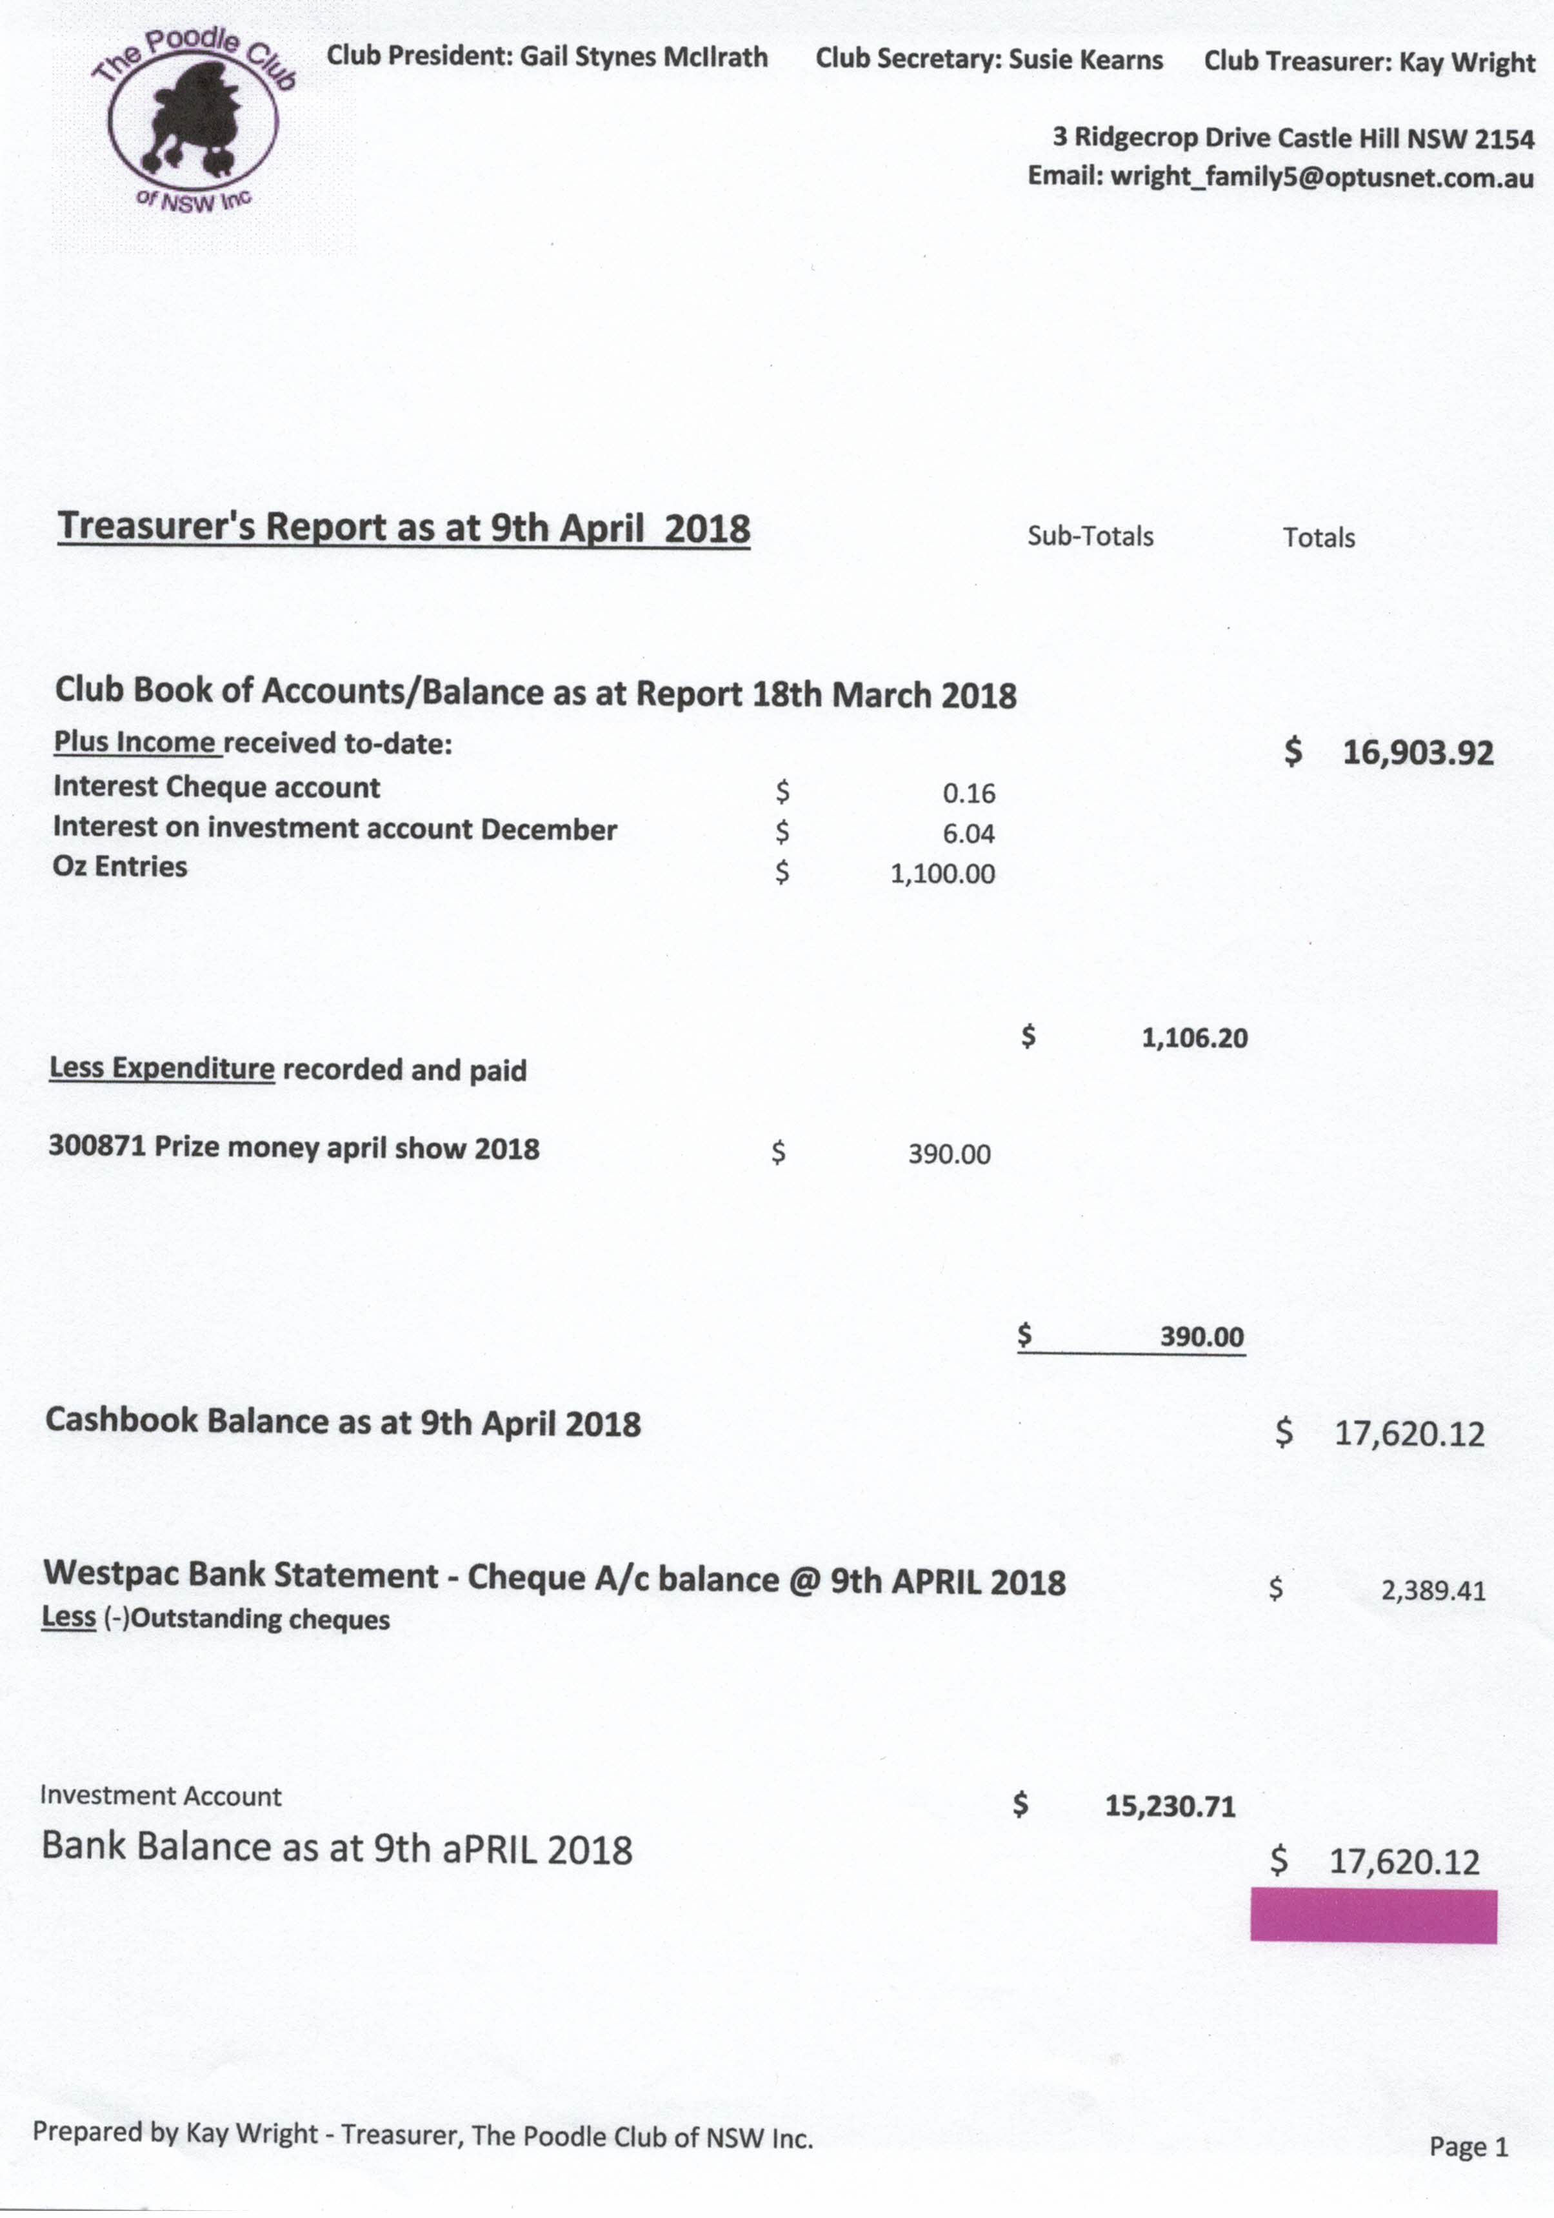

Special Thanks to Karen Wyers and Brad Wenzel for their donation of the 6 camping chairs for the Oct Trial
Show Business: General
Applications for
- 2019 National International Judge Approval
- 2019 National Show Date & Venue
- July 2018 Change of Date
To be followed up by Secretary
Dogs Lovers: Booth 660 was chosen. Application sent to Dog Lovers
Dogs On Show: Secretary to booked space & marquee. Club has been entered in the “Visit a Breed Lucky Draw” competition. Moved K Wright Sec B. Monteith
Secretary to seek alternative samples and quotes for Ribbons and Rosettes. Karen Wyers offered to attend to this.
MOTION: Karen to seek quotes and samples on ribbons & Rosettes and report to Secretary. Moved B. Wright Sec A. McIlrath CARRIED

Show Business: National
Still waiting on formal approval from Dogs NSW & ANKC. All required applications have been submitted.
MOTION: June Meeting to be a special meeting devoted to organizing the National.
Moved: G McIlrath Sec K. Wright CARRIED
Fun Day
Karen Wyers reported the next sub committee meeting would be held on 18/4/18.
There was discussion on the initial flyer, Karen felt it should have been circulated. The secretary explained it has been considered a draft and apologized for the misunderstanding.
Further discussion ensued with the feeling of the sub committee that the event should be cancelled. The pros and cons were evaluated and it was decided the event should proceed.
Karen reported that the sub committee’s plans were in hand for catering, program, prizes and presentations. She also advised that Joanne Speck had agreed to promote the event by listing it on her Groomer’s web page and links.
General Business:
Bernie advised that she has almost finished compiling the next Newsletter. She has agreed to attend to this on a 3 monthly basis.
The Poodle Club team was awarded 5th place at the recent team trial competitions. Congratulations!!
Gail presented a poodle wall hanging that is available from Cherie Gleerum at a cost of $100.00
Motion: Purchase the wall hanging for use as a raffle prize. Ticket price to be $5 each or 3 for $10
Moved: G. McIlrath Sec N. Monteith CARRIED

Meeting closed by Chairperson at: 9.30pm

