MINUTES OF GENERAL MEETING
The Poodle Club of NSW Inc

Date: 19/3/18 Venue: George Bell Building Castle Hill Showgrounds
Those Present: K.Wright; G. Stynes McIlrath; A McIlrath: B. Wright, T. Mangan, J. Kent; Karen Wyers Brian Wenzel S. Kearnes M O’Donnell Neil & Bernie Monteith
Apologies: Jenny Kent
Meeting Opened By Chairperson At: 7 -30pm.
Minutes From Previous Meeting:
Correction to Cut outs for National – should read a few, not 24, and Kay will not be making bookmarks for the National.
MOTION: Cancel Bunnings Bar B Q booked for 4/4/18. M. T Mangan. Sec B. Monteith
Carried
MOTION: Approve change of July Show Date to 21/7/18. M. K Wright. Sec T. Mangan
Accepted as Read
Moved A. McIlrath Sec K.Wright CARRIED
Business Arising From Previous Minutes:
- MC for National – Invite Rob Zammit were suggested. Secretary to send EOI’s.
- Roslyn Thomas has agreed to edit the National Catalogue working closely with Show Secretary and Miranda Duncan who will print the catalogue. Secretary to send letter of confirmation to RT. Moved T Mangan Sec B Monteith Carried
- Published start time for July show should be not before 10am.
- Brian York still to be asked re Photography for National Angus to Follow up
- Internet Banking to be set up by Treasurer
- NBC Agenda items are required by June deadline. NPC to call an urgent extra ordinary meeting allowing states to submit agenda items. T Mangan to submit items as NSW Delegate.
- Sunday May 20th is date for next fun day. Secretary to book Ring and facilities area. Brochure/Flyer approved
- Committee for May Funday – Tom, Karen Bernie & Jenny. Club Secretary to be included in committee correspondence.

Correspondence Out:
Date | Addressee | Subject | Action
20/2/18 | Marellan Ribbons | Confirmation of Order for March Show | Delivery Date Confirmed
20/2 | Members | Dogs NSW Govt Initiative
21/2/18 | Judy Miller Dogs NSW | Application to change July Show Date
21/2 | C Duval | Response re Brittish Terrier Show
21/2/18 | Judy Miller | 3 x New Show Date Applications for 2 Trials & COD for National
22/2 | Committee | Show Schedule July for Approval
22/2 | President | Advice of new email address
22/2 | T Mangan | Comments re website, minutes and suggest Sec step down as the role may be too much
22/2 | Lynda Brandt SANKC | Advising our change of date in July
22/2/18 | Judy Miller | Amended show date application
22/2 | Response to S Mashford | July Change of Date
23/2 | Randy Garren | New form to be completed as advised by Dogs NSW
23/2 | Abby Dogs NSW | R Garren New Form
23/2 | Judy Miller | Ammended Draft Schedule for July Show Date
23/2/18 | Rebecca Cavallo RAS | Request to hold PC NSW show Easter 2019
25/2 | The Boyds | Advice re emails bouncing
28/2 | Treasurer | Marellan Ribbons Invoice
28/2 | President | Response from Toshi Omara
1/3 | Treasurer | The Hills Invoice
1/3 | All Members | Vic Poodle Patter
4/3 | All Members | Show Entry Closing
4/3 | Puppy Enquirie | Forwarded to Members
5/3 | Adult Enquiry | Forwarded to Members
5/3 | All Members | Notice Of Meeting
7/3 | R Thomas | Request for completed Mship Form
7/3 | Kazoo | Request to reconsider resignation
7/3 | R Thomas | Reply to her letter 19/2/18

Correspondence In:
Date | From | Subject
20/2/18 | Marellan Ribbons | Confirmation of Order for March Show | Delivery Date Confirmed
16/1/ | Neil Monteith | Querying legality of Honorarium. Not in the Constitution | Read Letter. No action required noted his concern
16/1 | T Mangan | Notes for the National | Tom spoke of
16/1 | T Mangan | D Harbin re JTS | Need to speak to Deb Harbin about involvement
16/1 | T Mangan | National Show Committee & Roles | Tom spoke and again in show business
17/1 | R Thomas | Comment on fb statement by Wendy Downing | No action required
17/1 | Sandra Mashford | Invitation to Judge July 2018 Show | Favourable Response  Contract Sent
17/1/18 | Karen Wyers | Copy of Letter to Bunnings Shellharbour | Noted and replied
18/1 | Dog Lovers | Invitation | Need to accept the offer
18/1 | T Mangan | Response from Royal Canin | Tom read out response meeting happy with progress and Advances offer
18/1 | Marlene Sharpe | Request for NPC permission to hold National written on NPC letterhead | Not available
19/1 | All Members | Request for help at Bunnings Responses
19/1 | Anne Raymond Advance | Advice on prizes for Sydney Royal | Tom read
19/1 | Dogs NSW | Application and required documents to hold National Conformation and Trials 2019 | On Going document process. Expect response this week.
19/1 | Dogs NSW | Draft Schedule and signed contracts for July 18 | New application sent for new date and venue
24/1/18 | B Monteith | Draft Copy of Judge Contract Oct 2018 | To be signed by Judge
24/1/18 | B Monteith | Draft Schedule 2018 Trial | To be lodged once change of date approved
28/1 | Candice Brown | Requesting if Carol Johannesen can nominate her for membership | Reply with Yes
1/2 | The Hills | Invoice | Forwarded to Treasurer
5/2 | T Mangan | Requesting Minutes
6/2 | Dogs NSW | Dogs On Show Application | Decision Required Yes accept
6/2 | The Hills | Invoice & Overdue Notice | Forwarded to Treasurer
13/2/18 | Albion Park KC | Invitation to hold open show | Response Required  Suzie ??
13/2/18 | Anne Raymond Advance | Advice on product collection for Sydney Royal Show | Your show product will be available on the day of your show each morning between 8.15 am and 8.45 am from the storeroom at the back on the corner of the Howie pavilion grandstand.  Read out and need to collect on the day
14/2 | Abby Dogs NSW | Reminder to book venue | Replied advising we would be changing date
18/2 | President | Re Minutes & Agenda
19/2 | Rebecca Preece Harvey | Requesting written agreement for Dogs NSW | Reply Received
19/2 | Executive & Committee | January Minutes
19/2 | Sandra Mashford | Requesting availability for new July date. | Has agreed is available
19/2 | Hills SC | Overdue Invoices | Forwarded to Treasurer
19/2 | Karen Wyers | Bid Information for Poodle National | Distributed to Committee
19/2 | Roslyn Thomas | Not Happy email | Read out letter and President to call her and thank for letter and encouraging in areas we are addressing
REPORTS
Presidents Report:
Good evening and welcome to the meeting and thank you for your attendance
A busy month ahead for us all with Sydney Royal fast approaching. My best wishes to all that have entered and thaks to those that volunteer.
Planning progresses for 2019.
Gail
Secretary Report
Thank You all for your patience whilst I have been ill. It’s a slow process, but I am well on the road!

Membership renewals are due in June and we need to ‘tidy up’ this process. Currently 60+ members.
Susie Kearnes
Tom advised that there had been a meeting at Dogs NSW discussing Sec Guidelines for shows. It was suggested the club Secretary explore the outcomes
Treasurer’s Report:

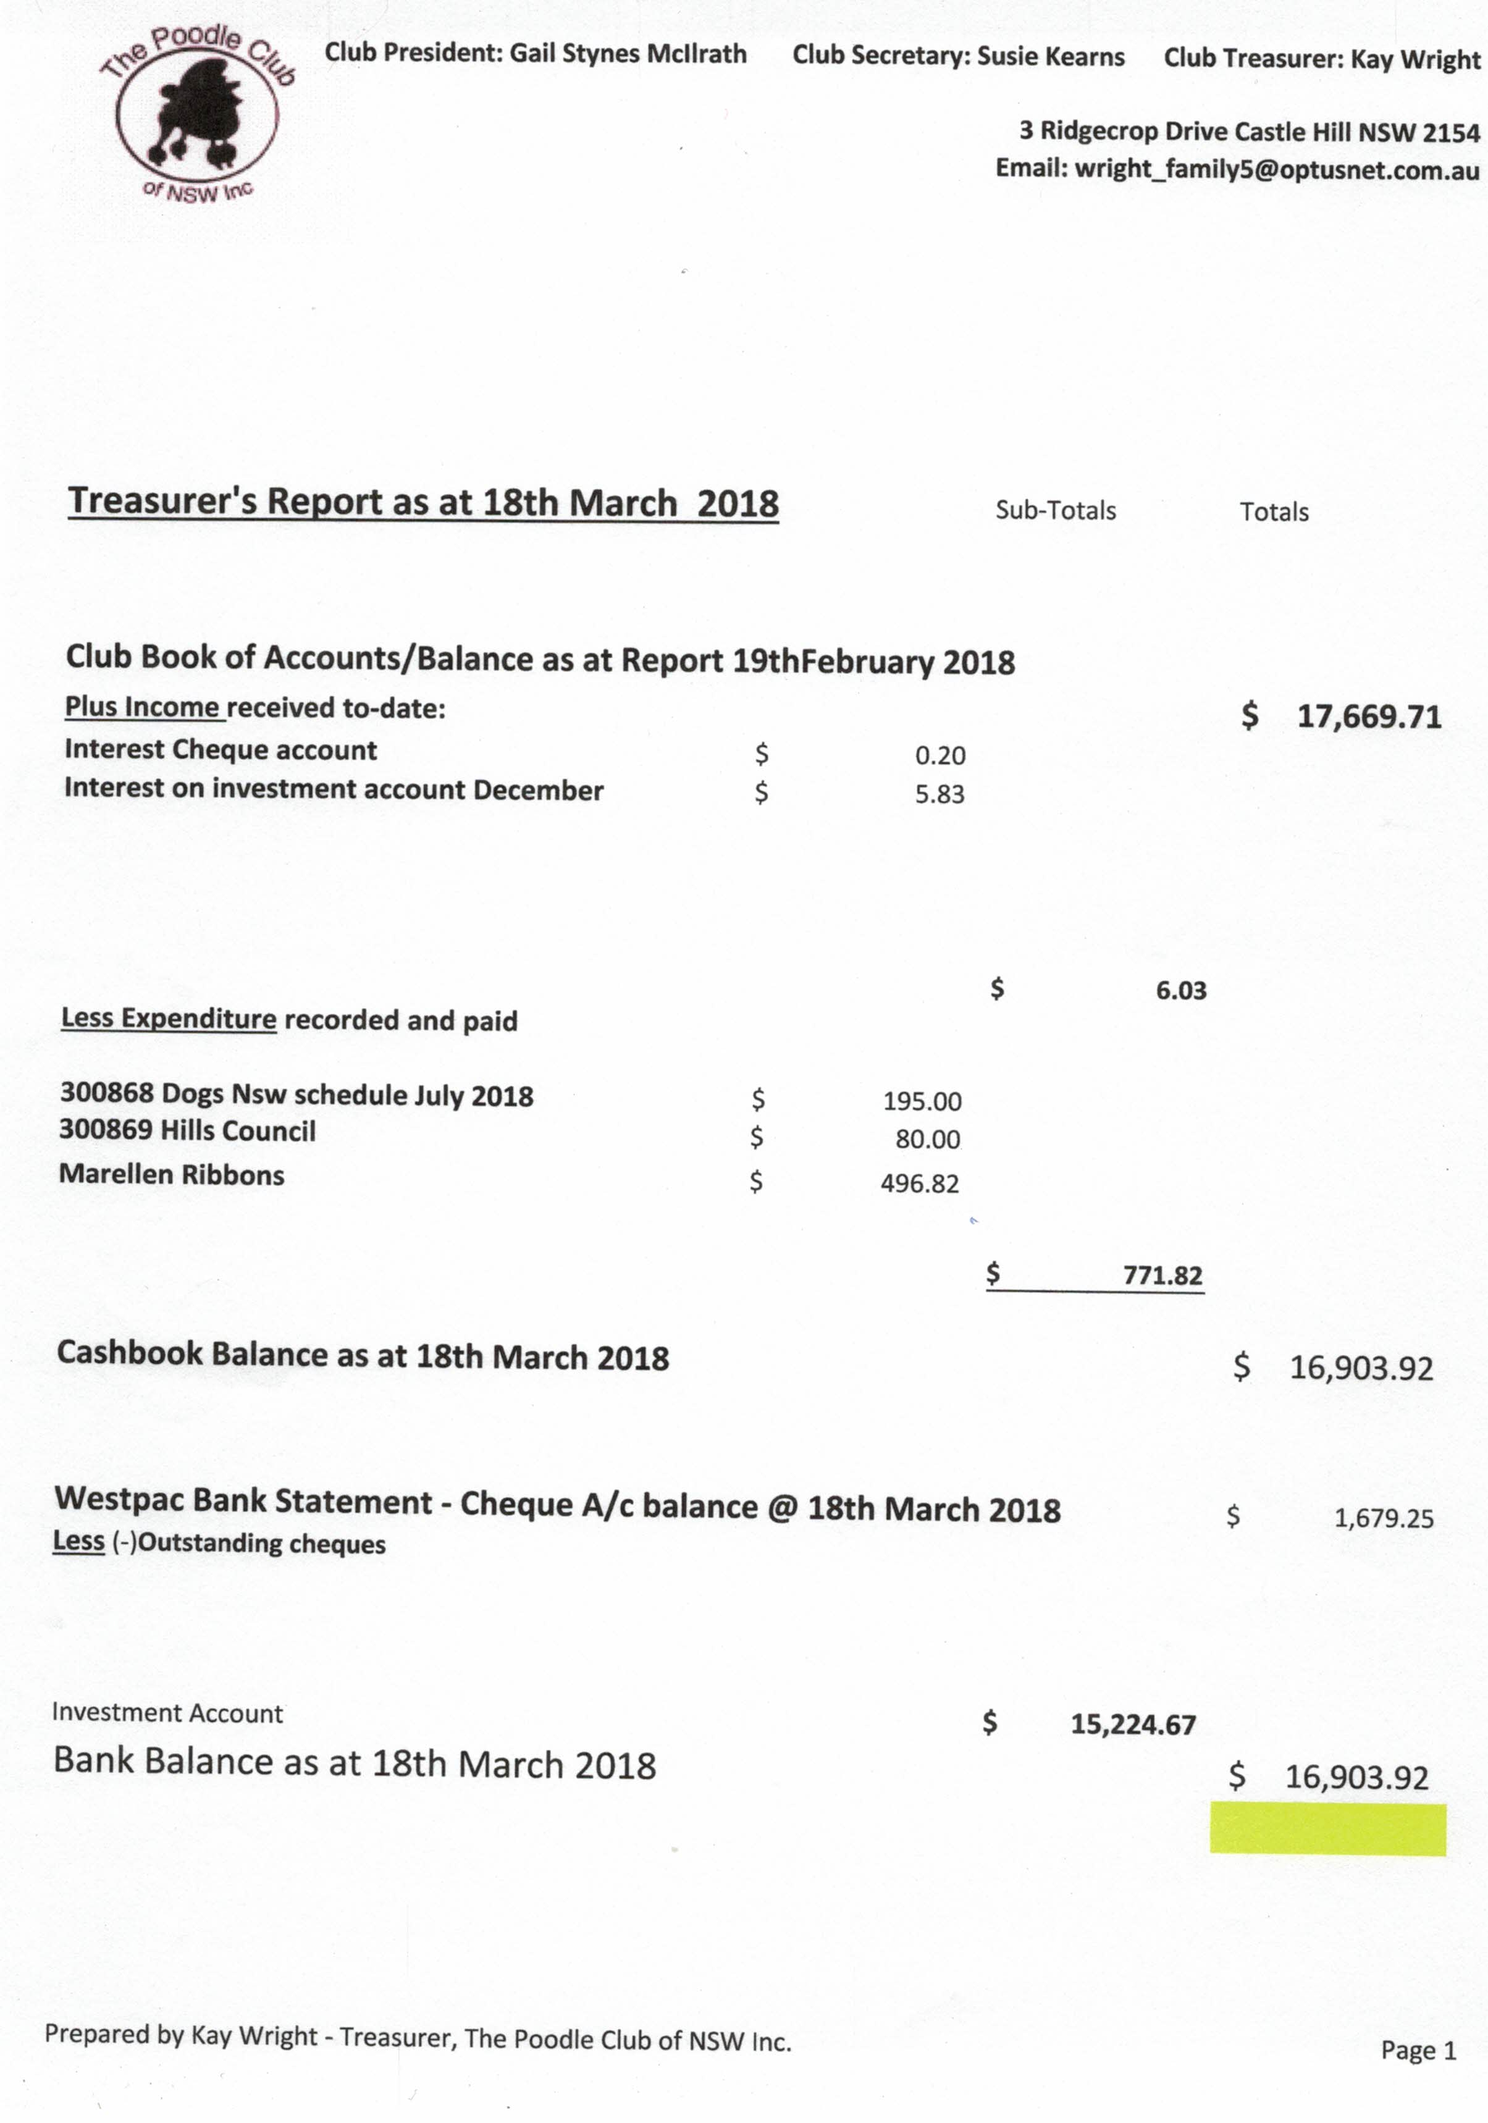

Trial Secretary Report:
Confirmation of Trial judge required as soon as Dogs NSW approve change of date
Reports Accepted: N. Monteith Sec. A McIlrath

Show Business: General
Applications for
- 2019 National International Judge Approval
- 2019 National Show Date & Venue
- July 2018 Change of Date
To be followed up by Secretary
Ribbons & Rossettes all in hand fpr March Show
Entries slowly coming in
Karen & Bernie will be Ring Stewards on the day – Thank You!
Dogs Lovers: Booth 660 was chosen. Sec to send application in
Dogs On Show: Secretary to book space & marquee. Club has been entered in the “Visit a Breed Lucky Draw” competition. Moved K Wright Sec B. Monteith
Sec to contact Jenny Kent re Hawkesbury vet students attending July Show
Show Business: National
Still waiting on formal approval from Dogs NSW & ANKC. All required applications have been submitted.
General Business:
Respond to Cardiologist with EOI re seminar – Secretary to attend
Secretary to write to Bob Curtis re membership.
Next Meeting several committee members are unavailable on the proposed date of 16*4/18. MOTION Change the date of the next meeting to 9/4/18. M. Kay Wright. Sec A McIlrath. Carried

Meeting closed by Chairperson at: 10.10pm

