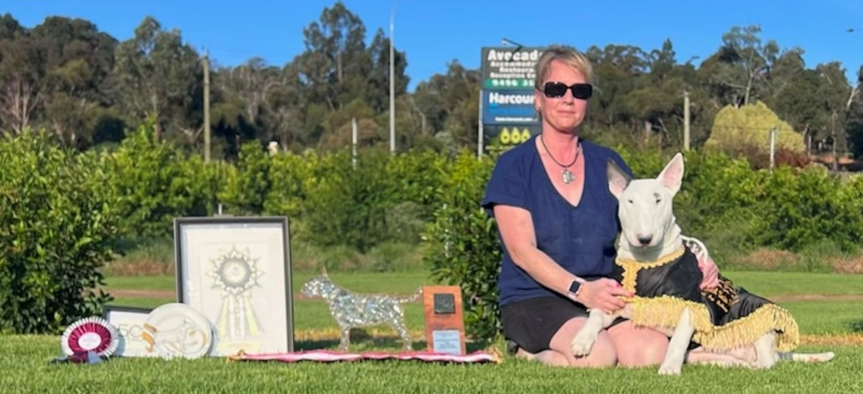
Tamara Yeoh
Prefix: Yandomir

My passion for Bull Terriers all started in my teens when I saw the most unforgettable White Male Bull terrier and the rest is history.
I purchased my first bull terrier in 1990 and have had them ever since, my first pedigree bitch I purchased from Trahern Kennels – Trahern Sinderella with my first litter with her in 2001 in which I also attained my prefix Yandomir.
In 2001 I attended my first trophy show in Brisbane under Judge Phyliss McCombie.
I have been breeding and showing ever since travelling all over Australia with some years been challenging with life changes, but I feel I have accomplished a lot since then with being awarded numerous Australian Champions and ROM’s with homebred animals as well multiple in show awards.
I have travelled overseas multiple times attending both the UK trophies and Silverwood, Montgomery Show and other specialty shows in the UK in which I have been lucky enough to see some amazing animals abroad and meet some amazing and wonderful breeders that have also given so much to our wonderful breed.
I have also served on the committee for the Bull Terrier Club of Queensland for numerous years and held numerous executive positions, currently President.
This year as a breeder was a prestigious and proud moment when with my homebred bitch Yandomir Kauzin Harmony winning the Souperlative box at the 2023 Australian Trophy Show.
I look forward to my first judging appointment and appreciate everyone that give their all to our breed.

