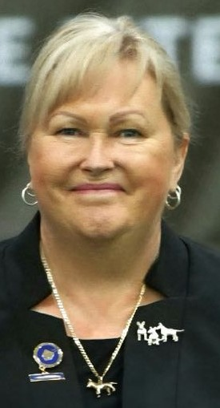
I have been involved in the Terrier Group for almost 40 years, where under the BRASSHEAD prefix I have bred shown and owned Bull Terriers & Staffordshire Bull Terriers. I currently have bred 13 ROM bull terriers and 2 NZ ROMs. In additional I owned and titled a further 8 Australian ROMs and have titled multiple Australian Champions and Grand Champions. I have also shown many Bull Terrier Miniatures to their ROM status.
I specialise in Bull Terriers & Bull Terrier Miniatures and am listed on the NBTC(A) ROM list, (National Bull Terrier Council of Australia) involved in Bull terriers for over 25 years.
I am an international all breeds judge and have been involved in the ANKC as an All Breeds Examiner /Assessor and Terrier Group Leader for the Trainee Judges Scheme.
Kerry King South Australia
Brasshead Bull Terriers
234 Dawkins Road,
Lewiston, South Australia
5501
I have been judging Bull Terriers at Championship level for over 25 years in which I have judged all bull terrier clubs of Australia and some of the most prestigious Bull Terrier events in the world. I have also judged all breeds shows in many countries.
My overseas appointments for Bull Terrier Clubs are as follows;
2025 The Barbary Coast Bull Terrier Club at the California Terrier Club USA
2024 The Country Competition and Bull Terrier Miniatures in Netherlands
2024 The TEXAS Gulf Bull Terrier Club USA
2023 The Bull Terrier Club of Chile
2023 The Major Trophies in South Africa
2022 The Bull Terrier Club of America (National at Silverwood)
2020 UK Trophy Show (Sandawana Trophy)
2018 Montgomery / Bull Terrier Club of America
2018 Montgomery / Miniature Bull Terrier Club of America
2016 Country Competition in Leiden, Netherlands
2015 Barbary Coast Bull Terrier Club of America
2015 Czech Republic Bull Terrier Club
2011 Highveld Ridge Bull Terrier Club South Africa.
2 occasions North Island Bull Terrier Club NZ
In closing I am the President and Life Member of the Bull Terrier Club of South Australia Inc and have been in this position for over 20 years a position I hold in high regard.
I have been fortunate over the past 30 years to have bred, owned & co-owned some of the top winning dogs in Australia.

Home Bred ROMs | Other ROMs I’ve title, and have owned/co-owned;
Brasshead Party Girl AI | Ch Evildouer Christmas Cracka AI
Ch Brasshead Crystal Queen AI | Aust Nz Ch Boromir Hand of Fate at Vortex AI
Ch Brasshead Butch Cassidy AI | Ch Credem Avenger At Brasshead AI
Ch Brasshead Anzac Poppy AI (Aust & NZ ROM) | Ch Bullroy Bolt Cutter
Brasshead Black Douglas | Aust & NZ Ch Boromir Quicksilver AI
Brasshead Witchy Woman | Grand Ch Maolmhin Seduction
Ch Brasshead Witches Britches | Grand Ch Bekmar Billy Idol
Brasshead River Queen AI | Grand Ch Maolmhin Devils Voodoo
Ch Brasshead Gothic Clown AI
Ch Brasshead Gothic Vortex at Bormir AI (Aust & NZ ROM)
Brasshead Bewitched
Ch Brasshead Bear Witch
Ch Brasshead Dominoe

