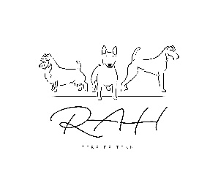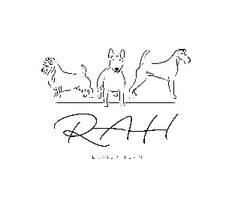

Honhazsta Bull Terriers

Anluan Irish Terriers

Roughnuts Australian Terriers

Neridah Sharrett

Judging CV

Neridah been a terrier enthusiast since she first started showing (Irish Terriers) in 1983. In 2010 she joined forces with her husband, Stan Honnery, and since then has jointly bred Bull Terriers under his prefix Honhazsta. Together they have bred and made-up numerous champions, Supreme Champions and ROM dogs.

In more recent years, they have resurrected the Minihaze prefix, under which they breed Bull Terrier Miniatures.

In 2018 Stan and Neridah began a journey into Australian Terriers. They soon fell in love with the breed and established their prefix Roughnuts. They have shown many dogs to Championship status, including one Supreme Champion who won multiple Best in shows, including the Perth Royal show.

After 32 years in Government, in 2014 Neridah undertook a change of direction and together with Stan established Fur Kidz Resort boarding kennel which incorporates a Dog Therapy pool.

Over the years Neridah has been actively involved in various activities including convening the judges training program for Group 2. She served on Executive of the West Australian Terrier Club for many years, with numerous years as Secretary. She worked on the Pure Breed Protection Committee – preparing briefs to government on tail docking and changes to the Dog Act. She chaired the Canine Association of WA Investigations Committee for (2006-7 and 2014 - 16) and served on the Protest and Dispute committee for a number of years. She has assisted numerous Dogs West working parties. She currently holds committee member status with the Bull Terrier Club of WA and is Vice President of the Bull Terrier, Bull Terrier Miniature Association of WA, having a long history in the formative years of that club.

Neridah is licenced to judge Group 1(Toys), Group 2 (Terriers), Group 3 (Gun Dogs),Group 4 (Hounds) and Group 7 (Non Sporting). She has judged all terriers in New Zealand, Italy, and across Australia. She has judged Irish Terriers, puppy sweeps at Montgomery County Kennel Club in the USA. She has also judged at Bull Terrier Specialty shows a number of times in Western Australia and in 2022 the ACT Bull Terrier Club specialty and North Island (NZ) Bull Terrier Club.

Neridah has attended both Silverwood (USA) and The International Weekend (Leiden – Netherlands) Bull Terrier specialties and looks forward to attending both again.

She enjoys mentoring new exhibitors and also groomers who wish to learn hand stripping of terrier coats. She has conducted breed lectures for many of the terrier breeds, including Bull Terriers, for the trainee judges in Western Australia.