The Dalmatian Club of NSW Inc
NEWS SPOTS
MAY 2020
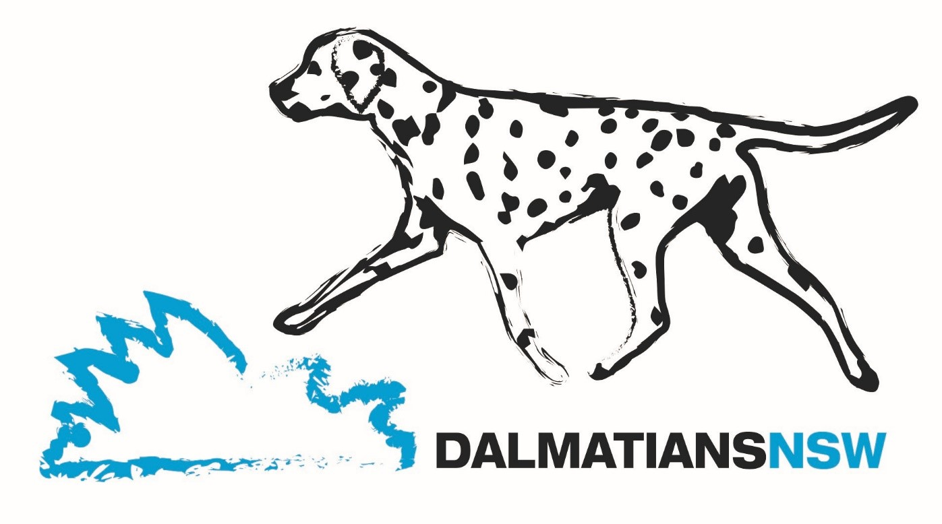

I hope you and your families have all stayed safe and healthy during the current Covid 19 restrictions and will continue to do so over the coming months.
So many people are suffering financial hardship due to the drought, bushfires and the current pandemic the committee felt it appropriate to waive the membership renewal fees for the upcoming 2020-2021 club financial year. The club has also been unable to run any events for our members so far this year and it is unclear when we will be able to do so in the foreseeable future.

A membership renewal form is with this issue of News Spots and it is important that you complete it and return it to the club either by email or post. We need to have confirmation that your contact details etc. are up to date on our records.

The committee also decided that fees for new members joining for the 2020-2021 year be reduced to half price.

If you have any questions regarding renewal or new membership fees please do not hesitate to contact me.

Our Committee & General Meetings due to he held this Wednesday 13th May have been cancelled. These meetings will be rescheduled for a future date when the current restrictions on the number of attendees is relaxed. The committee is also looking at other options for meetings, such as Zoom. Members will be advised via News Spots, Facebook or email/post.

A schedule for our October 2020 Specialty Championship Show has been submitted to DogsNSW for approval however the Club will not know if the show will go ahead for some time. There would need to be significant relaxation of the restrictions regarding the numbers allowed at an outdoor event along with social distancing rules for the show to proceed.

Dally Welfare NSW has had requests to help rehome Dals over the last couple of months which is not the easiest under the current restrictions. I am pleased to report however that we were able to help rehome a pair of Dals in the ACT and so far they are settling in well. We also have 2 families on our “waiting list”. Both have had Dals from us in previous years. Their much loved pets have recently passed to Rainbow Bridge and they are ready for a new spotted dog to love.

Page 1 Continued …

If anyone has some fun photos or stories about their Dallies please email them to me, would love to have some extra “stuff” for the next News Spots.

Take care everyone, stay safe and healthy, Marilyn

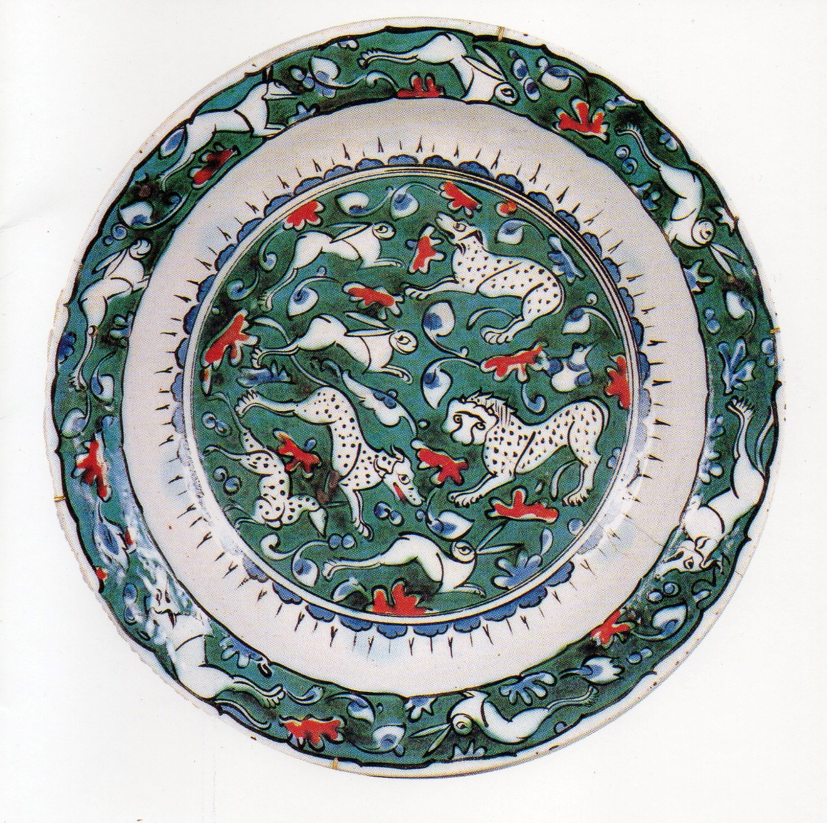

Spotted dogs depicted on an Iznik Dish
Turkey 1585

THE DALMATIAN CLUB OF NSW INC 2019-2020 COMMITTEE

President Dianne Wright
Vice President Ann Marie Godyn
Secretary/Show Secretary Marilyn Miller
Treasurer Ian Miller
Committee: Linda Bower, Michelle Bower, John Wright
NDC Delegate Michelle Bower
Welfare Marilyn Miller (Coordinator), Andy Robertson, Ian Miller
Life Members Jill Atkinson, Terry Blanch, Sandra Francis, Derek Johnson
Marilyn Miller, Andy Robertson, Mary Young

Email: dalmatiansnsw@gmail.com
Secretary/Show Secretary Ph. 0425 285 205
Welfare: dalmatianwelfarensw@gmail.com
Coordinator Ph. 0425 285 205

