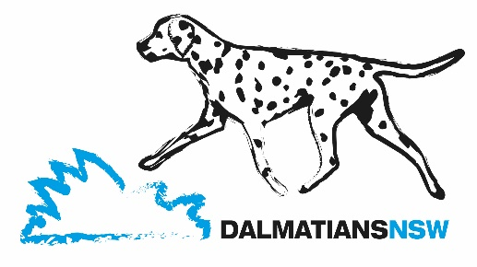
THE DALMATIAN CLUB OF NSW INC

Founded 1943 Affiliated with DogsNSW ABN 80142573754

2021/2022 NEW MEMBERSHIP / RENEWAL APPLICATION

MEMBERSHIP DETAILS

Type | Cost | New | Renewal
Single | $25
Dual | $30
Pensioner – Single/Dual | $15

Membership Year: 1st July 2021 – 30th June 2022. New members joining after 31st December 2021 pay half the above price.

MEMBERSHIP DETAILS

NAME/S

ADDRESS

SUBURB STATE POST CODE

PHONE _________________________________ EMAIL

No. OF DALMATIANS OWNED __ DogsNSW MEMBERSHIP No.
(Or applicable canine authority)

REGISTERED PREFIX DETAILS (if applicable)

PREFIX NAME PREFIX REGISTRATION No.

CONTACT NAME/S

SUBURB PHONE

WEBSITE EMAIL

I/We agree to the above Prefix Membership Details being listed on the Club website www.dalmatiansnsw.com

Electronic Prefix Logo has been emailed to dalmatiansnsw@gmail.com

Free litter notices now available for all Prefixes registered on our website

I/We wish to apply for Membership to The Dalmatian Club of NSW Inc. I/We agree to observe and comply with the Club’s Constitution, By-laws and Code of Ethics.

PAYMENT OPTIONS

Cheque / Money Order attached

EFT The Dalmatian Club of NSW Inc Confirmation No.
BSB 032 627
ACCOUNT NO 131043 Date of Transaction

Please insert “Membership and your Surname” in the description field (E.g. Smith MEM)

SIGNED ………………………………………………………………………… DATED

Please email to: dalmatiansnsw@gmail.com
Or mail to: THE TREASURER, TDCNSWINC, C/o 33 White Cedar Drive, Castle Hill, NSW 2154.

Approved at General Meeting held on

CODE OF ETHICS

Preamble:

This code of ethics establishes a standard of conduct for members of The Dalmatian Club of NSW Inc. in the normal course of owning, breeding, exhibiting, selling and judging Dalmatians.

Breeding represents a great responsibility to each individual, as he or she can either upgrade or nullify many years of conscientious effort. The breeder must be aware of this responsibility.

The purpose of breeding is to enhance the positive qualities and reduce the incidence of serious faults. With this in mind, potential breeding partners should be carefully investigated before a mating is undertaken.

As a member of The Dalmatian Club of New South Wales Inc., I hereby declare that:

1. I will abide by the Club constitution and by-laws and support the standard of the breed.

2. I will comply with all DogsNSW rules and regulations.

3. I will at all times display good sportsmanship and conduct myself in a manner that will reflect credit on the Club and the Dalmatian.

4. I will help educate the public in the Standard of the breed, inherent peculiarities of the breed, and in other areas where I am qualified.

5. As a breeder of Dalmatians, I will try to breed in such a manner as to enhance good temperament and continue to improve the physical health of the breed.

6. I will not knowingly breed from, or sell as suitable for breeding, any Dalmatian that has known genetic defects of a nature that are detrimental to the breed.

7. I will mate my Dalmatian only with a Dalmatian dog or bitch registered on the ANKC main register or relevant overseas equivalent.

8. I will sell Dalmatians, which are to my knowledge, in good health and free of communicable diseases or with full disclosure of their current health status.

- I will euthanise bi-laterally deaf puppies unless I choose to find a suitable home and am prepared to take the deaf pup back should it become necessary.

- I will supply, at the time of sale, each purchaser with the following, where applicable –

- A Registration Certificate issued by the DogsNSW.
- An Immunisation Certificate.
- A diet and care document which will include details about common ailments.
- BAER test document (if undertaken).
- Hip Score documentation (if undertaken).
- Local Council change of ownership document (if applicable).
- Microchip identification.
- Information on hip scoring and BAER testing.

11. Any sale/advertising entered into will be honestly represented and not misleading or fraudulent.

12. I will continue to offer assistance to the buyer for as long as such aid is required.

13. I will not sell or donate Dalmatians to commercial dog wholesalers, retail pet dealers, or directly or indirectly allow them to be given as prizes in contests of a kind, or for any purpose that may lead to their exploitation.

A CODE OF ETHICS IS ONLY AS GOOD AS THOSE WHO ABIDE BY ITS CONTENTS

