THE DALMATIAN CLUB OF NSW INC.
NEWS SPOTS
JUNE 2021
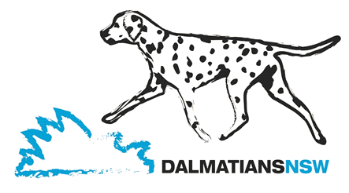

Winter has arrived and our spotty dogs are wearing their coats and hogging the fire and who can blame them. If you haven’t bought your Dally a coat yet then check out “Texicoats” on Facebook https://www.facebook.com/profile.php?id=100057411041543 Texicoats is owned by our Club Vice President, Anne Marie Godyn and regularly sponsors club events and fundraisers. Coats come in a variety of patterned fabrics and are made to your dog’s measurements.
Subject to approval from DogsNSW our Club’s 2021 October Championship Show will be held on Saturday 9th October in Ring 1 at the DogsNSW Complex at Orchard Hills. In conjunction with the Champ Show the Club will be holding the Club 2021 Open Show on the same day in the same ring. The Champ Show will commence at 9.00 a.m. and the Open Show will commence at the completion of judging of the Champ Show but not before 11a.m. Full details of Judges etc. will be advised following confirmation of approval by DogsNSW.

The end of the financial year is fast approaching and membership renewal is due. The 2021-2022 renewal form is included with your email/post with this issue of News Spots. When making payment via EFT please note that not all financial institutions include the name and reference of the person making the deposit, so when you have made this payment please email dalmatiansnsw@gmail.com to let them know your payment has been made and the name of the bank or building society.

Answers to last month’s puzzle Countries or Places of the World:
1. Canada 2. West Indies 3. Iceland 4. Russia 5. Mozambique 6. Bahamas
7. Taiwan 8. New Zealand 9. Holland 10. Columbia 11. Brazil 12. Poland
13. Wales 14. Portugal 15. Romania 16. Japan 17. Uzbekistan 18. Bali
19. Iraq 20. China 21. Belgium 22. Singapore 23. Bahrain 24. India 25. Hungary
26. North Korea 27. Kampuchea 28. Sweden 29. Italy 30. Hong Kong
31. Botswana 32.Grenada

VALE
Our Darling Lily has crossed the Rainbow Bridge.
In all the Dalmatians I have had since 1942,
There has never been one more gentle and caring.
A Rescue Dog, who realised she had found her
Forever Home, gave her all.
She has joined our previous dogs from the last 55 years here,
In the “Phiremans Garden of Tranquillity” and
Is sorely missed by both Joy and I.

Terry Blanch

Page 1.
NOTICE OF THE DALMATIAN CLUB OF NSW INC AUGUST 2021 GENERAL MEETING
TO BE HELD ON TUESDAY 24TH AUGUST 2021 COMMENCING AT 7.00 PM.

1. Apologies
2. Confirm minutes of September 2020 General meeting
3. Business arising from minutes
4. Correspondence
5. Business arising from correspondence
6. Treasurer’s report & Accounts for payment
7. Secretary/Show Sec/Welfare reports
8. New Members
9. General Business

Please note that members will be advised closer to the date of the meeting whether the meeting will be held be via audio visual link (e.g. Skype or Zoom) or in person at a venue to be decided.

NOTICE OF ANNUAL GENERAL MEETING OF THE DALMATIAN CLUB NSW INC
TO BE HELD ON TUESDAY 24TH AUGUST 2021 COMMENCING AT THE COMPLETION OF THE GENERAL MEETING BUT NOT BEFORE 7.30 PM

1. Apologies
2. Confirm minutes of 2020 AGM
3. Receive & adopt Balance Sheet & Accounts of the Club & accompanying Reports thereon.
4. Receive & adopt President’s Annual Report
5. Receive & adopt Secretary’s Annual Report
6. Receive & adopt all other Annual Reports
7. Appoint a Returning officer and two Scrutineers.
8. Receive from Returning officer result of ballot for election of Office Bearers & Committee for 2021-2022
9. Appoint Welfare Co-ordinator & 2 Welfare Sub-committee Member
10. Appoint an Auditor
11. Appoint Club Historian
12. Appoint Web Site Manager
13. Appoint Public Officer
14. Appoint NDC delegate
15. Committee Recommendation: That Item 7 of The Dalmatian Club of NSW’s Code of Ethics stating “I will mate my Dalmatian only with a Dalmatian dog or bitch registered on the ANKC Main register or relevant overseas equivalent” be amended to include the following “A bitch shall not be bred from unless it is in good health and has reached adequate maturity and, in any case, no mating shall be permitted before the age of 18 months”
16. Transact any other business, written notice of which shall be given to members at least 7 days prior to meeting date

Please note that members will be advised closer to the date of the meeting whether the meeting will be held be via audio visual link (e.g. Skype or Zoom) or in person at a venue to be decided.

Nomination and Voting registration forms for the AGM are attached to your email/post with this issue of News Spots.
Page 2.
Welfare Update: Busier this last week or so than Welfare has been for a while. We have been able to offer advice and in 2 cases have successfully helped find new homes.

Pleased to report that none of these have been as a result of dogs bought in the lockdown periods last year and their owners changing their mind now that some normality has returned to our lives. Relationship break up, change of accommodation and health problems remain the most common reasons.

Aside from rehoming, Welfare receives many requests for help with training and stopping bad habits that have been allowed to develop.
Some owners take the advice on board and things improve, others not so much and spotty
continues to get up to mischief!

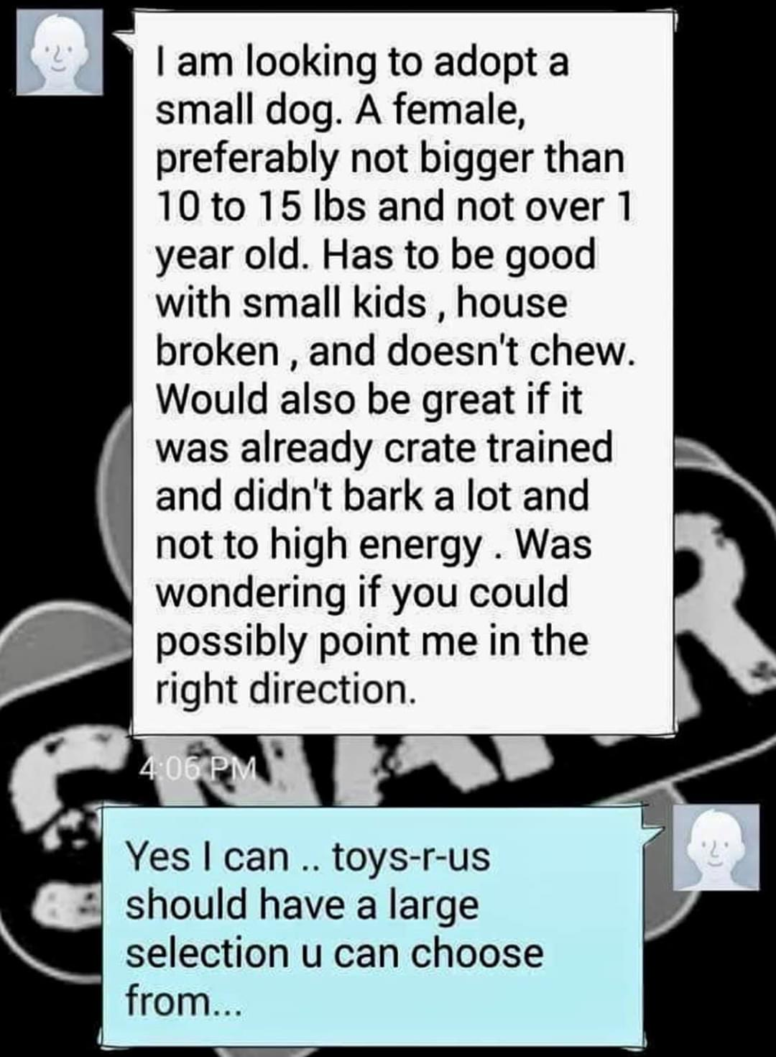

17th National Dalmatian Specialty. The Dalmatian Club of the ACT, the host club for the 17th National Specialty, gave an update at the recent National Dalmatian Council AGM. The 17th National was originally due to be held in March this year but due to COVID pandemic restrictions this had to be deferred. The Dalmatian Club of the ACT had discussed a tentative date for March 2022, however with recent news that international travel may still not go ahead by then, the club will review this again in August 2021.

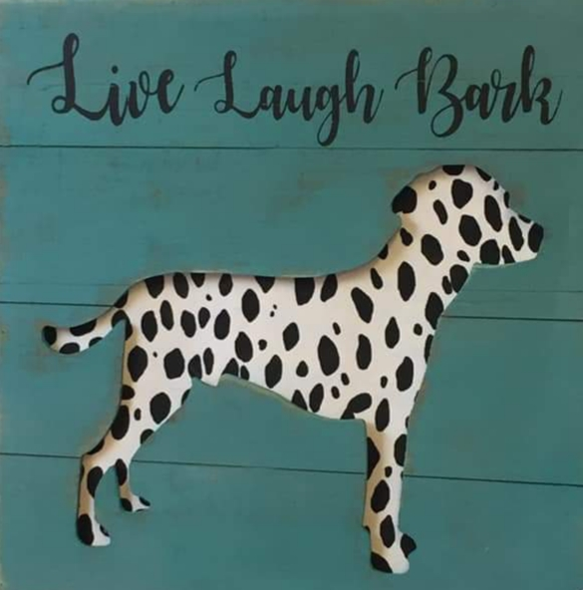

That is it for this month folks. If you have any questions please do not hesitate to contact me on dalmatiannsw@gmail.com

Happy Spotting, Marilyn

Page 3

