Collie Club of Victoria Inc.
Application for Membership / Renewal
I/We: ………………………………………………………. ………………………………………………………………….
DogsVic Members Yes No
If Yes, please provide your DogsVic Membership No:……..................................................................................
Address: ……………………………………………………………………………………………………………………….
…………………………………………………………………………………………………………………………………..
Telephone : Home……………………………………… Mobile: ………………………………………………………
Email: …………………………………………………………………………………………………………...
Hereby apply for membership / membership renewal of the Collie Club of Victoria Inc and acknowledge that the membership is renewable on 30th September each year.
I/We agree to be bound by the Rules and By-Laws of the Club, and the constitution, Rules and Regulations of the Victorian Canine Association Inc.
Signature of Applicant/s …………………………………………….………………… Date ……………………………
………………………………………………………………. Date ……………………………
Signature of Nominee : ……………………………………..................... Print Name: ………………………………..
(nominee must be a current financial member of the Collie Club of Victoria)

Please indicate category of membership required: Single Membership { } $25.00
Joint Membership { } $30.00
Junior Membership { } $5.00

Would you like to receive your Chatter by email? Yes No
(It arrives sooner and in full colour)
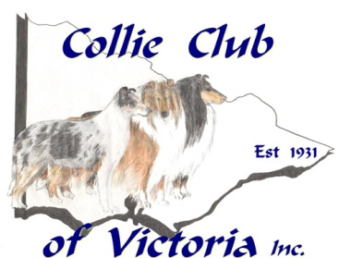
Please forward completed application together with fees to the Treasurer:
Bronwen Cramond
PO Box 312
Wangaratta, Vic, 3676
bronwenc@netc.net.au

(Cheques made payable to : Collie Club of Victoria Inc.)

Direct credit BSB 033 038 Account number 105757

Ref: Use your 'Surname' and 'Membership' however this form MUST be returned in either email or hard copy to the Treasurer.
Please Note: As per By-Laws for the Collie Club of Victoria, By-Law No 1 : “all subscriptions paid after 30th June shall be carried through to the following year”.

