GOOD NEWS for Breeding away from CM and SM. Lee Pieterse.
Looking backwards, over 5 generations, see the improvements with each successive generation, firstly with a crash course in the main areas we griffon breeders need to understand.
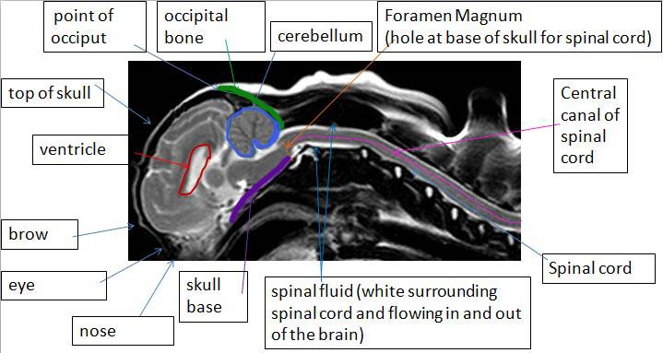
Syringomyelia: fluid filled cavities (syrinxes) within the spinal cord substance
above: quoted from Clare Rusbridge web site

Chiari-like malformation: (CM) is the most common cause of foramen magnum obstruction and syringomyelia in the dog. CM is a condition characterised by mismatch in size between the brain (too big) and the skull (too small). There is not enough room for the brain and the back part (cerebellum and medulla) is pushed out the FM

The image above shows an MRI with the cerebellum (blue) looking nice and rounded, it should approximately be as wide as it is high, without indent along the line of the occipital bone (green), or squashing, or having any part of it blocking the flow of spinal fluid through the hole at the base of the skull (orange) where the spinal cord exits. These ventricles (red) have a little too much fluid (hydrocephalous) but this means you can see them. Compare the above, to the problems in the MRI below................
.
1) cerebellum is not round, but squashed out of shape into malformation, with indented area at the back along the occipital bone and with part of the cerebellum pushed through the foramen magnum.
2) ventricles are so filled with hydrocephalous (water on the brain) there is hardly any room for the brain.
3) the central canal is not a single thin line, but is filled with blimps and bumps of fluid or "syrinxes" (remember fluid shows as white in the images in this document ). This is a very clear MRI image, showing very poor construction of the brain and cerebellum.

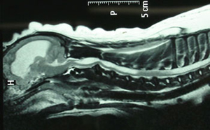1st generation
One challenge of breeding dogs is often about improving on what you have, I hope these pictures can demonstrate it is entirely possible to breed away from a very poorly constructed brain, (on MRI) and produce griffons with 'good' brains and no SM by selecting the best MRI offspring to breed on with.
When the griffon above, was mated to a Griffon with a very good brain construction on MRI, (who also had a mother with a very good brain) the result was the "2nd" picture. Compare as you go forward through the generations and see the continual improvement in these three key areas. The cerebellum is less squashed and closer to 'round', the ventricles get smaller, and the central canal gets slimmer and virtually non visible - and without any syrinx formation.
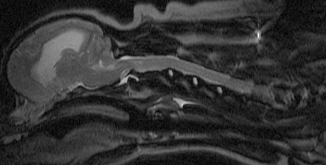 2nd 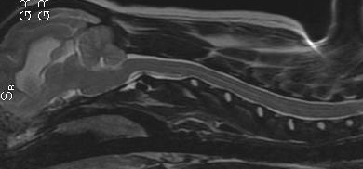 3rd
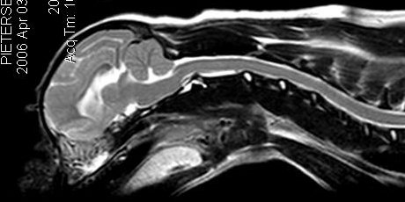 4th 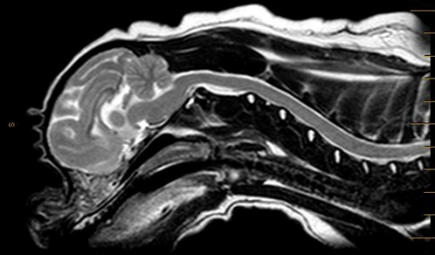 5th
THIS IS WHAT OUR OWN DOGS LOOK LIKE IN THE FLESH:
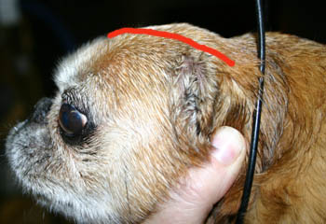 her MRI image 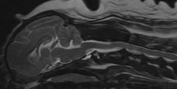
this griffon has no Chiari Like Malformation, no hydrocephalous and no SM. The red line shows where the Griffon below skull finishes - showing just how much more room she has, how much larger her head is. Her occiput is the highest part of skull viewed in profile, her skull is almost flat along the middle and she has a fairly low brow (no bombe & no dome).
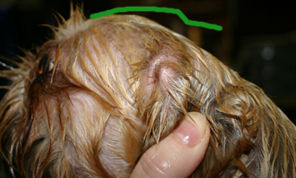 his MRI image 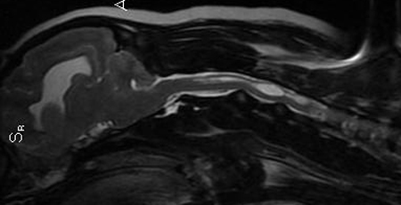
This griffon has Chiari Like Malformation, and an excess fluid (hydrocephalous), and multiple syrinxes and was a scratcher, he was eventually PTS due to SM. The green line shows where his skull needed to be larger and longer, to fit everything in without squashing it.
WHAT THEY LOOK LIKE FRONT VIEW:
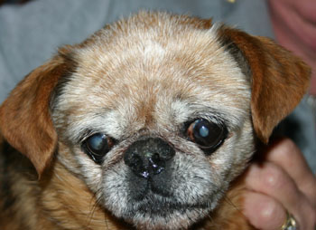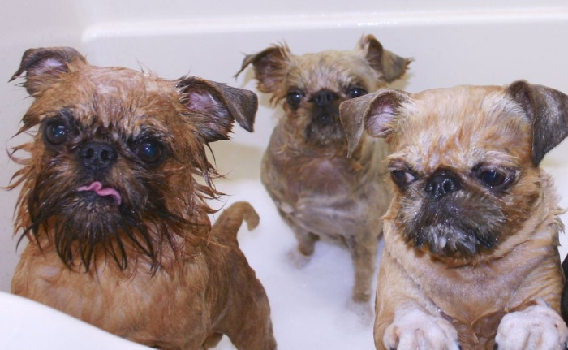
This is what 'no Chiari Malformation' looks like from 3/4 front on.
These three all have Chiari Malformation, they have broad faces, so they 'appear' to have large heads, but really, all they have is large faces, not large 'heads'. (they are in the tub, shampooed up to show the outline more clearly.
.

While we still rely on MRI to be absolutely certain, it appears that these skull shape differences can be very important characteristics to select in pups and breeding stock. We are looking at them younger and younger and attempting to look for these subtle differences in pups as young as we can, see below for our current experiment.
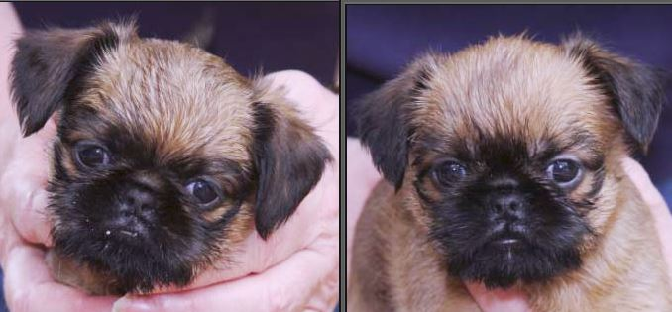
Which one do you think will have more room in her head? In a couple of years time, we'll MRI them and see.
Thank you for reading and considering these points, I hope it will encourage you to feel it is possible to improve Griffon MRI's by selective breeding and testing, and possibly, also observations on construction.
********************************************

