

**2022/23 Update**

Hello to all of the members of the Cairn Terrier Club of NSW and Cairn friends.

At the end of 2021/22, some of the outgoing committee assumed the club would fold, however new committee members and some returning have managed to keep the club going. The 2022/23 membership year has been a challenging one for the club, however there is light at the end of the tunnel, with:

* More democratic committee processes put in place to prevent previous issues;
* The Club Constitution being updated; and
* Two championship shows approved for 15 October 2023 to be held in Sydney, at an undercover venue. The Club shows are held on a Sunday with the day prior having two British Terrier Shows on at the same venue (Hawkesbury Showground). Members can enter four shows over the weekend with weather not an issue this time! The Club is collaborating with the Scottish Terrier Club of NSW for the Sunday shows and it’s hoped that members support this new venture. The schedule appears later in this update.

**2022 Club Show**

The Club show in October 2022 sadly had to be cancelled, due to its location being flooded along with the surrounding roads being unsafe. The club lost significant funds with an interstate judge still having to be paid, but at least all members and their dogs are safe and the Club has abided by the Dogs NSW regulations in the Show Extreme Weather Policy.

**2023 to date**

* A cairn walk was organised in Canberra in January by new committee member Annette Melia, with all attending enjoying the get together and coffee break afterwards.
* An informal cairn terrier walk is held every Sunday afternoon in Canberra with all welcome to attend, members and non-members. Lots of off-lead runs, swims in the lake and meeting other dogs are included. For details see the Club Facebook group.
* Members and their cairns attended the Scottish Festival “Bundanoon is Brigadoon” in the Southern Highlands in April, on a stand promoting the breed and the Club. A more detailed report of this appears later in this Update.

I have appreciated the support from committee and members encountered over the last year and am honoured to stand for Club Secretary again for 2023/24.

**Ginnette Loft**



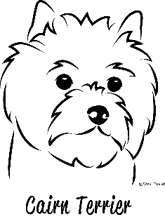 **Presidents Report**  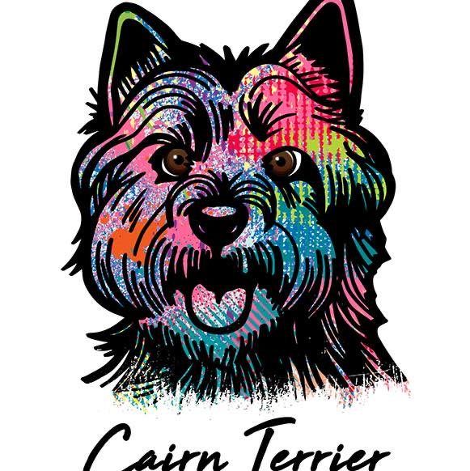

Welcome to our new members and thank you to all our members for rejoining and supporting our Club, for the 2022/23 membership year.

This year has seen our committee come together and work as one, each Committee member has volunteered their time and made a real commitment to ensuring our Club’s future. Thank you to every member, for all their ideas, in-put and assistance throughout the year. Whether it be picking up equipment, arranging met and greets with members and their Cairns, or providing valuable feedback and giving up their time to attend meetings and events, whilst being wonderful Ambassadors for the Club.

We have our new venue for our upcoming Speciality shows, we are very excited to join the Scottish Terrier Club of NSW for a wonderful day of Celtic showing.

We encourage all members, friends, and families to come along and enjoy the day. I look forward to meeting and chatting with you.

Keep safe and enjoy.

**Amanda Bruce**

PS: I am happy to stand for Club President again this year ☺

**CTC of NSW OFFICE BEARERS 2022-23**

President – Amanda Bruce

Secretary – Ginnette Loft

Treasurer – Stephanie McDonald

Vice Presidents – Kim Stenning, Peter Miller

Committee - Lyndal Kelly, Donna Robinson, Annette Melia

Publicity – Amanda Bruce & Ginnette Loft

Puppy Sales – Ginnette Loft

Patron – Rosemary Boyd

Show Manager – Stephanie McDonald

**Membership**

Please note that membership for **2023/24 is now due** as our membership year is from

**1 July 2023 to 30 June 2024**. Payment of membership can be via:

* Show Manager online, go to the Cairn Terrier Club of NSW area.
* Direct deposit to the Club account Cairn Terrier Club of NSW, BSB : 032724, account number 209906 and email these completed details to the Club Secretary at ginnette.loft@bigpond.com
* Cheque and hard copy of these completed details posted to:

CTC NSW SECRETARY

PO BOX 1322

QUEANBEYAN NSW 2620

If you are a new member or your membership details need to be updated, please complete the following details and email or post it to the Club Secretary at the details listed above.

**CAIRN TERRIER CLUB OF NSW INC**

**Membership form 2023/24**

Name(s)____________________________________________________________________

Address____________________________________________________________________

___________________________________________________________________________

Phone______________________________________________________________________

Email address________________________________________________________________

DOGS NSW or other canine body membership number_______________________________

Breeders Prefix (if applicable)___________________________________________________

Signature(s)_________________________________________________________________

**Fees**

|  |  |  |
| --- | --- | --- |
| **TYPE OF MEMBERSHIP** | **SINGLE** | **DOUBLE/FAMILY** |
| Full member | $10 | $20 |
| Junior(where one parent at least is a financial member) | $5 each | N/A |

**The Scottish Festival “Brigadoon is Bundanoon”** 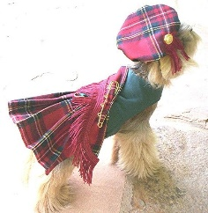

1 April 2023 saw Bundanoon transform into the Mystical Brigadoon, even the local train station had a name change for the day. I stayed with committee member Lyndal Kelly and her clan in Bowral. We started off on a frosty Southern Highlands morning and made our way to Bundanoon with 5 Cairns in tow. We meet Club Treasurer Steph with her 2 Cairns there and set up our Club stall.

We were over-whelmed with the support of the Southern Highlands Community, so many made their way with festival map in hand, straight for our stall to see our Cairns and to hug and pat them. Steph kindly offered Emma and Copper up for walks, and the dogs were happy to go for a wee wander with festival goers. Steph was kept busy, with adults and children waiting to take Emma and Copper for a walk.

The dogs all looked the part, looking splendid in their tartan red check bandana’s. A huge thank you to Lyndal for making them. Thank you to Donna Robinson for allowing us to take her Pepper along, with Lyndal’s Tilly and Jet and my Evie and Emy making up the cairn clan for the day.

All was going well until the long line of Piped Bands made their way past the stall, and the bagpipes and the rattle drum filled the air. Our Cairns weren’t all that happy with the rattle drum being very loud. Tilly barked in tune (lol) and my pup Emy jumped the pen, one of the bag pipe players tried to alert me, I was taking a video clip, when I realised, I left my phone still recording and ran. All turned out well in the end, the Pipe bands were going in Emy’s direction, and she ran back and jumped into my arms. I sat her up on the table and kept her calm, and by the end of the long line of Pipe bands she had become used to them.

Many Clans marched with families, their Scotties, and Westies, we even had an appearance of Nessy. The Loch Ness monster! The Clan stalls had so many lovely items for sale, Lyndal and I got our Clan scarves, which came in handy as it was a chilly day.

We had a few camp chairs set up and the smaller children loved sitting in them, patting Evie and Emy. Pepper, Jet, and Tilly enjoyed their pats and hugs. Whilst Emma and Copper loved their many walks. We had so many requests to take them home.

We were able to educate our audience letting them know Cairns were the original Highland Terrier. We had such a lovely day; the dogs enjoyed it and everyone who came were just thrilled with the dogs. Thank you for the festival organiser for reaching out to us and asking the Club to set up a stall. We are all keen to go again next year.

I’ve included a few pictures of the day, hope you enjoy.

Amanda Bruce

**The Scottish Festival “Brigadoon is Bundanoon”**

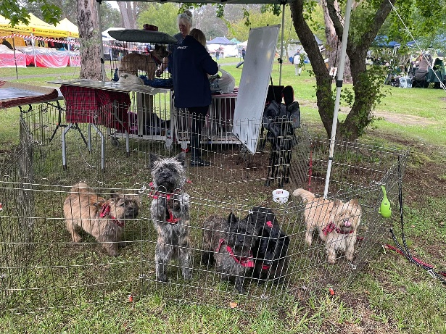 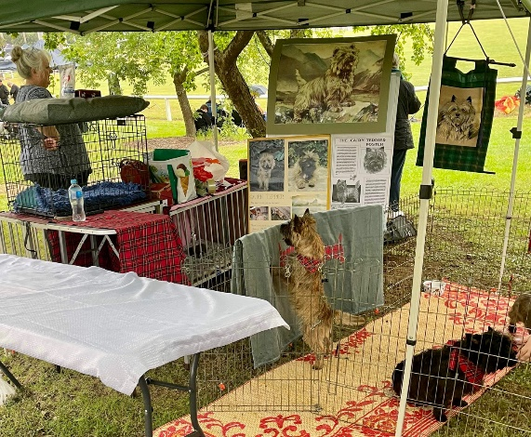

Cairns greeting the audience The CTC of NSW Breed stand

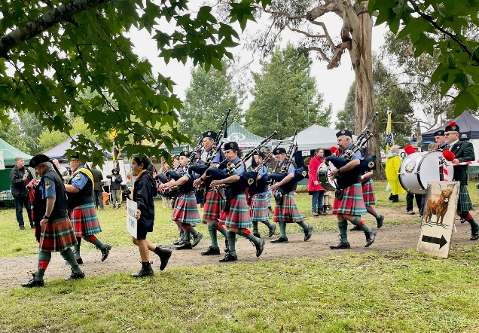 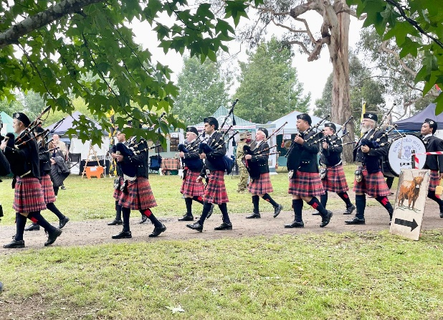

Two different clans marching with their Pipe bands

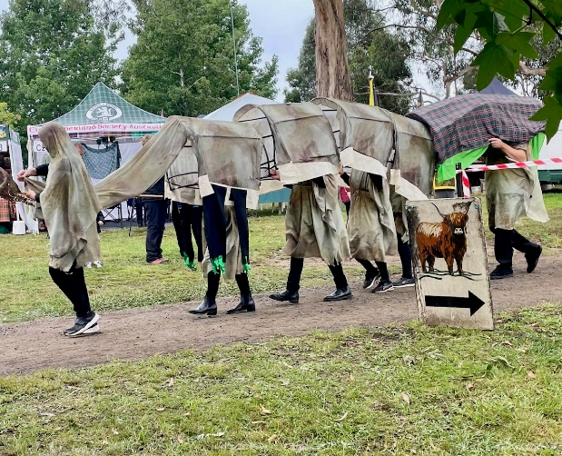 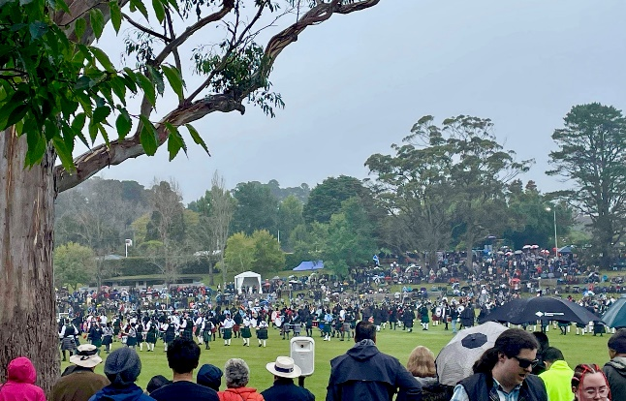

“Nessy” The finale, the gathering of the Clans



**Cairn Terrier Club of New South Wales**

**Championship Shows 2023**

**Sunday, 15th October 2023**

**Location:** Undercover area, Hawkesbury showground, 40 Racecourse road Sydney.

|  |  |  |
| --- | --- | --- |
|  | **Sunday 9:00 AM** | **Sunday not before 12:00PM** |
| **Ms A Baxter (VIC)** | Breed classes then Sweepstakes and Property classes |  |
| **Mrs S McMahon (NSW)** |  | Breed classes |

**Classes to be judged**: 1, 2, 3, 4, 5, 9, 10, 11, 12*, 13* & 18 (dogs & bitches)

* must be eligible to compete for Challenge

**Sweepstakes**: 3-6 months, 6-12 months, Neuter, Veteran.

**Property Classes:** Best Gait, Best Head, Best Coat.

**Dogs NSW Representative**: Ms S Consadine.

**Entry Fees**: Members $17 per entry, Non Members $22 per entry, Sweepstakes & Property Classes $2 per entry.

**Catalogues**: $6 ea (none available for purchase on the day)

**Refreshments**: BBQ provided, BYO drinks.

**Payment**: Cheque, Money Order or online through Show Manager.

**Entries to**: Show Manager, closing 9 October 2023

**Cheques made payable to:** Cairn Terrier Club of NSW

**Enquiries:** G Loft 0412217573, ginnette.loft@bigpond.com

**Prizes**: BIS, ruBIS, BCC & DCC AM show - Perpetual Trophy, Sash & Trophy

BIS, ruBIS, BCC & DCC PM show - Trophy and Sash

Class in Show – Trophy and Sash

Sweepstakes and Property Classes: Trophy

**Raffle** – $2 ea or 3 for $5 Tickets available on the day and on Show Manager. Please support the raffle to raise funds for the Club.



**Information article - Glucosamine For Dogs: Uses and possible Side Effects**

By [Dr. Ricky Walther](https://www.pawlicy.com/author/richard-walther-dvm/), Veterinarian

([Glucosamine For Dogs: Uses, Dosage & Side Effects | Pawlicy Advisor](https://www.pawlicy.com/blog/glucosamine-for-dogs/)) (Excerpt)

**Glucosamine is a naturally occurring amino sugar in humans, dogs and a number of other animals. It acts as the building block for collagen which helps create molecules that form cartilage, or the spongy material that acts as a cushion between healthy joints.**

Cartilage plays a significant role in the everyday functioning of the body, but it becomes damaged over time, the body produces less and it cannot replicate it. As a result, bones in joint sockets may rub against each other, leading to friction, inflammation, pain, and conditions such as osteoarthritis.

Glucosamine helps to repair cartilage damage and alleviate the symptoms of osteoarthritis, as well as:

* Reducing inflammation and pain
* Restoring mobility and range of motion
* Decreasing stress placed on joints due to hip dysplasia or structural changes
* Assisting in the healing of spinal disc injury
* Soothing recovery from joint surgery
* Maintaining peak performance and healthy joints in younger dogs

**Supplementation of glucosamine**

Adding glucosamine to your dogs daily feed is recommended to help improve movement and reduce arthritis symptoms. Look for *glucosamine sulfate* as the best type of supplementation, in either tablet, capsule or powdered form for daily use. Another ingredient to look for in a supplement is *chondroitin.*This isoften found in the body’s harder connective tissue, such as cartilage and can improve the symptoms, stop and even reverse the degenerative process of osteoarthritis.

You can start glucosamine supplements early in life, around the age of two to helpprevent joint-related issues down the road while promoting healthy exercise activity. However, any time in your dog’s life is not too late for glucosamine chondroitin to be helpful. Treatments may start at a higher dose until you see signs of improvement, then gradually taper down in strength. Keep in mind, the correct amount will depend on your dog’s unique weight, age, and severity of the joint condition.

**Possible side effects of glucosamine**

Glucosamine in dogs has mild side effects, if any at all, because it’s a naturally occurring substance in the body. Possible side effects might include: increased thirst, increased urination, trouble sleeping and occasional vomiting or diarrhoea. If they occur, these side effects are brief and should go away after several doses. Once you begin supplementation carefully observe your dog for any perceptible changes in behaviour to confirm there is no allergic reaction after the first dose. If you notice something that might be serious, such as difficulty breathing, stop serving immediately and take your dog to a vet.

Dog Funnies

