The British Terrier Club of
N. S. W. Inc
Founded 1907

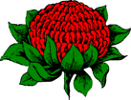
Terrier of the Year Competition 2018
Program
Saturday 4th May 2019
----------------------------------------
Your esteemed judges for this evening are

Dee Hyde
Derek Hyde
Blake Wistuba

Master of Ceremonies for the evening
Mr Graham Cruse
MEET THE JUDGES

Derek Hyde
The dog game has been a family pursuit for more than 50 years for us. We bred Afghans for some 10 years before acquiring our first Kerry Blue and in that time showed, successfully, a Whippet, a Miniature Schnauzer, a Lhasa Apso and a couple of Wirehaired Fox Terriers. Our earlier Kerry Blue imports (2 English Champions and 1 Junior Warrant Winner)
, we believe, have made a significant contribution to the popularity of the breed in Australia. One was National Dog of the year in 1979, which was no mean feat you may rest assured. Another won the Best Terrier in the Australian Bicentennial Top Dog Competition. In 1999, we imported a virtually unshown but high-quality Kerry Blue dog from Ireland who has left his mark on the breed. His son was awarded runner up Best Terrier in NSW in 2007.
On the judging front, I have had "All Breeds" Status since 1980. Judging milestones for me have been judging Kerry Blues in Ireland (in Kerry!), England (tickets at Blackpool), USA, and Finland. Judging all other Terrier Breeds has also been significant - overseas many terrier breeds and the Terrier Group in Finland, Cairns at Windsor (UK), BIS at a Three-day All Breeds Open Show in UK. Numerous breeds and Group at Czech Terrier Club: - in Australia, British Terrier Club of NSW, Terrier Club of South Australia, Terrier Club of Western Australia and the Sporting Terrier Club of Victoria plus quite a number of Terrier Breed Speciality Shows. Other all-breed appointments have been in all states of Australia, UK, USA, Canada, Finland, Czech Republic, Switzerland, Germany, Argentina, Philippines, Malaysia, India, Thailand, South Africa
In addition, I have always been heavily involved in the administration side of dogs and the associated dog shows. For example,19 years on the Council of the canine control in the ACT – Dogs ACT as it is now called, Senior Vice President for 4 of those years. Vice President of Belconnen All Breeds KC and National Capital KC. I have been the Treasurer of the Border Terrier Club of NSW for some 20 years and I have been awarded Life Membership of those organisations. For approaching 15 years, I have been the Chief Dog Steward looking after the Dog Section of the Royal Canberra Show.

Dee Hyde
The dog game has been a family pursuit for more than 50 years for us. We bred Afghans for some 10 years before acquiring our first Kerry Blue and in that time showed successfully a Whippet, a Miniature Schnauzer, a Lhasa Apso and a couple of Wirehaired Fox Terriers.
Our earlier Kerry Blue imports (2 English Champions and 1 Junior Warrant Winner), we believe, have made a significant contribution to the popularity of the breed in Australia. One was National Dog of the year in 1979, which was no mean feat you may rest assured. Another won the Best Terrier in the Australian Bicentennial Top Dog Competition. In 1999, we imported a virtually unshown but high quality Kerry Blue dog from Ireland. His son was awarded runner up best Terrier in NSW in 2007.
On the judging front I have had "All Breeds" Status since 1982. Judging milestones for me have been judging Kerry blues in Ireland and in Czech Republic, Canada, USA and Finland. Judging all other Terrier Breeds has also been significant; overseas, all terriers & group in Canada, many terrier breeds and the Terrier Group in Finland, numerous breeds and Group at Czech Terrier Club; in Australia, Irish & Lakeland Club of NSW, Scottish Terrier Club of NSW (many years ago), West Highland White Terrier Show, Border Terrier Club of NSW the Cairn Terrier Club Shows of Victoria & NSW as well as the Lhasa Apso Show & the Shih Tzu Show.
I have always had a keen interest in Lhasa Apsos & there has been a Lhasa in our home for the past 40 years.
I have for many years been involved in the administration of dog matters in Australia. Participating as President and Treasurer/Secretary of the ACT Ladies Kennel Club, National Capital Kennel Club, Treasurer of the DOGS ACT. Also I am a life member of many dog clubs including DOGS ACT, ACT Ladies Kennel Club, National Capital Kennel Club, Border Terrier Club of NSW and Belconnen All Breeds Kennel Club. We have both been participating in the training of judges for over 30 years now. I was the Co-ordinator for Australian Capital Territory Dog Judges Training & Examination Scheme for many years & have continued more recently on the practical examination of new judges.
I look forward to judging for CKU & I am sure will enjoy the experience

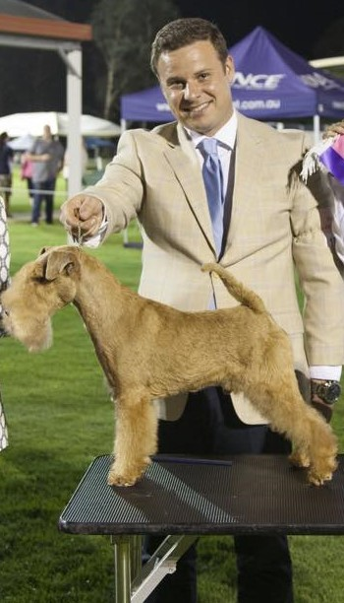

Blake Wistuba
Blake’s involvement and love for dogs started as a child, with his family breeding and exhibiting Fox Terrier Smooth and Australian Terriers under the “Beaufox” prefix. He has always had an interest and appreciation for all breeds and went onto owning, presenting and handling champion Bearded Collies, English Setters, Welsh Terriers, Airedale Terriers, Bull Terrier (Miniatures), Sealyham Terriers & Lakeland Terriers. Blake has had the privilege of handling these breeds to many Best in Shows, Best in Specialty Shows and Royal Best in Show and Best in Group placements, including Best in Show at Sydney Royal Dog Show with his English Setter in 2005. More recently, Blake has become involved with breeding and exhibiting Boxers and Boston Terriers with wife Rebecca under their “Arenbe” prefix.
He has been involved with numerous Dogs NSW and breed club committees over the years. Blake has also been involved with Junior Handler development in NSW, as President of the Junior Kennel Club of NSW and with the Junior Handler Working Party. He has judged Junior Handler State Final competitions in Perth, Adelaide and Brisbane.
Blake commenced judging conformation in 2012 and is licensed to judge Terriers and Gundogs. He has had the opportunity to judge these groups throughout Australia and New Zealand both at all breeds and specialty shows.

Club Officials

President: Mrs Liz Wells
Vice Presidents: Mrs RN Francis-Little
Mr P Pickett
Mr Steve Wesselink
Secretary: Mrs Sandy Wesselink
Show Secretary: Liz Nelson
Treasurer: Mrs D Bottero

Committee: Linda Long
Graham Wells
Craig Frazer
Faye Cutlack
Liz Nelson
Phil Nicholson

Life Members: Mrs E Walmsley, Mr A Walmsley, Mrs C Goldsworthy, Mr W Goldsworthy, Mrs O Black, Mrs H Pedersen, Mrs L Long, Mrs LK Brown, Mrs M Baran, Mr P Pickett, Mrs R Francis-Little, Mrs D Bottero.

Patrons: Mrs E Walmsley, Mr A Walmsley, Dr K Hedberg BVSC, Mrs B Jull

MESSAGE FROM THE COMMITTEE

We would like to welcome all of you tonight for the Terrier of the Year 2018 competition.
This competition is the culmination of the showing year and we have endeavoured to get the top winning dogs in each breed that are available

Your Master of Ceremonies for the evening will be Mr Graham Cruse

Thank you to our Prime 100 Dog Food & Orivet & Melanie Newman Salon Essentials who have generously supported The Terrier of the Year Competition by providing us with products for this evening's entrants.

Thank you all for coming and supporting The Terrier of the Year Competition and we wish you all the very best of luck!

HAVE A GREAT EVENING!

2018 FINALISTS
1 | AIRDALE TERRIER | AM GR CH, CH JOVAL THIS AINT NO DISCO (IMP USA)
2 | AMERICAN STAFFORDSHIRE BULL TERRIER | GR CH NEWBELLE ACDC ET JC WWWPD
3 | AMERICAN STAFFORDSHIRE BULL TERRIER | CH HOTASHELL HEIR TO THE THRONE
4 | AUSTRALIAN TERRIER | AM CH, CH TEMORA REMEMBER ME (IMP USA)
5 | BEDLINGTON TERRIER | CH BRECKLAND STUCK ON YOU (AI)
6 | BULL TERRIER | SUP CH. BULLACKTIV WALKING THE DEMON
7 | BULL TERRIER (MINATURE) | CH. BULLACKTIV DREAMWALKER
8 | FOX TERRIER SMOOTH | NZ CH. PINNACLE EYE FOR THE LADIES (INP NZ)
9 | JACK RUSSELL TERRIER | CH. WHATAJACK WHATA CHALLENGE
10 | JACK RUSSELL TERRIER | CH. LIZNEB BUILT TO LAST
11 | NORFOLK TERRIER | CH. JOTRUBA LAST TANGO IN HALIFAX
12 | NORWICH TERRIER | CH. WYNTERRA FIRST EDITION
13 | SCOTTISH TERRIER | CH. BESCOTTED LEGEND OF ZORRO
14 | SOFT COATED WHEATEN TERRIER | CH. ARDGAEITHE BALLINBAR MAGNUS
15 | STAFFORDSHIRE BULL TERRIER | CH. HIGHBOURNE LONHRO
16 | TENTERFIELD TERRIER | GR CH. ATENTA MISTA WAGS
17 | WEST HIGHLAND WHITE TERRIER | CH. CASPERSZ CREAM OF THE CROP

Program
5.30 Grand Parade and Rosette Presentation
6.00 Entrée served
6.30 Breed assessment commence.
7.30 Official break for Dinner
8.15 Round Robin Draw
8.30 Round Robin Competition Commences
10.15 Break for Coffee & Dessert. Four Dogs Remaining
10.30 Finals judging.
*please note these are a guild line and may be altered

MENU
----------------
Entree
Cold entrée buffet

Mains
Beef, lamb, pork
Roast potatoes
Sweet potato salad
Tossed garden salad
Baby carrots with honey
Beetroot, feta and almond salad
Caesar salad
Crunchy noodle salad
Pesto pasta salad

Desserts
Tiramisu
Alfredo Rochero
Individual lemon meringue tarts
Pavlova

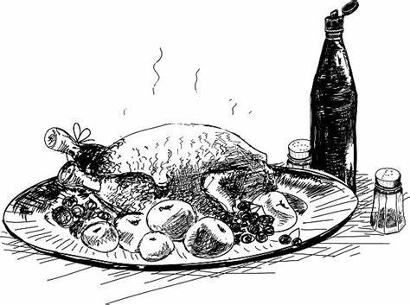

We Thank our generous sponsors

AIREDALE TERRIER

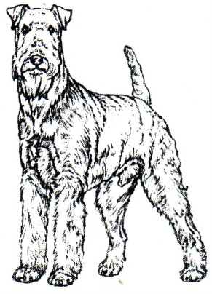
The Airedale Terrier, also called Bingley Terrier and Waterside Terrier, is a dog breed of the terrier type that originated in the valley of the River Aire, in the West Riding of Yorkshire, England. It is traditionally called the "King of Terriers" because it is the largest of the terrier breeds.

Driesdale Airedales presents
Am Ch & Am Grand Ch, Aust Ch Joval This Ain’t No Disco (IMP USA) - “Kwinn”

Kwinn has come to Australia to build on his wonderful showing career from the USA and is an integral part of Driesdale Airedales breeding program.
In the USA Kwinn in 2016 at 12 months of age won Best in Sweepstakes at the prestige Montgomery County Kennel Club and then went on to win 4 BIG, 19 BOB and obtaining his USA Grand Championship title.
Kwinn’s show career in Australia has taken off with a bang, Kwinn has achieved 1 RUBIS; 1 BIG; 2 RUBIG; and 5 Open in Group; 16 BOB. It only took Kwinn 4 months to achieve his Australian Championship title.
Joval Airedales has produced some amazing Airedale winners, in 2018 alone has won the prestige, Group 1 Terrier at the World Dog Show and National Championship (Bowl) Winner at the Montgomery Country Kennel Club.
Watch out for Kwinn in the show ring in 2019.

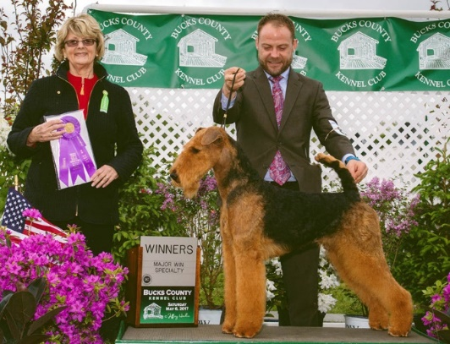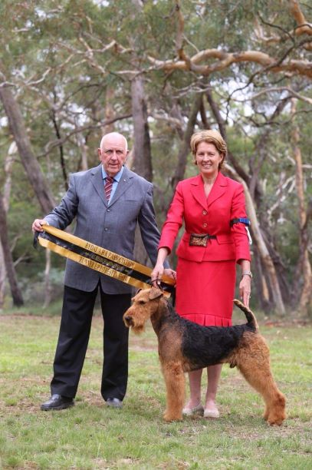

AMERICAN STAFFORDSHIRE BULL TERRIER
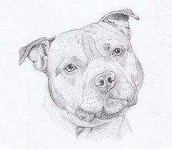
The American Staffordshire Terrier, also known as the Amstaff, is a medium-sized, short-coated American dog breed. In the early part of the twentieth century the breed gained social stature and was accepted by the American Kennel Club in 1936

GR CH NEWBELLE ACDC ET. JC. WWPD – “AKKA”
Akka is one of Newbelle Kennels most consistent winning Amstaffs. At 8 years old, Akka is a mature impressive dog with substance, flowing structure and correct movement.
Akka has been making impressions in the show ring since day 1, taking out Best Baby Puppy in Group at his 1st show. Since then he has been awarded Runner up in Show, Runner up in Speciality Show, Best In group, Multiple Runner up in Group, and Class in Shows under local and International judges. He has been award a CACIB and this is his 3rd time qualifying for the prestigious Terrier of the Year.
His amazing temperament and structure also make him well suited to the performance arena, where Akka has completed his Endurance Title, Junior Courser Title and was the 1st Amstaff in Australia to obtain his Working Weightpull Dog Title. He is currently working towards his Working Pack Dog Title. He is the only Amstaff in Australia who is a Grand Champion and has 3 working titles.
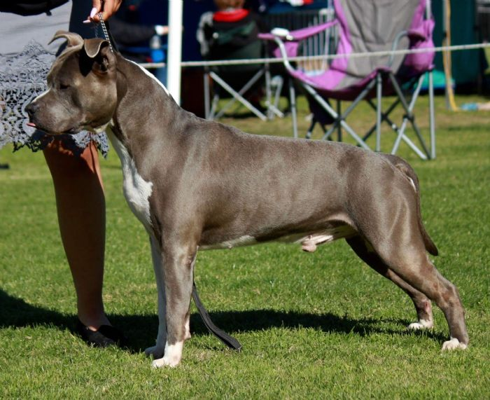

AMERICAN STAFFORDSHIRE BULL TERRIER
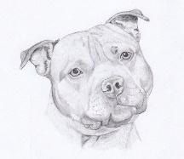
The American Staffordshire Terrier, also known as the Amstaff, is a medium-sized, short-coated American dog breed. In the early part of the twentieth century the breed gained social stature and was accepted by the American Kennel Club in 1936.
Ch HotasHell Heir To The Throne - “Pierre”
As he is just starting to mature, we have big hopes for this handsome boy. Ch HotasHell Heir To The Throne “Pierre”
Sire: BIS BISS Serb Ch. Ukr Ch. Cy Ch. Md Ch. Phil Ch. Bg Ch. Aze Ch. Mtn Ch. Aus. Sup Ch. Orion Red Mist King Of Rings (Imported Serbia)
Dam: MBIS RUBISS Gr. Ch Amstafican Return Of D Goddess
Bred By: Julia Martiniello
Owned By: Adrian Martiniello & Michael Beregshasi
Pierre was the only male in his litter and we knew he was special right from the whelping box. With limited time in the ring, he has done exceptionally well for a young dog, and is over ¾ of the way to his Grand Champion Title. Pierre has also proved himself at stud, producing a BEST IN SHOW all breeds winner from his very first litter.
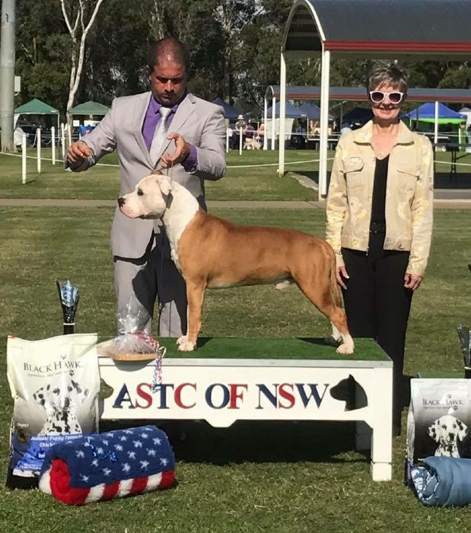
AUSTRALIAN TERRIER
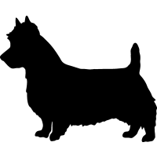
Several Terrier breeds were combines over a number of years to produce the hard bitten Aussie, by the late 1800’s a definite new breed type had emerges and a standard was set in 1896. The only true terrier evolved outside of the British Isles is a small, hardy, alert doge, essentially Australian.

AM CH, CH TEMORA REMEMBER ME (IMP USA)

Troy arrived in Australia in June 2017 when he was 15 months old and had achieved his American Championship prior to arriving. In less than 3 months in Australia he was awarded Best in Show at the 60th Anniversary Australian Terrier Show of NSW.
He has achieved:
Number 1 Dogzonline Pointscore Australian Terrier winner In Australia 2018.
Number 1 Australian Terrier Let’s Talk Terriers winner - Pointscore 2018.
Intermediate in Show – Spring Fair 2018
Runner Up in Show – Parramatta All Breeds Show – December 2018
Troy is owned, Loved & handled by Leanne Boote and was proudly bred by Mrs Julie Seaton (USA) in
We are very proud of what Troy has achieved in a short time and we look forward to his continued success in his show career.

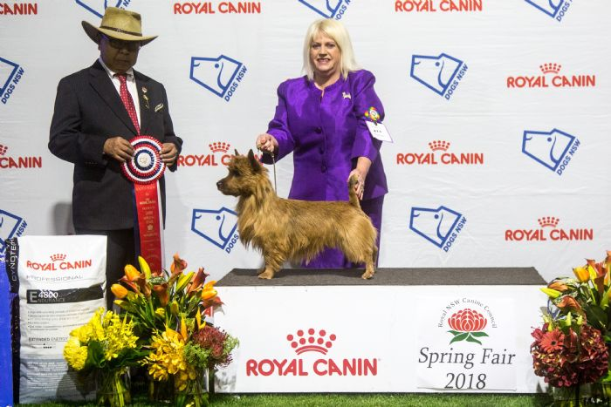

BEDDLINGTON TERRIER
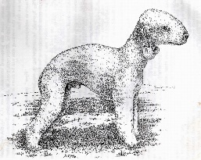
Bedlington terrier breed of dog developed in the 1800s in Northumberland, England, and named for Bedlingtonshire, a mining district in the area. The breed, which established itself locally as a fighting dog and a courageous hunter of badgers and other vermin, was later popular as a pet.

CH BRECKLAND STUCK ON YOU (AI)

Shadow is now 4 years old and has been a very consistent winner from an early age under local, interstate and overseas judges. He has also sired some wonderful puppies. A wonderful dog to live with, loves sharing the lounge with his daughter Lacey and playing with the grandkids when they visit.
Shadow has been shown fairly sparingly, however he is a multiple Group winner. Some of his achievements include:
R/Up BIS British Terrier Club of NSW October Show 2016 Mr K Sheppard (NSW)
R/Up BIS British Terrier Club of NSW October Show 2018 Ms N Sharrett WA)
BIGr 3 Dogs NSW Spring Fair FCI CACIB Show 2018 Mrs E Wogan (Ireland)
BIG 1 Dogs NSW Spring Fair Mrs Y Savage (Canada)
R/U BIS Dalwood Dog Show 2018 Mrs R Williams (NSW)
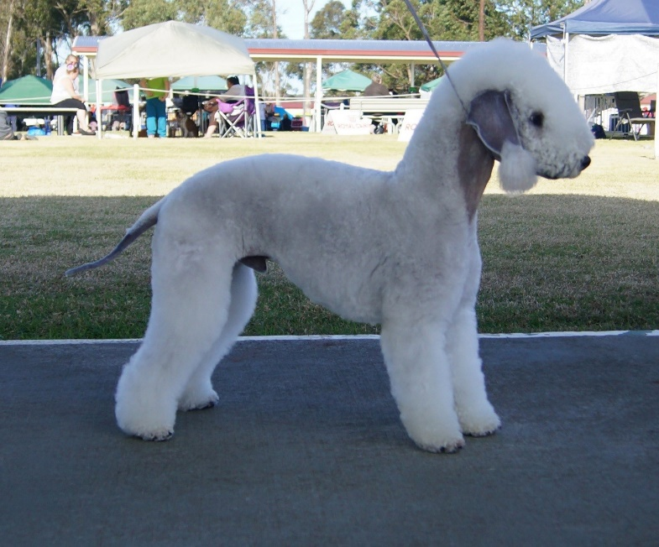Photo by Bullactiv

BULL TERRIER
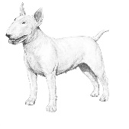
No one could mistake a Bull Terrier for anything else. He stands on firm powerful legs, staring straight at you, built on lines reminiscent of the bull from which his name is partly derived, but for all his somewhat forbidding presence, his is in fact a kindly chap.
Supreme Ch Bullacktiv Waking The Demon NTD - “Joker”

We are so proud once again of this superstar of a dog yet again being the Bull Terrier representative for Terrier of The Year!
Joker has more than proven himself both inside and outside the show ring
With an a very impressive show career Joker has won
2 x Best in shows
7 x Runner Up Best in Shows
1 x 3rd Best in Show
44 x Best in Groups
45 x Runner up Best in Groups
And countless group and in show awards under Local, international and breed specialist judges.
Joker is the youngest Bull Terrier to gain his Supreme Champion title with ease at just 18 months old.
He is also the first Bull Terrier in Australia to gain is Novice Trick Dog Title.
Joker has constantly proven himself time and time again and we couldn't be prouder of him.

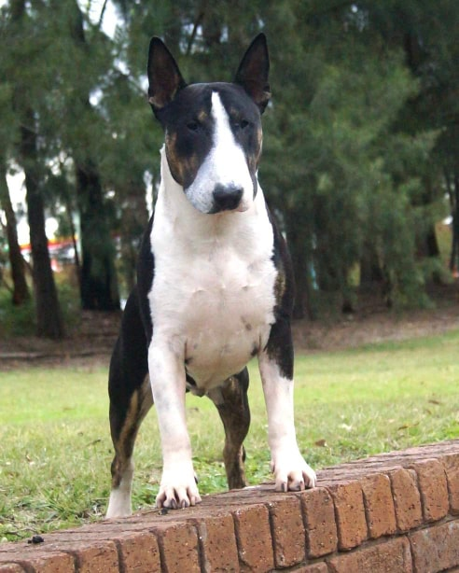
BULL TERRIER (Miniature)
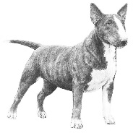

Originating in England, this breed was established by the UK Kennel Club in 1932, reaching our shores around 1965. They are such a loyal breed, which absolutely love kids and over all “family life”. They are definitely the “Clown of the ‘Canine race” and full of fun. With one of these guys around there is never a dull moment.

CH BULLACKTIV DREAMWALKER (ROM) - “SMOOCHIE”

Smoochie hit the ground running in her show career, at 3 months old going 1st in Sweepstakes at Sydney Royal 2017 (entry of 63 babies). From then on, she has never looked back!
At Specialty level she was awarded both Bitch Challege's from the Minor Puppy class under Breed Specialists Judges both from USA
Smoochie’s next Specialty she was once again awarded both Bitch Challenges and then onto win Best of Breed under UK Breed Specialist Judge
She gained the Prestigious Title of ROM (Recognition of Merit) at Specialty level in one weekend
Since then she has consistently won Bitch Challenge under International Breed Specialist Judges
Smoochie has also been a consistent BOB winner at All Breeds level. Also, Multi Class in Group and Multi Class in Show under both International and National Judges
Best Of Breed at Sydney Royal 2018
Number 1 Bull Terrier (Miniature) in Australia 2018 (DOLPS)
Number 2 Rising star Bull Terrier (Miniature) behind her litter sister 2017 (DOLPS)
Smoochie is everyone's friend. She loves being out, and really enjoys showing. She can be a little loud at times and is differently a little crazy but always happy!
Smoochie is proudly bred, loved and handled by
Bullacktiv Kennels
(Est 1985)
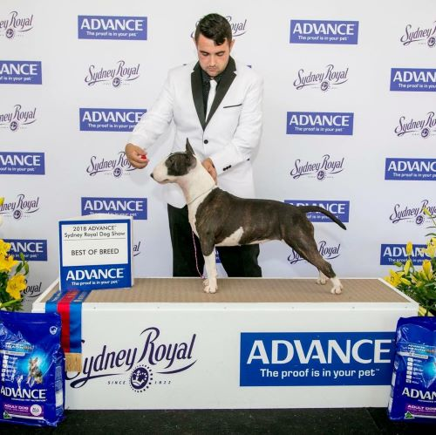

THE FOX TERRIER SMOOTH

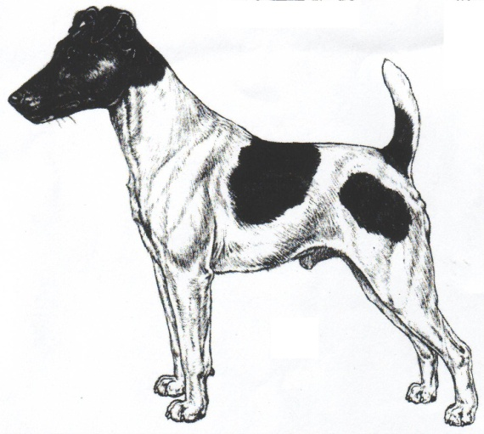
The Fox Terrier was developed in England for hunting and was highly sought after. This tenacious terrier would go into earth to bolt the fox, enabling the hunt to continue. Fox Terriers were also used to hunt badger and vermin.

NZ CH, CH Pinnacle Eye For The Ladies (IMP NZ) – “Bond”

BOND’ NZ CH AUS CH Pinnacle Eye For The Ladies (IMP NZ) came to us late September ad has really hit the ground running.
Already a BIS winner from the puppy class in New Zealand, Bond has continued to be successful here in Australia so far winning two all breeds best in shows, 2 all breeds runner up best in shows & 14 best in group awards and already over half way to his Supreme title & he’s only just turned two years old. We have high hopes of a successful show career for this boy
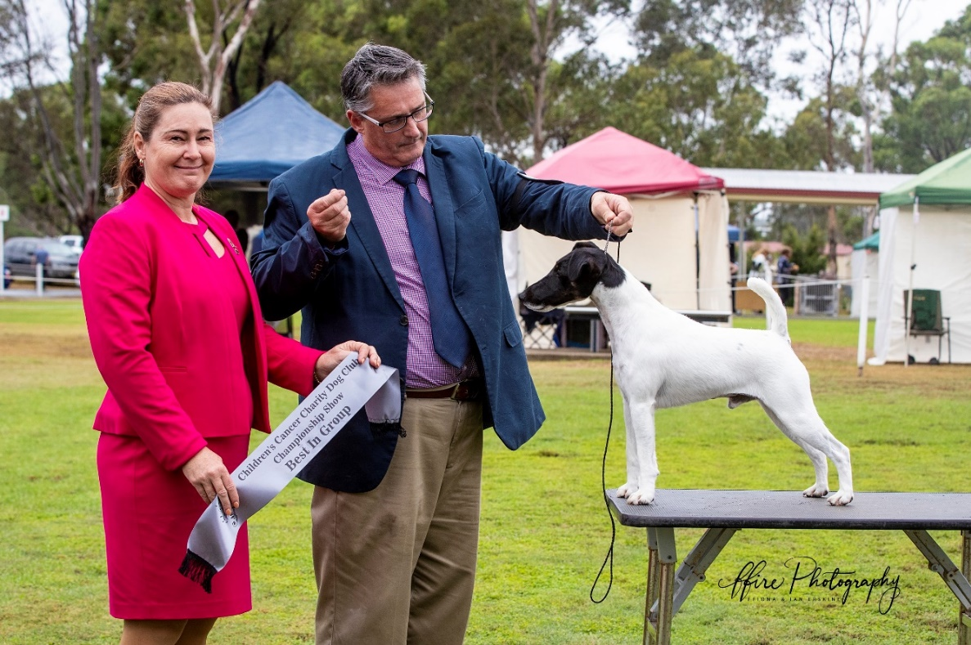

JACK RUSSELL TERRIER
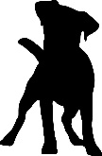
The Jack Russell terrier was evolved in Devon, England, by a hunting parson whose name the breed now bears – Reverend Jack Russell. The Jack Russell was officially recognised by the Australian National Kennel Council in 1991.

CH Whatajack Whata Challenge – “Crownie”

Whatajack Whata Challenge gained his title at 10 months of age.
Known as Crownie
For a smooth coat Jack Russell this was exceptional.
In July 2018 Dogs ACT had the Terrier Group National show & from minor class Crownie won 2 Best of Breeds 14 & 15 points under Terrier Specialists Mr Geir Flyckt-Pederson from the USA &
Mag Gerhard Pollinger from Austria. To me this was a great win as this was Mag Gerhard Pollingers Breed.
At the October 2018 Jack Russell specialty show Crownie won Reserve Challenge Bitch & Puppy in show under Terrier specialist Ms Sharron Bover from Victoria.
Also in October 2018 at the British Terrier show Crownie won BOB & Puppy in show & was in the final 6 dogs for best in Show under Mrs N Sharrett from W/A

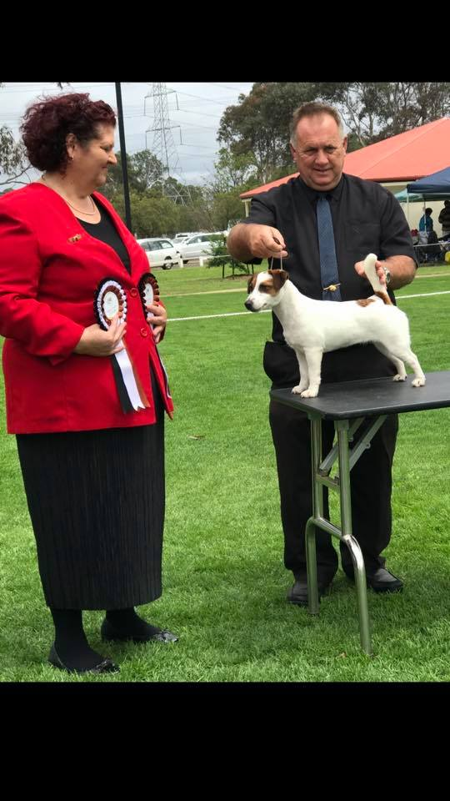

JACK RUSSELL TERRIER
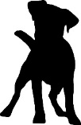
The Jack Russell terrier was evolved in Devon, England, by a hunting parson whose name the breed now bears – Reverend Jack Russell. The Jack Russell was officially recognised by the Australian National Kennel Council in 1991.

CH Lizneb Built To Last- “Tonka”
Tonka has always been a true showman in the ring since he started as a baby winning and being placed in huge sweepstakes classes, class in group and in show awards.
He won so many in groups and in show awards whilst he was young and easily obtained his title beating the older exhibits from a young age under terrier specialists and overseas judges.
He has been shown very limited over the past 2 years due to my other commitments but has still shown his worth in the show ring when we have been out occasionally winning some very nice Challenges and Best of Breeds.
Tonka is bred down from the well-known Carisbrooke lines and I can not thank Rita Francis-Little enough for leasing his dam to me twice to breed Tonka and his well-known half-sister “Flame.”
Tonka is loved, bred and handled by Liz Nelson and he has also been an asset to the Lizneb kennel producing some lovely youngsters for us.
He enjoys his place at home being the boss of the kennels and a fierce guard dog of our home.
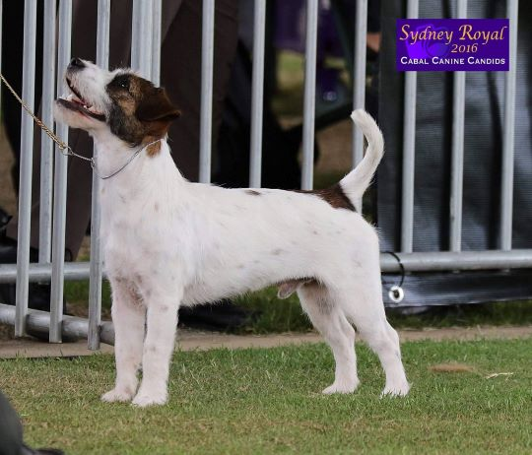
NORFOLK TERRIER
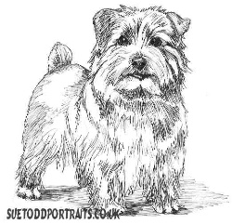
The Norfolk Terrier is a British breed of dog. Prior to gaining recognition as an independent breed in 1964, it was a variety of the Norwich Terrier, distinguished from the "prick eared" Norwich by its "drop ears". Together, the Norfolk and Norwich Terriers are the smallest of the working terriers.

Ch Jotruba Last Tango in Halifax JC
DOB: 28 March 2017
Attained his Championship title under the capable hands of Marlow Magnayon which included many classes in group.
He then went on to Lure Coursing which he is manic about attaining his Junior Course title.
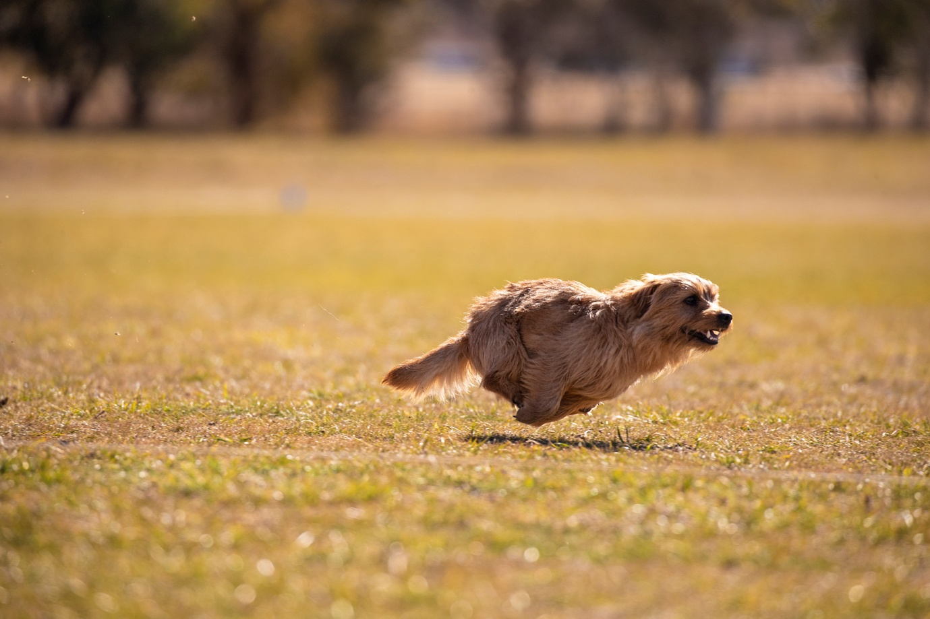

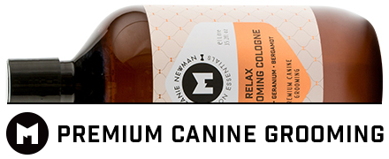

NORWICH TERRIER
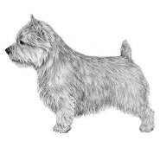
The Norwich Terrier originated as a ratter on farms but moved up in the world to bolt foxes from their dens during hunts. Today he’s an amusing companion who serves double duty by keeping your home and yard free of rats and other vermin.
Aust. Ch. Wynterra First Edition EIC. JE.
I am so proud that once again, Rupert has qualified to represent the Norwich Terrier at this year’s Terrier of the Year final. Now retired from the show ring, tonight’s final will be his swan song – although he may make an appearance in the Neuter Class later in the year! During his short show career, Rupert and I have learnt lots, from conformation, breed standards, grooming and show ring terminology, just to name a few. We have also made some wonderful friends along the way (both human and dog alike), whose love, support and encouragement has been greatly appreciated! Rupert’s most notable show achievements include Runner-Up Best of Breed (2017 Purina Sydney Royal), Best Puppy of Breed (2016 Purina Sydney Royal) and numerous of Best of Breed awards throughout NSW – thank you to all of the judges who have awarded him. After a brief introduction to Earthdog at the end of the 2017 season, Rupert proved a natural at racing into the burrows and working the quarry – he achieved his first ever Earthdog pass in only his second ever test! Lack of front teeth aside, the judge jokingly commented on how he’d “almost ripped her arm off”.2018 continued to be a crazy, busy year for Rupert as he started to excel, shine and succeed in the dog sport and obedience world. In May, Rupert gained his first ever clean run and first place in Novice Jumping Dog at Wollongong Dog Sports Club’s annual agility trial – made even more special in that we’d had little preparation due to months of rained out and cancelled training sessions. We were also awarded the club’s memorial trophy for Best Novice Dog of the Day. Rupert also became the FIRST EVER Norwich terrier in NSW to attain not just one, but TWO Earthdog titles. In just a few short weeks, Rupert successfully passed both his Earthdog Instinct Certificate (EIC) and Junior Earthdog (JE) tests with flying colours. His enthusiasm and keen terrier instinct is wonderful to watch and I can’t wait for the 2019 season to recommence where we hope to gain his Senior (SE) and Master (ME) Earthdog titles and start working towards his Earthdog Champion title. Not wanting to stop there, Rupert has further impressed with his intelligence and knack for obedience and trick training. We signed up in mid-2018 with Do More With Your Dog, a club affiliated with the AKC in which dogs are awarded official AKC Trick Dog Titles. By the end of 2018, Rupert is the FIRST EVER Norwich in Australia to have attained THREE Trick Dog Titles: Novice Trick Dog (NTD), Intermediate Trick Dog (ITD) and Advanced Trick Dog (ATD). We hope to complete his Trick Dog titles by qualifying for Expert Trick Dog and Champion Trick Dog by the end of 2019. The future is bright for my little shining superstar!!
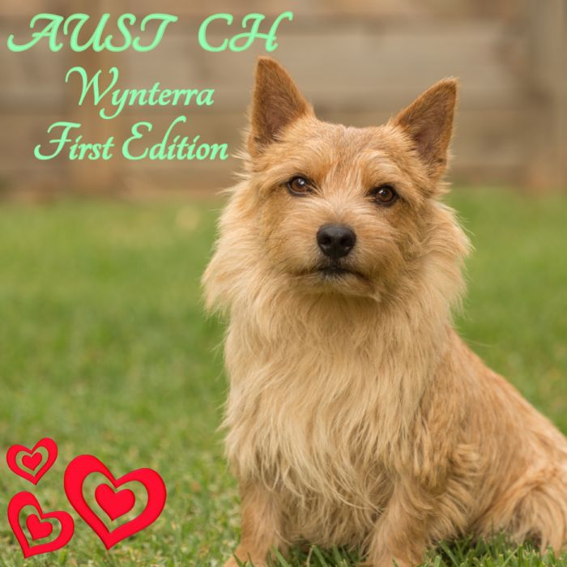
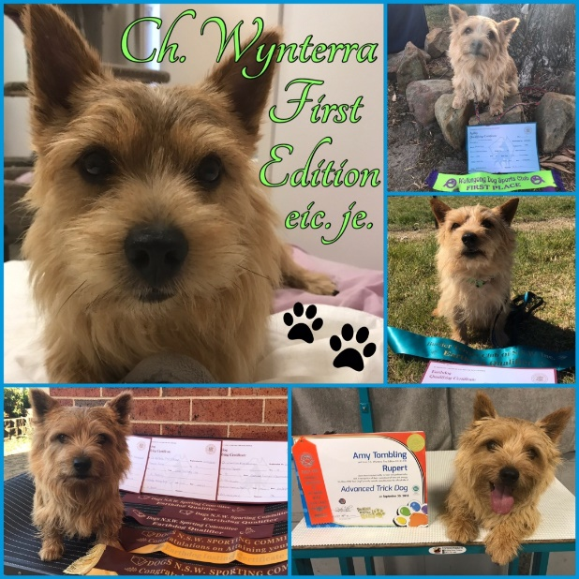
SCOTTISH TERRIER
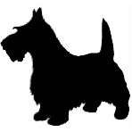
More than 200 years ago the highlanders in the Aberdeen area of Scotland began to develop
a terrier that could go to ground and hunt and kill the badgers, otters, foxes and rabbits that abounded in the cairns and mountainous terrain., This breed is now recognised as The Scottish Terrain but was originally called the “Aberdeen” or “Diehard”.

Ch Bescotted Legend of Zorro – “Zorro”

Zorro, Ch Bescotted Legend of Zorro, is from a lovely litter of puppies by BISS Ch Stuane Royal Myth and BISS Ch Macprain Marmalade. He is a joy to live with and is always up to mischief. His very first show he was awarded Best Baby Puppy in Show. It was a sign of things to come as since that first show has won many Class in Group, Best in Group 1st and 2nd, and classes in Show at both All breeds and Specialty Show levels. He is so much fun to show as he has lots of terrier attitude and beautiful conformation. He is still a young dog and I very much look forward to showing him as he reaches maturity and beyond and finding out the heights he can reach in his show career.
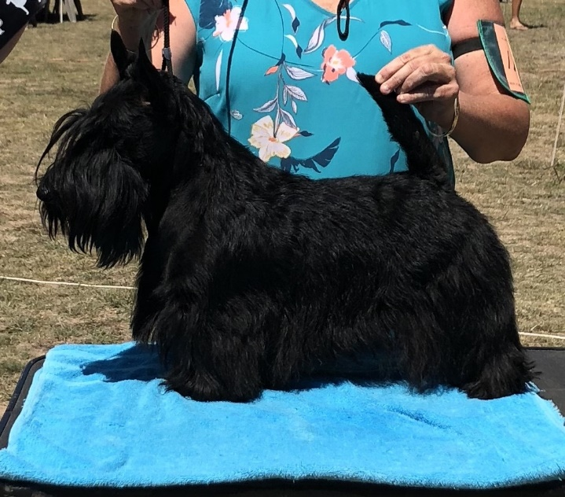
SOFT COATED WHEATEN TERRIER
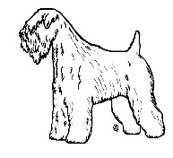
A native of Ireland, for many generations there was hardly a farm or small holding without it’s Wheaten! Loved and valued for his sterling qualities, he was used to herd cattle, pursue and destroy vermin and enjoy a day’s shooting in the company of his master. It is recorded that ehe Wheaten Terrier is the oldest Irish breed of Terrier.

Ch. Ardgaeithe Ballinbar Magnus

Ch. Ardgaeithe Ballinbar Magnus is our homebred boy from Wheaten Rebel lines via Aubrey, an accomplished Ballinvounig Irish imported sire adding to locally bred healthy wheaten lines and has proven himself in the show ring under breed specialists and international terrier specialists. Best of Breed at the Sydney Royal Easter Show Purina Dog Show under Terrier Specialist Ms Steeves (Canada) Critique: “BOB: Correct Size, lovely coat and colour. Beautiful balanced head, Excellent bite, Good Shoulder, Excellent ear placement and carriage, Very good tail set, correct angulation. Square dog with very good proportions and perfect size." He finished that day with Runner up Best in Show (to his sister!) at the SCWTB club of NSW Championship Show under Mr Haarto Stockmari (Finland).His show experience began with Baby puppy in Show and Group and progressed with winning State Puppy point score 2014 and 2015 Number 1 Australian Wheaten National Breed Leader in Breed Challenge competition and winning the Rywani Trophy in 2016, 2018 Awarded the Top Show Winning SCWT for N S W. It has continued with Best Dog (Dog CC) at the Annual NSW SCWT Specialty Shows 2016, 2017 and Open in Show 2018 and at the Victorian Specialty 2018 under breed specialist Mrs Susan Keely was RUBIS, Dog CC/Best Ausbred in Show and BOB Canberra Royal 2018., .All building from Runner up Best Dog at Sydney Royal 2015 and Puppy at Melbourne Royal ,Many Class in Specialty Shows and class in group, winning over prestigious breed competition locally and interstate. Most of all Magnus is a steady alert dog, good with children and reliable temperament and quick to hunt night creatures as a terrier should be and a delight in our home and a lovely example of the breed.
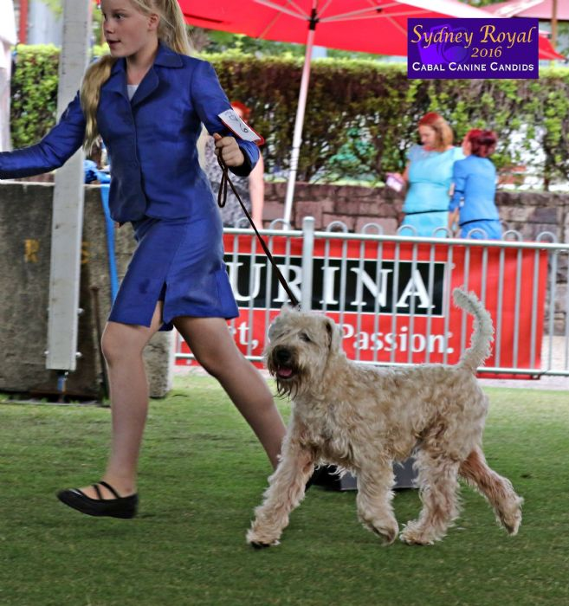
STAFFORDSHIRE BULL TERRIER
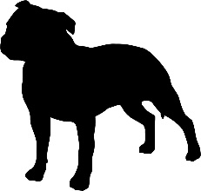
Older than the American Staffordshire and Bull Terrier, the breed originated in the “Black Country” of Staffordshire, England, home to famous potteries and coal mines. He is thought to be the original; “Bull Baiting” dog.

CH Highbourne Lonhro – “Derek”

Derek has been a consistent winner from baby puppy with many In Group and In Show awards. He was top male at Speciality Shows in 2017 and runner up in 2018.
Derek is a home bred dog and is always a pleasure to show, especially when his mother is on the end of the lead. Forever a Clown.

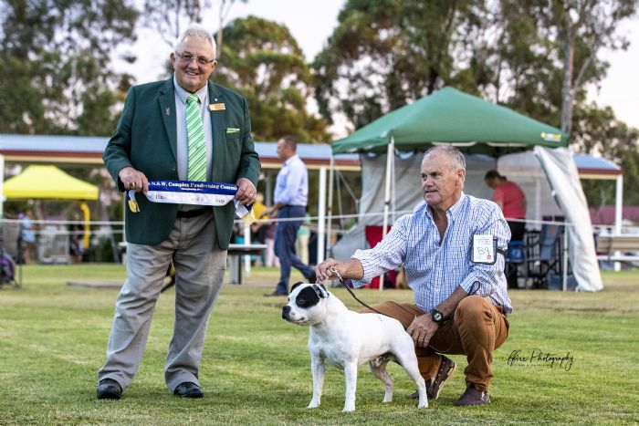
TENTERFIELD TERRIER
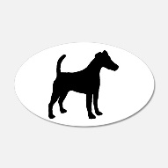
Developed in Australia, the forebears of the Tenterfield Terrier accompanied British settlers en route to Australia by ship. The forebears of these small dogs had been bred for ratting.
Grand Ch. Atenta Mista Wags – “Wags”
Grand Ch. Atenta Mista Wags was bred by Julie Spears and was born on 29th March, 2014. Seven months later Wags had enough points for his Australian Championship and was a Grand Champion at the age of 22.5 months. Wags has won over 40 age groups, including Puppy in Group at Sydney Royal in 2015. He has been awarded age groups in show, Runners Up to Best in Group and a Best In Group. Wags was Best of Breed at Canberra Royal in 2015 and 2017, and Best of Breed at Sydney Royal in 2016. He was the No. 1 Tenterfield Terrier in the Dogzonline Pointscore Show Dog of the Year Competition in NSW for 2014 and 2016, as well as No. 1 Tenterfield Terrier in the Breed Challenge Pointscore in NSW for 2015, 2016 and 2017. This is the fourth consecutive year that Wags has qualified for the British Terrier of The Year Competition. Wags has sired seven litters producing quite a few champions and remains a happy little chappy with a super-fast wagging tail. He loves to ‘strut his stuff’ and is a joy to show. I've had a hugely rewarding, enjoyable time showing this little fellow and his progeny, and I hope the incredible journey continues for a while to come.

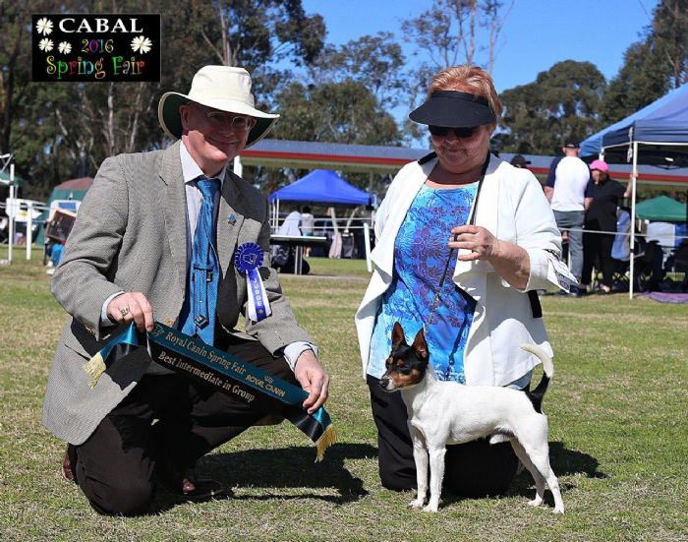
WEST HIGHLAND WHITE TERRIER
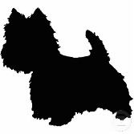
In the mid 19th century, Colonel Malcolm of Poltaloch developed a strain of good working terriers. The Colonel had accidentally shot one of his dandy coloured dogs and concentrated on breeding mostly whites, so they would be easy to identify on the moors of Argyllshire.

Ch Caspersz Creme of the Crop – “Brando”

Sire: NZ/Aust Ch Bocans Strictly Business for Whitebriar ( Imp UK)
Dam Ch Whitebriar Je Reviens (Imp NZ)
Only lightly shown to date Brando has held his own in the ring winning
Best in Show All Breeds
Multiple Class in Show
Multiple Best in Groups

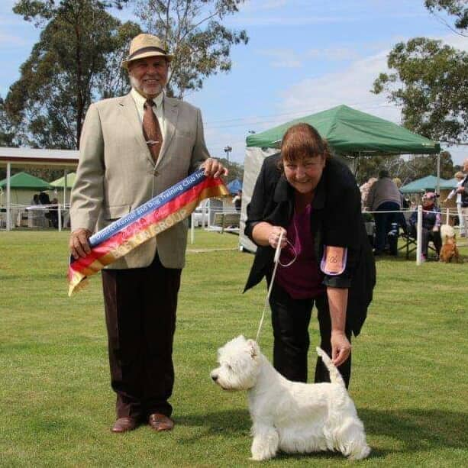
WINNERS FROM THE PAST

1982 - Scottish Terrier  Ch Aberdeen Fergus  W&C Goldsworthy | 1983 - Fox Terrier (Wire)  Ch/Am Ch Poncharelo of Anadare (Imp USA)  J Rowles | 1984 - Fox Terrier (Wire)  Ch/Am Ch Poncharelo of Anadare (Imp USA)  J Rowles
1985 - Sealyham Terrier  Ch/Eng Ch Torset Tomahauk (Imp UK)  A&E Walmsley | 1986 - Irish Terrier  Ch/Am Ch Aeriemars Riley (Imp UK)  A&E Walmsley | 1987 - Fox Terrier (Wire)  Ch Louline High Jack (Imp UK)  A&E Walmsley
1988 - Scottish Terrier  Ch/Am Ch Sandgregs Karate Kid (Imp USA)  Dennis/Lamping/Goldsworthy | 1989 - Australian Terrier  Ch Tahee Dirty Harry  Pieterse/Benyen | 1990 - Scottish Terrier  Ch Macprain Miranda  L Donoghue
1991 - Australian Terrier  Ch Tahee Dirty Harry  L Benyon | 1992 - Staffordshire Bull Terrier  Ch Southstock Pot Black  E Hargraves | 1993 - Staffordshire Bull Terrier  Ch Tykabul Cornelius Silk  T McGilvray
1994 - West Highland White  Ch Makaretu Diamond Lil  LK Brown | 1995 - West Highland White  Ch Makaretu Diamond Lil  LK Brown | 1996 - Irish Terrier  Ch Analuan Top Gunn  Liz Walmsley
1997 - Jack Russell  Carisbrooke Bogart  LK Brown | 1998 - Bull Terrier  Ch Rijacia Romulus  J&P Puffet | 1999 - West Highland White  Ch Whitebriar Just my Guy  LK Brown
2000 - West Highland White  Ch Whitebriar Just my Guy  LK Brown | 2001 - West Highland White  Gr Ch Whitebriar Just my Guy  LK Brown | 2002 - Bedlington Terrier  Ch Breckland Golden Eye  Wells/Crew
2003 - Fox Terrier (Wire)  Ch Cwmgarews Jet Setter (Imp UK)  W Brown | 2004 - Australian Terrier  Ch Enomis Hes all Right  Withers/Freshwater | 2005 - Norfolk Terrier  Gr Ch Nanfan Calamus  Hindley/Rasmusen/Baker
2006 - Fox Terrier (Smooth)  Ch Woodshack War Path  D&ABowe | 2007 - Fox Terrier (Wire)  Wariglaire Rumourising  D Geoghan | 2008 - Norfolk Terrier  Gr Ch Bricken Red Diamand  E Hindley
2009 - West Highland White  Ch Whitebriar Just Pucka  (Imp NZ)  LK Brown  2012 – West Highland White  Ch Whitebriar Just My Guy  LK Brown | 2010 -Sealyham Terrier  Ch Chalan Make My Day  D & H McPherson  2013 – Jack Russell Terrier  Ch Whatajack Grand Elegance  G Butler | 2011 – Scottish Terrier  Ch Raglan Rear Admiral (SWE) K Ferguson, L Rose  2014 – Jack Russell Terrier  Ch Whatajack Fire Fly  G Butler
2015 – West Highland White  Ch White Villan I Put A Spell On You (Imp FI)  LK Brown | 2016 – Am Ch, NZ Ch, Sup Ch  Hampton CT Broxden Pinnacle You Cheddar Believe It (Imp NZ)  J & L Rowles & G Whitfield & S Evans | 2017 – Am Ch, Sup Ch Clayco High Mtn Rattlin Bones  P Mills, B Mills, Mrs E Knight & Mrs T Dennis
