**Breeds of East Asia Dog Club**

**ACT**

**February 2025 Raffle**



We are lucky enough to have been given one of these amazing dryers from

DGS Imports to raffle before they are even available to purchase here in Australia (available early 2025). To be drawn on Sunday at the Canberra Royal 23rd Feb.

***K-9 III Variable Speed Dog Dryer – Blue***

Description:

* *The****K9 iii variable speed****dog dryer is known as a true powerhouse in professional dog grooming circles and by far and away from the****most powerful blower****in the K-9 dryer line.*
* *We have received reports that state the variable speed iii pet dryer cuts dog drying time in 1/2! That means grooming your pet is faster and easier.*
* *With adjustable airflow speed that allows the user to get as little or as much dryer power as they need. Choose this powerful and versatile variable speed pet dryer to make grooming your dog a breeze.*

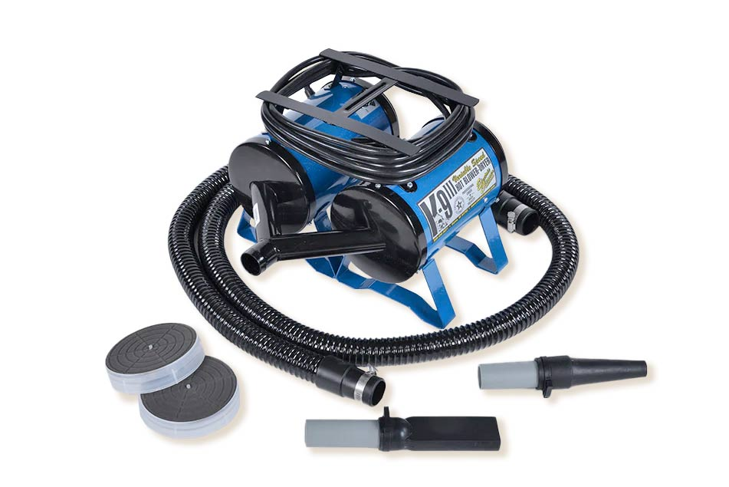Price (Retail): $1,390

Specifications:

* 18 Guage Steel Body
* Variable speed
* Two 923 Motors
* 25lbs
* 17” (L) x 16” (W) x 11” (H)

Included:

* Dryer
* 10 Foot High-quality Hose
* 2 Air Intake Filters
* Flat tip Dryer Nozzle
* Round tip Dryer Nozzle
* Includes 2-year manufacturer Warranty

Tickets are $10 each or 3 for $25 and are available on show manager, by direct deposit Bendigo Bank BSB 633000 Acc 158298216 (send confirmation email) or by contacting the club breedsofeastasiadogclubact@gmail.com