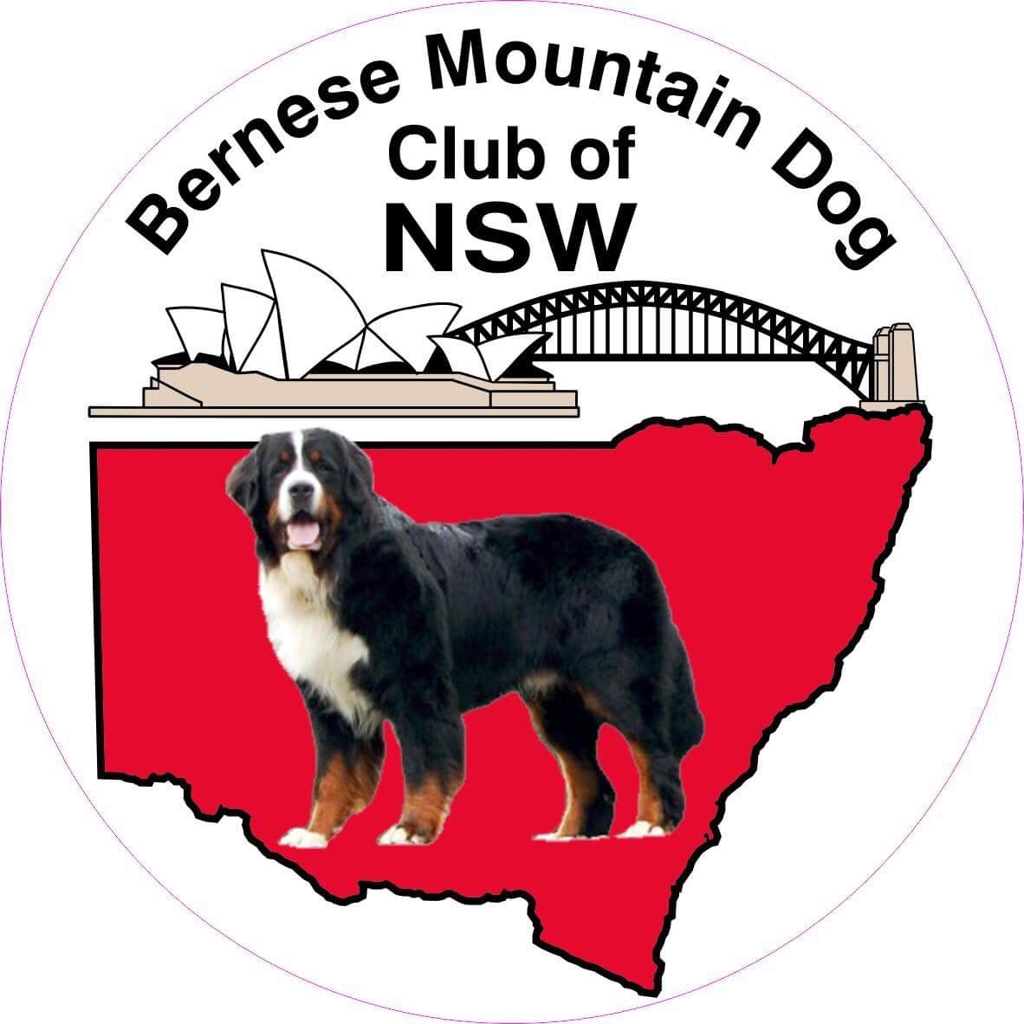
(Affiliated with DOGS NSW)

Membership Application / Renewal
2023 (1 July 2023 to 30 June 2024)

Renewal – Only require your name and signature unless your details have changed.

Name/s …………………………………………………………………………………………

ADDRESS: ……………………………………………………………………………………...

……………………………………………………………………….Postcode ………………..

Telephone (Home) ……………………………… (Mobile) …………………………………..

Email address …………………………………………………………………………………..

DOGS NSW (or equivalent) Membership Number …………………………………………

Kennel Prefix (if applicable) …………………………………………………………………...

I/We wish to apply for / renew membership of the Bernese Mountain Dog Club of New South Wales (the Club) and agree to abide by the constitution of the Club.

Signed: ……………………………………………………

Date: ………………………………

Signed: ……………………………………………………

Date: ……………………………….

Membership Annual Fee:Single$20, Double/Family$30, Associate(Interstate) $15

BMDCNSW Bank Account Details: BSB 062622 Account Number 10521007

Email: bmdcnsw@outlook.com.au Web: www.bmdcnsw.com

Details of Member’s Dogs

Pet Name | Pedigree Name | M/F | D.O.B

