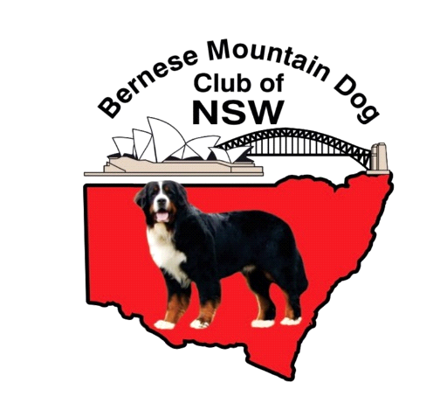
BERNESE MOUNTAIN DOG CLUB OF NSW
MINUITES OF THE ANNUAL GENERAL MEETING
Friday 3rd October, 7.05 pm via Zoom

- Present: Lyn Brand, Murray Fisher, Vanessa Hodgson, Steve Cable, Trish Cable, Melissa Murray, Michael Murray, Steve Wesselink, Zoie Talbot and Sandy Wesselink.

- Apologies: Lyndel Porter

Moved by Zoie Talbot and seconded by Steve Wesselink that the attendances and apologies be accepted. Carried

- Minutes of the 2024 Annual General Meeting.
Circulated to all members prior to the meeting.
Moved by Murray Fisher and seconded by Melissa Murray that the minutes be accepted as a true and accurate record. Carried

Business arising: Nil

- Committee Reports:
  - President’s Report – Lyn read to meeting – Moved by Steve Cable and seconded by Melissa Murray that the President’s report be accepted. Carried

  - Secretary’s Report – Sandy read to meeting - Moved by Lyn Brand and seconded by Melissa Murray that the Secretaries report be accepted. Carried

  - Treasurer’s Report – read to meeting – Audited End of financial year balance at Bank $3,364.50.
- Further payment to be made:
$833.00 for tents used at show (subsidised by those using the tent)
- Further income:
$50.00 Donation
$30.00 membership
Moved by Melissa Murray and seconded by Steve Wesselink that the Treasurers report be accepted. Carried

- General Business:
  - 2026 Championship show - The meeting discussed the options for our 2026 show. It was agreed that we need to change our date to move our show away from other Bernese Specialities and Royal Shows.

The meeting agreed that the Club should investigate the opportunity to hold our show at the same time as the Spring Fair. This would attract entries as it would allow entry to at least 3 shows and our Speciality.

It was moved by Zoie Talbot and seconded by Steve Wesselink that the club request a permanent change of date to the Spring Fair weekend from Dogs NSW. Carried

The Committee is to meet in approximately one month to discuss further details of show.
5.2 Donation – Zoie advised that she has a donation of $150 to be included in the bank balance.

Election of Office Bearers
The Committee vacated their positions and the Secretary performed the role of returning officer. The following nominations were received:
Position | Nominee | Nominators
President | Lyn Brand | STEVE CABLE  TRISH CABLE  MURRAY FISHER  MELISSA MURRAY  MICHAEL MURRAY  STEVE WESSELINK  SANDY WESSELINK
Vice-President | Murray Fisher | STEVE CABLE  TRISH CABLE  MELISSA MURRAY  MICHAEL MURRAY  STEVE WESSELINK  SANDY WESSELINK  LYN BRAND
Secretary | Sandy Wesselink | LYN BRAND  STEVE CABLE  TRISH CABLE  MURRAY FISHER  MELISSA MURRAY  MICHAEL MURRAY
Treasurer | Steve Cable | TRISH CABLE  MURRAY FISHER  SANDY WESSELINK  LYN BRAND  MELISSA MURRAY  MICHAEL MURRAY
Committee | Michael Murray  Melissa Murray  Vanessa Hodgson  Steve Wesselink  Trish Cable  Lyndal Porter – Nominated, not present to accept nomination  Zoie Talbot  Tina Flint  Stevie Flint | STEVE CABLE  TRISH CABLE  MURRAY FISHER  LYN BRAND  SANDY WESSELINK  STEVE WESSELINK  STEVE CABLE  TRISH CABLE  MURRAY FISHER  LYN BRAND  SANDY WESSELINK  STEVE CABLE  TRISH CABLE  MURRAY FISHER  SANDY WESSELINK  STEVE WESSELINK  LYN BRAND  MELISSA MURRAY  MICHAEL MURRAY  STEVE CABLE  TRISH CABLE  LYN BRAND  MURRAY FISHER  SANDY WESSELINK  MELISSA MURRAY  MICHAEL MURRAY  STEVE CABLE  MURRAY FISHER  SANDY WESSELINK  STEVE WESSELINK  LYN BRAND  STEVE CABLE  TRISH CABLE  MURRAY FISHER  SANDY WESSELINK  STEVE WESSELINK  LYN BRAND  MELISSA MURRAY  MICHAEL MURRAY  STEVE CABLE  TRISH CABLE  MURRAY FISHER  SANDY WESSELINK  STEVE WESSELINK  LYN BRAND  MELISSA MURRAY  MICHAEL MURRAY  LYN BRAND  MURRAY FISHER  SANDY WESSELINK  STEVE WESSELINK  LYN BRAND  MELISSA MURRAY  MURRAY FISHER  SANDY WESSELINK  STEVE WESSELINK  LYN BRAND  MELISSA MURRAY

It was moved by Steve Cable and seconded by Murray Fisher that all present accepted their nominations.
There being no further business, the meeting closed at 7.35pm.

