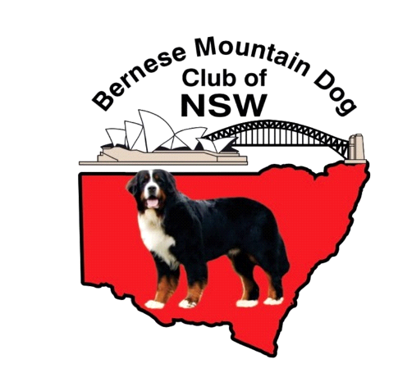
BERNESE MOUNTAIN DOG CLUB OF NSW
ANNUAL GENERAL MEETING 2025
To be held on Tuesday 13th October, 2026 7.30 p.m. via zoom
VIA ZOOM MEETING
Please join using the following link: Join Zoom Meeting

https://us06web.zoom.us/j/85472172078?pwd=lDdAKyI5LAqSbP8hKKFJrre9BGp9wn.1
Meeting ID: 854 7217 2078
Passcode: 445840
AGENDA
- Attendance

- Apologies

- Minutes of the 2025 Annual General Meeting

- Committee Reports
  - President’s Report
  - Secretary’s Report
  - Treasurer’s Report

- Election of Office Bearers and Committee

- Special Business – Notices of motion

