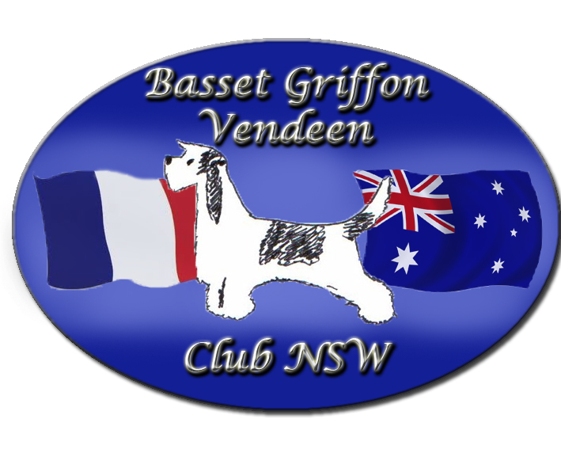
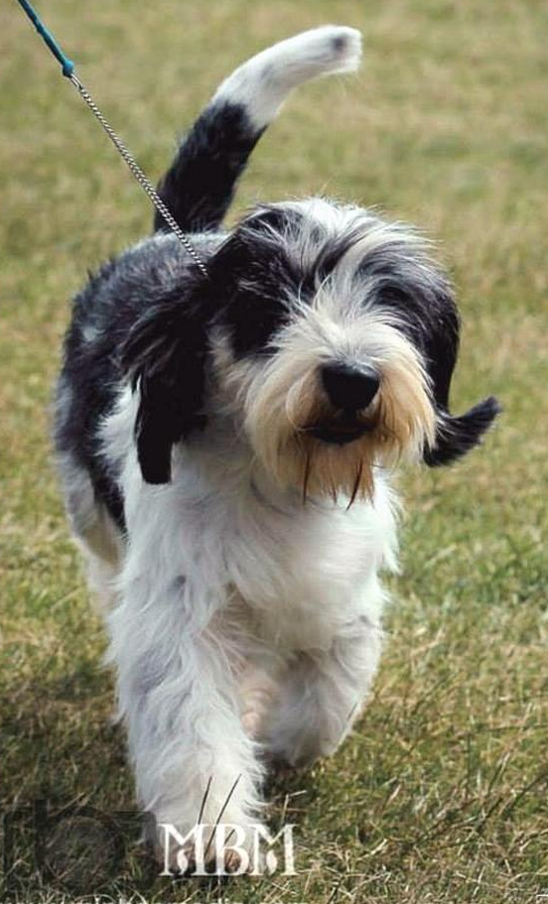
Newsletter Number Eleven
Winter 2014

The Basset Griffon Vendeen Club of NSW
President : Robert Lauder  Vice President: JannelleTremenheere  Secretary : Claire Parker  Email : lafoliepbgv@yahoo.com.au Ph: 0249436275  Treasurer: Yvonne Lauder  Membership Secretary: Jane Quinn | Editor & Publicity Officer: Michelle Parker Brien  Email : mbrienparker@yahoo.com Ph: 02 49436275  Committee:  Yvonne Lauder  Michelle Lauder.  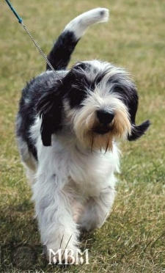  Jo Meadows  Michelle Parker Brien  Jane Casperson Quinn  Cover photo  Hershey on the move
STOP PRESS

Congratulations
To : The Rokeena PBGV Breeder Team
Best Breeder Team in Show – Adelaide Royal
Well done Robyn and Russell – a proud moment for a breeder
The team was made up of
Darcy – Sup Ch/NZ Gr Ch Rokeena Garcon Reveur
DJ – Ch Rokeena St Louis Blues
PARTY – Rokeena I m a Party Girl
RODNEY ROCKET. – Rokeena Hot Topic
Robyn said afterwards ,”To say I am one of the proudest breeders at the moment is an understatement. I am indebted to Shellie Marshall the rest of the team for steering the kids to this great win. I think what makes it so special to me is after 14 years in the breed, this team was made up of dogs from 4 different litters.
All had home bred Rokeena sires and dams. Beginning in a new breed with a rare Breed is not easy, but to see the fruits of your labour acknowledged by 3 different judges is enough to make you excited.
Once again thank you girls without you this would not have happened. As an aside, Darcy lead the team and was the sire of two of the other team members who were out of his first two litters.
I will wipe the tears away now and have another glass of bubbles.

Contents
The Basset Griffon Vendeen Club of NSW 2
Congratulations 2
From the Editor 4
BGV Hound Facial expressions 4
Puppy Owner membership- only $5 6
Membership Renewals Due 6
Whelping Slurry 14
Cute Baby Photos 14
Batman vs Peebs 15
CH Goldtreve Reymundo 16
Brisbane Royal Results 18
Adelaide Royal 19
Overseas News 20
From Europe 20
From the USA 22
From the UK 22
Asia 23
Face Book Groups 23
Point Score results 24
North of the Harbour 20th July 2014 24
Australian Show Results 26
New Home required for PBGV 28
Why PGBV’s are Special 28
Dogs on Show 29
Grand Puppies 29
Liver Treat Cake 30
Hounds On the Run 30
The Basset Griffon Vendeen Club of NSW 32
Membership Application Form 32

From the Editor
In this issue we have Reports from both Brisbane and Adelaide Royals, latest show news and a smattering of news from overseas.
There is a good news story for the clubs first rescue PBGV and the very sad news of the death if one of our new members from a sudden and aggressive form of cancer. RIP Sharyn Riding
Membership renewals are overdue and we ask all members to renew as soon as possible. We are only a very small club and we very much need the ongoing membership in order to survive.
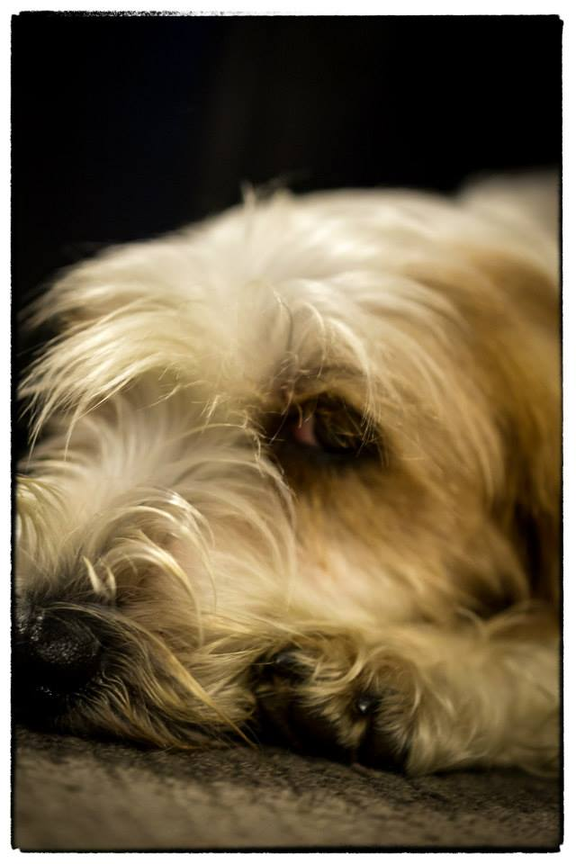
All members are reminded of the clubs $5.00 Puppy membership which breeder can use for all their new puppy buyers. This will provide 12 months membership for all puppy buyers and if breeders can do this with every litter they breed it will help our membership enormously.
Since the last issue the club has had a Breed Stand at the Dogs NSW Dogs on Show day to promote purebred dogs to the general public. A report on this day is also included
As usual I have stolen shamelessly from Face Book and other websites and I thank those members who have wittingly or unwittingly provided me with news and information for this issue.
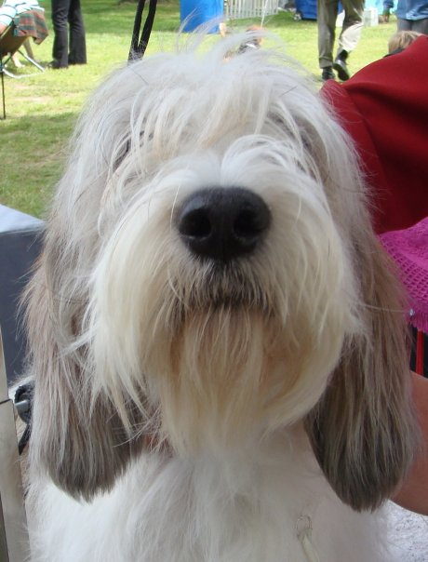
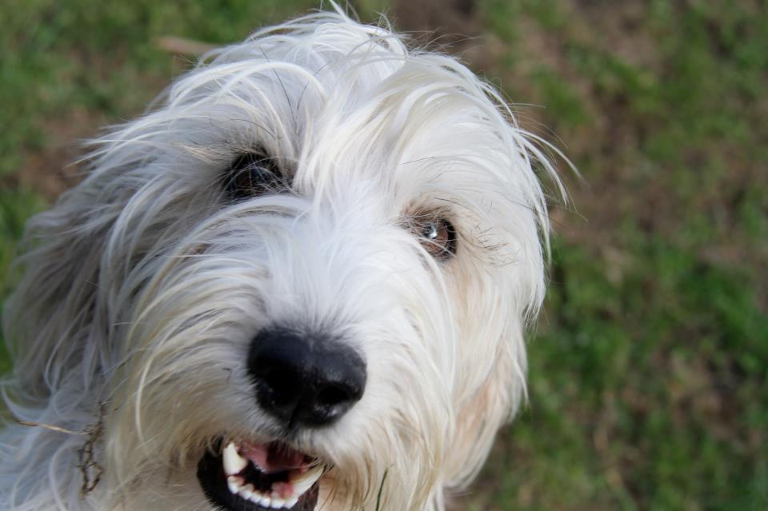

BGV Hound Facial expressions

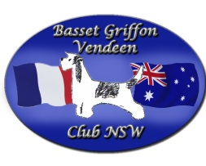
The Basset Griffon Vendeen Club of NSW
General Meeting
24th of June 2014 Riverstone RSL Club
Meeting Opened 7:30pm
Present: Robert Lauder, Yvonne Lauder, Michelle Lauder, Claire Parker, Kylie Delacourt
Apologies: Jane Quinn, Helen Stanford, Michelle Parker-Brien, Jannelle Tremenheere, Beryl Hession, Jo Hession
Minutes of last meeting Presented by Claire Parker, Moved by M Lauder, Seconded by Y Lauder. Passed.
No Business arising.
Treasurers Report.
Yvonne has had difficulty switching over to this role as she still does not have access to the account. Claire reported that the paper work had been completed, and this issue should be fixed soon.
The bank account has $1862 in it. Kylie Delacourt moved that Yvonne pay all of the outstanding accounts as soon as she has access to the account, seconded M Lauder. Passed.
Show Business
Claire presented a 2014 Show report. Moved Y Lauder, seconded R Lauder. Passed
2015 Show.
- C Parker moved that we hold the show at Castle Hill again. Seconded K Delacourt. Passed
- Judges: Y Lauder nominated Mr N Bryce-Smith of the UK on the proviso that he be approved to judge GBGV’s as well. Seconded K Delacourt. Passed.
- C Parker to check on his availability, cost and approval.
- Y Lauder moved, that if Mr Bryce Smith was not available or appropriate, the following judges by considered as replacements: Mrs N Ruik (Ire), Mr W Poole (USA), Mrs D Duffin (Vic), Mrs B Tophill (Vic) Mrs J Croad (QLD). Seconded C Parker. Passed.
- Claire to inquire about these judges availability depending on the availability of Mr Bryce Smith.
- General conversation also agreed that we should try to organise our 2016 judge earlier to try and get an overseas specialist.
Sydney Royal
- M Lauder moved that we request PBGV’s and GBGV’s to be judged on the Wednesday or Thursday prior to Good Friday. Seconded C Parker. Passed.
- Claire to write to the RAS.
- International Health Committee
- R Lauder nominated Robyn Wallis to be our Representative on the International Health committee. Seconded C Parker. Passed.
- Claire to complete relevant paperwork.
New members: Claire nominated Heather Notting, Sharyn Riding and Madeline Shanahan. Seconded by K Delacourt. Passed.
Claire to put notice in next newsletter about $5 Puppy Owner membership.
Pointscore
Michelle Parker Brien submitted outline for the pointscore. Y Lauder moved that we accept her rules submission for breed points only. Seconded K Delacourt. Passed.
Y Lauder moved that the following shows be included
- North of The Harbour – July 2014
- Hound Club of NSW– October 2014
- Hound Club of NSW – April 2015
- Hunter Valley Hound Club – May 2015
- Southern Region Hound Club – June 2015
Claire is to select an appropriate show in the Western Region
Seconded M Lauder. Passed.
Claire to advertise schedule of shows ASAP and request Michelle Parker Brien to record results.
Correspondence
- Letter from J Quinn Re: Resignation
- Letter from Dog Lover’s Show
Business arising from Correspondence:
- Yvonne and Claire to take over Membership Secretary role
- Will not take part in Dog Lover’s Show this year due to the large scale commitment required.
Fundraising
- Claire moved we hold another 100 Club or Best In Show Sweep. Seconded K Delacourt. Passed. Claire to organise.
- M Lauder moved we hold a Bunnings BBQ as these can earn $1000 + in one day. Seconded K Dealcourt. Passed. Yvonne to request a date.
Any Other Business
AGM Date to be decided when Treasurers situation has sorted out.
Meeting closed 9pm

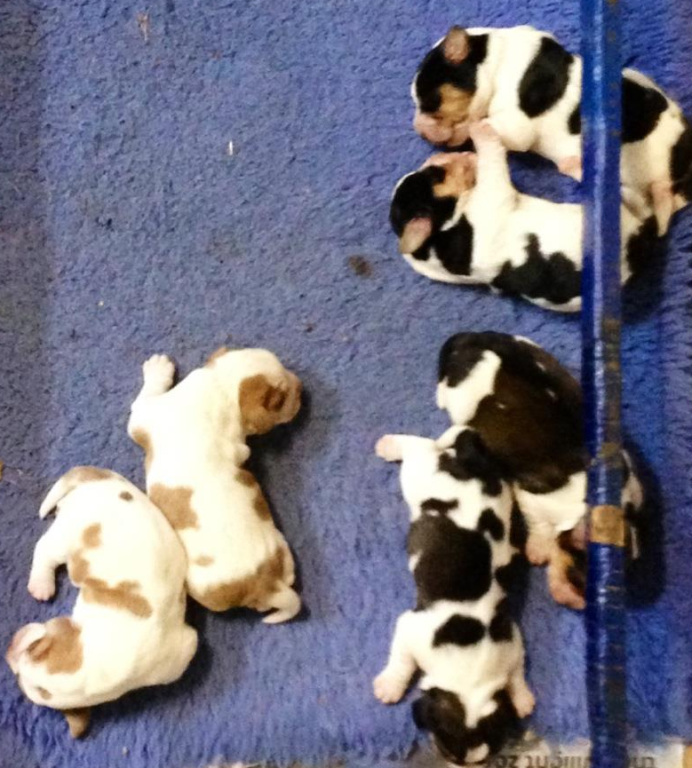
Puppy Owner membership- only $5

As a small club we are always in need of new members.
In order to promote this the club has a Puppy Buyer membership of only $5.00.
If you are a breeder and have a litter of puppies you can provide 12 months membership to the club for each puppy buyer, for the low cost of $5.00.
Each new puppy buyer will get 12months membership, including the club newsletter and membership to the BGV Club of NSW FB page.

Please keep this in mind when you sell your pups. Members do not have to live in NSW but can be anywhere in Australia or even overseas. .
The membership form is available on the last page of this newsletter and can be printed off for each new puppy buyer.
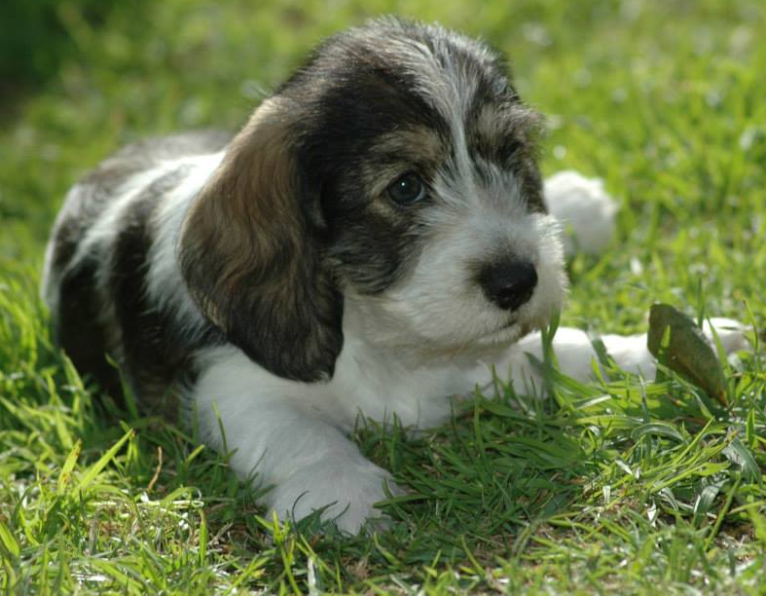

Membership Renewals Due
All members are asked to renew membership as soon as possible if you have not already done so.
We need your ongoing support if the club is to continue. We are only a small club and we need as much support from members as possible to help us promote out lovely breeds.
Please complete the membership form at the back of the newsletter and return to the Secretary

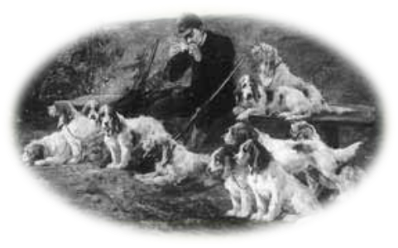
Vendeen Views and News
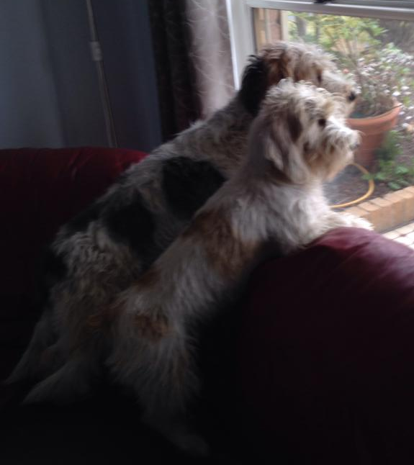
RIP Sharyn Riding. Sadly our club lost one of its newest members at the end of August.
Sharyn and her family owned a GBGB, Monty and a PBGV, Saffy.
Sharyn had previously had breast cancer and thought she had successfully beaten it as she had been free of it for over 2 years .
Then in June she was diagnosed with it again and despite intensive radiation treatment she lost her battle on August 29th.
Our thoughts and sympathy go to Sharyn’s husband and daughters at this time of sorrow.
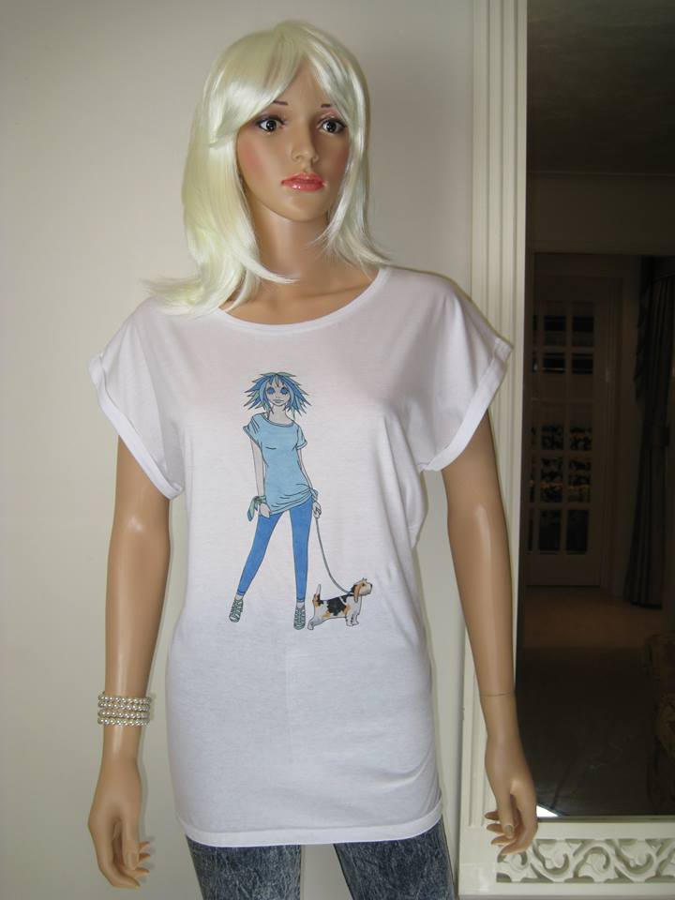
BGV Fashion Statements For anyone wanting some fashion with the hounds featured the link below has been discovered with T shirts featuring the breeds. The company is called Faithful Friends - Different dog designs Alice Brands Tops & Tees . It is a UK brand and can be found by following the link below
http://www.etsy.com/uk/shop/AliceBrands
http://stores.ebay.co.uk/Alice-Brands
http://www.alicebrands.co.uk

Richard Tries landscaping
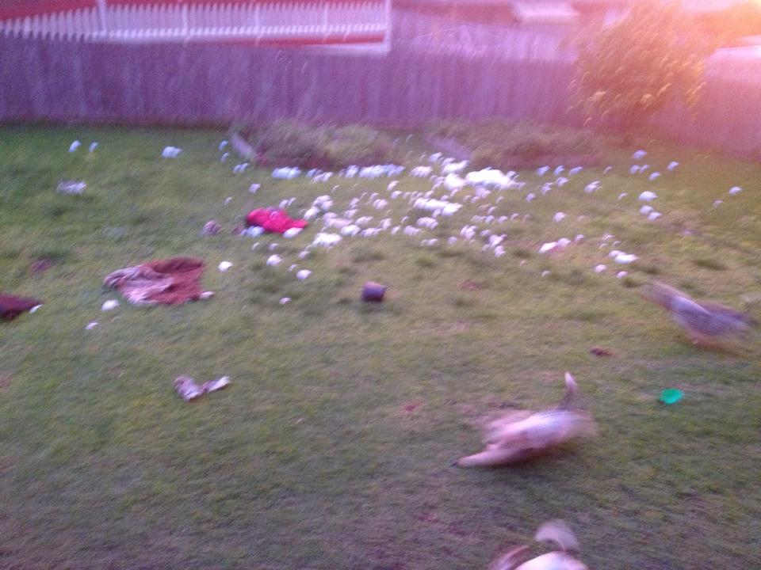
Heather Notting had a surprise when she returned home to find that her PBGV, Richard had decided to enhance the back yard in her absence. Richard had made such a good job of shredding the spare bed that Heather thought she had come home to snow.
She has decided that he wins the award for the best in backyard hound after his effort.
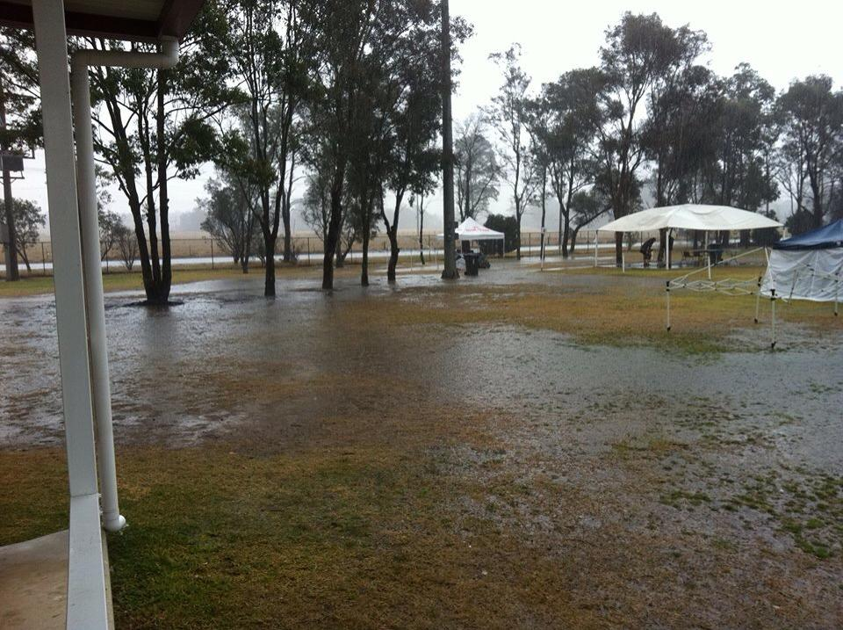
Robyn Wallis is getting a reputation as a drought breaker. On August 17th she was judging in Sydney at the Dog Complex at Orchard Hills- an area known to be very dry.
The day she arrived to judge was one of extremely heavy rain and the show grounds were under water.
As Robyn said, “ Sorry Sydney!!! Hurricane Robyn strikes again!!”
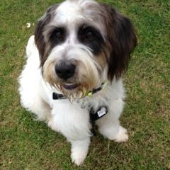

Happy Ending for club’s first Rescue PBGV
It was a happy ending for Snoopy when his foster carers Ash and Wade decided to keep him to join their PBGV family.
On July 21st, Claire Parker advised the club of a PBGV who was at the Yagoona RSPCA. He was not microchipped or desexed and had been originally surrendered at Port Macquarie RSPCA.
Claire was able to speak to his previous owner’s sister who advised that he had already been surrendered on an earlier occasion and had been adopted from a pound in the Port Macquarie region.
She told Claire that the dog was friendly and outgoing but had some anxiety issues and car sickness. Anxiety is not uncommon in a dog that has been surrendered on 2 occasions and has not had a permanent home.
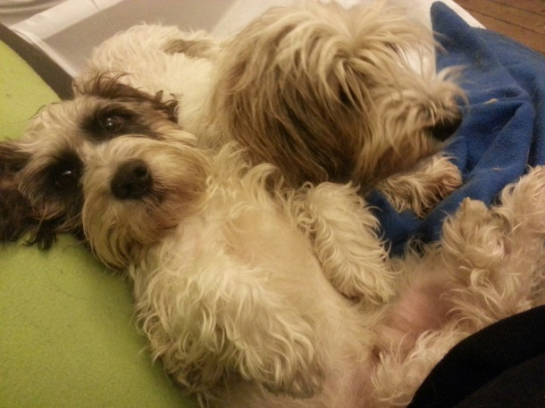
Claire had been advised that the PBGV was about 18month to 2 years old, and has previously been called Snoopy and Griff.
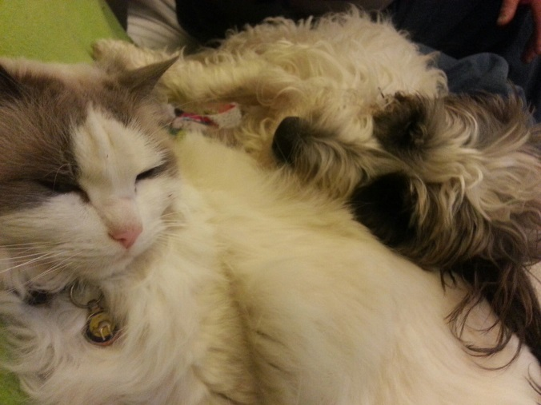
Negotiations with the RSPCA led to a successful outcome. On July 25th the club's Rescue Officer, Yvonne Lauder collected him from the RSPCA and club members Ash and Wade Lewis, offered to be his foster carers. They picked him up from Yvonne that afternoon.

Ash and Wade, on September 1^{st,} , gave him a positive report saying that he was doing well and has settled in well. "He is still very much a puppy in his behaviour and sometimes causes a little bit of trouble (don’t all PBGV’s) and he eats everything including his Kong toys. However, he is a quick learner and he is very affectionate and eager to please. He has made friends with their other PBGVs, Bosley and Izzy , and their cat Woody who he adores, as can be seen in the photos .
He has settled in so well that Ash and Wade decided to keep him and give him a chance of a permanent and loving home.
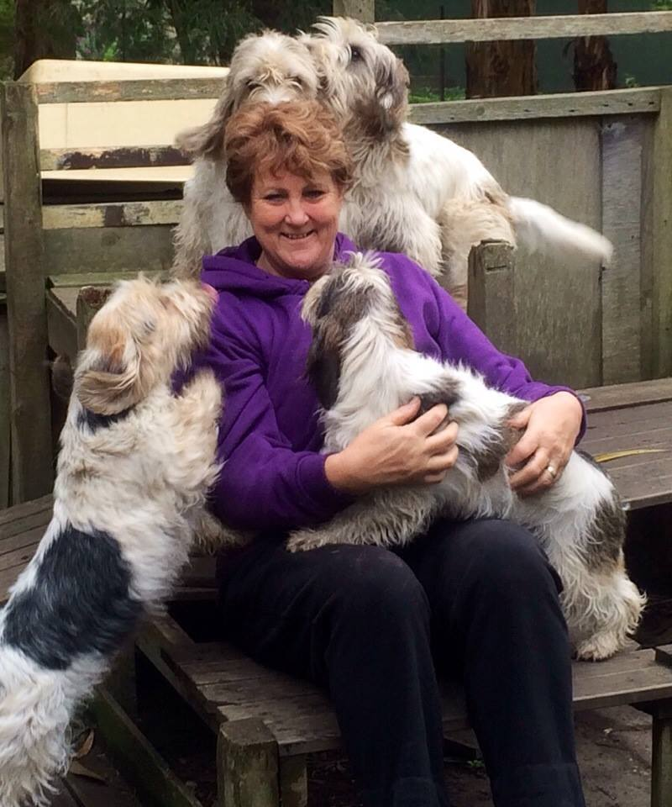
Thank you to all our members who acted so promptly to save Snoopy. It was a team effort and the club can be proud of the quick response and the happy outcome.

Nothing like being loved by a pack of PBGVs
Robyn Wallis enjoys the enthusiastic love of some of her hounds. So nice to feel so loved!!
She said “Of course I know if a rabbit ran passed I would be dropped like a hot cake!!!! “

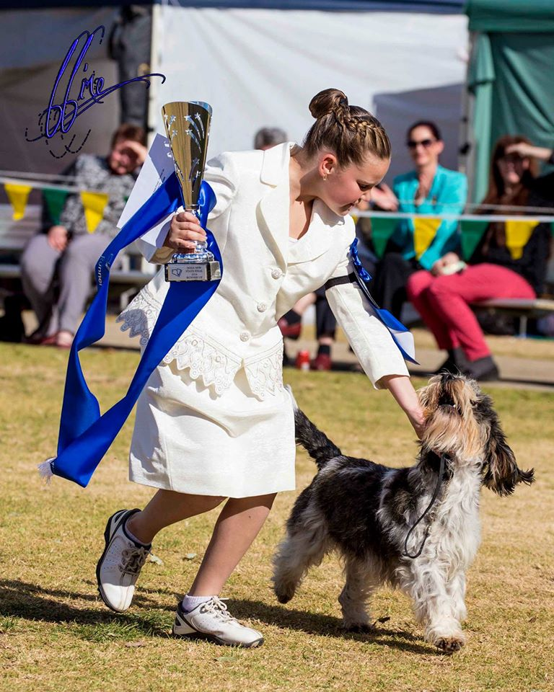
PBGV helps win State Child Handlers
Beryl and Jo Hession’s girl ,Pheobe ( Ch Rokeena Nutz about Snickerz) and Tanara Craig were stars at the recent State Child handlers competition held in NSW.
Nine year old Tanara was in the youngest group of handlers (7 – 10 yrs) and not only won her age class but also went on to win Runner Up State finalist.
A tough job for anyone, but always harder when you are up against older and more experienced competitors.
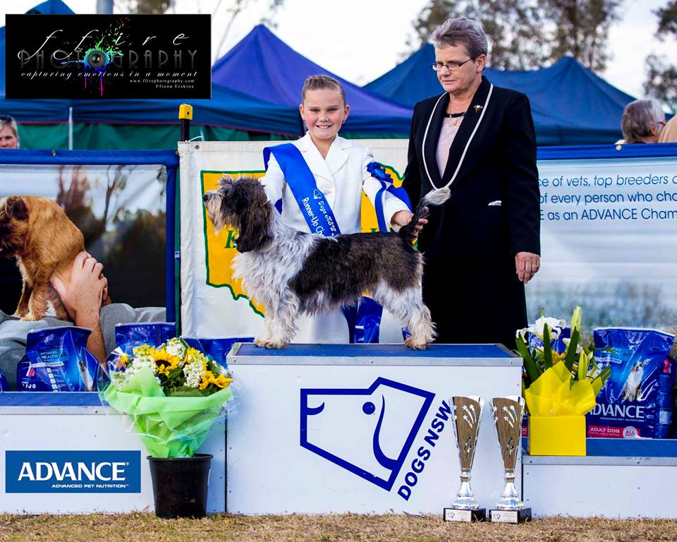
As can be seen from the photo, Pheobe, loved every minute of the experience.

.

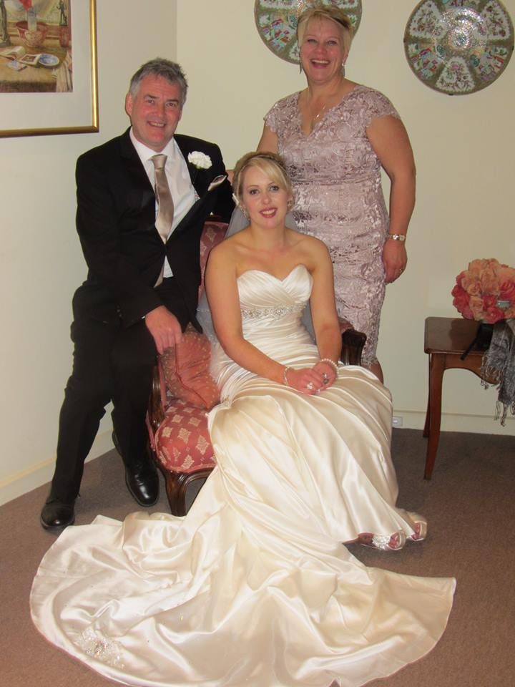
Congratulations to Kristy Knowles who married Luke Allen on 22nd August 2014.
Kristy and her mother Jackie have been members of the club since its inception and brought the well known, Ir Ch Switherland the Outlaw , with them when the family moved to Australia from Ireland.
After the wedding, Kristy and Luke honeymooned at the Gold Coast.
We wish them every happiness in their future life together

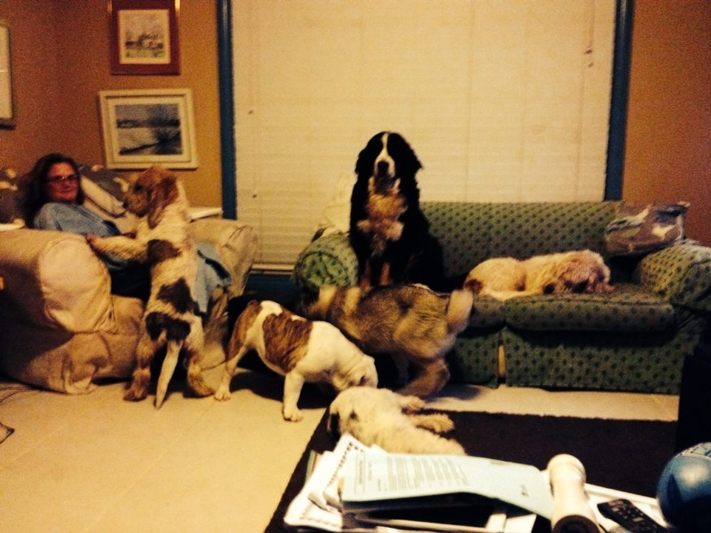
At Jane Casperson Quinn’s house, only visitors and old ladies get to sit on the sofa, although the Grands and the rest of the gang look very happy to sit on laps, if given the opportunity

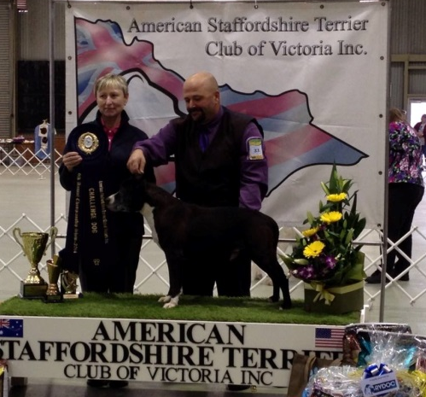
As well as handling wife, Jane’s GBGV’s, Andrew Casperson also has a love of the bull breeds.
In June his retired boy, Supreme CH Bellamon Lakota (Cas), at the age of 12 years old, came out in the Veteran class to win Runner Up Best in Show at the Victorian AmStaff specialty at KCC Park .The judge was breed specialist Hana Brezinova (Czech) of Tipit Z Hanky Amstaffs

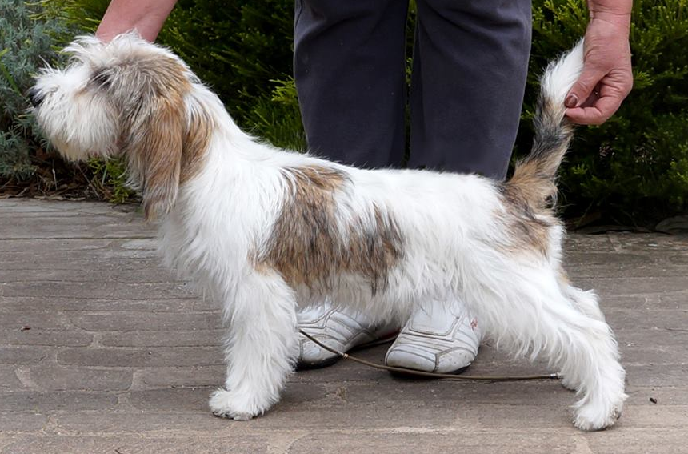
Three pups from Robyn Wallis’s Irish litter have been having success in the show ring in 3 different states of Australia.
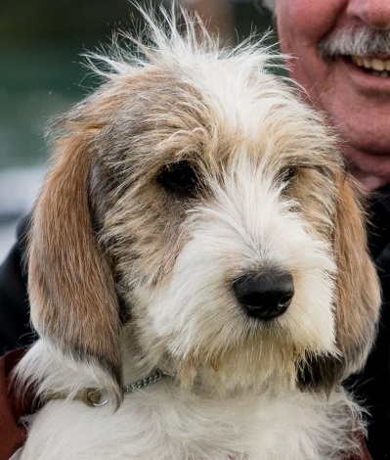
In Victoria, Rokeena Molly Malone,Tinkerbell,owned and shown by Marsha Uphill, won Baby in Group
Tinkerbell
In South Australia,Mr Nialls, Rokeena Kiss Me Im Irish,
Mr Nialls
owned by Jeff and Jill Tassell, has won a Baby in Show and in Queensland, Giggles, Rokeena Irish Laughter , with Marion Rowley is also doing well in the ring.
Giggles
In fact this as been a very international litter and an example of the co operation that exists between breeders fro the benefit of the breed.
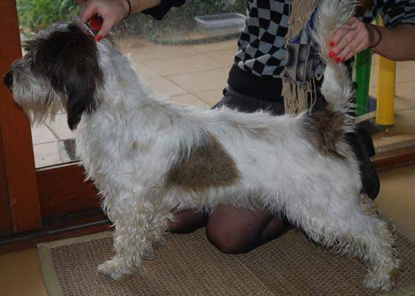
The mother of these pups is an Irish bitch , Tilly, from Clonellan kennels in Ireland. She was the pet of Madeline Shanahan and her family who moved to Australia from Ireland.
Tilly doing her first ever show stand
Madeline is the cousin of club secretary, Claire Parker. Claire was not in a position to breed from her, but thought that her bloodlines were too valuable to lose in our very small gene pool so she suggested that Madeline get in touch with Robyn Wallis- and the rest – as they say is history.
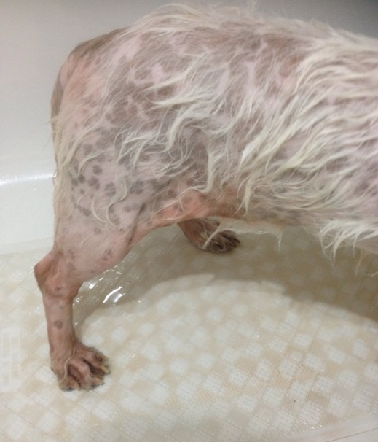
In the last issue of the newsletter I recounted the story of a bitch puppy that Jo and Beryl Hession had sent to an exhibitor in Tasmania to be shown. This young girl was returned to them in a terrible state of neglect, with barely any hair on her legs and body.
Photo of Pana when she was returned to Jo and Beryl
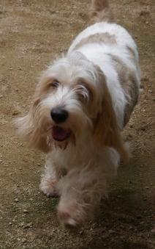
I am pleased to say that this story now has a happy ending. After love and care, Jo and Beryl were able to build her back up and she has now gone to a new home where she is very much loved and treasured.
She is now called Pana and is the loved pet of Sumie Tamori in Japan where she is getting the care that she deserves.
Pana after love and care, enjoyin g herself in her new home
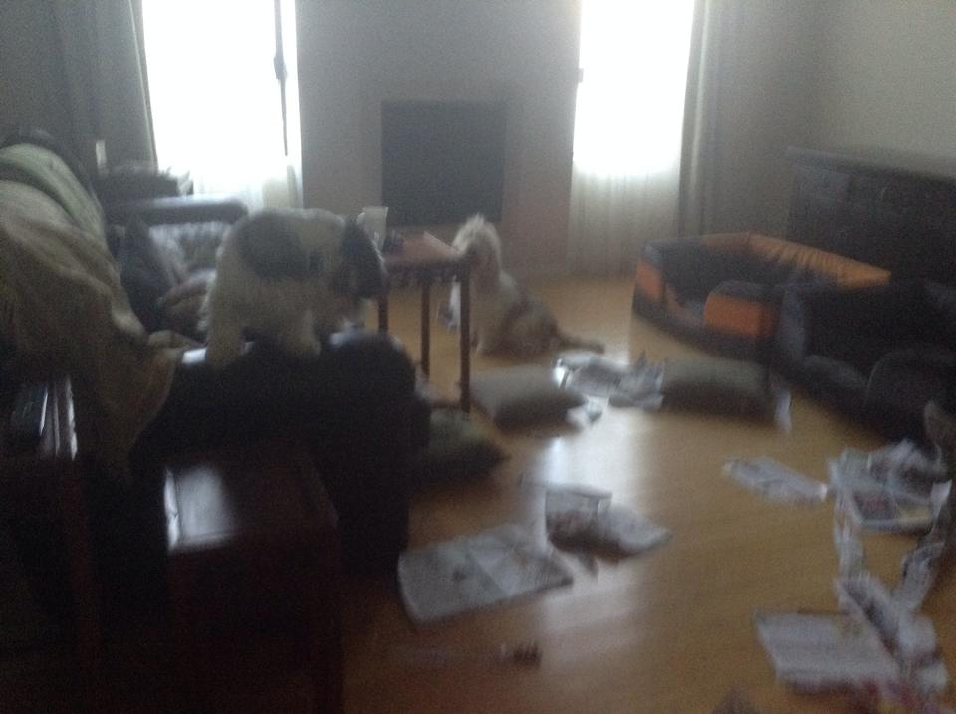
As can be seen in the photos she is now a happy girl with a beautiful coat, kept in top condition.

Maureen Thomas thought that she would stay in bed just that little bit longer – her PBGVs had other ideas and decided to try interior design. Somehow I don’t think that their designs will catch on

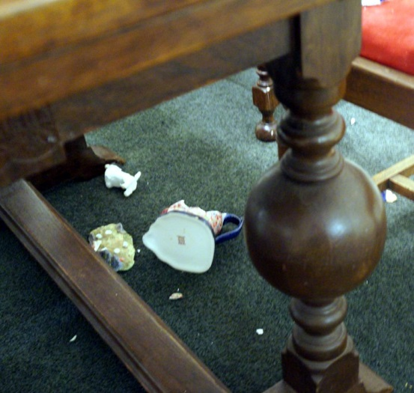

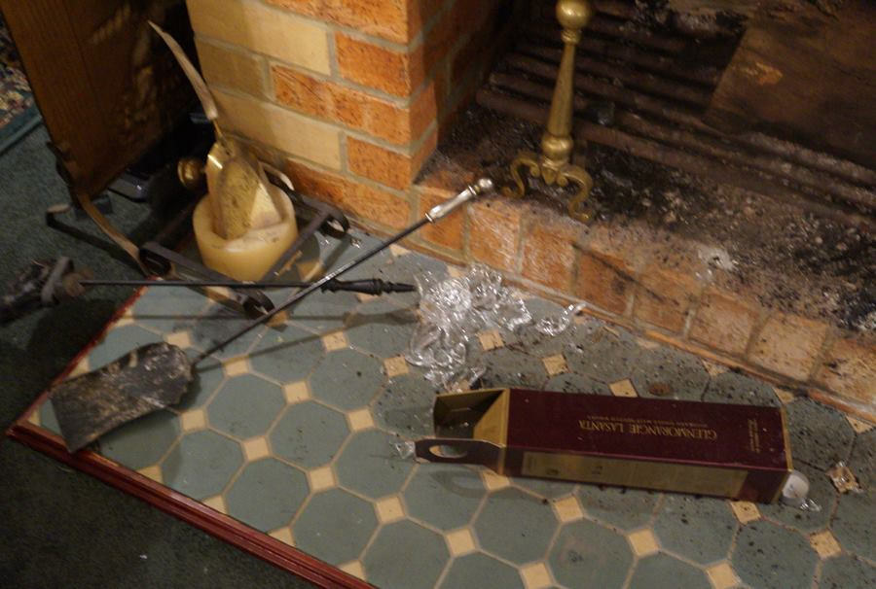
Robyn Wallis thought that she had a poltergeist in her house when she heard things smashing in the living room and came out to find a picture of chaos and destruction.
Glassware and china had been thrown to the floor and smashed.
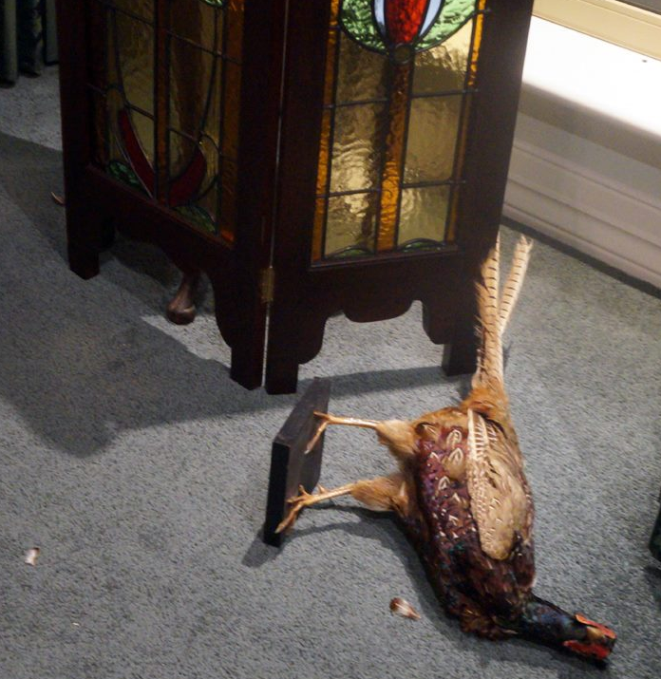
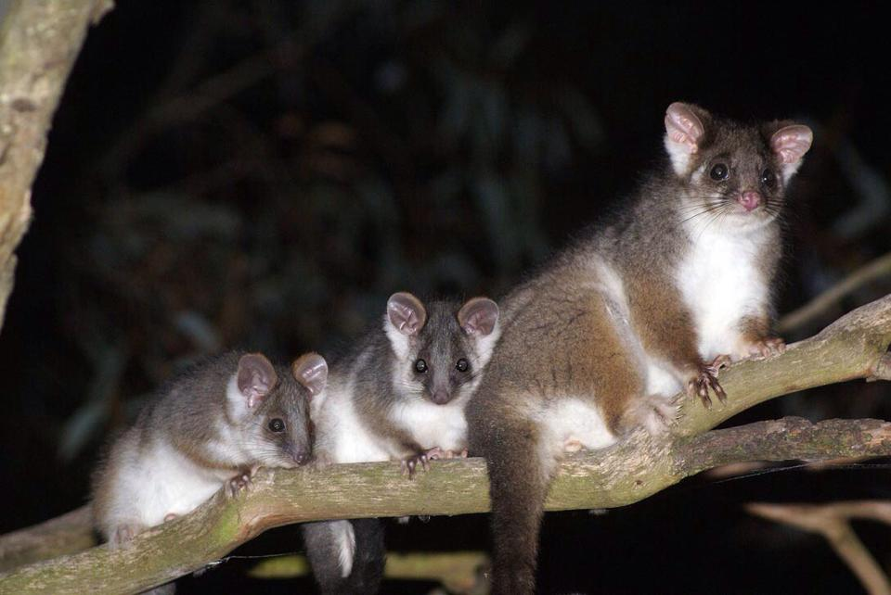
When they looked n to the room they couldn’t see anything but when they left the room they could hear the sound of more things smashing.
Then they saw the culprit – a rampaging possum!!!!
And Mrs Possum enjoyed her visit so much that she returned the next night and brought her whole family with her to share the visit.

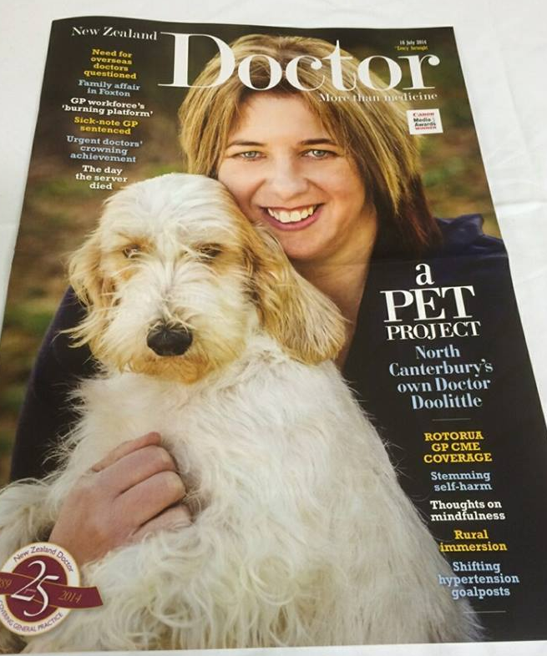

Doctor and PBGV breeder and owner, Robyn Hay from Canterbury in New Zealand, took up photography earlier this year. She has taken some amazing and beautiful shots from various places around New Zealand
Now she is a magazine star as well. Robyn and PBGV (of course) feature on the front of a NZ medical magazine described as North Canterbury’s own Dr Doolittle.
Below are some of the photos Robyn has taken
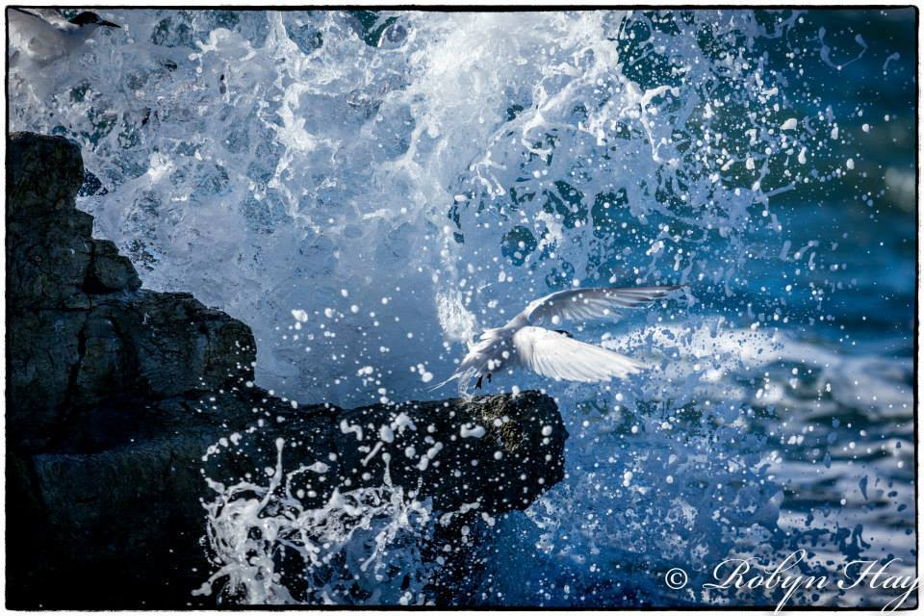
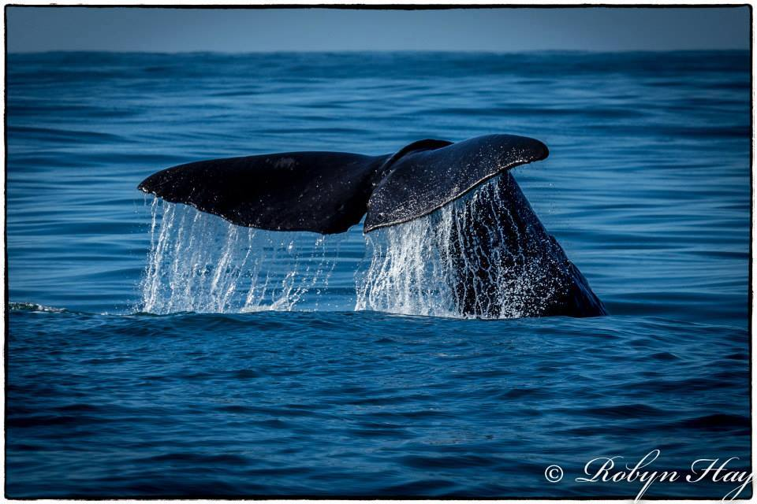

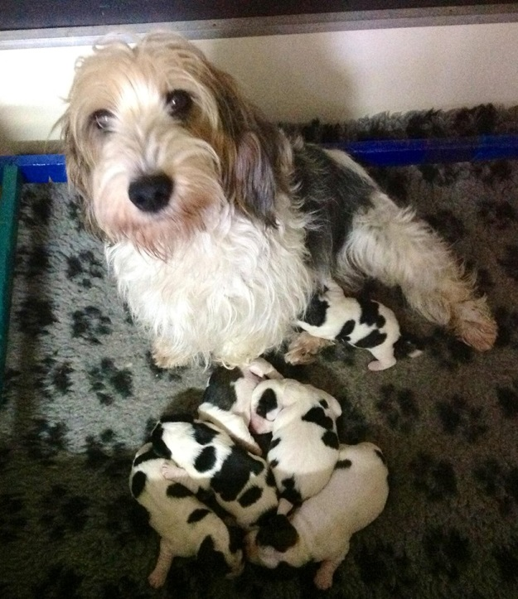
Whelping Slurry
This mixture is said to be ideal to give to bitches while in labour as it is said to give them energy to help with labour. I haven’t tried it myself but it looks as if it cannot do any harm.
Ingredients
1 heaped Tablespoon of full cream vanilla icecream
2 teaspoons of full cream yoghurt
2mls of Lectaid concentrate
Half a Citracal+D Tablet crushed
Instructions
Mix well and start giving after the second stage begins and in between puppies.
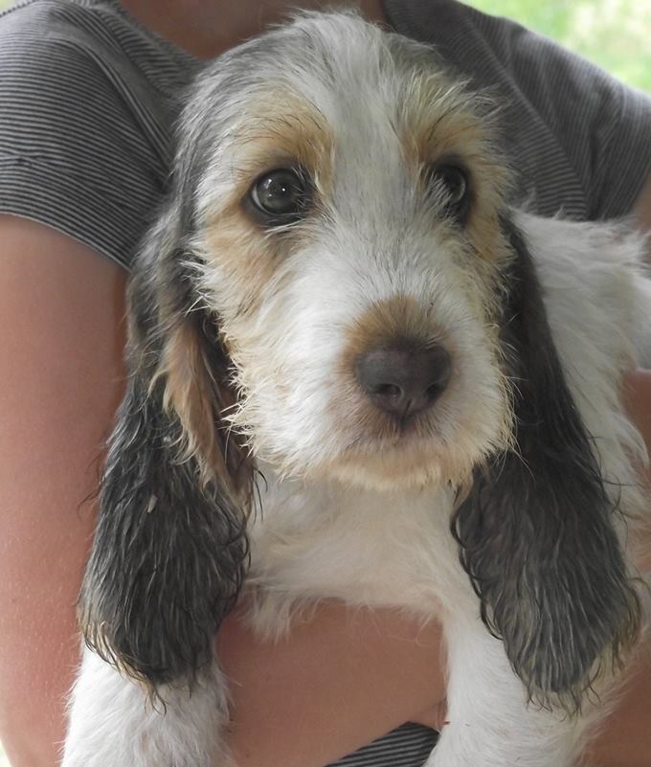
You will have to adjust the amounts for the larger breeds and make enough to last for the full whelping. This really helps the babies wake up as well.

Cute Baby Photos

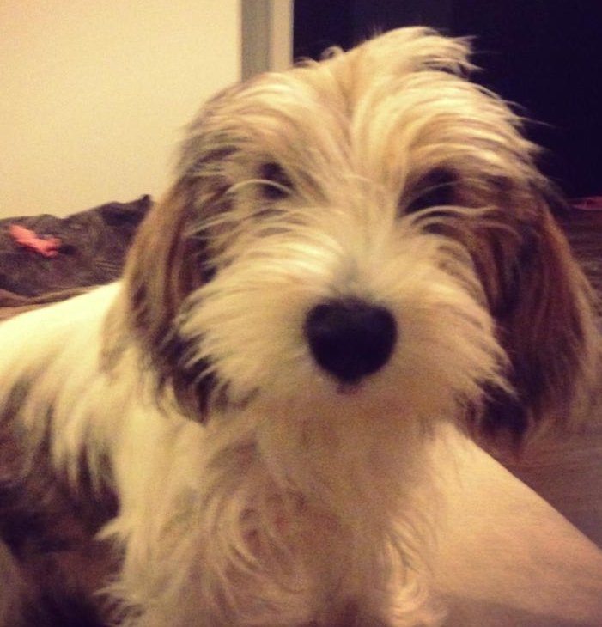

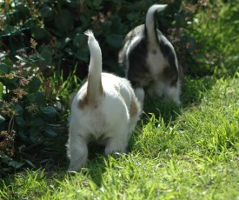

Batman vs Peebs
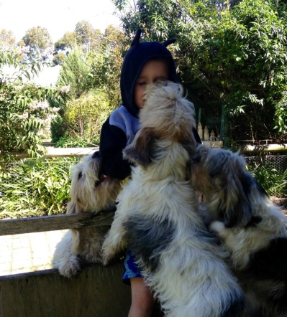
This is the pictorial story of Batman, fighting off a pack of way too friendly PBGVs.

Once upon a time there was only 1 then, 2, then 3 and 4 PBGVs all determined to lick Batman.
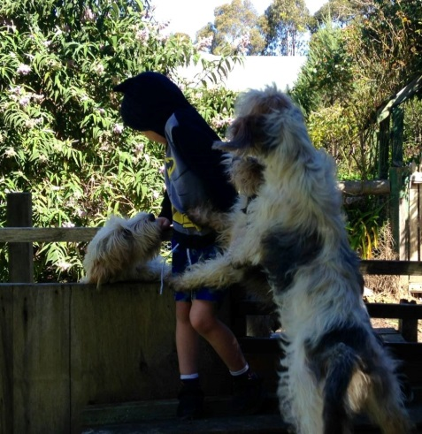

Batman fought bravely ….
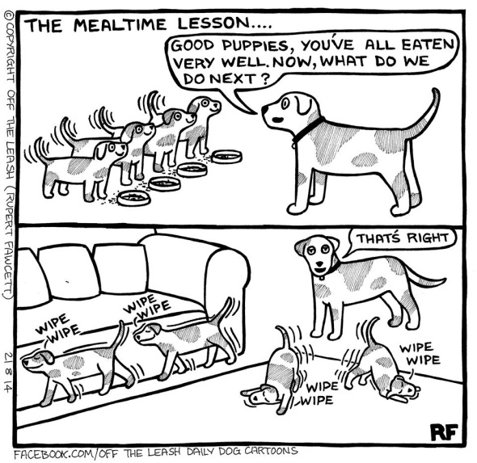

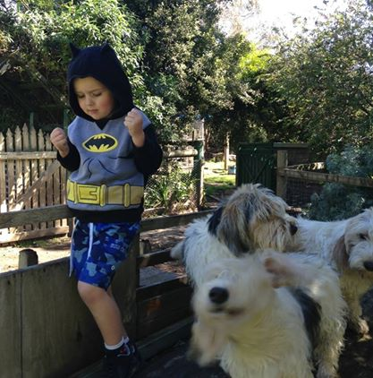
…and then finally subdued them. (Thanks to Robyn Wallis)

Abby has a new friend

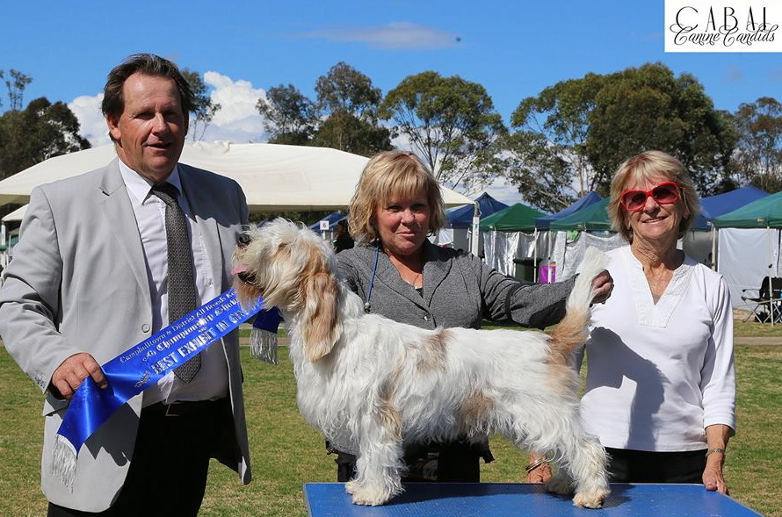
CH Goldtreve Reymundo
Beryl and Jo Hession have been having a wonderful time with their young homebred boy Mundo.
He is from their first ever PBGV litter and has had a fabulous run of success in the show ring from the time he entered the show ring.
He has rarely been out of the Group wins and has had 25 classes in Group & 15 Classes in Show.
He topped it all off with a Best in Show win and 2 Runner Up in Show awards in August when still under 13 months of age.
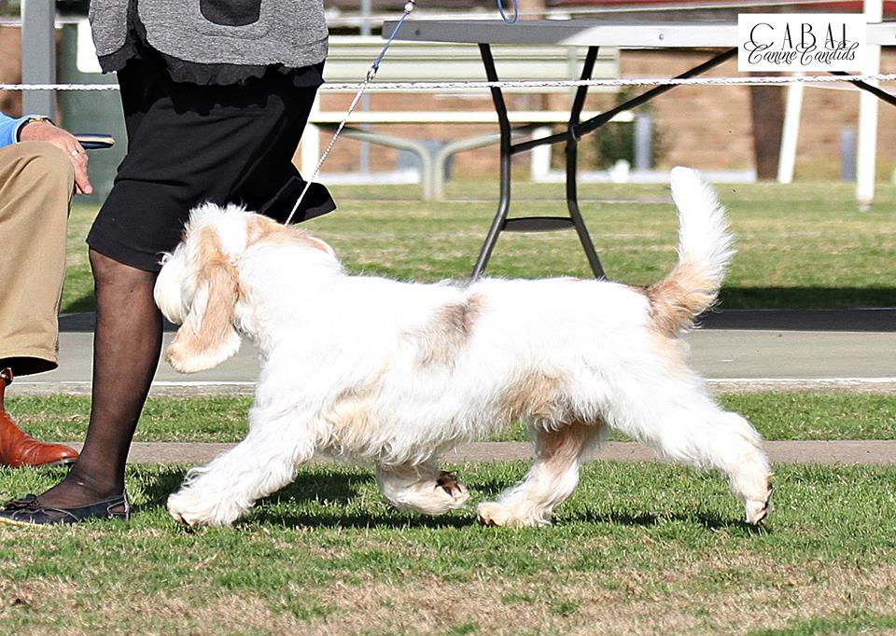
His wins include:
9/5/14 RUBIG Hawkesbury D.Ag Soc
25/5/14 RUBIG Ku-ring-gai KC
15/6/14 RUBIG Brisbane Water Legacy
28/6/14 RUBIG Warners Bay Dog Club
29/6/14 BIG Blaxland & Glenbrook RSL Show
6/7/14 RUBIG Hawkesbury KC Show A
10/8/14 BIG Tullamore K.C
11/8/14 BIG Tullamore KC
12/8/14 Best In Show Tullamore K.C
13/8/14 RU B In Show Peak Hill P & A Soc
15/8/14 BIG Port Stephens Dog Sports Club
16/8/14 RU B In Show Hunter Valley Hound Club NSW
17/8/14 Best In Show Port Stephens Dog Sports Club
20/8/14 RU B In Show Peak Hill PA & H Assoc
24/8/14 BIG Campbelltown & DABKC
He gained his title at 10 months of age and at the present time he is the No. Rising Star NSW All Breeds and No 2 All Breeds Aust.(DOLPS).
Beryl and Jo must be understandably of his achievements.

Brisbane Royal Results
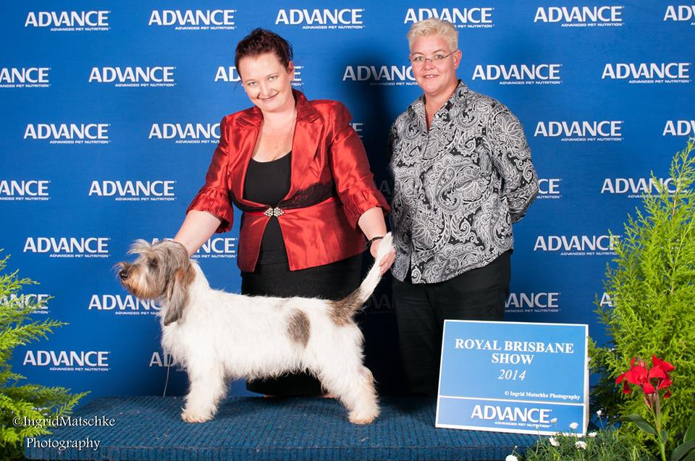
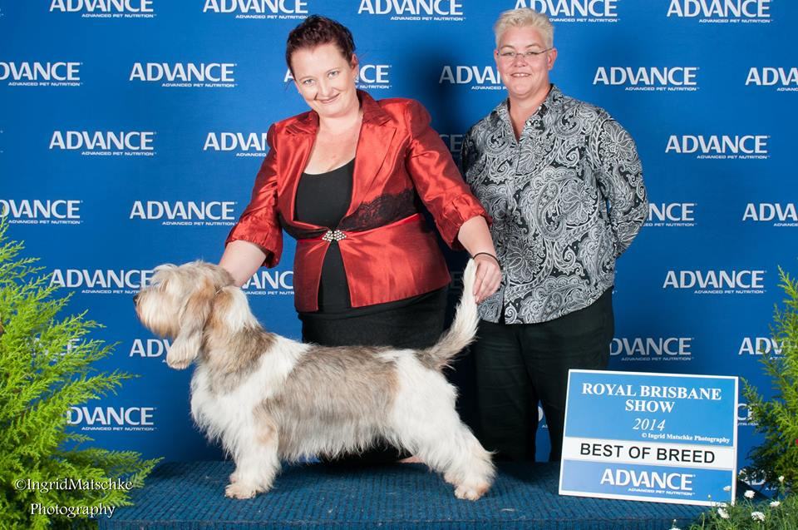
Petit Basset Griffon Vendeen
BEST EXHIBIT OF BREED
Cooney, Amanda -CH. BONDESTIN RIGHT ON THE KISSER

RUNNER UP EXHIBIT OF BREED
Cooney, Amanda-CH. BONDESTIN IM TO SEXY

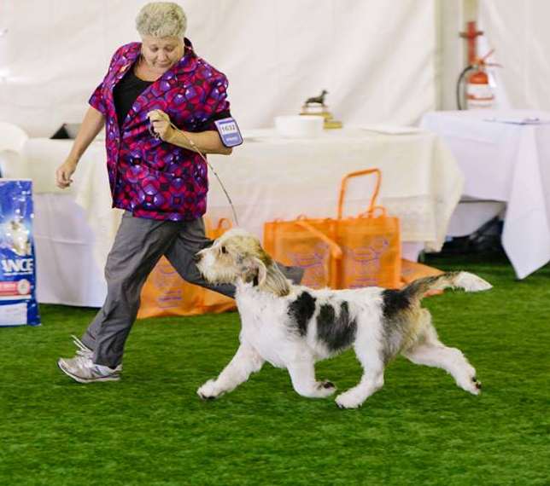

Grand Basset Griffon Vendeen

Best of Breed
Harnett, Jacky CH. RICKABY BOUND FOR GLORY

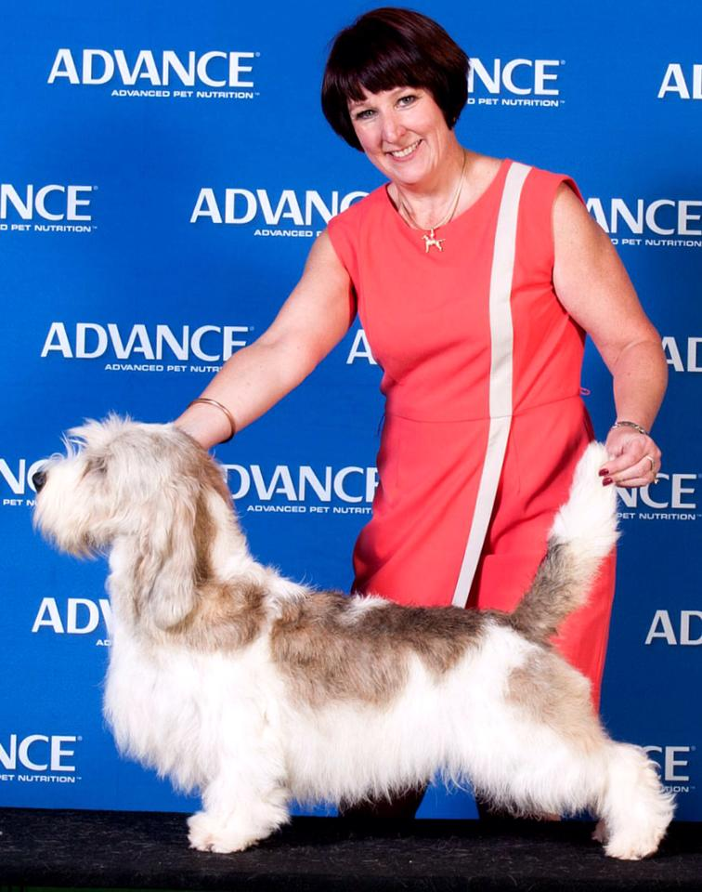
Adelaide Royal
Best Exhibit In Group- 4th and
Best of Breed & DCC- NZ Gr / Aust Sup.Ch Rokeena Garcon Reveur
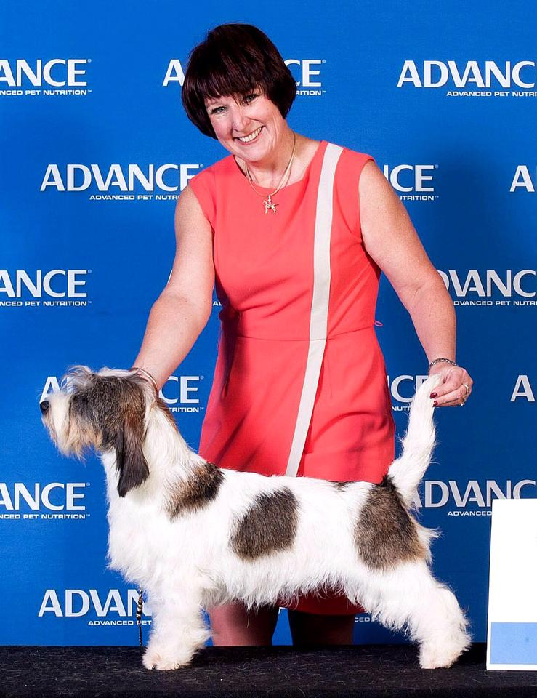

Runner Up Best of Breed and Bitch CC- Rokeena I'm A.Party Girl
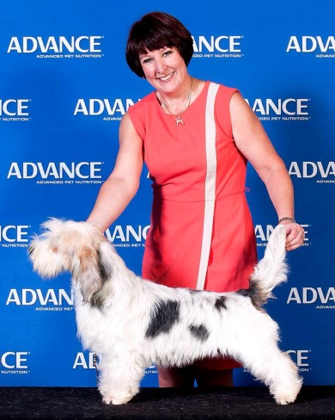

Re DCC and Puppy of Breed - Rokeena Hot Topic

Res BCC – Ch Rokeena Extravaganza

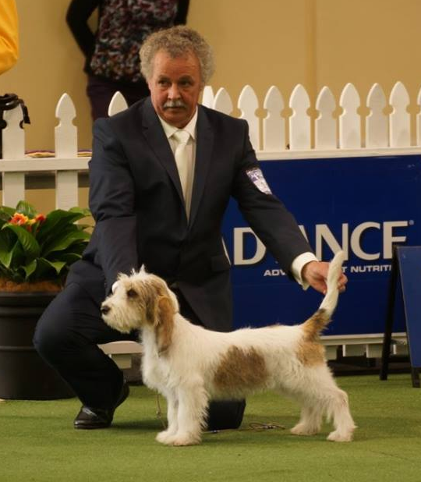

Baby of Breed – Rokeena Kiss me I’m Irish

Best Breeders Team – Rokeena PBGV’s

No Grands were entered

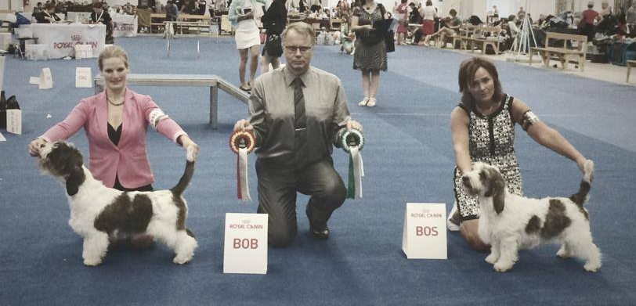
Overseas News

From Europe
The World Dog Show
Helsinki August 2014

Petit Basset Griffon Vendeen
Judge: Bo Skalin-Sweden
BEST OF BREED - Caramel Appel Van Tum-Tum's Vriendjes, , breeder: Gwen Huikeshoven. Owner: Gwen Huikeshoven & Wendy / Martin Doherty & Sara Robertson, Netherlands
BEST OPPOSITE : Vilauddens Vega, breeder: Marie Mård Ruotsi, Owner: Marie Mård
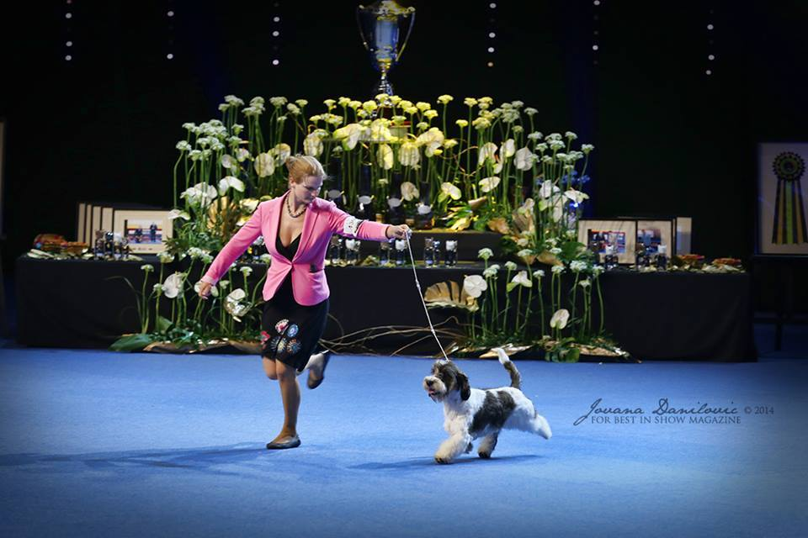
The World show was a triumph for the Van Tum-Tums Vriendjes kennels with the PBGV Best of Breed going on the win 3rd Best in Group
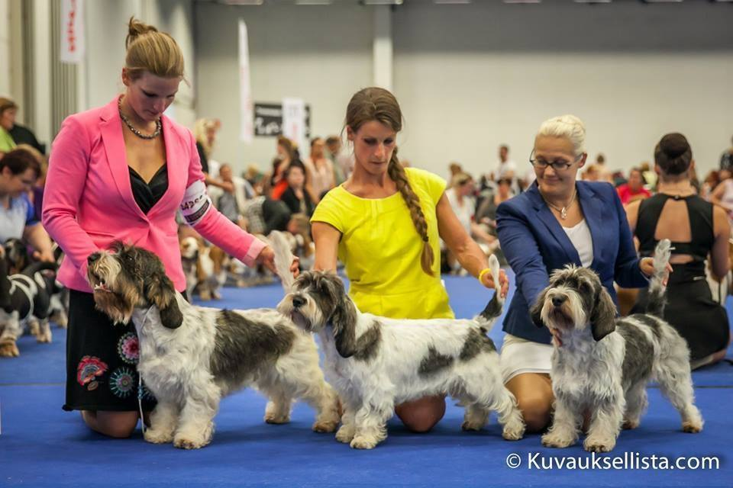
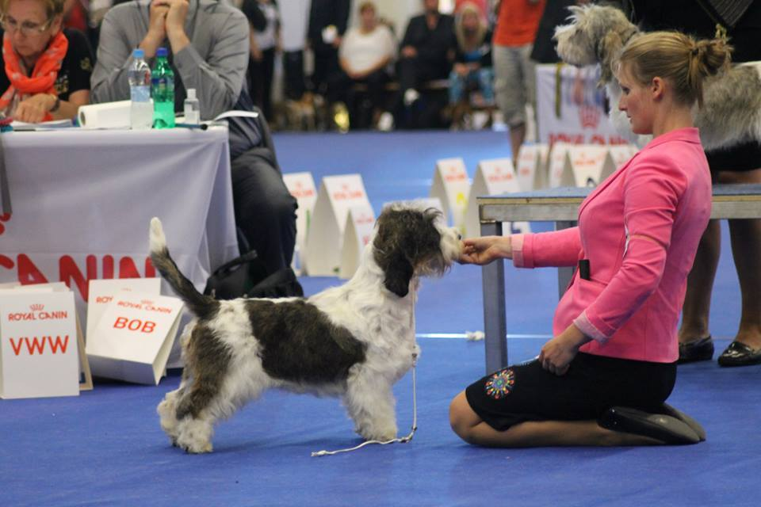
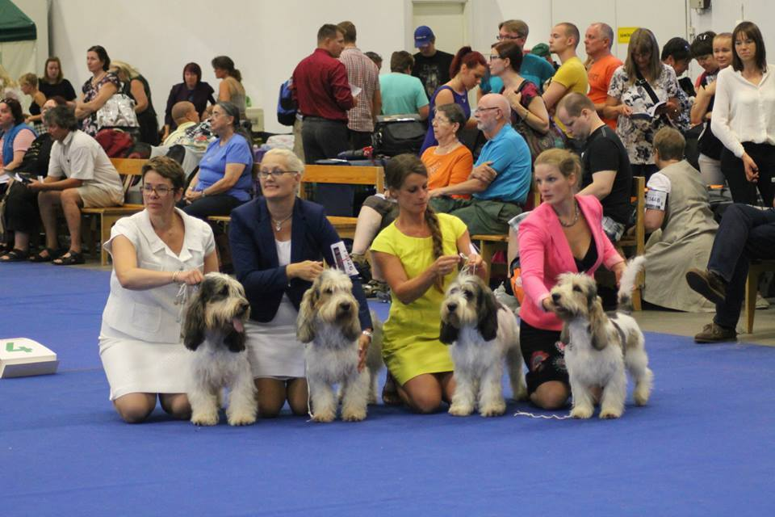
They also won Best breeders Group in PBGVs with Van Tum-Tum's Vriendjes, Mini, Sugar and Marsie. Apple didn't compete as he had to go back in the group final

And then went on to also win Best Breeders group in the GBGVs with Van Tum-Tum's Vriendjes Fido, Hocus, Artiste and Meisje

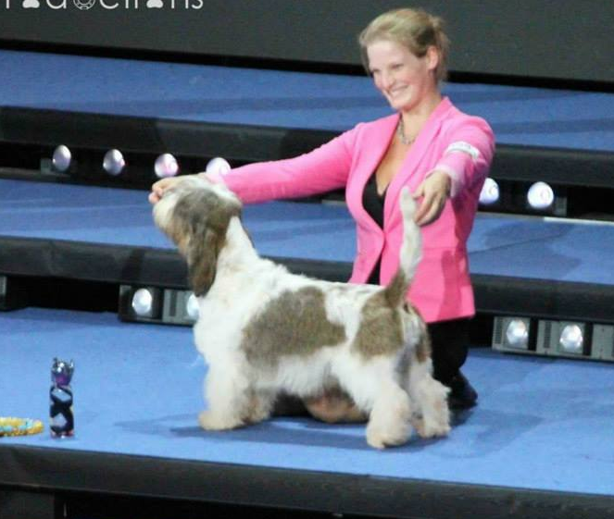
And as if that wasn’t enough, PBGV, Multi Ch Soletrader Bjorn Borg won Reserve Veteran in Show

The success has continued for Apple as he has just made history by winning Best In Show at the first ever Benelux Winner Show, held in Luxembourg

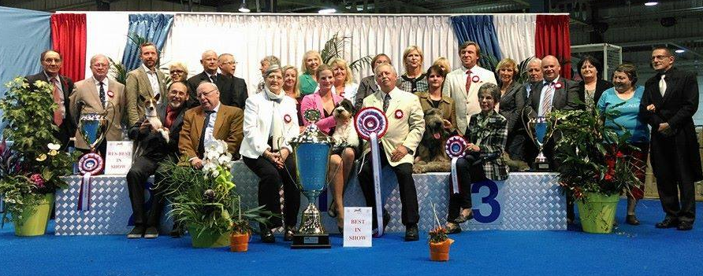

Multi Ch Dehra Amazona Bvlgari Retires
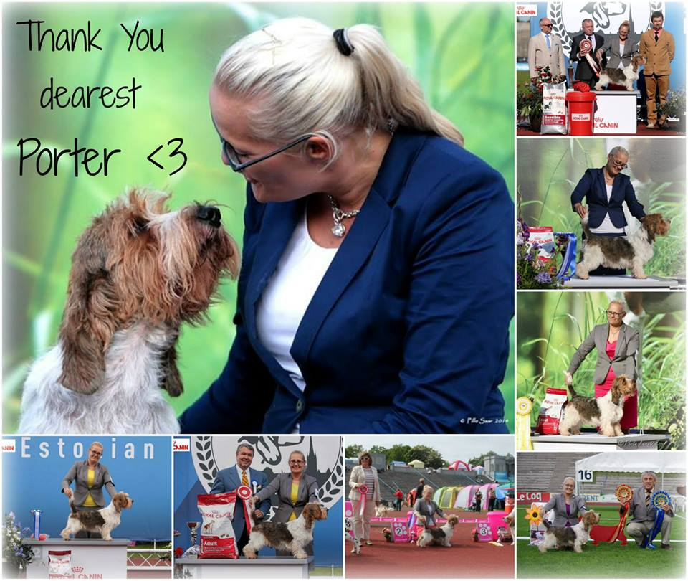
Born in the USA and bred by Nick Frost, Porter travelled to Europe to show, initially with Gwen Huikeshoven and then later with Hanna Leinonen.
He made his mark wherever he went as both a stud dog and a show dog.
Hanna announced his retirement in the following way:
“Last weekend Porter travelled to Estonia his 2nd and final time. It was time to say farewell to Tallinn and thank you for amazing time and memories there.
Our boy was shown total of five times there and results were just amazing for this 9-year-old.
★ Best In Show & Reserve Best In Show Veteran at Estonian Winner 2014
★ Reserve Best In Show & Best In Show Veteran at Group Show 2.6.14
★ Best In Show & Best In Show Veteran at Group Show 22.8.14
★ Reserve Best Of Group at TalIinn IDS 23.8.14
★ Best Of Group 3 at Tallinn IDS 24.8.14
★ Estonian Winner'14
★ Estonian Veteran Winner'14
★ Estonian Champion
★ Estonian Veteran Champion

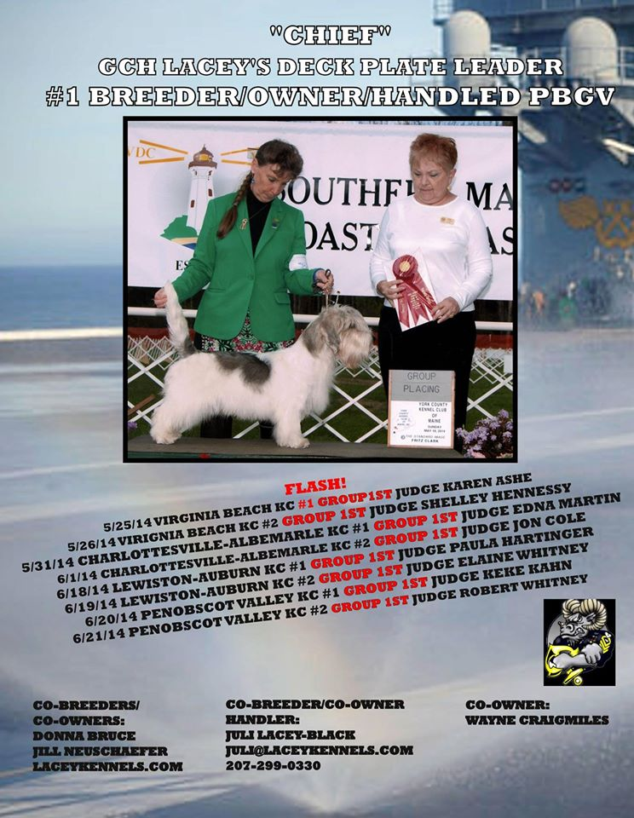
From the USA
GCH Lacey's Deck Plate Leader has had a successful run of shows winning one Group 2nd, 2 Group 3rd's and 1 Group 4th in a recent weekend circuit.
This continues his success in the hound group as a multiple BIG winner

From the UK
Gavin Robertson of Soletrader kennels is a very proud man with his young bitch, Eng Ch Soletrader Annie Mac, gaining her English title at 12months and 1 week of age.
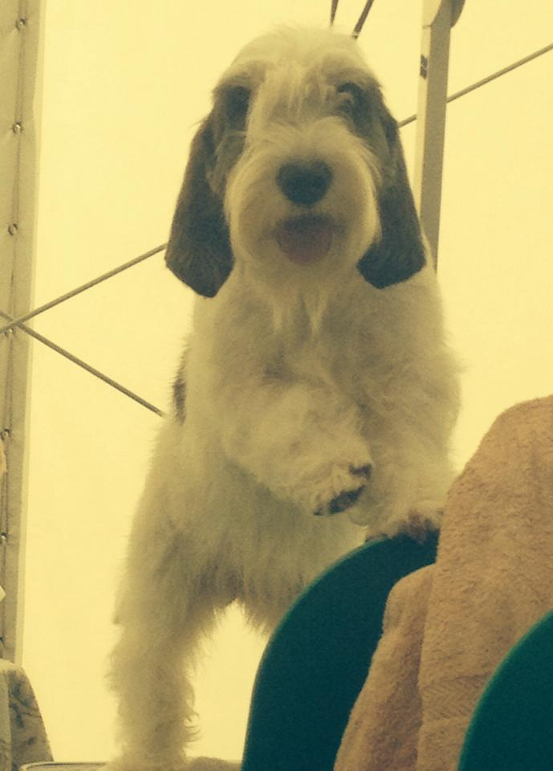
She won the required 3 CC’s while still under 2 months of age so had to win another one after she turned 12 months in order to be awarded the title . Gavin said “For our first time ever in dogs we have won 3 CC's with a puppy, Annie Mac is 12mths today and can't be an official Ch until she wins 1 more CC.
We're very proud breeders, owners and above all Jilly is a proud mother...” Annie Mac is the daughter of the famous Jilly Ch Soletrader Peekaboo who won Best In Show at Crufts .
One week later at Richmond Ch show Annie Mc won her 4th CC and went on to win Best in Group.
A very promising youngster who looks as if she will firmly follow in her famous mothers footsteps

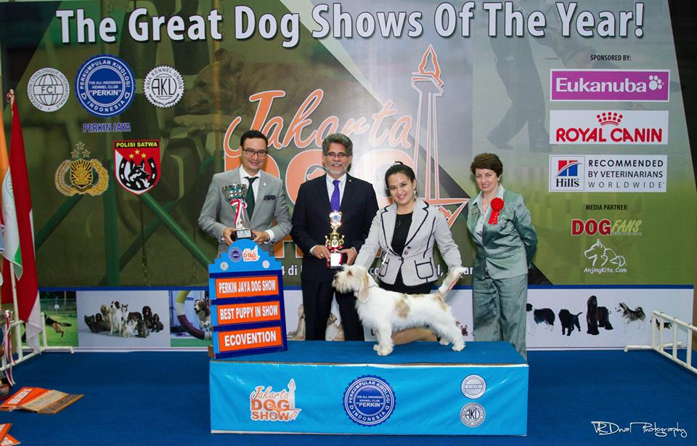
Asia
Robyn Wallis sent Rokeena Candy Kisses to Asia earlier this year – after winning best Australian Bred at the BGV Champ show in April.
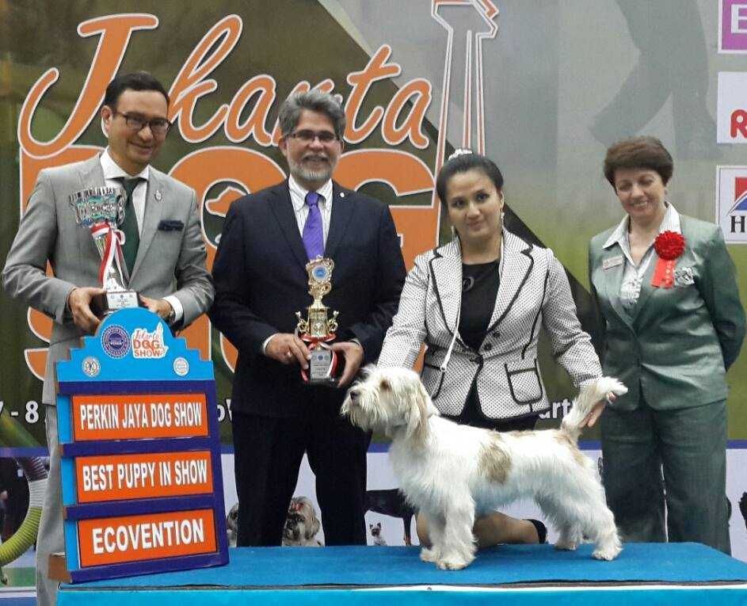
Candy hit the rings with 2x Best Puppy in Show awards at her very first shows there.

Face Book Groups
There are now a number of groups on Facebook that cater for the Grand and Petit Basset Griffon Vendeen breeds.
Here are some that may be of interest to owners and lovers of the breeds
- The Basset Griffon Vendeen Club of NSW (must come first of course)- https://www.facebook.com/groups/508643029191905/
- The Rarer Basset Hound Club Vic- https://www.facebook.com/groups/153510511506249/
- PBGV Pedigree Research - https://www.facebook.com/groups/PBGVpedigree/
- PBGV Puppies and Adults - https://www.facebook.com/groups/pbgvpuppies/
- PBGV Show dogs - https://www.facebook.com/groups/pbgvshowdogs/
- Grand Basset Griffon Vendeen -The Happy Dog- https://www.facebook.com/groups/147268372011306/
- GBVG - https://www.facebook.com/groups/127749550631555/
- PBGV - https://www.facebook.com/groups/186569541383566/
- Grand Basset Griffon Vendeen GBGV - https://www.facebook.com/groups/gbgvfotos/?fref=ts
- Grand Basset Griffon Vendeen Club of America - https://www.facebook.com/groups/284425461623741/
- Petit Basset Griffon Vendeen PBGV - https://www.facebook.com/pages/Petit-Basset-Griffon-Vendeen-PBGV/197362573613305?fref=ts

Point Score results
The club has now commenced a point score competition for all members with 6 shows in different parts of the state. The rules of the point score can be seen at the end of this article.
The shows are:
- North of the Harbour Saturday 20.7.14
- Hound Club of NSW - 6/10/14
- Hound Club of NSW- April 2015
- Hunter Valley Hound Club - May 2015
- Southern Region Hound Club - June 2015
- To be decided
The aim of the point score competition is to encourage competition and to make a bit more fun for members and exhibitors. Hopefully we will see some strong entries at these shows.
At the time of writing 1 Point score show has been held- North of the Harbour.
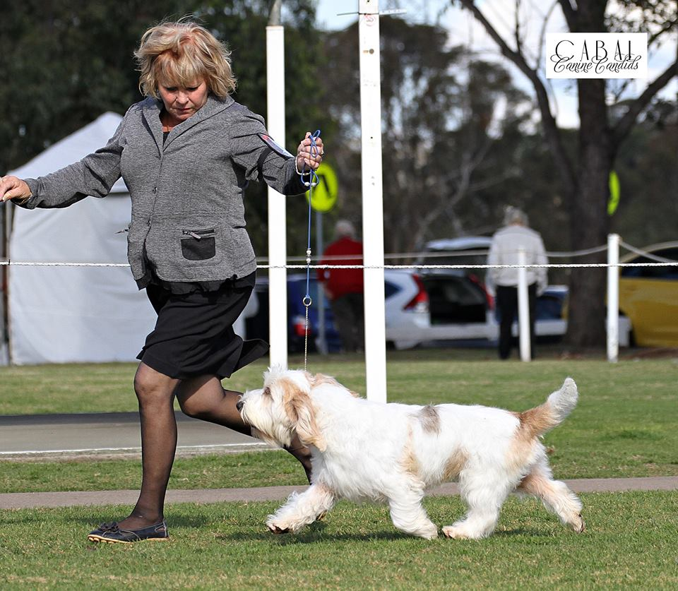
Dubbo had been scheduled but as there were no PBGVs or GBGVs entered it has been decided to change the show

North of the Harbour 20th July 2014
The first point score show was at North of the Harbour on 20th July 2014 under judge Mr A Kazmierski (Poland)
There were no Grands entered and a small entry of Peebs but the quality was there and the winners were:
BOB & DCC Ch Goldtreve Remundo B&J Hession

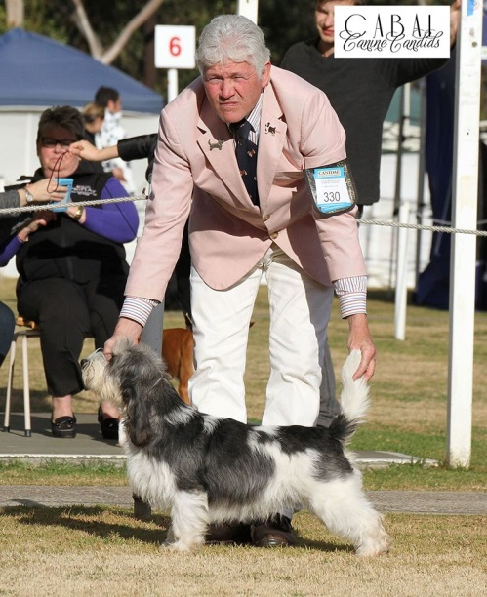
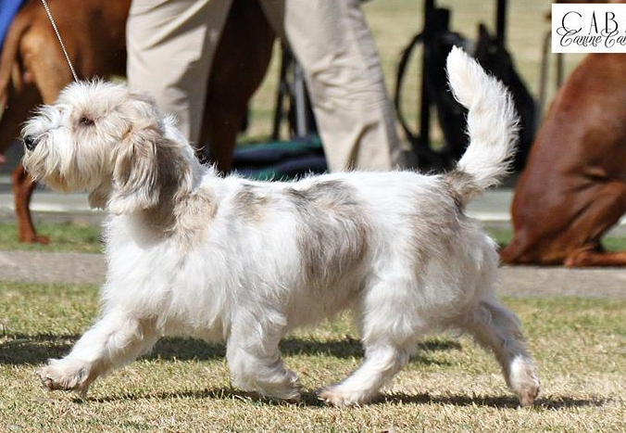

Rup BOB & BCC - Ch Rokeena Addicted to Love – R & Y Lauder

RDCC – Ch Rokeena Man After Midnight- R & R Wallis & Y & R Lauder

RBCC – Lafolie This Wheels on Fire K Delacourt & C Parker

BGV Club of NSW Point Score Competition
Rules and Scoring System
1. Points will be awarded to exhibits at designated point score shows of the BGV Club of NSW
Points will be awarded in the following manner:
Best of Breed | 10 points
Runner up in Breed | 8 points
Challenge (without BOB or Runner up) | 6 points
Reserve Challenge (without BOB or Runner up) | 5 points
First in Class | 3 points
Second in Class | 2 points
Third in class | 1 point

2. Points will be awarded to the exhibit will be highest result gained by an exhibit.
They will not be accumulative at a single show.
3. The total points gained by each exhibit will be added together and published in The BGV Club Newsletter
4. The competition will be open to all exhibits including those in Baby Puppy
5. Recognition will be given to the Winner of the Point Score and the Runner Up in the Point Score.
6. Only club members are eligible. Should a non-member win the points won by the member will be awarded only. Eg if a non-member wins BOB and a member wins Runner Up BOB then no BOB points will be awarded and the member will be awarded the points for Runner Up BOB

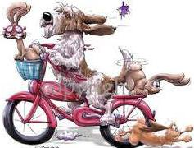

Australian Show Results
LaFolie This Wheels On Fire aged 12 months.
Dogs on Show Sydney 20th June 2014
Best Junior In Group
Bitch CC, RUBOB
Abbie also won Junior in Group at the T&G Championship show, handled by Kylie this time.

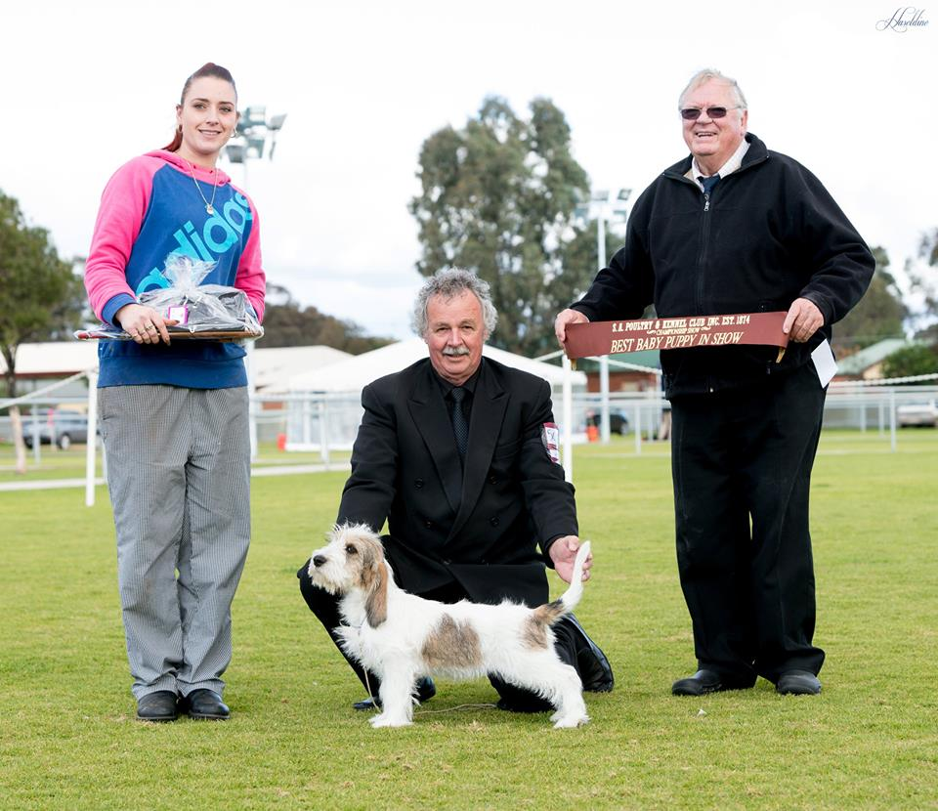

New PBGV owner’s Jeff and Jill Tassell in South Australia were thrilled with the results from there 2 new family members Jeff wrote:
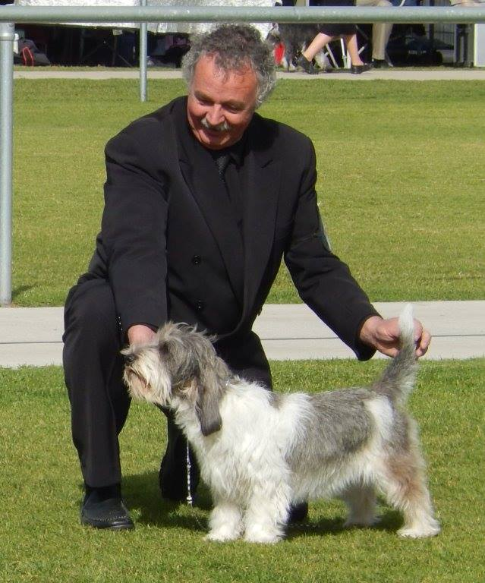
“Finally after 30 years in the dog show world we have finally breathed in the rarefied air of the In Show awards with our little fire cracker Mr Niall's (Rokeena Kiss Me I'm Irish) being awarded Baby Puppy In Show at the S.A. (South Australia) Poultry & Kennel Club Show on Sunday, this weekend of shows is one of our larger shows & has an International Judging Panel, Niall's was put through in group by Mrs B Mangin (Queensland) & then In Show by Mr F. Van Der Spuy (South Africa).

Not to be out done our beautiful junior girl Patsy (Aust Ch Lafolie Absolutely Fabulous) was awarded Best of Breed from a wonderful group of PBGV's on Saturday & Junior In Group by Mrs J Hodgkinson (Canada) & on Friday she was awarded Runner up Best of Breed behind Tracie Edwards beautiful Sparkles' & then Junior in Group by Mrs M Wierzchowska (Poland).

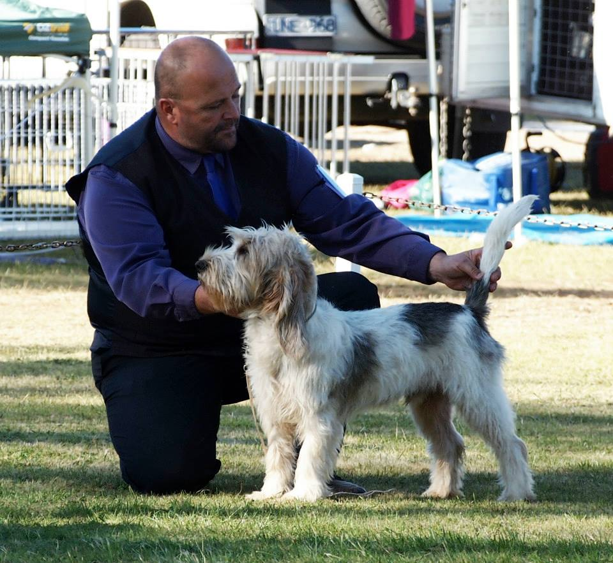
Jane Casperson Quin had a successful show at Ganmain with in Laserre Cheverny winning Puppy in Group and
Laserre Mademoiselle Yvette winning Junior in group

And
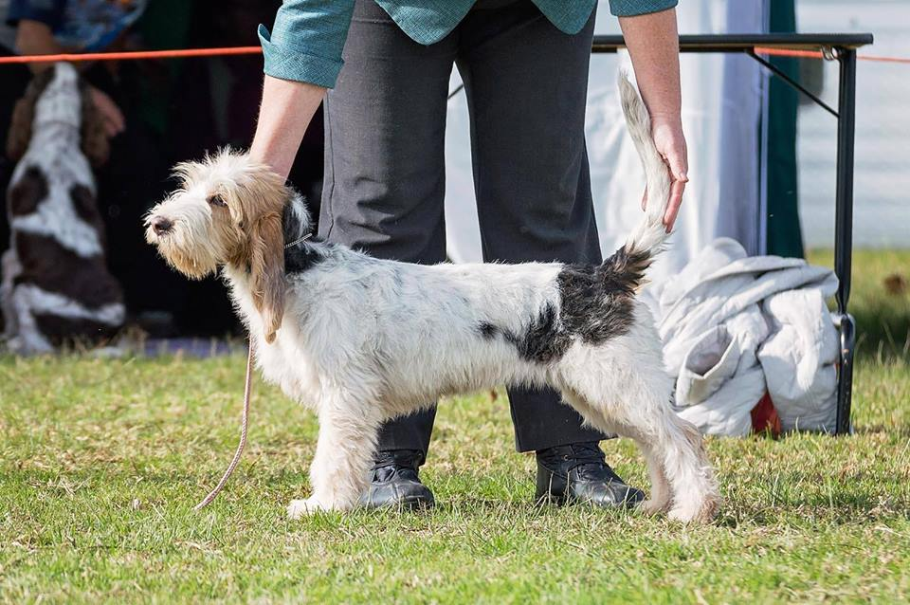

Laserre Mignon Bulles with Trish O'Neill, won Minor Puppy in Group

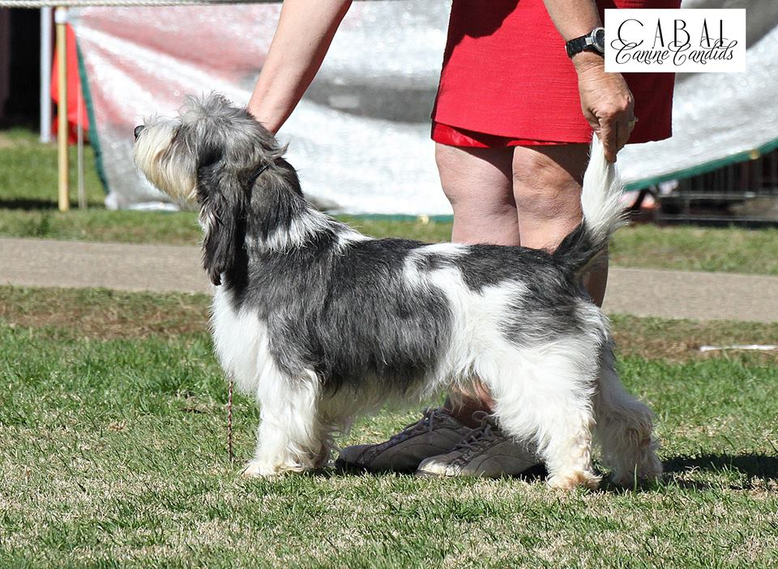
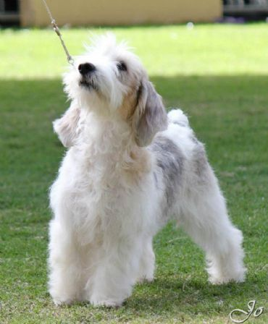
At Newcastle Toy and AB Show in September, Ch Rokeena Addicted To Love won Best in Group & Intermediate in Group. Yvonne said “Super proud of Maddie with her first BIG”

At the same show Ch Rokeena Man After Midnight won Australian Bred in Group.

Also on the same weekend at Woodlands Charity show on Saturday the GBVG, Rickerby Cruise ,bred by D & D Matthews and now owned by D Tidey, won Best in Group.
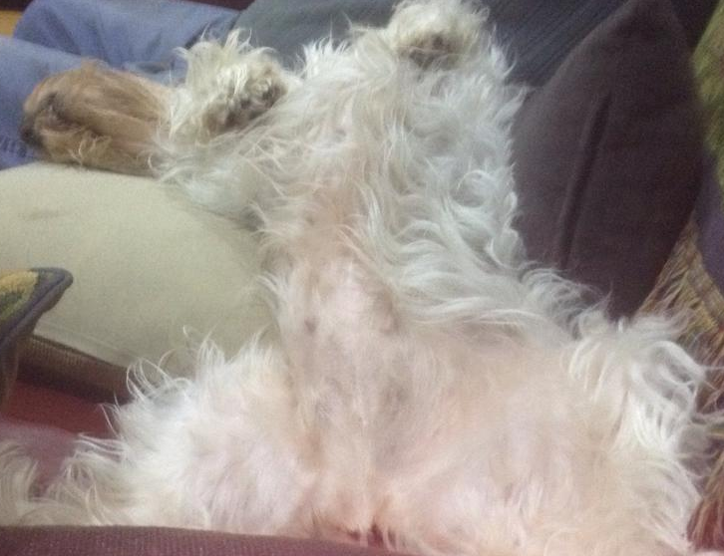

On the same weekend Maureen Thomas's PEPPER Rokeena Hot Stuff won Puppy in Group in Perth in Perth and his brother RODNEY-Rokeena Hot Topic won Puppy in Group in Melbourne.
I don’t have a photo of Maureen’s winning dog – but here is one of another one preparing for a show!!

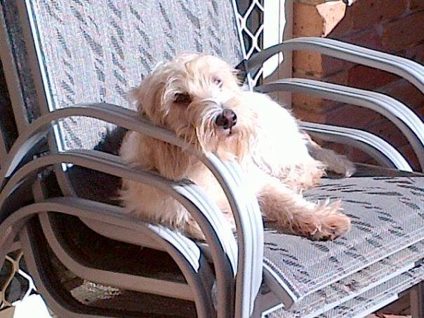
New Home required for PBGV
From Claire Parker: Sad to say that we have another PBGV looking for a loving and permanent home again.
Due to the sad unexpected death of her owner Saffy has been returned to me. She is a lovely, outgoing one year old female available. Saffy is a gorgeous, friendly and active orange and white girl who is only available due to the extremely unexpected death of her owner.
Saffy is desexed, up to date with all vaccinations and parasite protection. She gets on well with other dogs and loves to play!!!
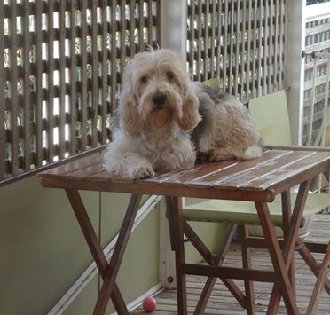
Saffy will remain with us until a suitable home can be found. Please feel free to pass on my details if you think you know anybody suitable

Why PGBV’s are Special
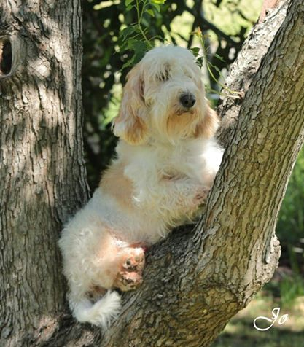
Sam doesn’t sit on the ground like an ordinary dog

Hamish prefers to rest in trees

Arthur hides behind curtains

Niles thinks he is so tiny that he can sleep in a little Griffon Bruxellois bed
But
For Truffelz nothing but a full size bed is good enough to stretch out on

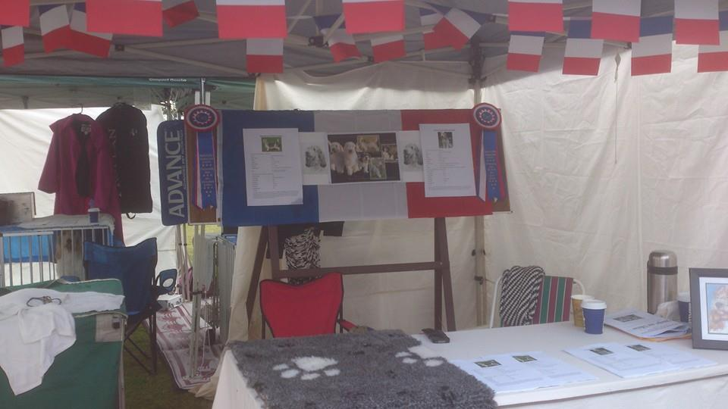
Dogs on Show
The BGV Club participated at the Dogs NSW Dogs on Show day for the first time in June.
It was a team effort, co- ordinated by Secretary Claire Parker
Helen Stanford lent the gazebo and provided the decorations, the English Springer Spaniel Association, via Robert and Yvonne Lauder, lent the equipment
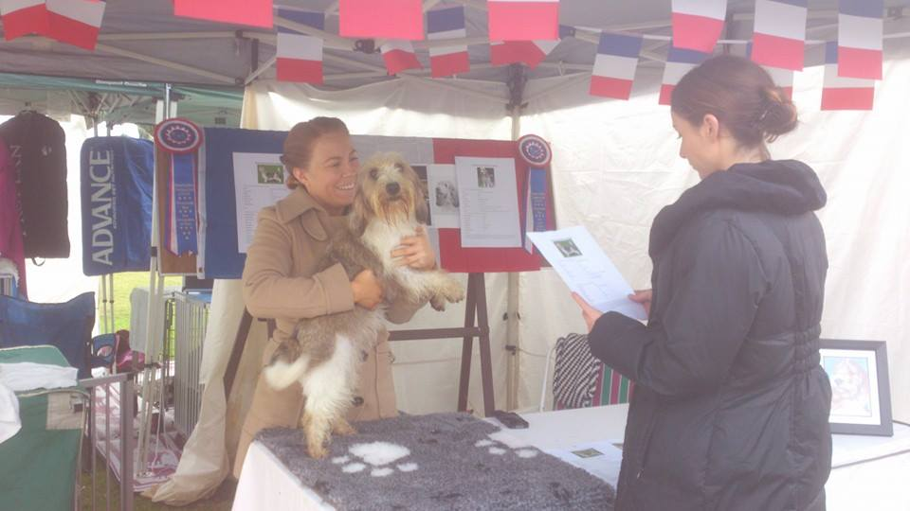
Sarah Peddie McGuirk, took care of the stand while the dogs were exhibited and everyone enjoyed themselves, including the dogs who got a lot of attention.
As Claire said “Well for beginners we did an alright job.”

Debbie and Daryl Matthews of Rickaby kennels have announced their 5th homebred Grand litter of 2 dogs 5 bitches born 3 August 2014. The Sire is CH/UK CH Wilmit Bracconier De Debucher (UK) (Poacher) Best in Show and Multi Group Winner and the dam is Rickaby Colours (Charm).
They are also expecting their 6th litter at the end of September by CH Debucher Xport Quality (UK) and CH Debucher Waltzer (UK) .
For more information on these litters or GBGV please contact Debbie +61 2 68885610

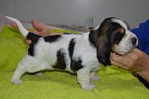
Grand Puppies
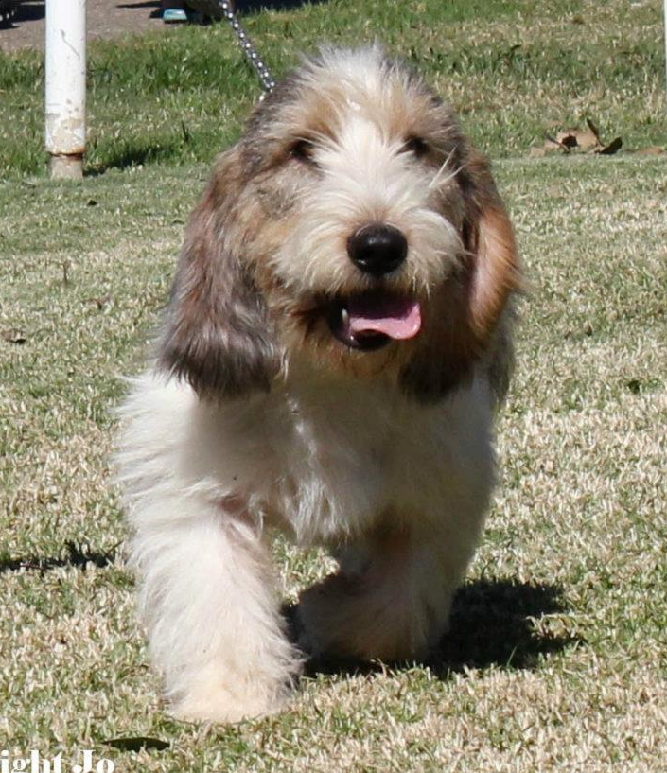

Liver Treat Cake
This is worth trying to use as a treat for training or as bait for show dogs.
Ingredients
1 Piece Liver (take any size container from the supermarket)
1 Can Sardines in oil (home brand)
3 Cloves garlic
3 Eggs
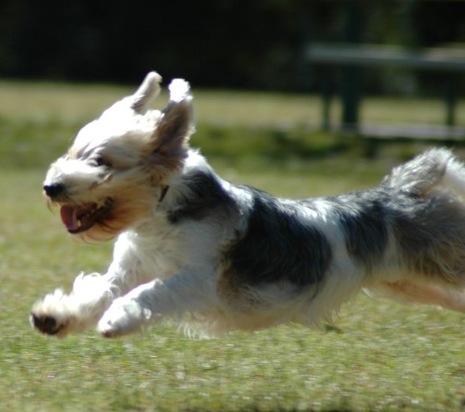
1 Tablespoon Italian Herds
1 – 1 ¼ cups Self Raising Flour
Method
Blend all ingredients except flour in food processor/blender
Add and fold flour until cake consistency
Place in preheated oven 200c for 20 minutes
Allow to cool. Cut to size and keep in freezer until ready to use.
Your dog will love these
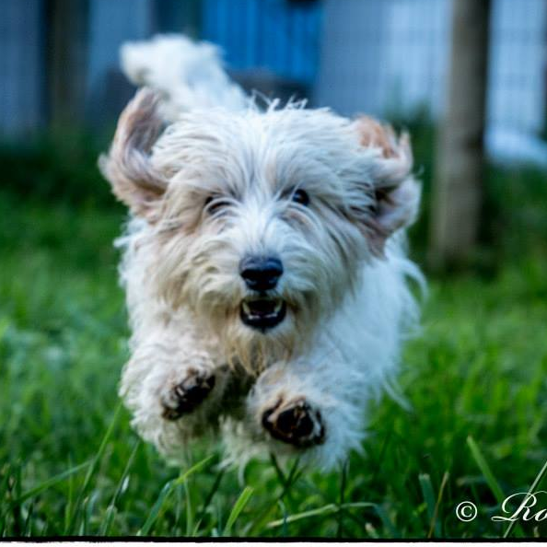

Hounds On the Run

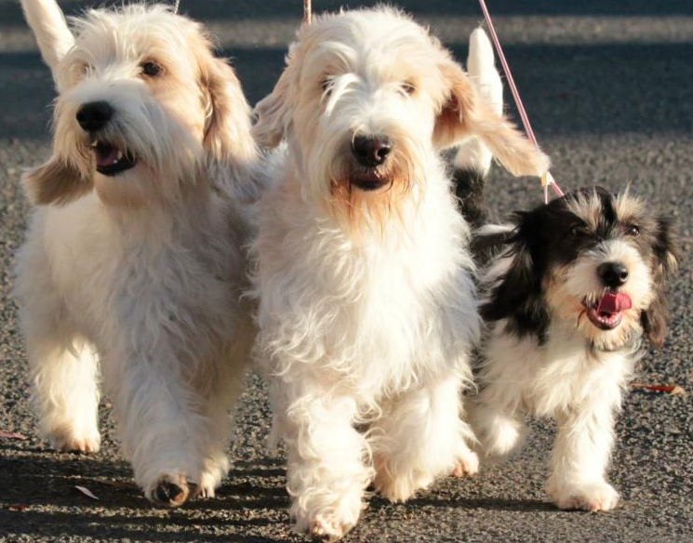
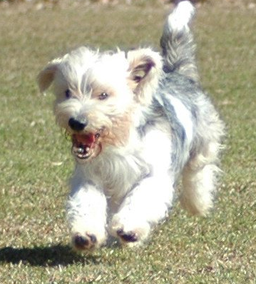

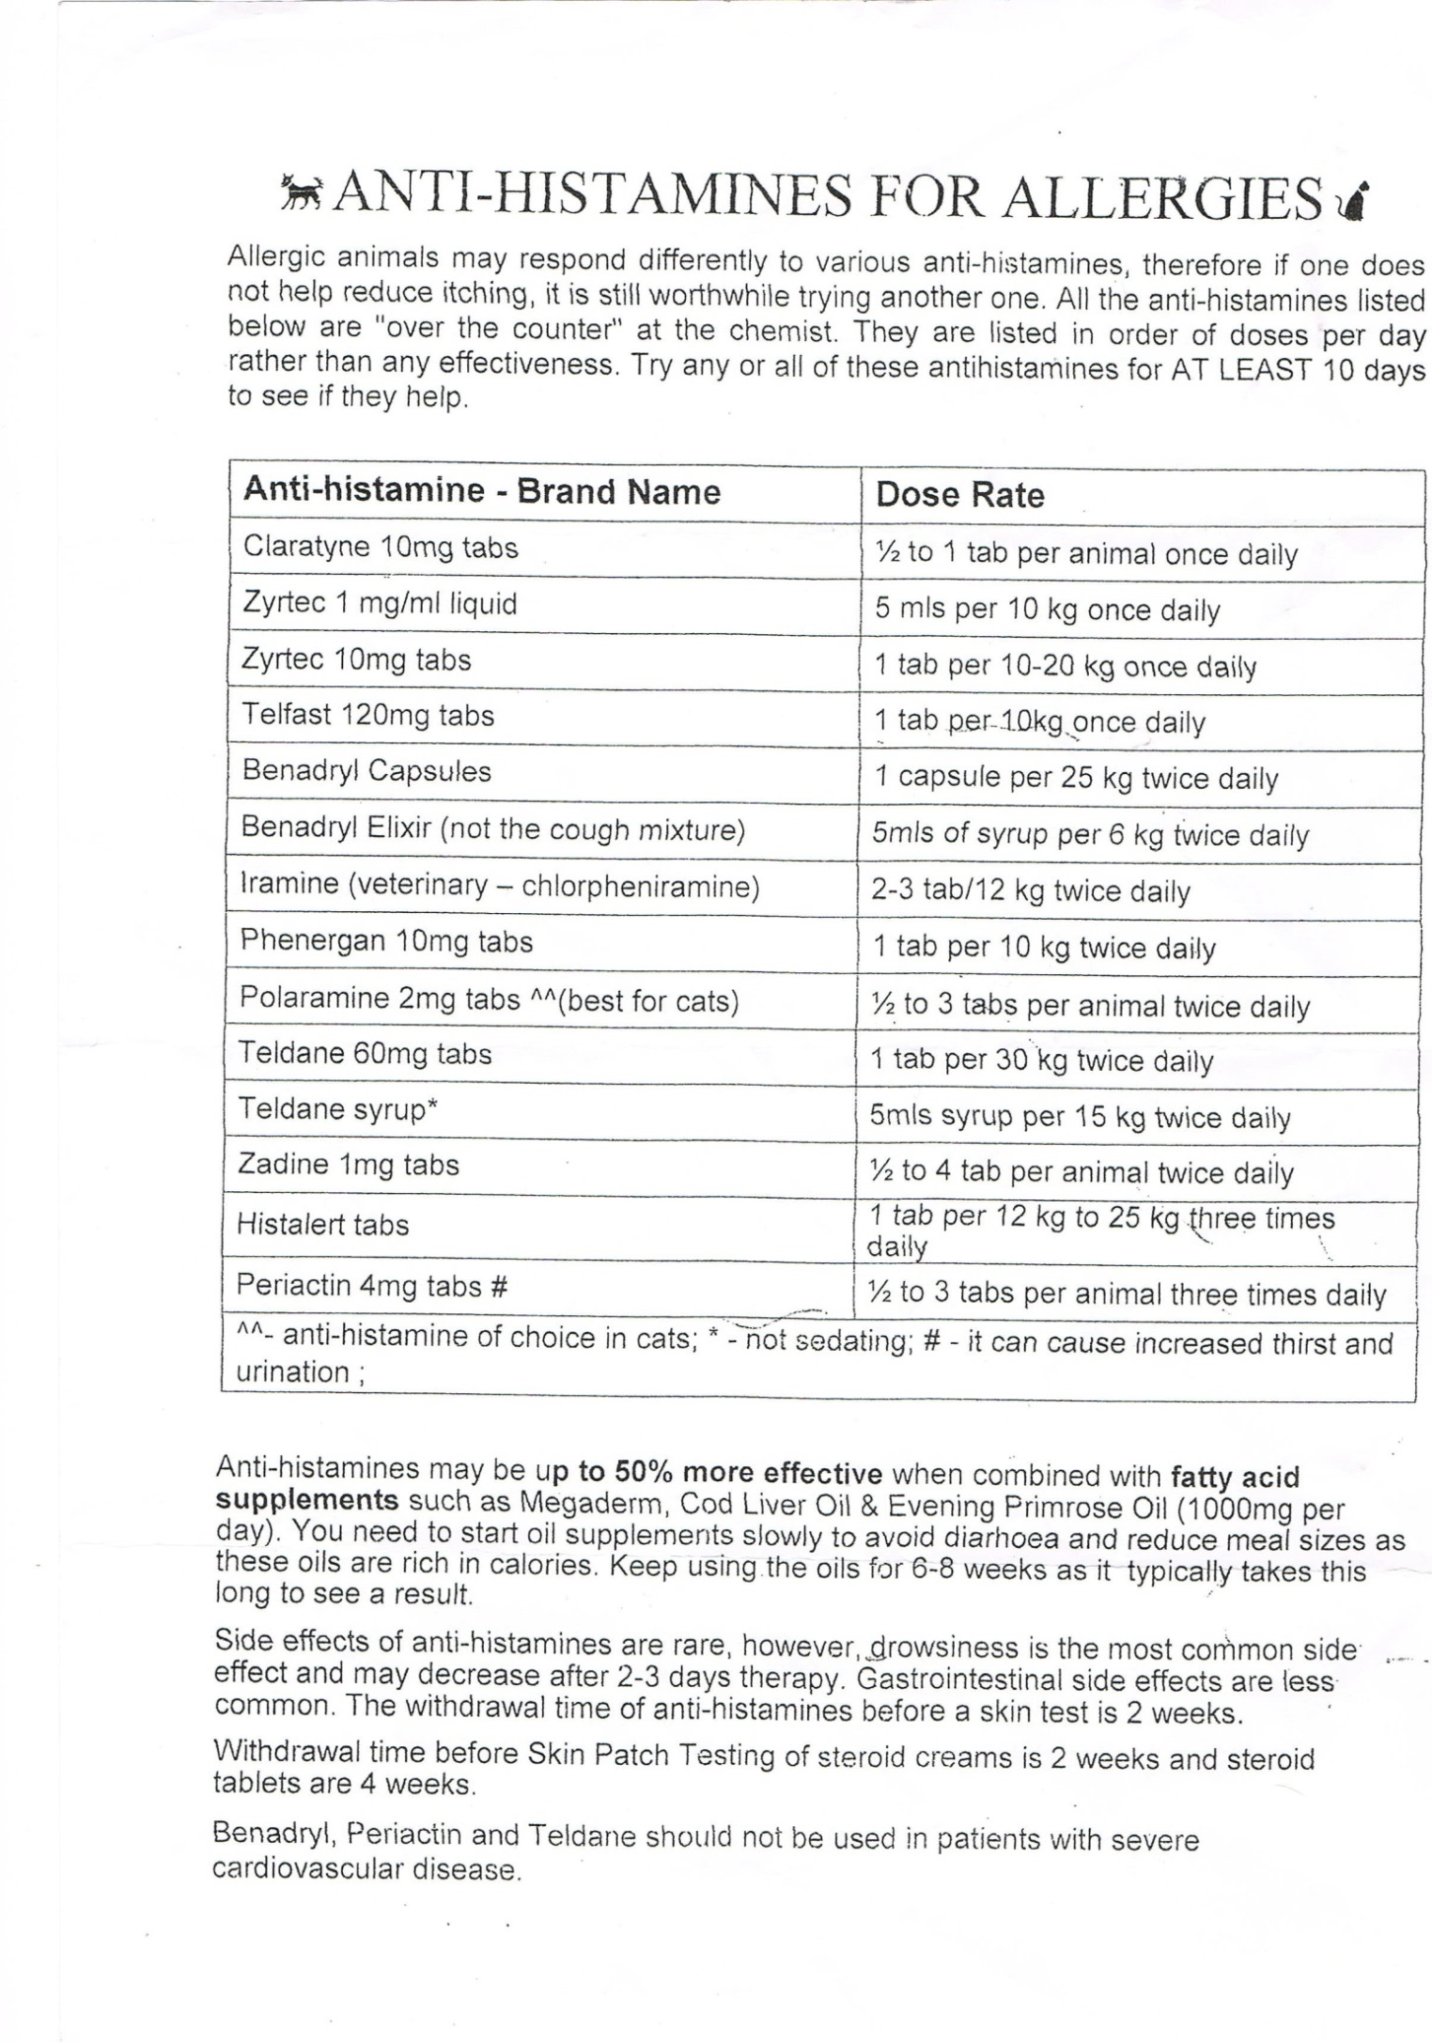

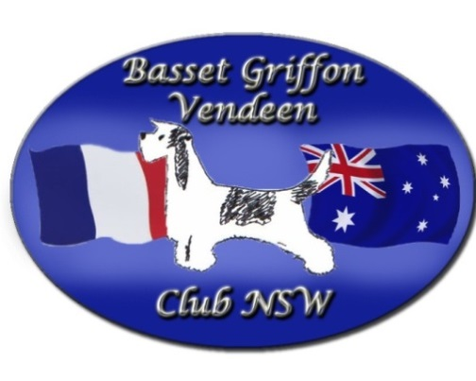
The Basset Griffon Vendeen Club of NSW

Membership Application Form
Please complete this form for all new/renewal memberships and return to:
The Secretary, 2/3 Abbott St, Coogee, NSW, 2034.
Single: $20 Dual: $25
Name/s: |  | Dogs NSW Membership No:
Address:

Home Phone: | Mobile: | Email:
Prefix (if applicable): |  | Number of GBGV:  Number PBGV:
I/we would like to renew/join my/our membership to The Basset Griffon Vendeen Club of NSW

please find attached the sum of $.................................

I/we would also like to donate the sum of $........................... to The Basset Griffon Vendeen Club of NSW health account.

I/We agree to abide by the Code of Conduct and ethics as set out in The Basset Griffon Vendeen Club of NSW rules and regulations.

Signed …………………………………………………………………Signed …………………………………………………………..

Date …………………………………………………

