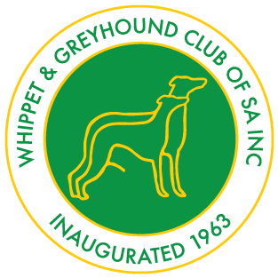ENTRIES CLOSE on Tuesday 3rd April 2018
Championship Show
Sunday
15th April 2018
David Roche Park
CROMWELL ROAD, KILBURN
SUNDAY 15th April 2018
Judging Time: 10.00am

Judge: Mrs K Coralluzzo (Vic)

Show Manager: Mrs D Jolly SACA Rep: Mr J Binding
Membership: Single $15.00; Double / Family $25.00; Pensioners $10.00; Junior $10.00.
Financial Year: 1-11-2017 to 31-10-2018
ENTRY FEES: $15.00, Babies $10.00, Catalogues $5.00
(3 Generation Pedigree please)
Classes: 1,1A, 2,2A, 3,3A, 4,4A, 5,5A, 9,9A, 10,10A, 11,11A, 12,12A (Veteran), 14, 14A, 18,18A(Neuter)
Order of judging: Greyhounds followed by Whippets, then General Specials.
Trophy and Sash: For all In Show awards.
Entries To: Mr Bill Godfrey
PO Box 40
Forest Range, 5139
8389 8489
Mobile contact on show day only: 0402812202.
Catering: $5 per head for shared platters in the Marsula/Brine rooms at completion of the show. Please pay with entries, so we know for catering numbers. Cool drinks available for sale. Complimentary tea/coffee at ringside.
SSAE for acknowledgement of entries. A separate entry form must be completed for each class entered.
Hot Weather Policy applies & if implemented the show will commence at 6pm.
Internet transfer for entries: email treasurer: jasjanb@internode.on.net
BSB: 633000 Acc/No: 145666012

