MERCHANDISE ORDER SHEET

ORDER NAME: ___________________________________________________________
CONTACT NUMBER: ______________________
POLO ($40)
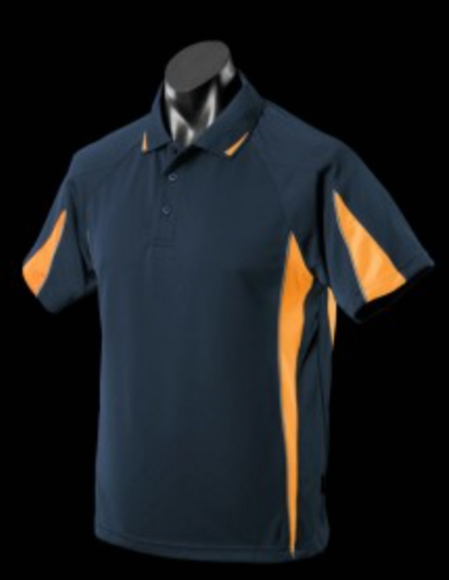
MENS  (1304) | S | M | L | XL | XXL | 3XL | 5XL
LADIES  (2304) | 8 | 10 | 12 | 14 | 16 | 18 | 20 | 22 | 24 | 26

GENEVA SOFT SHELL JACKET ($120)
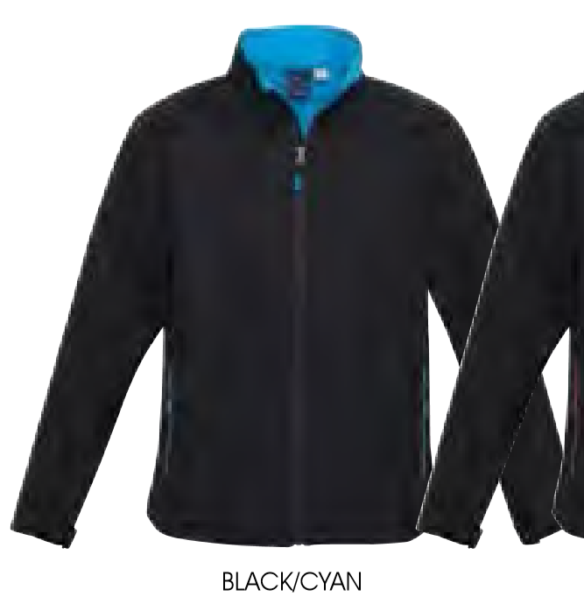
MENS (J307M) | S | M | L | XL | XXL | 3XL | 5XL
LADIES  (J307L) | S | M | L | XL | XXL

GENEVA SOFT SHELL VEST ($90)
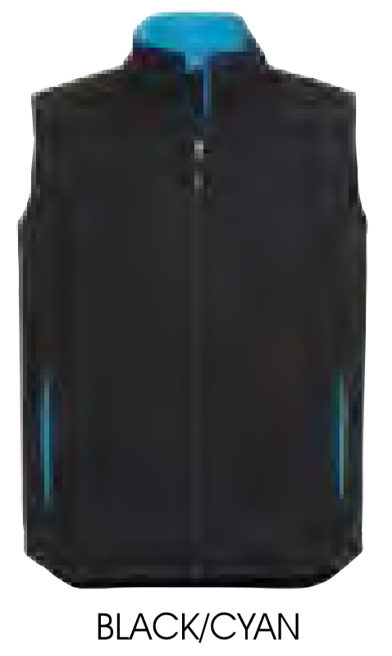
MENS (J404M) | S | M | L | XL | XXL | 3XL | 5XL
LADIES  (J404L) | S | M | L | XL | XXL

ITEM MEN/WOMEN SIZE PRICE
__________________ _______________ ________ $_______________
__________________ _______________ ________ $_______________
__________________ _______________ ________ $_______________
__________________ _______________ ________ $_______________
__________________ _______________ ________ $_______________
__________________ _______________ ________ $_______________
TOTAL $_______________
Please email your merchandise order sheet to RRCV@outlook.com
Payment can be made by cheque or direct debit: Westpac bank: BSB 033-071 ACC NO 77-1428
General Account for direct debit please include ‘CLOTHES’ followed by your ‘NAME’ as reference
PLEASE NOTE YOU WILL COLLECT AT THE SHOW

