Usher (Ush)
Usher who responds to ‘Ush’ was born in December 2010 and is a two and a half year old male (desexed) Rhodesian Ridgeback.
He is a wonderfully natured dog, with a huge heart. He loves dogs of all shapes and sizes, and is wonderful with puppies when he plays with them at the off lead park. Ush also has a fondness for children, and is very gentle when he interacts with them. He is ‘happy go lucky’, inquisitive, bright, playful dog who loves companionship, long walks, and snuggling up under the covers when the weather gets a bit chilly. He is very attentive and will sit, drop, eat and come on command.
Ush has been lovingly cared for but, has had some health issues. He has a gastric condition known as eoeinophillic enteritis, which is managed by corticosteroids and a prescription diet of Royal Canin Hypoallergenic food. He also has an intermittent bacterial skin infection that is treated by washing once a week with medicated shampoo (Pyohex), and in the case of breakouts antibiotics.
Due to personal and financial circumstances, I am no longer able to provide him with all the care that he requires. I would really like to find someone to adopt him that is able to provide him the continued level of care that he deserves. This person will be richly rewarded with a family member/best friend that will love them hugely and unconditionally.

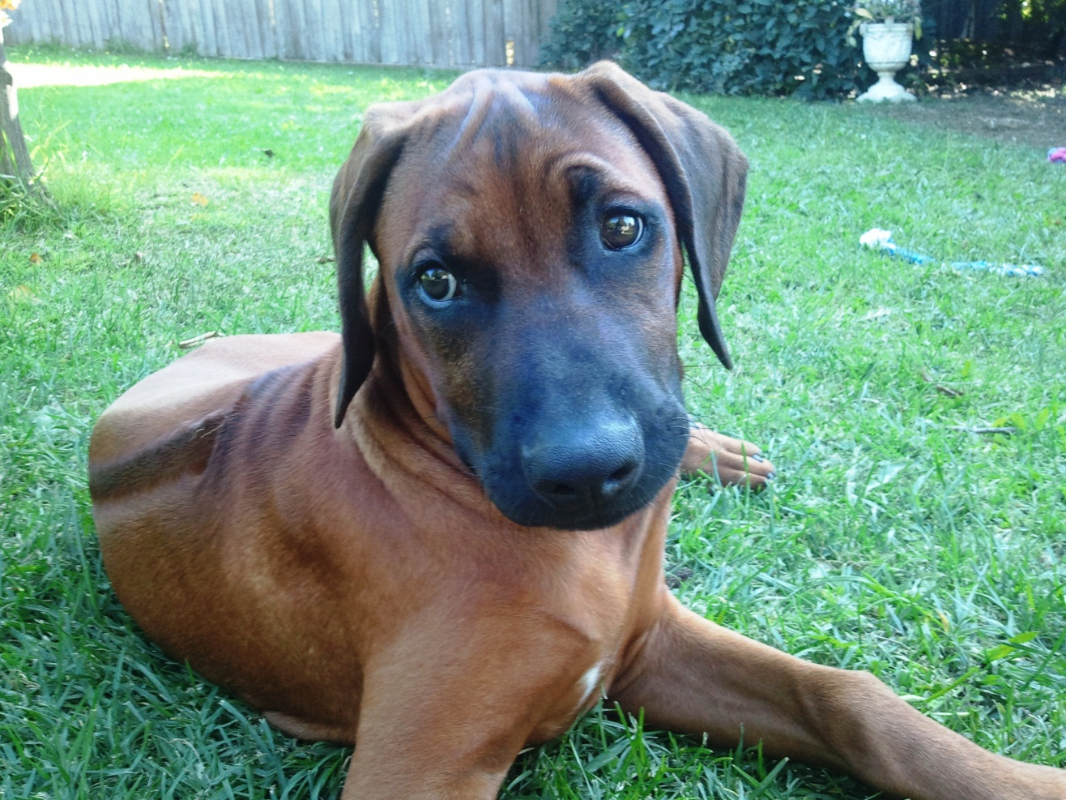
Usher in 2011 at approx. 6 months of age
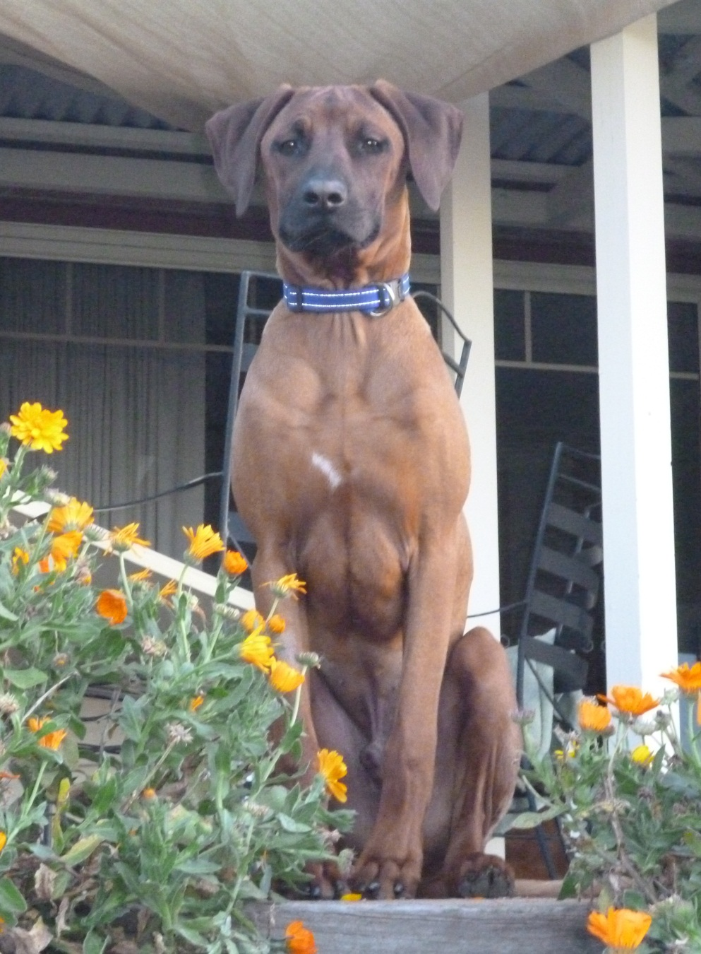
Usher in 2011 at approx. 12 months of age
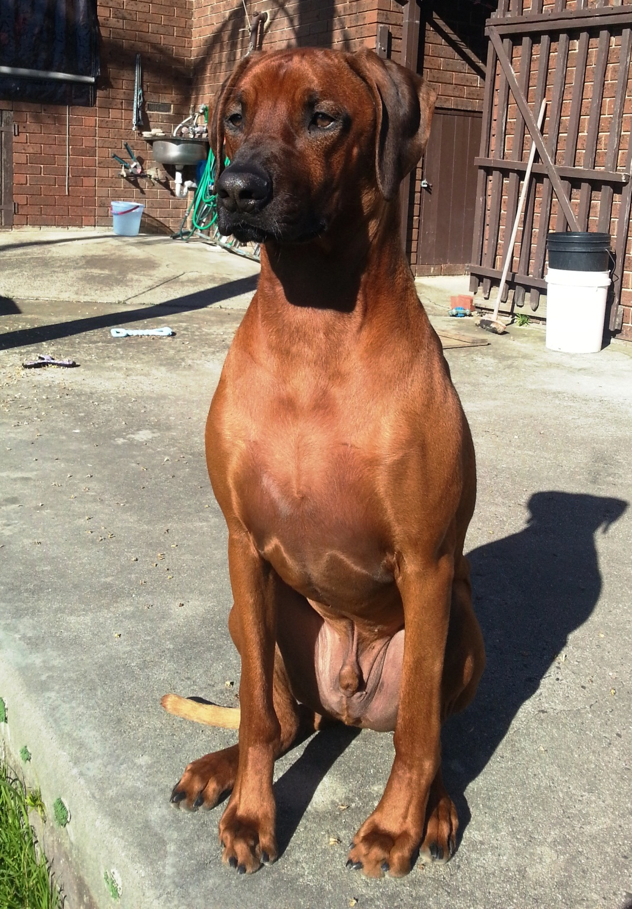
Usher in 2013 at approx. 2 ½ years of age

