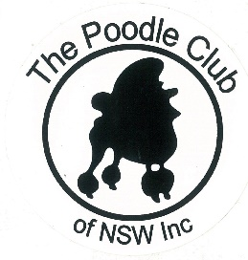
MINUTES OF GENERAL MEETING
The Poodle Club of NSW Inc

Date: 23/10/2017 Venue: George Bell Building Castle Hill Showground
Those Present: K.Hirae; K.Wright; M. O’Donnell; G. Stynes McIlrath; A McIlrath: S.Kearnes; T. Mangan
Apologies: B.Monteith; N.Monteith; K.Wyers; B. Wenzel;
Meeting Opened By Chairperson At: 7.45pm.
Minutes From Previous Meeting: Accepted as Read
Moved K.Wright Sec A. McIlrath CARRIED

Business Arising From Previous Minutes:
- K Wright to send deposit to Hawkesbury Showground
- Remove Secretary’s phone number from Breeder’s listing
Accepted M. O’Donnel Sec K. Wright
Correspondence Out:
Correspondence Out:
- Request to Dogs NSW re change of Date for Oct 2018 show and various responses
- Request to Sutherland Kennel Club to run our show in conjunction with theirs at Orchard Hills and various responses
- Affiliation Renewal form to Dogs NSW and various responses
- Email to remind members of renewal
- Jakub Kruczek offering Judging Position for July 2018
- Janet Fleming re Membership
- Email to Westpac with AGM minutes
- Email to Committee seeking approval of contract for Jakub
- Email to Committee seeking approval of Show Schedule for March 2018
- Email to Rebecca Cavallo re Specialty at Sydney Royal 2018
- Email to Randy Garren with contract

Correspondence In:

- Responses from all Judges sent EOI - Favourable
- The Hills Shire Council Bookings for 2018
- Rebecca Cavello confirming acceptance of Specialty March 2018
- Invoice from Marellan Ribbons
- Email re lecture on heart disease
- Email re Interclub Challenge
- Agreement from RAS re March 2018 show
REPORTS
Presidents Report:
Gail reported on the recent PR interview on the Today Show. She felt the Pugs were the feature and that our breed did not benefit from it.

Secretary’s Report:
Fun Day –
Smaller than expected entries, wet/cold weather probably contributed to this. All participants were enthusiastic and the seminars were well received. If the undercover ring is used again next year, better set up is required to prevent people entering without paying.

Trial Secretary’s Report:
POODLE CLUB TRIAL SECRETARIES REPORT
OCTOBER 2017
The main event this month was the Obedience Trial held in conjunction with the Poodle Club Fun day on Saturday 14th October at Castle Hill Show Ground.
Although the weather was somewhat unsettled it did not interfere with the event.
We had 21 entries attend, with several no shows from others.
The obedience event was commenced right on the designated time at 9 AM and then followed by the Rally-O Event.
The Canberra Judge Charlie Giles is a popular judge and considered very fair in his awarding of exercise points to competitors, his advice is also well received.
We had 35 entries which exceeds the allowable 30 competitors that Dogs NSW allow a judge to judge in an event which is somewhat less than breed judges are allowed to judge, but is most likely based on ring time.
The winners of winners award went to Jane Freeman which is a runoff between each of the class winners.
The two most advanced classes Utility Dog Excellent and Utility Dog did not achieve a qualifying result as these are difficult sets of exercises for the competitor.
In the Rally O Obedience the most advanced exercise is Rally O Masters and we achieved only one qualifier, Jane Freeman. This is an exercise of team work between handler and the dog and the team must do each exercise shown on the 18 to 24 stations and within a qualifying time.
Total income from registrations  Cost of ribbons presented. |  | $450.00
1.Winner of winner's rosette 1@ 16.27 | $ 16.27
2.1ST prize rosettes 8 @ 11.82 | $ 94.56
3.2nd prize ribbons 6 @ 2.18  4.3rd prize ribbons nil | $ 13.08
Judges Fee | $150.00
Judge & Steward's lunch | $ 30.00
Dogs NSW entry levy | $ 35.00
Note.
A lesson to learn is the need to inspect grounds and equipment at least the day before to avoid last minute problems.
We had some problems accessing the equipment and luckily we were able to use the Hills ring posts and ropes.
On the day one of our bar jumps broke and this has now been welded up. One of the broad jumps has achieved a broken end previously, luckily the new rules have deleted one of the boards and we have removed that item.
The ring 1 position had a bindy patch which meant repositioning the position to avoid the patch.
Bernice Monteith
Trial Secretary

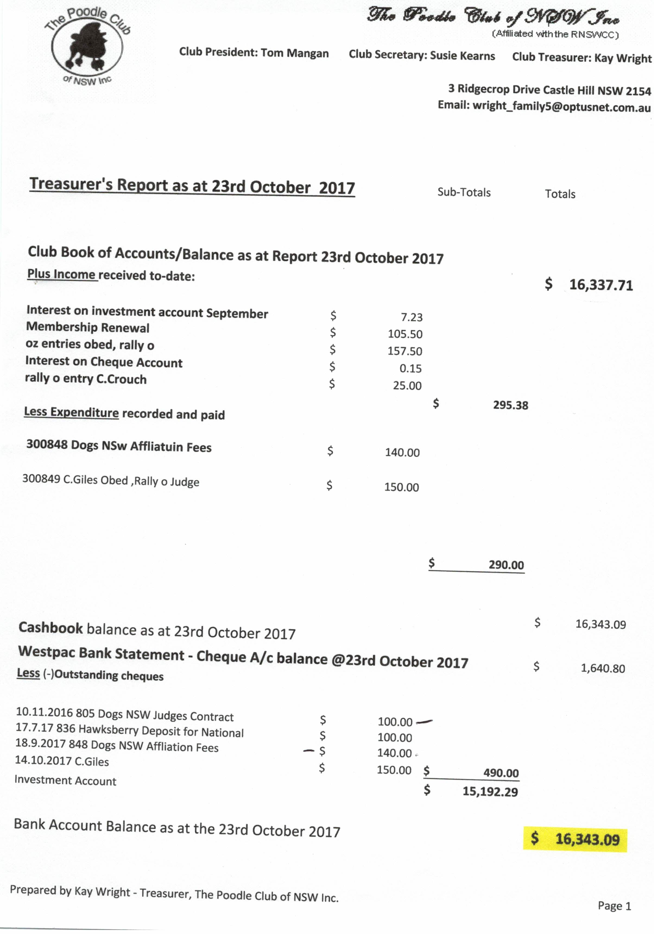

Reports Accepted: Moved T. Mangan Sec . K. Wright

Show Business:
  - 2019 National – Contract etc sent to Randy Garren
  - Booking Confirmed for Hawkesbury Showground
      - Change of Show Date Request with approval from Sutherland ABKC sent to Dogs NSW for July 2018 Show
      - Schedule and prices for Easter 2018 show confirmed by the meeting. Schedule to be sent to Dogs NSW by Sec
      - Formal Letter to Robert Zammit re breed seminar given to Kazoo to deliver
      - Jakub has advised he is unable to judge July 2018. Sec to approach judges from National list.
Moved Kay Wright Sec M. O’Donnell CARRIED
General Business:
- Sponsorship for National – Gail nominated T. Mangan to liaise with vendors re sponsorship. Sec Angus. CARRIED. It was agreed Tom should start with food sponsors
- Kay requested approval to pay overdue account to NANA MAC of $80.00 - APPROVED
- Angus offered to ask AMY about design and cost for National Jackets.

Meeting closed by Chairperson at: 9.32pm

