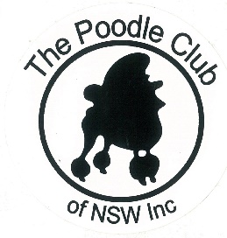
MINUTES OF GENERAL MEETING
The Poodle Club of NSW Inc

Date: 18/9/2017 Venue: George Bell Building Castle Hill Showground
Those Present: B.Monteith; N.Monteith; B.Weston; K.Hirae; K.Wright; B Wright; J.Kent. M. O’Donnell; G. Stynes McIlrath; A McIlrath: K.Wyers; B. Wenzel; S.Kearnes
Apologies: T. Mangan
Meeting Opened By Chairperson At: 7.30pm.
Minutes From Previous Meeting: Accepted as Read
Moved B. Monteith Sec A. McIlrath CARRIED

Business Arising From Previous Minutes:
- Dates For Bunnings at Dural are 30th & 31 December 2017, 7th Jan and 2nd April 2018. It was agreed Kay Wrihgt would become the liaison for Bunnings
- Discussion on PR carried over to next meeting
Accepted M. O’Donnel Sec K. Wright
Correspondence Out:
- Reply to Isabella re Corded Coat in Show Ring
- Robert Zammit x 2 re breed seminar on 2/12/17 - no response
- Email to Dogs NSW re $5 balance on Breeders Directory - now all sorted
- Email to Bunnings Dural re EOI dates for 23/12/2017 & 24th March 2018
- Email to Kylie Gallimore re Membership
- Email to Hawkesbury Showground confirming booking for 8,9,10 June 2019
- Email to NOTH secretary Rebecca re 2018 2nd show
- Email to Hills Shire Council confirming change of booking from 13/10/17 to 14/10/17 and adding booking of Undercover ring for Fun Day
- Email to Rebecca Cavallo re Specialty at Sydney Royal 2018
- Email to Dogs NSW confirming Booking of Amenities Building 2/12/17
- Email to Shirley Donaldson booking catering for 2/12/17
- Reply to Hugh Jameson re Sydney Uni Event
- Reply to Meg Bonventi re Oktoberfest Parade
- EOI for National Judging to Debra Ferguson Jones, Bruno Nodalli, Randy, Garren, Richard Bohannon, Michelle Shultz, Tom Vantonia.

Correspondence In:

- Bunnings Dural Dates Additional to Roster
- Email advice of D. Johnston’s new email address
- The Hills Shire Council – Notice of Overdue Account
- Email from Kylie Gallimore re Membership status – now financial
- Email from Dogs NSW with Log on details for Breeders Listing
- Email from Dogs NSW advising the Breeders listing subscription is now active
- Email from Dogs NSW confirming receipt of the outstanding $5
- Email from Albion Park Kennel Club advising that Poodles will be a featured breed at their next shows and if we would like to donate sashes etc . MOTION: PC NSW to donate BOB & R/U BOB sashes for poodles to a value of $100. Moved S. Kearnes. Sec K. Wyers CARRIED
- Booking confirmation from Dogs NSW for Amenities Building 2/12/2017
- Email from Meg Bonventi of Oktoberfest Parade fundraiser for Furry Friends Forever Rescue
- The Hills Shire Council Booking Confirmation for 14th October – Ring 1 & Undercover Ring. Paid by SK
- Email from Jenny Reid requesting information hip dysplasia readings in Australia
- Email from Caroline Zabrano re Vet Camp
- Email from Bunnings Dural with confirmation dates for 2017 & 2018
- Email from Gail Hawkings requesting minutes of meetings
- Email from B. Monteith re Newsletter
- Email from NPC AGM reminder – Sat 23rd Sept
- Reply from Michelle Schultz re National judging
REPORTS
Presidents Report:
Nil.

Secretary’s Report:
Still tidying up membership list. Permission was sought and granted to send reminders and current mail out to members whose financial status was expiring
Trial Secretary’s Report:
Entries coming in slowly. Robert Zammit will donate Winner of Winners prize.
Expenditure for rosettes from Marellan Ribbons was approved.

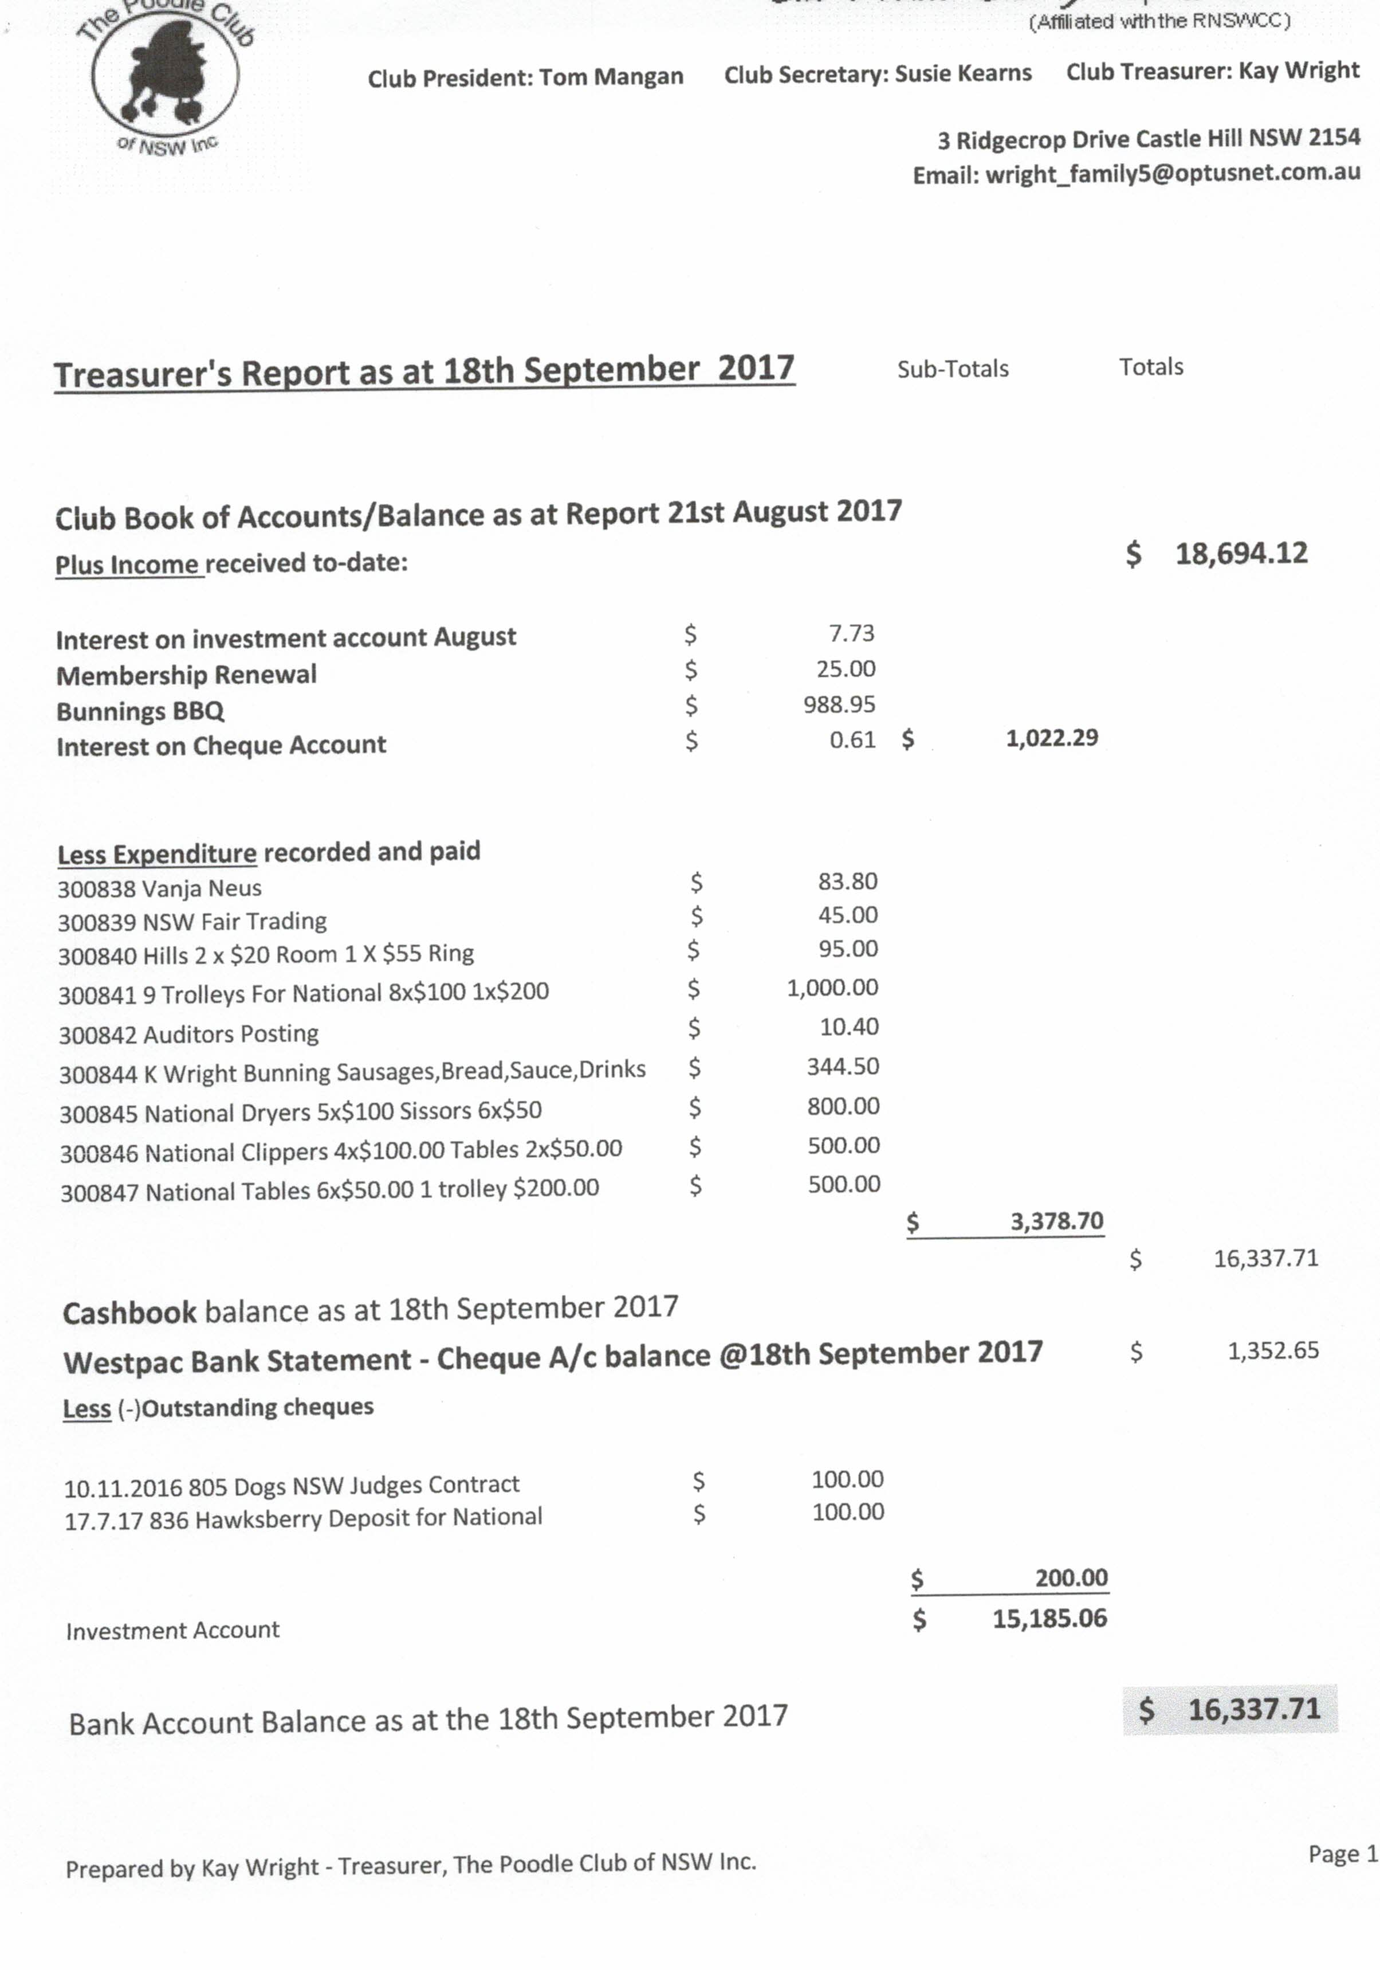

Purchases for National – Trolleys, clippers, tables, dryers which covers all confirmation prizes. 2 Trolleys to be raffled.
The meeting requested a financial report on this expenditure and a budget for the National.
Reports Accepted: Moved B. Monteith Sec J. Kent

Show Business:
  - 2019 National – Favourable responses from the EOI’s sent. Kazoo advised Toshi would be available for the June date afterall. Lengthy decision ensued with the following outcome:
  - Motion: Randy Garren be offered the judging engagement for the 2019 National. In the event he declines, the following judges will be invited in order of preference:. Randy Garren then -
      - Tom Vantonia
      - Richard Bohannon
      - Michelle T. Schultz
      - Debra Fergusson Jones
Moved Kay Wright Sec M. O’Donnell CARRIED
National Judge to be offered a return discount economy airfare, 4 nights accommodation and $200 meal allowance.
It was suggested that Toshi be nominated for the 2021 National
- 2018 Easter – Still awaiting confirmation from RAS
- 2018 2nd Show – As there has been no response from NOTH the following was decided
MOTION: Request change of date with Dogs NSW to 14/7/2018 and offer Judging engagement to Jakub Kruzcek. Moved S. Kearnes Sec K. Wrigth CARRIED
Specialty Judge to be offered a return discount economy airfare, 3 nights accommodation and $200 meal allowance.
General Business:
- Discussion on catalogue presentation for National
- Karen & Brad offered their apologies for the Oct & Nov Meetings
Meeting closed by Chairperson at: 9.55pm

