MINUTES OF GENERAL MEETING
The Poodle Club of NSW Inc

Date: 19/6/2017 Venue: George Bell Building Castle Hill Showground
Those Present: T. Mangan, S. Kearnes, K. Wright, M. Boyd, L. Boyd, J. Kent, B. Weston, M. Weston, K. Hirae Visitor: R. Dewhurst
Apologies: N & B Monteith
Meeting Opened By Chairman At: 7.30pm

Minutes From Previous Meeting: Accepted as Read.
Moved J. Kent Sec M. Boyd CARRIED

Business Arising From Previous Minutes:
Some discussion on Show & Trial preparation. Secretary to prepare a checklist encompassing administrative and practical aspects of preparing for a show or trial.
MOTION: A Trial & Show Committee be formed to facilitate show & trial preparation. Members of this committee to be Show Secretary, Trial Secretary & Treasurer.
Moved: M. Boyd Sec: J. Kent CARRIED
MOTION: Jenny Kent be added to the Trial & Show Committee.
Moved: S. Kearnes Sec: B. Weston CARRIED
T. Mangan reported that Wayne Burton has advised the prospective judge from Sweden, shall eventuate.
Correspondence In:
- Emails from Roslyn Thomas and Edwina Thomas expressing dissatisfaction with the meeting’s decision re a commemorative wreath.
  - After discussion it was agreed the secretary is to reply with a copy of the minutes from the meeting the decision was made.
- Email from Bunnings Fundraising advising an information evening would be held 4th July 2017.
  - Kay Wright & Jenny Kent advised they would attend. Secretary to respond with RSVP by 3rd July 2017.
- Email from The Wish Foundation requesting information on breeders of brown standards
  - Secretary to respond recommending Amber Pennington and Vicki Cotrell.
- Various Membership Renewals by email and post.
  - Financial details supplied to Treasurer
- New Dual Membership Application from Jenny & Tony Ralph of Caves Beach
  - Membership Proposed By: Tom Mangan Sec: J. Kent ACCEPTED

REPORTS
Presidents Report:
Bulletin 11 June sent to approx 100 current and old members

Dogs on Show 17 June - Marquee and chairs etc booked. Will need assistance with set up and manning the stall. Looking for Dogs to display

Dog Lovers Show 5 & 6 August – Meet The Breeder talk Organised

Lagotto sub-contract offer for Easter 2018

RAS response for Easter 2018

2018 2nd show: Jakob; Richard.

Committee email 16 June
- Sydney International Equestrian Centre
- Visit to Hawkesbury Showground Tuesday 27 June Gate 2, 40 Racecourse Road, Clarendon
- Samoyed Club: Phone call to Sec Rachael. $10000 for marquee for 2 days at OH. Hired amenities building for function. Gazebo hire was about $60 per exhibitor in compatible groups. Will email details.

- Information pack on SIEC facility and booking information tables and distributed.
  - A fair amount of discussion took place on this issue. There are many concerns regarding the surface suitability. SIEC will notify Lorraine Boyd for an inspection the next time it the arena surface is prepared for a canine function.

Treasurer’s Report:
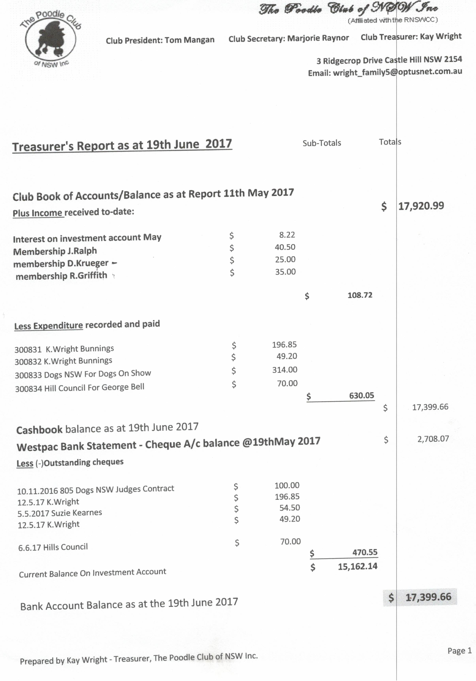
Secretary’s Report: Thanks to Tom Mangan for attending to Bulletin, AGM, Membership and Nomination notices etc whilst I was ill.
A request for clarification of annual reports to be submitted to Dogs NSW. Tom advised Dogs NSW will send a request with the required information and format. (This has since been received.)
Show Business:
- 2018 PCNSW Shows - Lengthy discussion on 2018 show venues, dates and judges. No formal decisions were made. The following is to be looked into
  - Invite Jakob to judge at the 2nd 2018 championship show – date undecided.
  - Contact other clubs running All Breed Shows with the view of holding our specialty in conjunction with them. Such as Norwest, Sydney, North of the Harbour and Spring Fair Kennel Clubs.
  - Tom advised we are still awaiting approval to hold 1st show with RAS and what day poodles are on at the Royal next year
- 2019 National –
  - Make decision on date at July meeting
  - 1 nomination received for Toshi as judge
  - Check Toshi’s availability over Easter 2019
  - Inspection of Hawkesbury Show Ground 27th June as a suitable venue
General Business:
- Susie Kearnes reported a recent inspection by Dogs NSW and RSPCA of her dogs and facilities. The outcome was a clear one, but she reported there were many facts and requirements within the Breeding of Dogs and Cats Code of Practice that members may not be aware of and required major changes in housing requirements and administration.
- Discussion of future promotions led to a decision being made by consensus that display material be developed.
- Susie Kearnes offered to upgrade the current membership form – the meeting approved.
- Kay Wright and Susie Kearnes to obtain quotes for a new Club Banner that will conform to the requirements for display at a National.
- Jenny Kent presented 2 articles on grooming which was distributed to members and wo be included in the club information file.
- Tom Mangan suggested the web page for National Boxer Rescue be looked at for improvement on our rescue function.
- It was suggested that Dana Johnson be asked to provide a report on her experience at judging at the Swedish Poodle National.

Meeting closed by Chairman at: 10.05pm

