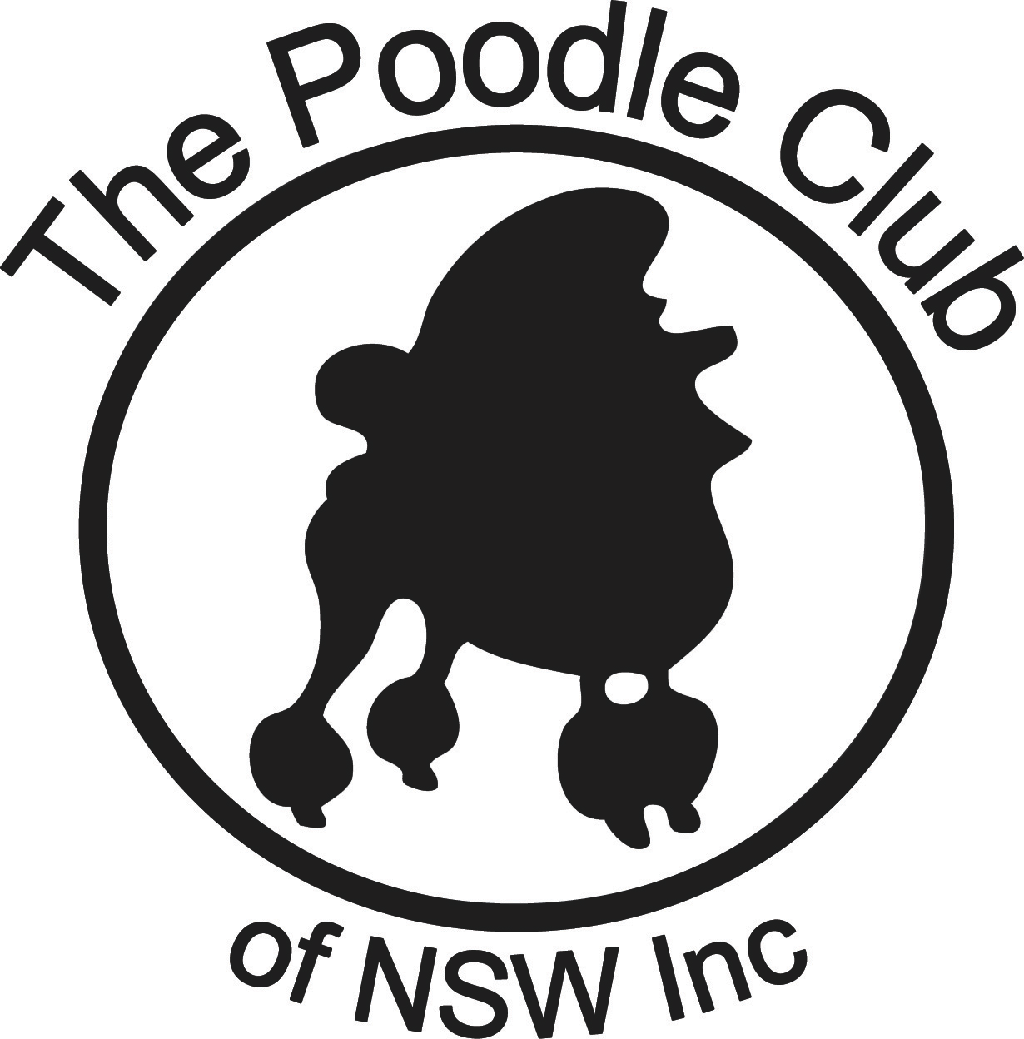

LIST OF POODLE BREEDERS

The following registered breeders are members of The Poodle Club of NSW Inc and are registered breeders with their state ANKC affiliate (in NSW, that is DogsNSW).
DISCLAIMER
The Poodle Club of NSW Inc accepts no responsibility for any agreement entered into between a breeder of a puppy and a puppy buyer. The puppy buyer accepts full responsibility for choosing the breeder and the puppy they purchase.

The breeders who appear in this list are merely breeders that The Poodle Club of NSW understands may have litters for sale. In providing you with their details, The Poodle Club of NSW makes no representations as to the reputation of any breeder appearing in this list or as to the soundness or suitability of any puppy you may decide to acquire from any breeder. You must satisfy yourself that any puppy you may decide to acquire is healthy, sound and meets your requirements.

The Poodle Club of NSW accepts no responsibility in respect of information contained in the Breeders List or in respect of any puppy you may decide to acquire from any breeder in it.

POODLE SIZES
The Poodle Club of NSW Inc supports the breeding of healthy, quality pure bred Poodles that meet the requirements of the Breed Standard published by the Australian National Kennel Council. Only 3 sizes are recognized in the Breed Standard: Standard (38cm and over at the shoulder), miniature (28cm and under 38cm at the shoulder) and Toy (under 28cm at the shoulder). Terms such as Teacup or Royal Standard are regarded as sales gimmicks.

If you have any further enquiries please contact the Club Secretary.

STANDARD POODLES (from 38cm at the top of the shoulder, and usually well over 50cm)
KENNEL PREFIX & ANKC Affiliate REGISTRATION NUMBER | NAME & CONTACT DETAILS plus WEBSITE and Facebook | COLOURS BRED | OTHER INFORMATION | PUPPIES OR OLDER POODLES AVAILABLE
IUVO  NSW 2100063199 | Linda Fraser  Mob: 0458580413  Email: lfraser@bigpond.net.au | BLACK  BLUE, CREAM, WHITE | Genetic Health Testing done; RD Genetic Testing done; Parent Hips + Elbows tested & Colour Testing done | Litter possibly in late 2016 or in 2017
KALLITHA  NSW 2100037000 | Marjorie Rayner  Mob: 0411866938  Email: marjrayner@outlook.com | WHITE | Health testing done.
KELLYVIX  NSW 2000471340 | Margaret Foord  Mob: 0412263429  Email: Margaret.foord53@gmail.com | WHITE | Health testing done.
MANRAY  NSW 2000785090 | Tom Mangan  Mob: 0419620160  Email: tcmangan@bigpond.com  Website: http://oz.dogs.net.au/manraypoodles  Facebook: www.facebook.com/tom.mangan.98 | WHITE, BLACK | Health testing done.  Location: Central Coast, NSW
MARECHAL  NSW 2003401550 | Roslyn Thomas  Tel: 02 67671314  Email: marechal2@bigpond.com | WHITE, BLACK, BLUE, SILVER | Health testing done.
PICARDY  NSW 2000903710 | Lorraine Boyd  Mob: 0412482424  Email: boydgallery@internode.on.net  Website: www.picardypoodles.com | WHITE, BLACK | Health testing done.
POODELLE  NSW 2100045592 | Jenny Head  Mob: 0412131707 | WHITE, BLACK | Health testing done.
SIROKKO | Susie Gale  Mob: 0416289482  Email: susiegale1@gmail.com  Website: sirokkostandardpoodles.blogspot.com.au | WHITE, BLUE, BLACK | Health testing done.

MINIATURE POODLES (from 28cm to under 38cm at the top of the shoulder)
KENNEL PREFIX & ANKC Affiliate REGISTRATION NUMBER | NAME & CONTACT DETAILS plus WEBSITE & Facebook | COLOURS BRED | OTHER INFORMATION | PUPPIES OR OLDER POODLES AVAILABLE
COIFICO  NSW 2100036555 | Mark & Dayna Johnston  Mob: 0407038809  Email:  daynajohnston@dodo.com.au  Facebook: www.facebook.com/Coifico-Miniature-Poodles-226792264001676/ | BLACK, BROWN
CROSSWYNDS  NSW 2100030841 | Margaret Goodfellow & Tracy Hood  Email: caninecapers1@hotmail.com  Website: www.crosswynds.com | BROWN | DNA health testing done.
DARELLSIG  NSW 2100042229 | Darelle Krueger  Tel: 02 66449873  Mob: 0410676758  Email: sdkrueger6@gmail.com  Website: www.darellsigpoodles.com/ | BLACK, BROWN |  | Adult Poodles sometimes available.
HILLANI  SACA  5000013540 | Janet Hillier  Tel: 08 83376414  Email: hillanipoodles@bigpond.com  Website: hillanipoodles.com.au | WHITE, SILVER
KELLYVIX  NSW 2000471340 | Margaret Foord  Mob: 0412263429  Email: Margaret.foord53@gmail.com | BLACK | Health testing done.
MYFLAIR  NSW 2100071816  QLD  4004437220 | Margret Barton  Mob: 0417233333  Email: myflairpoodles@st.net.au  Website: www.myflairkennels.com | BLACK, WHITE | Health testing done
PUDELICIOUS  NSW 2100060179 | Susie Kearnes  Mob: 0412496460  Email: skearnes38@gmail.com | APRICOT, RED, & BROWN | I do health testing, DNA testing for health and colour plus temperament and suitability testing. 2 of my dogs have just been externally tested and approved for use in the NSW Responsible Pet Education Program.
ROKSHANI  NSW 2000861680 | Anne Copeland  Tel: 02 64561150  Email: rocshani@gmail.com  Facebook: www.facebook.com/anne.copeland.986?fref=nf | BLACK & BROWN | Health testing done.

TOY POODLES (under 28cm at the top of the shoulder)
KENNEL PREFIX & DOGS NSW REGISTRATION NUMBER | NAME & CONTACT DETAILS plus WEBSITE & Facebook | COLOURS BRED | OTHER INFORMATION | PUPPIES OR OLDER POODLES AVAILABLE
ALAMOANA  NSW 2000405440 | Nola Westren  Tel: 02 9153 7303  Email: alamoana1@optusnet.com.au  Website: www.alamoanapoodles.com | RED, BLACK, BLUE | Health testing done.
ALANG  NSW 2100075157 | Geraldine Myers  Email: Geraldine.m7@bigpond.com | WHITE
CHIPPINDALL  NSW 2100051813  2100072511 | Peter Coombe, Judith Davies  Mob: 0429447505  Email: peter.coombe@bigpond.com  Website: www.chippindall.com.au | BLACK, APRICOT, BROWN, RED
JAZAL  NSW 2000816360 | Kay Wright  Tel: 96590965  Mob: 0422967957  Email: wright_family5@optusnet.com.au | WHITE, SILVER, BLACK | Health testing done
JEUNESSE  NSW 2100029919 | Lorraine Young  Tel: 02 96284143  Mob: 0407702882  Email: jeunessep2@bigpond.com | BLACK
KYLACE  ACT 9100002573 | Kylie Gallimore  Tel: 02 62310019  Mob: 0418457521  Email: kylace@bigpond.com | WHITE, SILVER
MONCOEUR  NSW 2000523370 | Helen Bracken  Mob: 0402987809  Email: helenbracken@hotmail.com | BLACK, BROWN
MOJITOGOLD  NSW 2100048103 | Janet Fleming  Tel: 02 67690348  Email: janetflemingnew@gmail.com  Website: www.mydogs.com.au/fireflytoypoodles/ | APRICOT, RED, BLACK | Health testing done.
MYSTYKENT  NSW 2000534430 | Pat Kentwell  Tel: 02 67721737  Mob: 0429721737  Email: kentwell@bluepin.net.au  Website: www.mistykenttoypoodles.com | WHITE, BLACK, SILVER, BROWN | PRCD testing done.
ROBELLETOY  NSW 2100061997 | Robert & Michelle Griffith  Email: info@robelletoy.com.au  Website: www.robelletoy.com.au | BLACK, BROWN | PRCD testing done.
TDROP  NSW  2100040494 | Michelle O’Donnell  Mob: 0420301669  Email: tdrop@bigpond.com  Website: www.tdroptoypoodles.com/ | BLACK, WHITE, BROWN | PRCD testing done.
VIVARA  NSW 2000404870 | Carol Vimpany  Mob: 0408426667  Email: cvimps@bigpond.com | BLACK, WHITE | Health testing done.
WILKEN  NSW 2000484310 | Marea Williams  Email: wilkentoys@marea.net.au  Website: www.wilkenpoodles.com | BLACK, BROWN
ZILLARA  NSW 2000912650 | Dale Ward  Tel: 02 49886530  Mob: 0408630918  Email: zipndale@bigpond.com  Website: www.zillara.com | BLACK, BROWN | Not breeding at present.

FOR GENERAL INFORMATION ABOUT FINDING A BREEDER CLICK ON THIS LINK http://www.dogsnsw.org.au/puppies/choosing-a-breeder.html

FOR INFORMATION ABOUT HEALTHY POODLES, SEE THE HEALTHY POODLES PAGE ON THIS WEB SITE

FOR INFORMATION ABOUT ACTIVITIES WITH POODLES, SEE THE ACTIVITIES PAGE.

