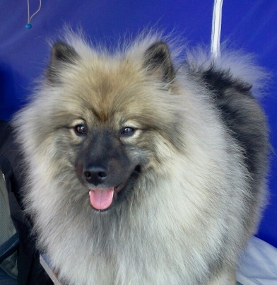
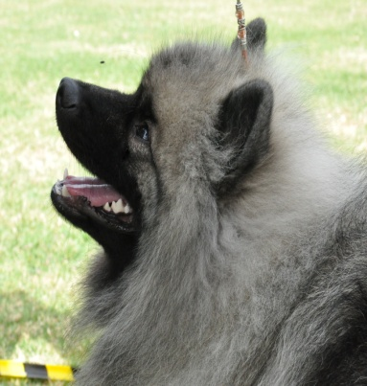
KAHNHOND KEESHOND
David & Denise Wall
P.O. Box 8036, Seymour, Vic, 3660
Mobile: 0434340815
Email: kahnhond@gmail.com
Website: http://www.kahnhond.com
Contract / bill of sale – companion dog
*This is our standard companion puppy sales contract; we reserve the right to change this contract
( in any way we deem necessary to protect the interest of the breed ) anytime up until it is signed by the buyer and accepted by the breeder.

Breeder(s): David Wall and Denise Wall
Mobile: 0434340815
Puppy Details:
Breed: Keeshond
Date of Birth:
Sex:
Colour: Silver/Grey
A.N.K.C. Reg. Number:

Registered Name:

Sire: Registered Name:
A.N.K.C. Reg. Number:

Dam: Registered Name:
A.N.K.C. Reg. Number:
........................................................................................................................................
Buyer(s):
Address:
Post Code: Telephone: Mobile:
Email:
Cost of Puppy: Deposit: Date Paid:
( NB: Deposit is deductible from the purchase price, but NOT refundable. )
1 of 4
“Companion Dog” means that this animal is sold as a pet rather than for breeding or show purposes. No warranties or guarantees, expressed or implied are made under this contract except as stated below.
- The dog is Purebred. The pedigree is correct and a ‘copy’ is given at the time of sale. A.N.K.C Purebred Dog Certificate of Registration (limited registration), will be forwarded to the new owner upon the breeders receipt of same from the Victorian Canine Association. The Breeder(s) reserves the right to withhold the Certificate of Registration until such time as they have been provided with evidence that the animal has been spayed/neutered.

- The seller(s) confirms that the Dogs Victoria Code of Practise for Hereditary Diseases had been complied with by the seller and that all reasonable steps have been taken to ensure the dog is healthy as required by Dogs Victoria Code of Practice.

- This dog has been well socialised and is guaranteed to be of good temperament. Its Sire and Dam are of good temperament. It is now up to you, as the new owner, to continue this integral socialisation and training process.

- This Dog has been raised on premium brand Dog Food (approx: 23% protein / 14% fat). We recommend that you continue feeding a premium brand of dog food for the duration of the dog’s life. Failure to feed a premium brand dog food (with approx 23% protein / 14% fat) will void all guarantees for this dog. We recommend Artemis Fresh Mix Adult Formula.

- The Buyer(s) agrees to keep the dog at an optimum weight for the life stages that the dog goes through.
. Optimum weight is defined as follows:
- You should be able to feel all of the ribs with your hand but your fingers should NOT fall between them.
- You should be able to find the hip bones easily by touch, BUT they should not be visible.
- When looking straight down on the top line, you should be able to see an indication of a waist. An excellent habit to get into is to regularly look at your dog before you feed it. If they’re getting too thin, feed them more. If they’re getting to fat, feed them less. Monitoring their weight day by day is so much easier than working to fix a weight problem once it has become all too obvious.

- The Buyer(s) agrees to keep all immunisations current, provide safe, secure and clean housing, provide nutritionally complete food, confine dog in a fenced yard or kennel run, or to walk on a leash but not to restrain unsupervised on a rope or chain.

- The Buyer(s) agrees to have blood collected or any medical testing done at the request of the Breeder for any reason at the cost of the seller. As responsible Breeders, we may require dogs we have bred to participate in breed health research programs for the betterment of the Keeshond Breed, this may be done by x-ray, blood samples or cheek swab (DNA) samples.

- The Buyer(s) agrees to notify the Breeder within 7 (Seven) days of any medical condition that affects the health of the dog. At the request of the Breeder(s), the Buyer(s) agrees to supply a copy of any results of any such determining tests that have been done by a Veterinarian to the Breeder(s). This includes ANY medical condition. It may include genetic or inherited diseases / conditions. Whilst we take every precaution to breed only the healthiest Keeshond possible, sometimes a medical condition may affect a dog that we have bred that we are not aware of until many years later. Knowing the health conditions of dogs that we have bred, assists us in making educated and more informed decisions when it comes to planning and breeding future litters. While the condition may not seem serious or important enough to contact us about, we need to know as it may have serious ramifications to any future breeding we have planned. We value your communication!
- If for any reason the Buyer(s) is unable to keep the dog for the duration of his/her life. The Buyer(s) agrees to contact the Seller(s) and return the dog to the Seller(s).
2 of 4
- The Buyer(s) agrees not to breed from this dog, not to cause this dog to be bred, or to use this dog for any breeding purposes with the same breed or any other breed.

- This dog is sold subject to the Alteration Agreement, failure to have the dog altered (spayed/neutered) within the specified time period VOIDS ALL GUARANTEES.

- This dog is to be desexed.. A copy of the desexing certificate as completed by the Buyer(s) Veterinarian is to be forwarded to the Seller(s) within 14 (fourteen) days of the dog being desexed. If the dog is not desexed within 6 (SIX) months, we (the Breeder/Seller) have full rights to demand the dog back with no compensation or refund to the Buyer(s). The Buyer(s) also forfeits all rights to the DOG.

- My purpose for purchasing this Purebred Keeshond is for companionship only. Since it is sold as a Companion and NOT for my breeding purposes, I agree that this dog will not be used or cause to be used for breeding purposes in any way, including the collection and storage of semen without the written consent of the Breeder(s).

- My purpose for purchasing this Purebred Keeshond is for companionship only. Since it is sold as a Companion, and NOT for Confirmation Showing I agree that this dog will not exhibit in/at any Confirmation Show anywhere without the written consent of the Breeder(s).

- The parties in this contract will notify each other within 14 (fourteen) days of an address change and/or phone number change.

Since violations of this contract would be detrimental to the reputation and value of our Kennel Names and the Keeshond Breed, the owner of the puppy agrees that any such violations entitle us to payment on demand of an amount equal to the cost of recovery of the dog, any vet or medical bills, and the cost to rehome the dog
Any other changes or additions to this contract must be stated below:

Buyer: ______________________________________________________Date: __________________________
Witness: _____________________________________________________Date:__________________________
Print Name:____________________________________________________________

Breeder/Seller: __________________________________________________Date:_______________________
Witness: ________________________________________________________Date:______________________
Print Name: ________________________________________________________________

3 of 4

Non Breeding Agreement:
Companion Quality Dogs come from the same litters as our breeding and Show prospects and the same care is taken in raising and placing these dogs. Altering (spay or neuter) your dog will prevent any future problems / inconveniences and may enable your dog to live a longer and healthier life.
The purchaser acknowledges that this Purebred Keeshond is sold on a limited registration and as a Companion Only.
The Purchaser agrees that he/she will not use, allow or cause to be used, this dog for breeding purposes in any way, including the collection of semen, without the written consent of the Breeder(s).

Buyer(s):____________________________________________________ Date: _________________

Witness: ____________________________________________________ Date: _________________
Print Name: _________________________________________________

Breeder(s) / Seller(s): ___________________________________________ Date: _________________

Witness: _____________________________________________________ Date: __________________
Print Name: __________________________________________________
*Pending Victorian Canine Association Confirmation

4 of 4

