IRISH WOLFHOUND CLUB OF SOUTH AUSTRALIA INC
CHAMPIONSHJIP SHOW RESULTS WITH PHOTOS
3RD JUNE 2017

BITCH CC BEST EXHIBIT IN SHOW & OPEN IN SHOW  Ch Greycroft Irish Storm J & S Lewington  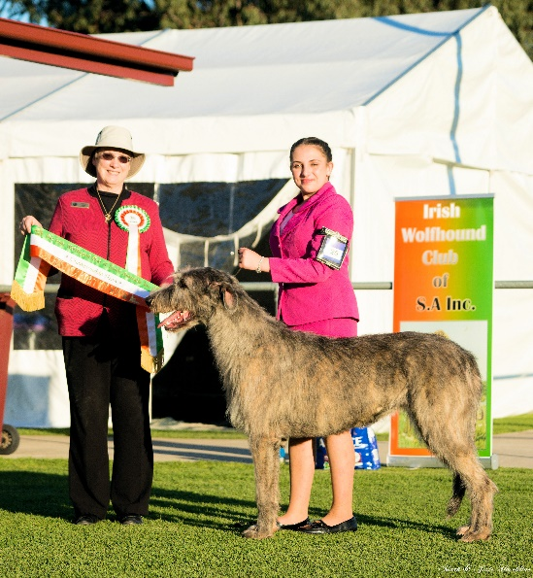 | DOG CC RUNNER UP BEST EXHIBIT IN SHOW AND OPPOSITE SEX IN SHOW  Suipreme Ch Glenfels The Boy from Oz  S Baker  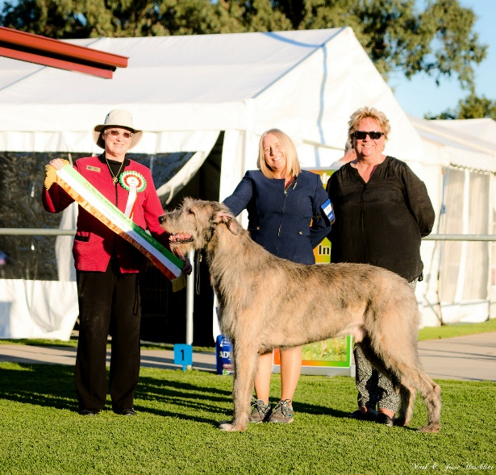
BABY IN SHOW  Wulfgar Kerryman At Glenfels Whirlaway Kennels and S Baker  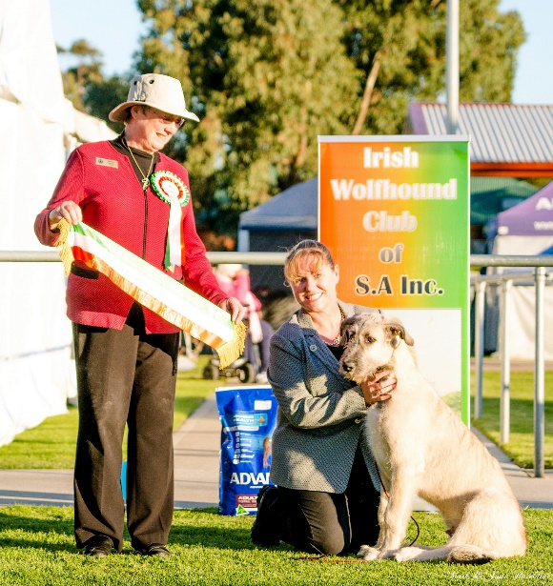 | PUPPY IN SHOW  Fleetwood Amore Della Muysica (AI)  B & S McClure  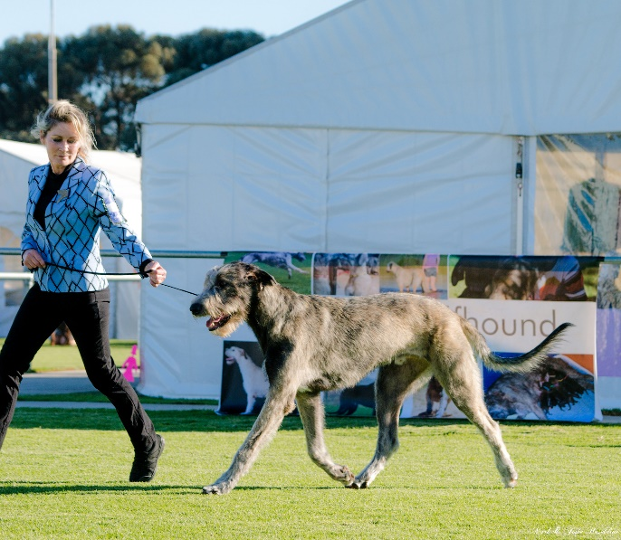

JUNIOR IN SHOW  Wulfgar Just My Valentino (AI) M Thomson & S Gendle  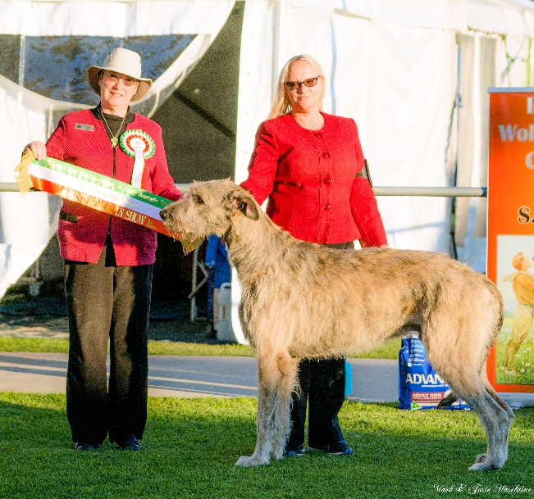 | INTERMEDIATE IN SHOW  Wulfgar Its De Lovely S Gendle  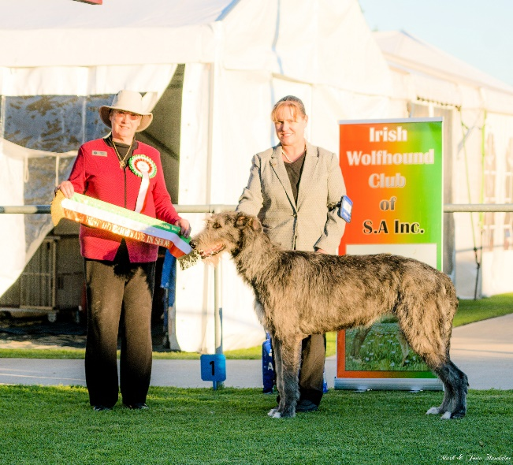
STATE BRED IN SHOW  Ch Glenfels Mirakel Maktiga Frida S Baler  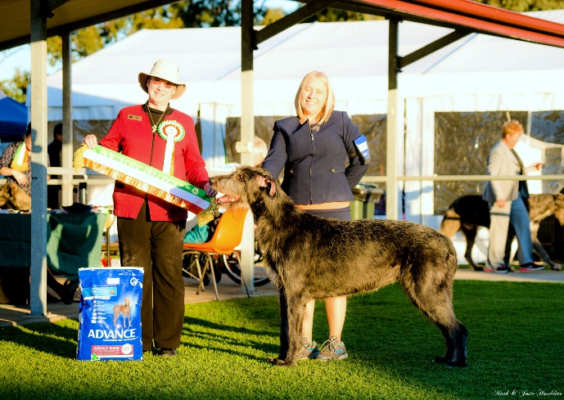 | AUSTRALIAN BRED  Ch Drayton Lady Dorothea A Barber  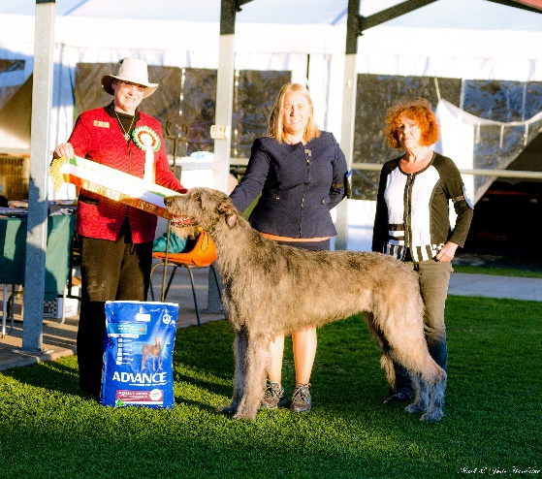
NEUTER BITCH CC AND NEUTER IN SHOW  Ch Wulfgar Firecracker M Thomson  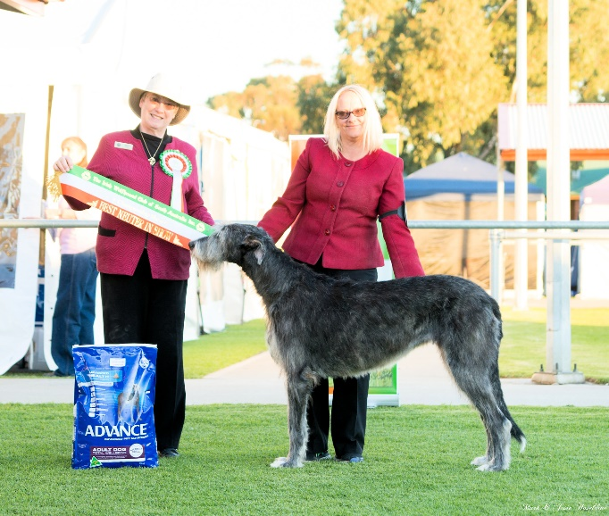 | NEUTER DOG CC AND RUNNER-UP NEUTER IN SHOW  Ch Greycroft Tullamore Paddy S Runciman  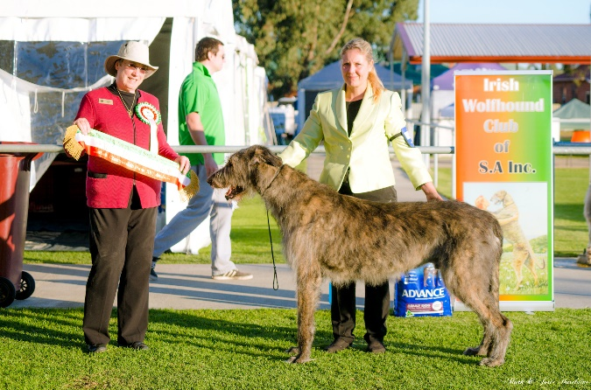

RESERVE DOG CC  Ch Tirowen Rupert S Butterworth and J Armstrong  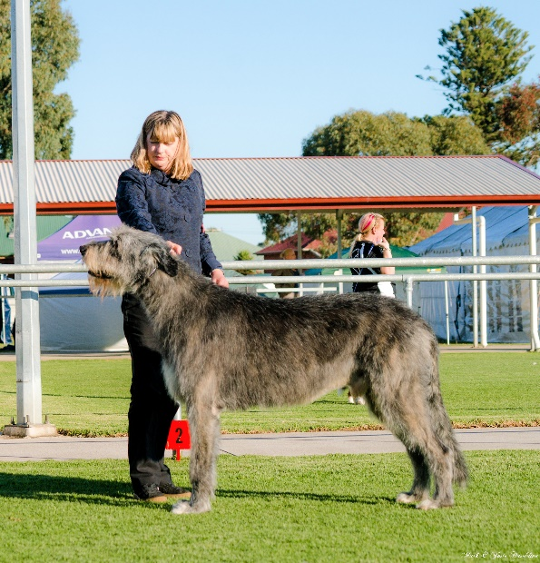 | RESERVE BITCH CC  Ch Wulfgar Fountainhead S Gendle  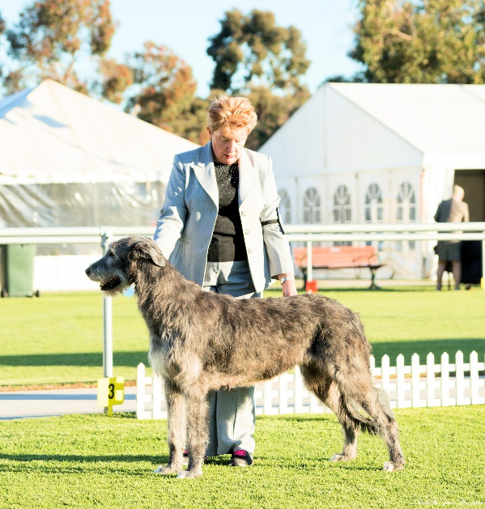
A FEW CANDID PHOTOS
