Irish Wolfhound Club of South Australia Championship Show
3rd June 2017
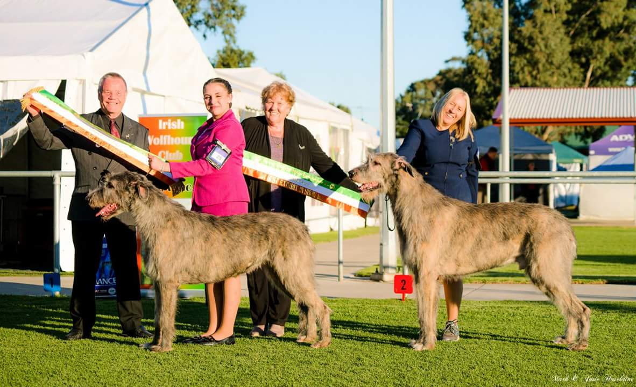
Best in Show & Open in Show Ch Greycroft Irish Storm
Runner-up in Show and Opposite Sex Supreme Ch Glenfels The Boy From Oz

Critique by Judge: Ainslie Mills (Canada)
I would like to thank the Irish Wolfhound Club of South Australia for asking me to judge their specialty show. I very much enjoyed the assignment and assessing the lovely entry of Wolfhounds. Generally, I found correct rough, harsh double coats, black pigment, small rose ears, dark eyes, round compact feet and correct head and tail carriage on the move with a few exceptions. Most of the dogs were in reasonable muscular condition and the adult classes saw dogs of strong, commanding appearance.
Depth and breadth of chest varied especially in the younger exhi9bits and while rears mostly had decent angulation, the front quarters varied considerably, especially concerning the length and return of upper arm. Many rears moved closer than idea going away. Overall, temperaments were lovely and steady.

Baby Puppy Dog Class
1st place WULFGAR KERYMAN AT GLENFELS (AI) Whirlaway Kennels and Mrs S Baker.
This 17-week-old baby had nice angulation, a pleasing head and expression and was smooth going around. He had good proportions and length of neck. He was obviously going through various stages of development and growth so his coming and going movement was not yet totally sound in front and his rear was close moving.
Puppy Dog Class
1st place FLEETWOOD AMORE DELLA MUSICA (AI) (IMP NZ) Ms B McClure and Mr S McClure
This puppy had a pleasing head with good substance for his age but still looking a bit tubular in body. He was easy moving going around but close moving in rear. I would have liked to see more forechest and forequarter development with better length and return of upper arm.
Junior Dog Class
All the Junior dogs had correctly textured coats for their age. Placements were strongly influenced by movement and carriage.
1st Place WULFGAR JUST MY VALENTINO (AI) Ms M Thomson & Mrs S Gendle
Nice head and expression with correct length and proportion and level planes. He was substantial with good breadth and depth of chest and a long rib cage. Nice angulation front and rear.
2nd Place TIROWEN WILLEM Dr F J & Mrs A T McEvoy, Mr S & Mrs C Bieserkerski
Good substance and length of rib cage but less pleasing head and less return of upper arm than the first place dog.
3rd Place SHANNONSRUN MY MATE CULLIGAN Mrs J Marlin
Nice head with good parallel planes and correct proportion. A less substantial dog with less body depth in comparison to the first and second place dogs. His straighter front angulation was reflected in less reach on the move.

Intermediate Dog Class
1st Place ORNUMFLOW YUKON GOLD B Skybinsky
This youngster had nice head planes, proportion and topline. He presented a strong rear going away. He had good length of ribcage but I would like to have seen greater depth of chest. He had less return of upper arm and not enough forequarter development. He lacked reach in front in profile movement and tended to be high stepping instead of reaching forward. He had a good coat texture.
Australian Bred Dog Class
1st Place CH WULFGAR FENNOSCANDIA Ms C. Maciver and Mrs S Gendle
A good-sized dog with nice smooth profile movement. He held his topline well on the move. He had decent forechest and forequarter development and width of chest but I would like to have seen a bit more depth of body. Good length of head with good planes and pleasing expression. Nice rear angulation.
Open Dog Class
1st Place and Dog CC, Runner Up and Opposite Sex in Show SUPREME CH GLENFELS THE BOY FROM OZ (AI) Mrs S Baker
A dog of commanding appearance, sound moving in both profile and on the down and back. He held his topline well both standing and moving. He had correct depth of body with a long ribcage, a lovely blend of neck into the shoulder and correct coat texture. He had a pleasing head and expression with level head planes, nice ear and dark eye. A lovely representative of the breed.
2nd Place and Reserve Dog CC CH TIROWEN RUPERT Mr S Butterworth & Ms J Armstrong
A bit larger dog with good length of rib cage and correct body proportions. Nice blend of neck into shoulder. Less forechest and shoulder angulation than the first-place dog. Not as true moving on the down and back but easy going around.
Puppy Bitch Class
- Both puppies had good coats, pleasing heads with dark eyes, nice length and balance of muzzle and skull.
1st Place WULFGAR KEEVA Mrs S Gendle
Coordinated easier mover for age. Nicely balanced with good angles.
2nd Place FLEETWOOD LIA AT CUMOCROI (AI) (IMP NZ) Mrs S Runciman
Smaller bitch with less front development and angulation. Had a dip in topline and appeared a bit high in rear.
Junior Bitch Class
1st Place FLEETWOOD MAUREEN AT CREENA (AI) (IMP NZ) Mr C & Mrs J Michelmore
Nicely balanced with nice angles, good length of ribcage, some forechest, good feet and pleasing head and expression. A bit close moving in rear going away.
Intermediate Bitch Class
1st Place WULFGAR ITS DE LOVELY Mrs S Gendle
A sound moving dog with good body proportions and outline, good breadth and depth through the forechest with a long rib cage. Pleasing head and expression. Ideally could have more depth in chest.
State Bred Bitch Class
1st Place CH GLENFELS MIRAKEL MAKTIGA FRIDA Mrs S Baker
Smooth moving in profile, nice forechest and correct topline. Good coat texture.
2nd Place CREENA MISS VELVET RIBBON Ms J Marlin
Typey looking bitch with many desirable breed characteristics. Good coat texture but not moving as well in rear as first place entry.
3rd Place GLENFELS ARYA Mr J D & Mrs S P Lewington
Not happy to be showing this day which may be partially responsible for a dip in topline. Less angulation front and rear than first and second place entries.

Australian Bred Bitch Class
1st Place CH DRAYTON LADY DOROTHEA Mrs A Barber
A balanced bitch, lovely on the move with strong rear quarters, good depth of chest and length of rib. Pleasing, correct head and expression.
Open Bitch Class
1st Place Bitch CC and Best in Show CH GREYCROFT IRISH STORM Mr JD & Mrs S P Lewington
Well balanced bitch with deep chest, long ribcage, pleasing head with parallel planes and correct proportion. Good forequarters with correct balanced angulation, front and rear. Sound and true in structure and movement and a wonderful representative of the breed.
2nd Place Res Bitch CC CH WULFGAR FOUNTAIN HEAD – Mrs S Gendle
A very nice bitch. Very smooth and easy going around but not holder her outline as well in motion. Good substance but less depth of body than first place.
Note from Judge:
I neglected to make any notes on the neuter or veteran entries. It was lovely to see the older dogs in the ring enjoying themselves. Thank you again for your hospitality and for the lovely plaque to remember the dau.

Open Neuter Dog
1st Place CH GREYCROFT TULLAMORE PADDY Mrs S Runciman

Open Neuter Bitch
1st Place and Neuter of Breed CH WULFGAR FIRE-CRACKER (AI) Ms M Thomson

Breeder of Best Exhibit in Show (Automatic) J & S Lewington.

PROPERTY AND SPECIAL CLASSES
Note: Best in Show, Runner-up and Best of Opposite do not enter any Property Classes.
CLASS EXHIBIT NAME
Best Interstate Exhibit CH Wulfgar Fountain Head
Best from the West Fleetwood Lia At Cumocroi
Best Headed Dog Ch Wulfgar Fennoscandia
Best Headed Bitch Wulfgar Its De Lovely
Best Gaited Ch Wulfgar Fennoscandia
Best Brace Ch Wulfgar Fennoscandia/
Ch Wulfgar Fountain Head
Bred By Exhibitor (Automatic) Ch Greycroft Irish Storm
Best Veteran Ch Greycroft Annika

