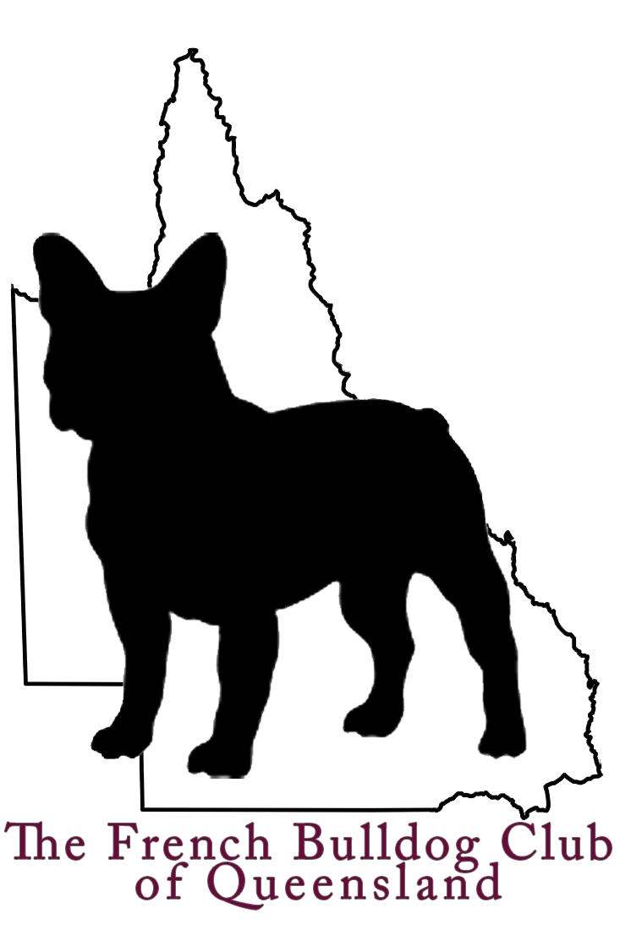 |  | The French Bulldog  Club of Queensland  PO Box 729  Oxenford QLD 4210  www.qldfrenchbulldogclub.com

Secretary’s Report 2013

Many thanks to everyone who has come along to tonight to our AGM for 2013. We currently have 62 members, and we have already reached 18 members for 2014, with renewals yet to start coming in. Renewals will be sent out by the end of November, due on the 31th December 2013 – forms are available tonight for those wishing to complete.

Our fun days have doubled in size at each attempt, and it has been great to see the club gather strength – thank you to our volunteers at these events with BBQ, games, fund raising, ticket sales, etc – the days would not be possible without your input and assistance. The club is also at the forefront of breed education, with many buyers stepping away from the less than reputable breeders and ensuring they are buying from health tested, happy and structurally sound dogs.

The club has taken a firm stance on colour education and thanks again to our breeders and show members who have ensured that pet purchasers are aware of what is desirable and what isn’t – with a focus on scams and puppy farms.

We conducted our first Championship and Open shows with great success! With an entry of 76 and 47 respectively, it was an amazing day, with special thanks once again to all our club volunteers led by the unflappable Tia McArthur.

Thank you to our outgoing committee for your hard work and dedication – congratulations to our incoming committee, I am looking forward to working with you all to make our club even greater!

Kelly McClelland
Secretary
The French Bulldog Club of QLD

