All of the following clothing will have the 13th National Logo embroidered on the front left side in Gold.

Clothing must be pre ordered and pre paid and will be available for collection on the Thursday night prior to the show or anytime over the National Weekend.

Order form is attached, please ensure sizes are correct as there will be no returns or refunds on any items.

The closing date for orders is final to ensure that we receive all items in time for the National event.

We also have some other items available – please see below for further details.

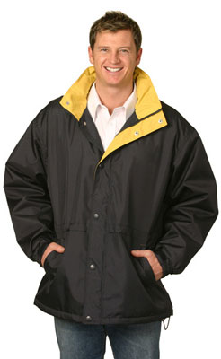 | Jacket  Stadium Outwaterwear Contrast Jacket (unisex)  Description:  Superb tailoring makes this a most practical cool weather garment.  Water repellent Oxford shell, inner with thick anti-pill polar fleece.  Hideaway hood with drawstring closure.  Front chunky zip under press-studded storm flap, high wind collar and adjustable cuff with velcro flap.  Colour: Navy/ Gold  Price: $70.00  (Measurement: CM)
  Size | XS | S | M | L | XL | 2XL | 3XL
  Half Chest | 58.0 | 62.0 | 65.0 | 68.0 | 71.0 | 74.0 | 77.0
  Body Length | 72.0 | 75.0 | 78.0 | 81.0 | 84.0 | 87.0 | 90.0

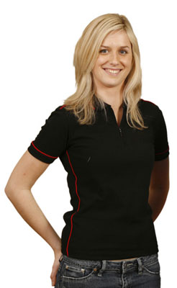 | Ladies Polo Shirt  Ladies' Mini-waffle Contrast Piping Polo  Description:  220gsm poly/cotton Mini-waffle knit.  Smart contrast polo for corporate, club and team wear.  Contrast colour on collar, cuffs & side panels.  UPF50+.  Colour: Navy / Gold  Price: $30.00  (Measurement: CM)
  Size | 8 | 10 | 12 | 14 | 16 | 18
  Half Chest | 46.0 | 48.5 | 51.0 | 53.5 | 56.0 | 58.5
  Body Length | 62.0 | 64.0 | 66.0 | 68.0 | 70.0 | 72.0

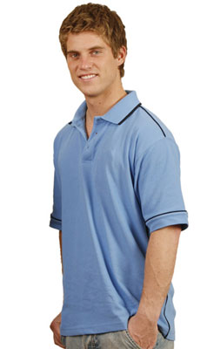 | Mens Polo Shirt  Men's Mini-waffle Contrast Piping Polo  Description:  220gsm poly/cotton Mini-waffle knit.  Smart contrast polo for corporate, club and team wear.  Contrast colour on collar, cuffs & side panels.  UPF50+.  Colour: Navy/ Gold  Price: $30.00  (Measurement: CM)
  Size | S | M | L | XL | 2XL | 3XL | 4XL | 5XL
  Half Chest | 53.5 | 56.0 | 58.5 | 61.0 | 63.5 | 66.0 | 68.5 | 71.0
  Body Length | 70.0 | 72.0 | 74.0 | 76.0 | 78.0 | 80.0 | 82.0 | 84.0
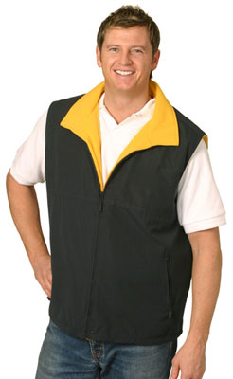 | Vests  Shower Proof Micro Fibre / Polar Fleece Reversible Vest (unisex)  Description:  One side polar fleece fabric & other shower proof micro fibre.  Hidden zips in both side seams for invisible embroidery backing.  Size label in left front pocket.  A favourite for sailing, water sports, cycling, walking & active lifestyles.  Colour: Navy/ Gold  Price: $45.00  (Measurement: CM)
  Size | XS | S | M | L | XL | 2XL | 3XL
  Half Chest | 54.0 | 57.0 | 60.0 | 62.5 | 65.0 | 67.5 | 70.0
  Body Length | 64.0 | 66.0 | 68.0 | 70.0 | 72.0 | 74.0 | 76.0

Also available:
Caps - Navy / Gold in colour, logo embroidered on front panel in gold Price: $20.00

Oversized Golf Umbrella – with 2 Boxer Heads on every 2nd panel
Price: $35.00
Signature Sports Bag – with 2 Boxer Heads embroidered on side bag size (cm) 59.5w x 30h x 32d – Colour: Navy/ White / Silver
Price: $40.00
